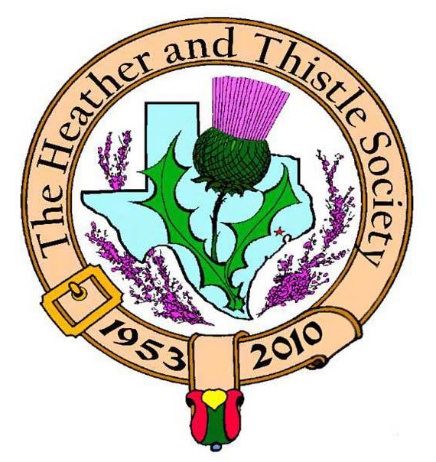

Heather & Thistle Society

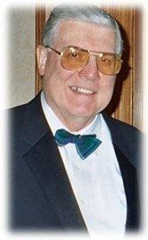
Chieftain Dr. Melvyn Douglass

Volume 10, Issue 6

May, 2010
Newsletter Editor:
Jim Monteith

Officers:

Chieftain – Dr. Melvyn Douglass
Sub-Chieftain – Linda Biddle
Sgt.-at-Arms – Richard Dickson
Secretary – Carol Robertson Treasurer – Dr. Walter May

Committee Chairs:

Sunshine-Irene Boyd
Membership-Jeanette Douglass
Past Chieftains-Jim Monteith
Burns Supper- Robert Boyd
Publicity-Melvyn Douglass
Programs-vacant

Christmas


The Houston Scot

Chieftain’s Letter,

Thank you for the renewed confidence in asking me to serve this Illustrious Society as your 58th Chieftain!. Twenty-four years ago, as 34th Chieftain, you first introduced my wife and I to the responsibilities...and fun...of a closer relationship with The Heather and Thistle Society. Jeanette and I hold wonderful memories...share long-ranging relationships...and count many dear, dear friends, past and present!

We herewith renew our commitment to The Society's aim: "to promote and provide suitable opportunities to educate the general public in Houston, Texas concerning the history, literature, minstrelsy and song, customs and traditions of Scotland, so that the blessing of our Scottish culture may never die in our new homeland."

We envision a) encouraging member participation in activities and events throughout the year, and b) creating a meaningful and challenging environment which will entice and foster new and renewed relationships in support of a visible, meaningful, and relevant Society!

Heather and Thistle Society - Leadership Team for 2010-2011

Officers...
Chieftain – Melvyn Douglass, FSA Scot (34th & 58th Chieftain)
Sub-Chieftain - Linda Biddle
Sgt. At Arms – Richard Dickson
Secretary – Carol Robertson
Treasurer – Walter May (50th Chieftain)
--------------------------------------
Committee Chairs...
Sunshine – Irene Boyd
Membership – Jeanette Douglass
Past Chieftains – Jim Monteith (54th Chieftain)
Burns Supper - Robert Boyd (56th & 57th Chieftain)
Publicity – Melvyn Douglass
Programs – vacant
Newsletter - Jim Monteith & Robert Boyd
Webmaster – vacant
--------------------------------------
Past Chieftains Committee
Robert Boyd - 56th & 57th Chieftain
Ken Sorrels - 55th Chieftain
Jim Monteith - Chairman - 54th Chieftain
Cheryl May - 53rd Chieftain
Ed Biddle - 47th & 48th Chieftain

Heather and Thistle Society Membership Meeting May 15, 2010, 11:30am at the Houston Highland Games

H&T Members are invited to the HHGA Games/Festival as VIPs. Go to HHGA website at www.houstonhighlandgames.com and order tickets online at $7 rate.
As VIPs all H&T Members are invited to the HHGA Hospitality area (under the direction of Jeanette Douglass). Members joining H&T new and/or renewing at the Games will enjoy VIP privileges.
H&T members should show up at the VIP hospitality area at 11:30am to participate in the games opening parade and ceremony. For information contact:
Chieftain Melvyn Douglass
(832) 305-6044 voice or text
(281) 596-4513 fax

Whiskey Distilling
An ancient activity in Scotland, its early history is shrouded both in mystery and myth. By the 16th century “aqua vitae” or “usque baugh” in Gaelic, claimed by some to be Irish in origin, was being distilled on a considerable scale in small pot stills, mainly in the Highlands. The extent of manufacture was such that several Acts of Parliament were passed to restrict malt-making for distilling in time of poor harvest or famine. The first excise duty on spirits was imposed by Parliament in 1644 and it was revived at various times during the late 17th century. This indicates the powerful influence of legislation on the industry’s fortunes and its close relationship to agriculture. (from Collins dictionary of Scottish History)

Come Join the Fun at the 38th Annual
Houston Highland Games and Celtic Festival...
May 15 & 16, 2010 at the, Houston Farm & Ranch Club
1 Abercrombie Drive
Houston, Texas 77084
The Houston Highland Games and Celtic Festival is pleased to announce an outstanding line-up of traditional and rock Celtic music for the 2010 Games. (from the HHGA website)
Henri's Notions...
From soft finger-picked ballads to hard-driving jigs and reels, Henri's Notions creates a musical mix of traditional Celtic and American music as well as their own compositions that have a rhythm and voice reflective of their Southern heritage, which lends a pleasing familiarity to the music. The Notions draw from a broad palette of melodious sounds: the ardent sounds of fiddle,lilting flute, keen tin whistles, ringing mandolin, tenor banjo and bouzouki, and the bounce of the button accordian, all played over the resonant tones and drive of the rhythm section, consisting of acoustic guitars, percussion, bass and now and again – bones.
CLANDESTINE...
was well-known and well-loved from 1992 to 2003 for their particular brand of Texas Celtic music. They were regulars at the Texas Scottish Festival and the North Texas Irish Festival for many years and had full houses at McGonigel's Mucky Duck in Houston, the Cactus Cafe in Austin and Poor David's Pub in Dallas. The band toured the US extensively and had successful stints in Canada and France before breaking up in February 2003. Now Clandestine has re-formed with percussionist and singer Emily Dugas, fiddler Gregory McQueen, piper EJ Jones and a new member, Al Cofrin. (Former member Jen Hamel is pursuing her Ph.D. in Behavioral Ecology at University of Missouri-Columbia.) Al adds his cittern, voice, and another set of bagpipes to the mix. Al and EJ are joining Emily on vocals, with many songs now set in three-part harmony. Most of the group's blasting tune sets remain the same, complemented by some new ones in similar style.
TERIBUS...
is a bagpipe and drum quartet playing Celtic music influenced by musical traditions from around the world. Led by Kevin Hartnell, Richard Kean, EJ Jones, and Al Cofrin, the TERIBUS lineup has many years of experience playing pipes and drums at outdoor festivals. Their love of performance in a variety of settings is evident from the high energy and fun they bring to every show. Although their classical training and desire to please the musical academics in the crowd is always in the back of their minds, TERIBUS is equally likely to engage in antics never before seen in concert halls, creating the perfect combination for any festive event.
Ed Miller...
has been hailed as "one of the finest singers to come out of the Scottish Folksong Revival" and as "one of Scotland's best singing exports." Originally from Edinburgh, he has for many years been based in Austin, TX where he gained graduate degrees in Folklore and Geography at the University of Texas. Ed is available for concerts, clubs, house concerts, festivals, Highland Games and Burns Suppers, as well as for lectures and workshops and has recorded 8 CD's of Scottish songs.

Heather and Thistle Society Membership Application
Date _________________

Last Name ____________________ First Name ____________________ Middle Name ________________

Spouse First Name ___________________________ Home Phone (_____) - _______ - ________

Home Address ________________________________________ City _____________State ______Zip ________

Business Address ______________________________________ City _______________ State ______ Zip ______

Business/Profession ____________________ Email Address: (Needed for monthly newsletter email)______________________

List Children under 18 if application for family membership. Children 18 and older must have their own membership.

__________________________________________ ________________________________________

__________________________________________ ________________________________________

Interests and Hobbies: ___________________________________________________________________________

Clan Tartan ______________ Sponsor:__________________ Shall we list you in our directory? [ ] Yes [ ] No

Are you interested in serving the Society in some capacity [ ] Yes, please contact me. [ ] No, not at this time.

Membership type: [ ] Family - $20.00 per year(includes family members under 18 [ ] Single - $15.00 per year

[ ] New Member [ ] Renew Membership

Please mail your application with membership fee to Dr. Walter May, 6143 Sienna Arbor Lane, Houston, Texas 77041-6038.

Heather and Thistle Society meets at various locations in Houston for business and social gatherings.

Applicant’s Signature _________________________________ Check No._____ Amount Paid $______ Date Paid_________

CHIEFTAINS OF THE HEATHER AND THISTLE SOCIETY

1953-54 Andy Christie* 1971-72 Phil Robinson 1990-91 Alex Munroe
1954-55 Gordon Baxter* 1972-73 Bill Ramsey* 1991-92 David McLane
1955-56 Jack O’Donnell* 1973-74 Jack Hume 1992-93 Ted Hirtz
1956-57 Jack Keith* 1974-75 Bryan Kilgore* 1993-94 Ed MacAllister
1957-58 Bob Bishop 1975-76 Murray Baird* 1994-95 Zoe Alexander*
1958-59 Alan Baxter* 1976-77 Dave Guest* 1995-96 Douglass Moore*
1959-60 Jack Buchanan* 1977-78 Dan Smith 1996-97 Paul Ross
1960-61 Andy Christie* 1978-79 Jack Hume 1997-98 David Haring
1961-62 George Watters* 1979-80 Arthur Down* 1998-99 Heather Lawson
1962-63 John Smith* 1980-81 Gordon White* 1999-00 Ed Biddle
1963-64 Andy Christie* 1981-82 Mickey Carmichael 2000-01 Ed Biddle
1964-65 Ann Stewart 1982-83 Bob Gilbert 2001-02 Wayne Barton
1965-66 George Watters* 1983-84 Don Whitefield* 2002-03 Walter May
1966-67 Jack Buchanan* 1984-85 Arthur Marshall 2003-04 Becci Himes
1967-68 Robert Officer 1985-86 Owen McBride* 2004-05 Aaron Buchanan
1968-69 Robert Potter 1986-87 Melvyn Douglass 2005-06 Cheryl Duthie May
1969-70 Brian Reuter* 1987-88 Tom Murphy 2006-07 James Monteith
1970-71 Ian Taylor-Small* 1988-89 Edward Brodie* 2007-08 Kenneth Sorrels
*Deceased 1989-90 Lyman Matheson 2008-09 Robert Boyd
2009-10 Robert Boyd

Heather & Thistle Society Statement And Membership Information
The Heather and Thistle Society was founded in 1953 by Scots living in Houston who wished to “cultivate an interest in and fond recollections of Scotland, its history and traditions, its literature and ideals, its minstrelsy and song, its customs and amusements, and to provide opportunities for good fellowship and social contact through typically Scottish functions, so that the blessing of our Scottish culture may never die in our new homeland”.

The Heather and Thistle Society will meet numerous times during the year from September through June. The Executive Committee will be meeting regularly to handle the business matters of the Society. Member meetings will now be in the form of social events held at different venues around Houston. The annual Christmas Party meeting will be held at the St. Thomas Episcopal School in the Ingram Room at 4900 Jackwood, Houston, Texas 77096. Our annual general membership will be held in March, when officers of the Society are elected.

The Heather and Thistle Society has for 57 years held a grand annual Robert Burn’s Supper and Ball in late January of each year. We are an organization that promotes our Scottish heritage, in various ways.

The Heather and Thistle Society’s monthly newsletter, “The Houston Scot” is published from September through June. Original articles, information about Scottish or related events are welcome and should be sent to the editor, Jim Monteith, at 15703 Mound Road, Hockley, Texas 77447 or 936-931-2588.

Membership in the Heather and Thistle Society is open to all with an interest in Scottish heritage and culture. Annual dues are $15 for an individual and $20 for a family membership. Applications for membership may be obtained from our website or contact Dr. Walter May at 713-983-8866.
http://heatherandthistle.org/documents/membership.doc
Dues are due at the beginning of the fiscal year, March 1. Completed applications and membership fees should be mailed to:

Dr. Walter May
6143 Sienna Arbor Lane
Houston, Texas 77041-6038

