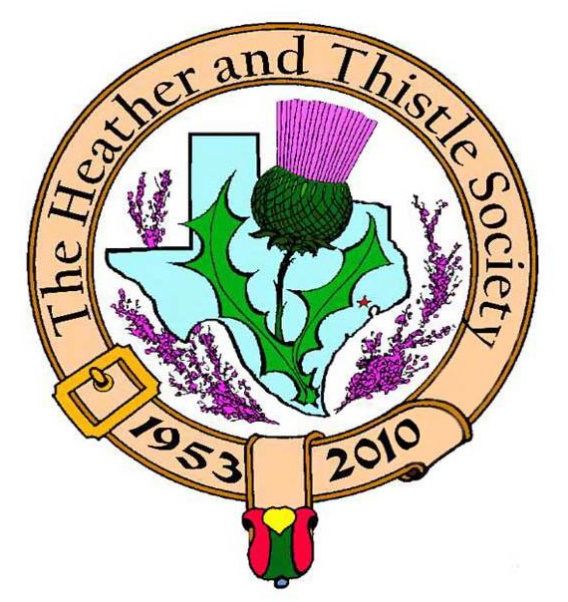

Heather & Thistle Society

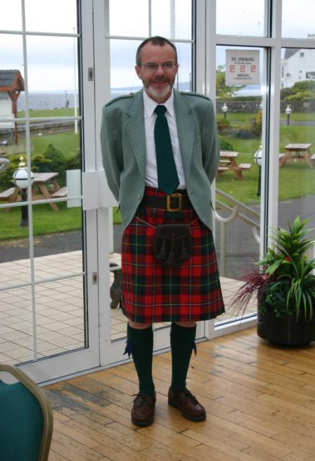 Chieftain Dr. Robert Boyd

Volume 10, Issue 4

January, 2010
Newsletter Editor:
Jim Monteith

Officers:

Chieftain – Dr. Robert Boyd
SubChieftain – Rev. Melvyn Douglass
Sgt.-at-Arms – Mark Monroe
Secretary – Carmelita Orr Treasurer – Dr. Walter May

Committee Chairs:

Sunshine-vacant
Membership-vacant
Past Chieftains-Cheryl May
Burns Supper- Ken Sorrels
Publicity-Melvyn Douglass
Programs-vacant

Christmas 

The Houston Scot

Chieftain’s Letter,
I would like to wish all members and their families a very happy and prosperous 2010. These are difficult times for the Heather & Thistle Society. Jim Monteith’s recent letter highlighted the extremely slow sales for the Burns Supper this year. Right now we urgently need everyone to pitch in to generate ticket sales to minimize the financial impact on the Society. As soon as possible after the Burns Supper the Executive Committee will begin reviewing how the Society might be restructured to move forward, possibly in conjunction with other groups, including an assessment of future Burns Suppers. Any input is welcome and encouraged. We’ll present proposals to the membership as soon as possible. Please support the Burns Supper and the enjoyable event we have planned for the next day starting at 3:00 PM in Hermann Park.
Annual Party a success
Our annual Party and gift exchange was held in the Ingram Room at St. Thomas Episcopal School where about twenty members attended and a good time was had by all. The competition for a bottle of Lismore single malt was especially intense.
Sunshine Items
Past Chieftain Alex Munroe is now home following a second hip surgery last month. He and Maryann are for the time being living in Port Aransas with their daughter Cameron and her husband. Alex’s progress can be followed at the website www.caringbridge.org/visit/alexmunroe and messages can be left there too.
January 19, 2010 – H&T to be guests at RSCDS for practice session
RSCDS has invited us to attend a session to brush up our ceilidh dancing in time for the Burns Supper. Details have been sent out to the membership and posted on the website.
Burns Supper January 23, 2010 –PLEASE BUY YOUR TICKETS NOW
The Society’s 57th Annual Robert Burns Supper & Ball will be held in the Marriott Westchase on January 23, 2010. An Order Form and all necessary information are on the website.
Sunday January 24 at 3:00 PM: Robert Burns Bust in Hermann Park
A short ceremony will be followed by a social meeting in the Churchill Room at the Black Labrador Pub, 4100 Montrose, at which the H&T Burns Club will give its annual performance and a Scottish Trivia Quiz will be held. Drinks and pub food can be ordered.
Tartan of the Month – Caledonia
In honor of our good friends and partners the Houston Highlanders we are pleased to feature the band’s adopted tartan. Check it out at www.heatherandthistle.org.
Robert Boyd
Chieftain

The Heather and Thistle Society
57th Annual Robert Burns Supper
Saturday, January 23, 2010
Houston Marriott Westchase , 2900 Briarpark Drive, Houston, TX 77042
Ticket Order Form
Name of Ticket Holder * | No. Tickets | Total # Member Tickets @ $65 | Total # Non-Member Tickets @ $80 | Total Dollar Amount
Mail to:
Name:
Address:
City |  | State |  | Zip
Phone # |  | E-mail
* Member tickets may be purchased by/for only those with current dues as of September 30, 2009. Tickets ordered in November must be paid for in full by December 1st. Please list names for whom member tickets are requested. Use a separate sheet for each table of ten.
Enclose a self-addressed, stamped envelope with this form and your check made payable to the Heather and Thistle Society. Mail to:
 | Mrs. Robert A. McClure (Joan)
 | 553 Brown Saddle Road
 | Houston, TX 77057-1413
 | Ph: 713-782-6707
Date received |  | Ticket Nos. | Table Nos. | Tickets Mailed
__________________ |  | _________________ | _________________ | _______________

Heather and Thistle Society Membership Application
Date _________________

Last Name ____________________ First Name ____________________ Middle Name ________________

Spouse First Name ___________________________ Home Phone (_____) - _______ - ________

Home Address ________________________________________ City _____________State ______Zip ________

Business Address ______________________________________ City _______________ State ______ Zip ______

Business/Profession ____________________ Email Address: (Needed for monthly newsletter email)______________________

List Children under 18 if application for family membership. Children 18 and older must have their own membership.
_____________________________________________________________________________________________________

Interests and Hobbies: ___________________________________________________________________________

Clan Tartan ______________ Sponsor:__________________ Shall we list you in our directory? [ ] Yes [ ] No

Are you interested in serving the Society in some capacity [ ] Yes, please contact me. [ ] No, not at this time.

Membership type: [ ] Family - $20.00 per year(includes family members under 18 [ ] Single - $15.00 per year

[ ] New Member [ ] Renew Membership

Please mail your application with membership fee to Dr. Walter May, 6143 Sienna Arbor Lane, Houston, Texas 77041-6038.

Heather and Thistle Society meets at various locations in Houston for business and social gatherings.

Applicant’s Signature ______________________ Check No._____ Amount Paid $______Date Paid ________

Heather and Thistle Members

Ticket sales for our upcoming 2010 Burns Supper at the Marriott Westchase in Houston are poor to this date. We have only sold 130 tickets, which is just 13 tables. The number of people attending our Burns Suppers has steadily decreased over the last 6 years. The Burns Supper planning committee has been adjusting to this decrease in attendance as best as we can. The committee really has no firm idea how many tickets will be sold each year. We had 432 people attend the 2009 Burns Supper and we had planned for 450. We planned for only 350 to attend the 2010 Burns Supper and we are falling far short of that goal. The Burns Supper planning committee has to negotiate a contract each year with the host hotel. We have to guarantee the hotel a minimum amount of money based on how many people attend. We have to sell more tickets to cover our contract costs. Otherwise, H&T loses a lot of money putting this supper on for our members and guests. H&T is a non-profit organization. Our proceeds from the Burns Supper are donated annually to the Scottish Arts in the Houston area.
Members, please do your utmost to buy or sell some tickets for your organization. Please find a ticket order form attached on page two of this newsletter. Order forms are also on the website www.heatherandthistle.org.

Royal Scottish Country Dance Society Invites H&T Members to Free Dance Lesson

The Houston Branch of RSCDS is pleased to invite all members of Heather & Thistle to come and brush up on their Ceilidh dancing on Tuesday, January 19, 2010 at 7:30pm. The dance will be held in Studio A of the Dad's Club YMCA at 1006 Voss Rd. (N. of I-10, between Bingle and Campbell). Enter the first gate, turn to the right and follow the drive to the back of the buildings to the large parking area. This will be an evening of fun and friendship for all. There is no charge for Heather & Thistle members or their guests.

Heather & Thistle Society Statement And Membership Information
The Heather and Thistle Society was founded in 1953 by Scots living in Houston who wished to “cultivate an interest in and fond recollections of Scotland, its history and traditions, its literature and ideals, its minstrelsy and song, its customs and amusements, and to provide opportunities for good fellowship and social contact through typically Scottish functions, so that the blessing of our Scottish culture may never die in our new homeland”.

The Heather and Thistle Society will meet numerous times during the year from September through June. During the rest of 2009 and into 2010 the Executive Committee will be meeting regularly to handle the business matters of the Society. Member meetings will now be in the form of social events held at different venues around Houston. The annual Christmas Party meeting will be held at the St. Thomas Episcopal School in the Ingram Room at 4900 Jackwood, Houston, Texas 77096. Our annual general membership meeting in February, when officers of the Society are elected, will also be held at St. Thomas Episcopal School.

The Heather and Thistle Society has for 56 years held a grand annual Robert Burn’s Supper and Ball in late January of each year. We are an organization that promotes our Scottish heritage, in various ways.

The Heather and Thistle Society’s monthly newsletter, “The Houston Scot” is published from September through June. Original articles, information about Scottish or related events are welcome and should be sent to the editor, Jim Monteith, at 15703 Mound Road, Hockley, Texas 77447 or 936-931-2588.

Membership in the Heather and Thistle Society is open to all with an interest in Scottish heritage and culture. Annual dues are $15 for an individual and $20 for a family membership. Applications for membership may be obtained from our website or contact Dr. Walter May at 713-983-8866.
http://heatherandthistle.org/documents/membership.doc
Dues are due at the beginning of the fiscal year, March 1. Completed applications and membership fees should be mailed to:

Dr. Walter May
6143 Sienna Arbor Lane
Houston, Texas 77041-6038

