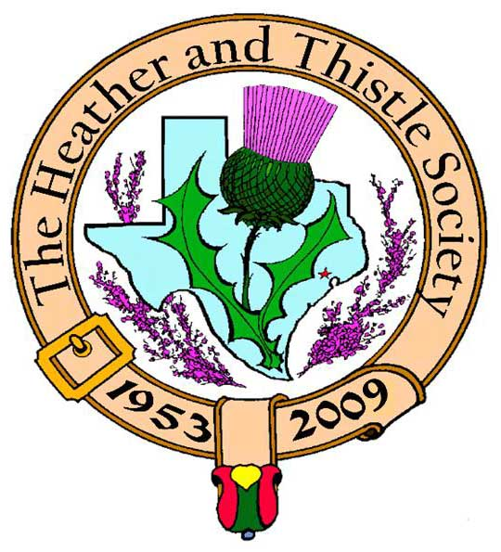

Heather & Thistle Society

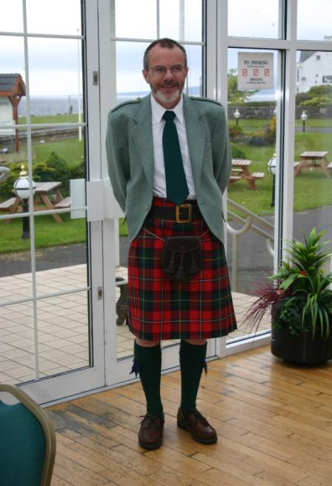 Chieftain Dr. Robert Boyd

Volume 10, Issue 3

November, 2009
Newsletter Editor:
Jim Monteith

Officers:

Chieftain – Dr. Robert Boyd
SubChieftain – Rev. Melvyn Douglass
Sgt.-at-Arms – Mark Monroe
Secretary – Carmelita Orr Treasurer – Dr. Walter May

Committee Chairs:

Sunshine-vacant
Membership-vacant
Past Chieftains-Cheryl May
Burns Supper- Ken Sorrels
Publicity-Melvyn Douglass
Programs-vacant

Heather and Thistle Society has a website. For more information about our Society please check it out. It is located at www.heatherandthistle.org.
Christmas

The Houston Scot

Chieftain’s Letter,
I would like to wish everyone a very enjoyable Thanksgiving with their families. Thanks to everyone who responded to the recent push we made for payment of this year’s dues. Our current account is looking much healthier now. I urge everyone to purchase tickets as soon as possible for our 2010 Robert Burns Supper & Ball on January 23rd, and to encourage as many friends as possible to attend. I would like to see a large attendance at the annual Party and Gift Exchange we have coming up on November 30, details below.
Most enjoyable evening at McGonigel’s Mucky Duck
Fifteen H&T members attended the Ed Miller / Brian McNeill concert at McGonigel’s Mucky Duck, on November 5. We were all seated together and enjoyed a most lively concert, as well as good food and ale – altogether another successful social evening. Ed Miller was kind enough to acknowledge us from the stage, and commented that the surroundings were much friendlier than his recent appearances for us at our former regular meetings. I think everyone agrees we are on the right track with this new format.
Annual Party Monday November 30 at 7:30 PM at St. Thomas Episcopal School
Our annual Party and gift exchange will now be held on Saint Andrew’s Night November 30 (previously set for December 14). The format is the same as in previous years – everyone is asked to bring a dish to share and a modestly-priced gift for a white elephant exchange to be run under our usual rules. The venue as in previous years will be the Ingram Room at St. Thomas Episcopal School. A short business meeting will be held.
Sunshine Items
Past Chieftain Alex Munroe had a fall and broke his leg about a month ago. He is in a rehab center in Corpus Christi. Alex’s progress can be followed at www.caringbridge.org/visit/alexmunroe and messages can be left there too. His daughter Cameron is on hand to help Maryann and we wish Alex all the best in his recovery.
January 5 or 12 – H&T to be guests at RSCDS for practice session
RSCDS has invited us to attend one of their early January sessions to brush up our ceilidh dancing in time for the Burns Supper. More details at the party on November 30.
Burns Supper January 23, 2010 –Tickets now on sale to the general public
The Society’s 57th Annual Robert Burns Supper & Ball will be held in the Marriott Westchase on January 23, 2010. Ticket sales were opened to non-members at $80 each on November 1. An Order Form and all necessary information is included in the October 2009 Newsletter on the website.
Sunday January 24 at 3:00 PM: Robert Burns Bust in Hermann Park
A short ceremony will be followed by a social meeting at a local pub or restaurant, at present planned to be the Black Labrador Pub, 4100 Montrose, at which the H&T Burns Club will be invited to give its annual performance. Details of the event will be published in the next Newsletter.
Tartan of the Month – United States Bi-Centennial
For the Thanksgiving Holiday. Check it out at www.heatherandthistle.org.
Robert Boyd
Chieftain

The Heather and Thistle Society
57th Annual Robert Burns Supper
Saturday, January 23, 2010
Houston Marriott Westchase , 2900 Briarpark Drive, Houston, TX 77042
Ticket Order Form
Name of Ticket Holder * | No. Tickets | Total # Member Tickets @ $65 | Total # Non-Member Tickets @ $80 | Total Dollar Amount
Mail to:
Name:
Address:
City |  | State |  | Zip
Phone # |  | E-mail
* Member tickets may be purchased by/for only those with current dues as of September 30, 2009. Tickets ordered in November must be paid for in full by December 1st. Please list names for whom member tickets are requested. Use a separate sheet for each table of ten.
Enclose a self-addressed, stamped envelope with this form and your check made payable to the Heather and Thistle Society. Mail to:
 | Mrs. Robert A. McClure (Joan)
 | 553 Brown Saddle Road
 | Houston, TX 77057-1413
 | Ph: 713-782-6707
Date received |  | Ticket Nos. | Table Nos. | Tickets Mailed
__________________ |  | _________________ | _________________ | _______________

Heather and Thistle Society Membership Application
Date _________________

Last Name ____________________ First Name ____________________ Middle Name ________________

Spouse First Name ___________________________ Home Phone (_____) - _______ - ________

Home Address ________________________________________ City _____________State ______Zip ________

Business Address ______________________________________ City _______________ State ______ Zip ______

Business/Profession ____________________ Email Address: (Needed for monthly newsletter email)______________________

List Children under 18 if application for family membership. Children 18 and older must have their own membership.

__________________________________________ ________________________________________

__________________________________________ ________________________________________

Interests and Hobbies: ___________________________________________________________________________

Clan Tartan ______________ Sponsor:__________________ Shall we list you in our directory? [ ] Yes [ ] No

Are you interested in serving the Society in some capacity [ ] Yes, please contact me. [ ] No, not at this time.

Membership type: [ ] Family - $20.00 per year(includes family members under 18 [ ] Single - $15.00 per year

[ ] New Member [ ] Renew Membership

Please mail your application with membership fee to Dr. Walter May, 6143 Sienna Arbor Lane, Houston, Texas 77041-6038.

Heather and Thistle Society meets at various locations in Houston for business and social gatherings.

Applicant’s Signature _________________________________ Check No._____ Amount Paid $______ Date Paid_________

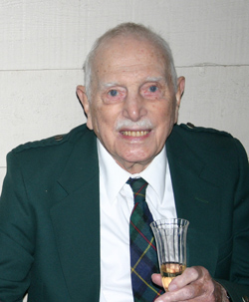

Dr. Arthur Lewis Down 1916 – 2009

27th Past Chieftain (1979-80) Arthur Down, born in London, England March 25, 1916 died peacefully at his home in Houston November 15, 2009. He is survived by his loving wife Joan, children Martin and Bridget and their families. Arthur spent many years in the chemical industry in the West Indies, latterly with Texaco, and after a spell at head office in New York City came to Houston, the last stop in his long and successful career with Texaco, in the mid-1970s. Ever since then he and Joan were stalwart members of Heather & Thistle and served the Society in an exemplary manner. Arthur for many years represented the Society at the annual World Burns Federation Conference, and recruited guest speakers from Scotland for our Annual Burns Supper; he and Joan graciously hosted many of the speakers in their own home. The Downs presented the Society with the beautiful silver badge of office that the Chieftain now wears. Arthur co-founded the Society’s Burns Club and has organized the Club’s own Burns Supper for all of the twenty-one consecutive years it has been held, as well as taking an enthusiastic role in the Club’s annual Burns performance. Arthur brought a phenomenal memory and attention to detail to everything he tackled, which guaranteed great success. We in Heather & Thistle will miss Arthur Down greatly. We offer sincere condolences to Joan and her family. In lieu of flowers the Downs have been kind enough to suggest Heather & Thistle as a suitable charity for donations.

Heather & Thistle Society Statement And Membership Information
The Heather and Thistle Society was founded in 1953 by Scots living in Houston who wished to “cultivate an interest in and fond recollections of Scotland, its history and traditions, its literature and ideals, its minstrelsy and song, its customs and amusements, and to provide opportunities for good fellowship and social contact through typically Scottish functions, so that the blessing of our Scottish culture may never die in our new homeland”.

The Heather and Thistle Society will meet numerous times during the year from September through June. During the rest of 2009 and into 2010 the Executive Committee will be meeting regularly to handle the business matters of the Society. Member meetings will now be in the form of social events held at different venues around Houston. The annual Christmas Party meeting will be held at the St. Thomas Episcopal School in the Ingram Room at 4900 Jackwood, Houston, Texas 77096. Our annual general membership meeting in February, when officers of the Society are elected, will also be held at St. Thomas Episcopal School.

The Heather and Thistle Society has for 56 years held a grand annual Robert Burn’s Supper and Ball in late January of each year. We are an organization that promotes our Scottish heritage, in various ways.

The Heather and Thistle Society’s monthly newsletter, “The Houston Scot” is published from September through June. Original articles, information about Scottish or related events are welcome and should be sent to the editor, Jim Monteith, at 15703 Mound Road, Hockley, Texas 77447 or 936-931-2588.

Membership in the Heather and Thistle Society is open to all with an interest in Scottish heritage and culture. Annual dues are $15 for an individual and $20 for a family membership. Applications for membership may be obtained from our website or contact Dr. Walter May at 713-983-8866.
http://heatherandthistle.org/documents/membership.doc
Dues are due at the beginning of the fiscal year, March 1. Completed applications and membership fees should be mailed to:

Dr. Walter May
6143 Sienna Arbor Lane
Houston, Texas 77041-6038

