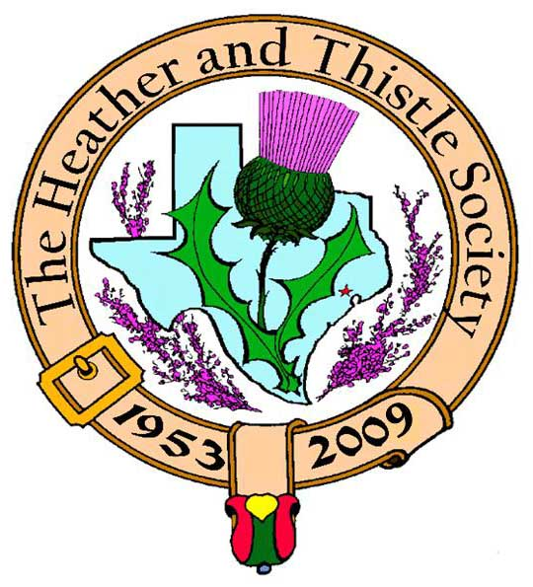

Heather & Thistle Society

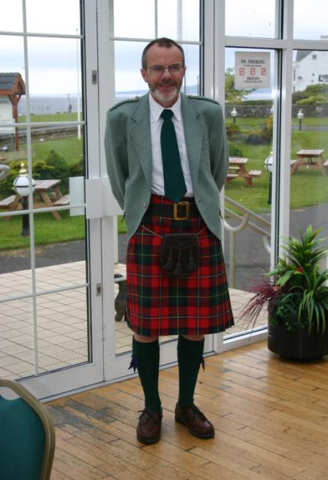 Chieftain Dr. Robert Boyd

Volume 10, Issue 2
October, 2009

Newsletter Editor:
Jim Monteith

Officers:

Chieftain – Dr. Robert Boyd
SubChieftain – Rev. Melvyn Douglass
Sgt.-at-Arms – Mark Monroe
Secretary – Carmelita Orr Treasurer – Dr. Walter May

Committee Chairs:

Sunshine-vacant
Membership-vacant
Past Chieftains-Cheryl May
Burns Supper- Ken Sorrels and
Jim Monteith
Publicity-Melvyn Douglass
Programs-vacant

Heather and Thistle Society has a website. For more information about our Society please check it out. It is located at www.heatherandthistle.org.
The Houston Scot

Chieftain’s Letter,
This is a critical time for our Society. Membership dues are well down compared with previous years because of the graying of our members as well as the current economic situation. Our paid-up membership of about 130 is only half of what it was just a few years ago. For this reason we need all the support we can muster to sustain the Society, and in particular I would urge everyone to purchase tickets as soon as possible for our 2010 Robert Burns Supper & Ball on January 23rd. Tickets are on sale to members only until the end of October. I would also hope for a large attendance at the two functions we have coming up in November, details of which are given below.
September Meeting at the Bull & Bear very well attended
I am delighted to report that the first of our new-style social meetings was extremely successful. The Executive Committee met on September 28 for a business meeting and program discussion at the Bull and Bear Tavern & Eatery. The meeting was open to all members and twenty attended, plus special guest “Flat Stanley” courtesy of Past Chieftain Cheryl May’s granddaughter. Stanley honored us by wearing the kilt, and several members did the same to do a bit of advertising – good job! Treasurer Walter May provided a review of membership revenue which as noted above did not make for very good reading. On a more positive note Past Chieftain Ted Hirtz and his wife Susan reported on their recent trip to Scotland for the World Burns Federation Conference. We all had a great time and enjoyed reasonably-priced pub food and drinks following the business meeting. Thanks to the Bull & Bear staff for their exemplary service. This was an extremely good start to our new program year.
Next Meeting: Thursday November 5 at 7:30 PM at McGonigel’s Mucky Duck
H&T members are invited to attend as a group an Ed Miller concert scheduled for McGonigel’s Mucky Duck, 2425 Norfolk, Houston 77098, phone 713-528-5299. Tickets price $15 by mail or in person, cash or check only. Members should purchase tickets directly, but mention the Heather & Thistle group so we will all be seated together. This will be a purely social event and I encourage everyone to support Ed Miller by attending.
Change of Date: Annual Party now to be held Monday November 30 at 7:30 PM:
Our annual Party and gift exchange will now be held on Saint Andrew’s Night (previously set for December 14). Same format as in previous years, venue also as in previous years in the Ingram Room at St. Thomas Episcopal School. A short business meeting will be held.
Sunshine Items
Past Chieftain Arthur Down continues to make good progress following surgery. Sergeant-at-Arms Mark A. Monroe was forced to miss our September meeting because of a family bereavement, and Past Chieftain Lyman Matheson and his wife Phyllis also missed the meeting. We wish them all the best.
January 5 or 12 – H&T to be guests at RSCDS for practice session
RSCDS has invited us to attend one of their early January sessions to brush up our ceilidh dancing in time for the Burns Supper. More details later.
Burns Supper January 23, 2010 – Members’ Tickets on Sale October 1
The Society’s 57th Annual Robert Burns Supper & Ball will be held in the Marriott Westchase on January 23, 2010. Members can buy tickets beginning October 1; Sales will be opened to non-members beginning November 1.
Sunday January 24 at 3:00 PM: Robert Burns Bust in Hermann Park
A short ceremony will be followed by a social meeting at a local pub or restaurant at which the H&T Burns Club will be invited to give its annual performance.
Tartan of the Month – Monteith
In memory of Jim Monteith’s mother. Check it out at www.heatherandthistle.org.
Robert Boyd
Chieftain

The Heather and Thistle Society
57th Annual Robert Burns Supper
Saturday, January 23, 2010
Houston Marriott Westchase , 2900 Briarpark Drive, Houston, TX 77042
Ticket Order Form
Name of Ticket Holder * | No. Tickets | Total # Member Tickets @ $65 | Total # Non-Member Tickets @ $80 | Total Dollar Amount
Mail to:
Name:
Address:
City |  | State |  | Zip
Phone # |  | E-mail
* Member tickets may be purchased by/for only those with current dues as of September 30, 2009. Tickets ordered in November must be paid for in full by December 1st. Please list names for whom member tickets are requested. Use a separate sheet for each table of ten.
Enclose a self-addressed, stamped envelope with this form and your check made payable to the Heather and Thistle Society. Mail to:
 | Mrs. Robert A. McClure (Joan)
 | 553 Brown Saddle Road
 | Houston, TX 77057-1413
 | Ph: 713-782-6707
Date received |  | Ticket Nos. | Table Nos. | Tickets Mailed
__________________ |  | _________________ | _________________ | _______________

Heather and Thistle Society Membership Application
Date _________________

Last Name ____________________ First Name ____________________ Middle Name ________________

Spouse First Name ___________________________ Home Phone (_____) - _______ - ________

Home Address ________________________________________ City _____________State ______Zip ________

Business Address ______________________________________ City _______________ State ______ Zip ______

Business/Profession ____________________ Email Address: (Needed for monthly newsletter email)______________________

List Children under 18 if application for family membership. Children 18 and older must have their own membership.

__________________________________________ ________________________________________

__________________________________________ ________________________________________

Interests and Hobbies: ___________________________________________________________________________

Clan Tartan ______________ Sponsor:__________________ Shall we list you in our directory? [ ] Yes [ ] No

Are you interested in serving the Society in some capacity [ ] Yes, please contact me. [ ] No, not at this time.

Membership type: [ ] Family - $20.00 per year(includes family members under 18 [ ] Single - $15.00 per year

[ ] New Member [ ] Renew Membership

Please mail your application with membership fee to Dr. Walter May, 6143 Sienna Arbor Lane, Houston, Texas 77041-6038.

Heather and Thistle Society meets at various locations in Houston for business and social gatherings.

Applicant’s Signature _________________________________ Check No._____ Amount Paid $______ Date Paid_________

The Heather and Thistle Society Minutes September 27, 2009

The September meeting took place Monday, September 27th, 2009 at the Bear and Bull Tavern following the new meeting format. About 20 members were present.
Chieftain Robert Boyd opened the meeting at about 7:45 PM following giving people chance to order drinks and dinner. Minutes published in the Newsletter for the June meeting were approved.
Treasurer Walter May reported we have $1,493.13 in the checking account, $1,414.36 in the Past Chieftains Contingency Fund and $18,313.10 in the Burn’s Supper Planning Committee account. The latter is after giving the Marriott Houston Westchase Hotel a $4,500 deposit for the 2010 supper. Over the summer we received a refund of $1,703.60 for sales taxes paid at the last supper.
As of the meeting, we had 83 dues paying members (including couples) and 49 non-dues paying members. The latter are past chieftains or widows who have lifetime status. A request was made that people with lifetime status pay dues to help the financial condition of the society. The response has been gratifying.
Chieftain Boyd reviewed coming programs for the year. These are summarized in the Chieftain’s letter In this Newsletter.
The Sunshine Committee reported that Past Chieftain Arthur Down continues to make good progress from surgery. Arthur and Joan have changed their plans and will remain in Houston.
The business meeting was adjourned about 8:00 PM. Members remained for food, drink and conversation. The meeting format was well accepted.

Walter May, Acting Secretary

Heather & Thistle Society Statement And Membership Information

The Heather and Thistle Society was founded in 1953 by Scots living in Houston who wished to “cultivate an interest in and fond recollections of Scotland, its history and traditions, its literature and ideals, its minstrelsy and song, its customs and amusements, and to provide opportunities for good fellowship and social contact through typically Scottish functions, so that the blessing of our Scottish culture may never die in our new homeland”.

The Heather and Thistle Society will meet numerous times during the year from September through June. During the rest of 2009 and into 2010 the Executive Committee will be meeting regularly to handle the business matters of the Society. Member meetings will now be in the form of social events held at different venues around Houston. The annual Christmas Party meeting will be held at the St. Thomas Episcopal School in the Ingram Room at 4900 Jackwood, Houston, Texas 77096. Our annual general membership meeting in February, when officers of the Society are elected, will also be held at St. Thomas Episcopal School.

The Heather and Thistle Society has for 56 years held a grand annual Robert Burn’s Supper and Ball in late January of each year. We are an organization that promotes our Scottish heritage, in various ways.

The Heather and Thistle Society’s monthly newsletter, “The Houston Scot” is published from September through June. Original articles, information about Scottish or related events are welcome and should be sent to the editor, Jim Monteith, at 15703 Mound Road, Hockley, Texas 77447 or 936-931-2588.

Membership in the Heather and Thistle Society is open to all with an interest in Scottish heritage and culture. Annual dues are $15 for an individual and $20 for a family membership. Applications for membership may be obtained from our website or contact Dr. Walter May at 713-983-8866.
http://heatherandthistle.org/documents/membership.doc
Dues are due at the beginning of the fiscal year, March 1. Completed applications and membership fees should be mailed to:

Dr. Walter May
6143 Sienna Arbor Lane
Houston, Texas 77041-6038

