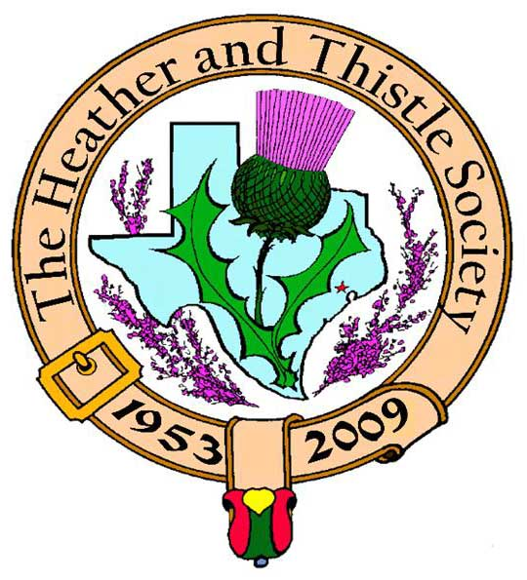

Heather & Thistle Society

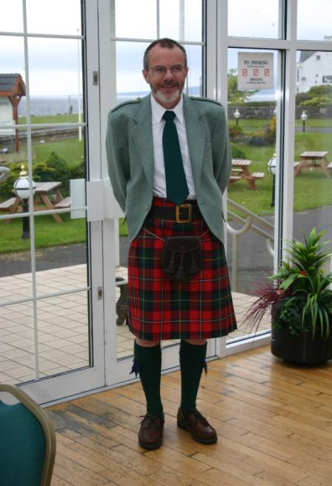 Chieftain Dr. Robert Boyd

Volume 9, Issue 10
September, 2009

Newsletter Editor:
Jim Monteith

Officers:

Chieftain – Dr. Robert Boyd
SubChieftain – Rev. Melvyn Douglass
Sgt.-at-Arms – Mark Monroe
Secretary – Carmelita Orr Treasurer – Dr. Walter May

Committee Chairs:

Sunshine-vacant
Membership-vacant
Past Chieftains-Cheryl May
Burns Supper- Ken Sorrels and
Jim Monteith
Publicity-Melvyn Douglass
Programs-vacant

September 28, 2009 meeting will be held at the Bull and Bear Tavern and Eatery at 11980 Westheimer, Houston, Tx. This is at the intersection of Westheimer and Kirkwood.Time is at 7:30pm. See you there!!!!!

The Houston Scot

Chieftain’s Letter,
We’ve had such a long, hot dry summer in Houston. I’m sure you’ll agree with me that we’re ready to start some Fall activities and perhaps that will encourage the onset of cooler weather too! Your Executive Committee has been busy over the summer developing what we think is a more attractive and varied program of meetings for the upcoming 2009-2010 year. I encourage everyone to respond to the suggestions we’ve developed with constructive comments. The whole purpose of the change of program schedule and venue is to try to increase the attendance from the dismal levels we’ve seen for the last two years or so.
Summer Barbeque July 12 – an outstanding success!
The barbeque held at our house in July was a resounding success. Over fifty members and guests showed up for what was a memorable gathering. Great food and beverages were served. Thanks to all who put in such a lot of work to make this happen, especially Cheryl and Walter May who took on the responsibility for most of the organization and food purchasing and preparation. On the day we had help from Jim Haggarty and John and Fiona Wiesehan and many other members. It was fun to meet and talk, as well as honor the Downs. It was so good to see Alex and Maryann Munroe at the BBQ. They too will soon be leaving Houston as full-time residents and will be less regular attendees at H&T. The success of the event prompted us to go ahead with plans for more of the same type of social gatherings.
Sunshine Items over the Summer
Past Chieftain Alex Munroe suffered a stroke earlier in the summer. He has recovered very well, but that has resulted in the Munroes electing to spend quite a bit of the year in Port Aransas where their daughter Cameron lives. We wish them all the best. Since the BBQ Past Chieftain Arthur Down has undergone a colostomy and just this week has returned home. We wish him a full recovery. The Downs plans to relocate to California have been canceled and he and Joan are revisiting their options. Past Chieftain Jim Monteith’s mother recently passed away. Our sincere condolences to his family.
Membership Dues for 2009-2010 – Cut-Off Date September 30
Members are reminded that dues for this year which were payable on March 1, 2009 are now well past due, and must be paid in full by September 30 to maintain eligibility for discounted tickets for the 2010 Burns Supper.
Burns Supper January 23, 2010 – Members’ Tickets on Sale October 1
The Society’s 57th Annual Robert Burns Supper & Ball will be held in the Marriott Westchase on January 23, 2010. Members can buy tickets beginning October 1; Sales will be opened to non-members beginning November 1.
Meetings Program for September Onwards
As noted above the Executive Committee recognizes that something new needs to be tried to boost attendance at the regular meetings. We propose to have fewer meetings, less business items at the meetings, and to hold the meetings at more friendly venues with more time for socializing. A shorter Newsletter will continue to be sent out monthly September through June. Here is the proposed schedule for the coming year:

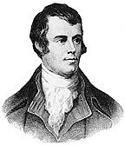

57th Annual Heather and Thistle Burns Supper will be held at the Westchase Marriott once again on Saturday, January 23rd, 2010. Member tickets go on sale October 1st, 2009. Non-member tickets will be sold starting November 1st.
H&T members need to have their member dues current by the end of September, 2009 in order to get the member price on the Burns Supper tickets. Please send in your renewal if you have not already done so.
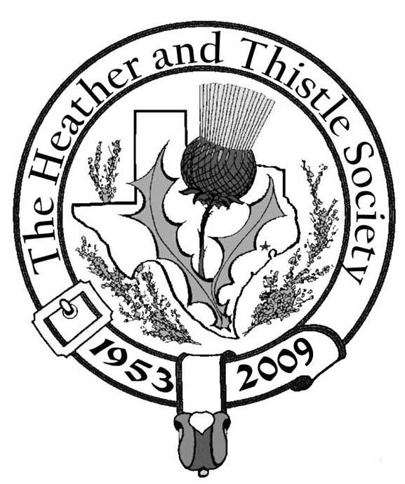

Don’t Forget that our upcoming September meeting will not be held at the St. Thomas Episcopal School.

Chieftain letter continued from page 1:
Monday September 28 at 7:30 PM: The Executive Committee will meet for a business meeting and to discuss the new concepts for the Society. The Past Chieftains Committee is invited and the meeting is open to all members who are encouraged to attend. The meeting will be held at the Bull and Bear Tavern & Eatery, 11980 Westheimer, Houston, TX 77077 (@ Kirkwood). Those who wish to socialize further will be able to order reasonably-priced pub food and drinks following the business meeting. RSVP by September 21 to Robert Boyd 281-558-1131 or info@heatherandthitsle.org so we can reserve appropriate space at this new venue.
Thursday November 5 at 7:00 PM: H&T members will be invited to attend (as a group) an Ed Miller concert scheduled for McGonigel’s Mucky Duck, ticket price $15. This will be a purely social event.
November: Executive Committee meeting open to members, date, time and place to be advised. Also, the possibility of H&T being guests at a suitable RSCDS meeting during November for “coaching” for the ceilidh dancing at the Burns Supper is being investigated and details will be provided.
Monday December 14 at 7:30 PM: Christmas Party and gift exchange. Same format as in previous years, venue as in previous years in the Ingram Room at St. Thomas Episcopal School. A purely social event.
Saturday January 23: Burns Supper, details above.
Sunday January 24 at 3:00 PM: Meet at the Robert Burns Bust in Hermann Park, followed by a social meeting at a local pub or restaurant at which the H&T Burns Club will be invited to give its annual performance.
February or March: The Annual Meeting of Heather & Thistle will be held at which new officers will be elected and sworn in, and all other business matters requiring attention will be dealt with.
May: A Summer Barbeque or Picnic will be held, at a venue to be advised. No business meeting.
Tartan of the Month – Munroe:
In honor of Alex and Maryann Munroe. Check it out at www.heatherandthistle.org.
Robert Boyd,
Chieftain

Heather and Thistle Society has a website.
For more information about our Society please check it out.
It is located at www.heatherandthistle.org.

Heather and Thistle Society Membership Application

Date _________________

Last Name ____________________ First Name ____________________ Middle Name ________________

Spouse First Name ___________________________ Home Phone (_____) - _______ - ________

Home Address ________________________________________ City _____________State ______Zip ________

Business Address ______________________________________ City _______________ State ______ Zip ______

Business/Profession ____________________ Email Address: (Needed for monthly newsletter email)______________________

List Children under 18 if application for family membership. Children 18 and older must have their own membership.

__________________________________________ ________________________________________

__________________________________________ ________________________________________

Interests and Hobbies: ___________________________________________________________________________

Clan Tartan ______________ Sponsor:__________________ Shall we list you in our directory? [ ] Yes [ ] No

Are you interested in serving the Society in some capacity [ ] Yes, please contact me. [ ] No, not at this time.

Membership type: [ ] Family - $20.00 per year(includes family members under 18 [ ] Single - $15.00 per year

[ ] New Member [ ] Renew Membership

Please mail your application with membership fee to Dr. Walter May, 6143 Sienna Arbor Lane, Houston, Texas 77041-6038.

Heather and Thistle Society meets at various locations in Houston for business and social gatherings.

Applicant’s Signature _________________________________ Check No._____ Amount Paid $______ Date Paid_________

Heather and Thistle Membership Dues
We currently have very many members that are behind on their membership dues for 2009. Please take a few minutes and re-new your membership with the Society. On this page above is a membership application/renewal form. Cut it out or print it and mail to Dr. Walter May, our Treasurer, who will be happy to receive your membership renewal at 6143 Sienna Arbor Lane, Houston, Texas 77041-6038. Annual dues are $15.00 for an individual and $20.00 for a family. You must have your membership dues up to date by the end of September in order to get Burns Supper tickets at the member discount rate. Your dues are used to fund the Societies expenses, such as publishing this newsletter, and storing the property of the Society. Your dues are also used to promote Scottish arts in the Houston area and fund our annual Burns Supper.

Heather & Thistle Society Statement And Membership Information

The Heather and Thistle Society was founded in 1953 by Scots living in Houston who wished to “cultivate an interest in and fond recollections of Scotland, its history and traditions, its literature and ideals, its minstrelsy and song, its customs and amusements, and to provide opportunities for good fellowship and social contact through typically Scottish functions, so that the blessing of our Scottish culture may never die in our new homeland”.

The Heather and Thistle Society will meet numerous times during the year from September through June. During the rest of 2009 and into 2010 the Executive Committee will be meeting regularly to handle the business matters of the Society. Member meetings will now be in the form of social events held at different venues around Houston. The annual Christmas Party meeting will be held at the St. Thomas Episcopal School in the Ingram Room at 4900 Jackwood, Houston, Texas 77096. Our annual general membership meeting in February, when officers of the Society are elected, will also be held at St. Thomas Episcopal School.

The Heather and Thistle Society has for 56 years held a grand annual Robert Burn’s Supper and Ball in late January of each year. We are an organization that promotes our Scottish heritage, in various ways.

The Heather and Thistle Society’s monthly newsletter, “The Houston Scot” is published from September through June. Original articles, information about Scottish or related events are welcome and should be sent to the editor, Jim Monteith, at 15703 Mound Road, Hockley, Texas 77447 or 936-931-2588.

Membership in the Heather and Thistle Society is open to all with an interest in Scottish heritage and culture. Annual dues are $15 for an individual and $20 for a family membership. Applications for membership may be obtained from our website or contact Dr. Walter May at 713-983-8866.
http://heatherandthistle.org/documents/membership.doc
Dues are due at the beginning of the fiscal year, March 1. Completed applications and membership fees should be mailed to:

Dr. Walter May
6143 Sienna Arbor Lane
Houston, Texas 77041-6038



