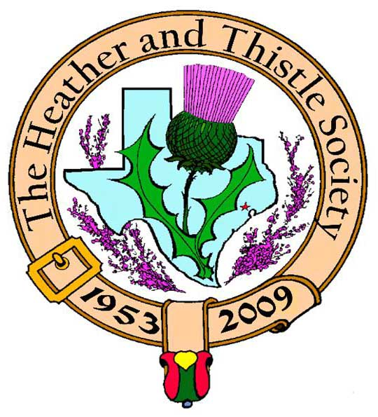

Heather & Thistle Society

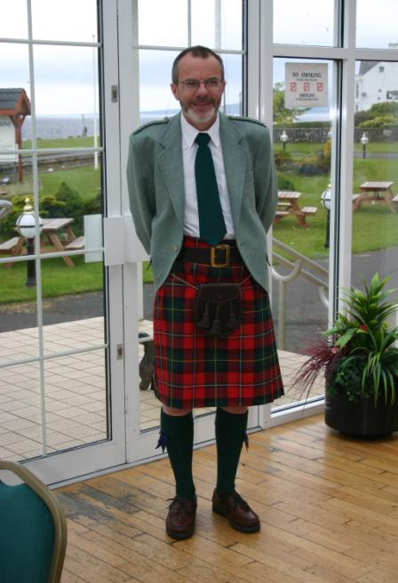 Chieftain Dr. Robert Boyd

Volume 9, Issue 9
June, 2009

Newsletter Editor:
Jim Monteith

Officers:

Chieftain – Dr. Robert Boyd
SubChieftain – Rev. Melvyn Douglass
Sgt.-at-Arms – Mark Monroe
Secretary – Carmelita Orr Treasurer – Dr. Walter May

Committee Chairs:

Sunshine-vacant
Membership-vacant
Past Chieftains-Cheryl May
Burns Supper- Ken Sorrels and
Jim Monteith
Publicity-Melvyn Douglass
Programs-vacant

Editor’s Request:
If you are currently receiving this newsletter via US mail and want to switch to email then send your email address to your editor at:
alabamascot@esagelink.com.

The Houston Scot

Chieftain’s Letter,
I look forward to welcoming everyone to the Summer Barbeque next month, see below and I would also like to take this opportunity to wish all members and their families a very good summer break. The hot and dry weather we have experienced these last few weeks should certainly have prepared us for what lies ahead! Then we can all look forward to getting together again for the new H&T session starting in September.
Dr. Donna Ingham intrigues June meeting with her Texas storytelling
The June meeting saw a delightful presentation of Texas folklore and storytelling by Dr. Donna Ingham, retired professor of the University of Texas at Austin. Donna made links to Scotland via Big Foot Wallace and the Scots present at the Alamo while giving spellbinding renditions of intriguing stories. Her piece de resistance however was a reprise of her award-winning performance as Austin’s biggest liar five years out of the past six with a hilarious story about a huge watermelon’s journey to Lubbock. Audience members were enthralled and were keen to purchase Donna Ingham’s books after the show. Thanks to Sgt.-at-Arms Mark A. Monroe for organizing and sponsoring Dr. Ingham’s presentation. Arthur Down gave a moving farewell speech at what was his last H&T meeting. On a less positive note, the size of the audience was extremely disappointing once again, and over the summer we really have to re-think what we can do to attract more interest, especially among younger people. Ideas are welcome, please come to the BBQ ready to talk about this.
Summer Barbeque July 12 to honor Arthur and Joan Down
The Past Chieftains’ Committee is delighted with the great response to the invitation to the barbeque in July – over fifty people have signed up to attend. Irene and I will host this event in our backyard. We now have an additional reason to have this event with the news that Past Chieftain Arthur Down and his wife Joan will be moving to California at the end of July, so we are delighted dedicate the BBQ in honor of their thirty years’ service to the Society.
Program Items for September Onwards
We do need ideas for after the summer break. Our Program Chair Dr. Gordon Macleod has reluctantly had to give up this position because of his heavy work commitment at present. We thank him and look forward to seeing him at our meetings. Until a volunteer steps forward, hopefully soon, I will fill in for Gordon.
Tartan of the Month – Kerr
Arthur and Joan Down wear the Kerr tartan, so in their honor and to wish them well in their new life in California Kerr is again the Tartan of the Month for July. Check it out at www.heatherandthistle.org.
Robert Boyd
Chieftain

In Memoriam
Arthur Gordon Mason, age 78, longtime member of the Heather and Thistle Society, died Friday May 29, 2009 in Houston, Texas. Arthur was well-known through-out the Scottish Community. He was a wonderful featured singer at the H&T Burns Supper and entertained so many over the years. Arthur was born in Corby, Northamptonshire, England, on December 11, 1930, to William and Mary Mason. He came to the U.S. in the early 1970’s to visit a sister and stayed. Arthur had several careers. He taught at Awty International School and Rice University. He served as a psychologist of the Houston Police Department and in private practice and sang professionally in his lyrical tenor voice. In his prime, Arthur sang at weddings, funerals, wakes and dozens of special occasions. He sang at the Shamrock Hotel and was a mainstay at Irish Society and H&T functions. Arthur never married and is survived by a sister, Betty Keenan of Houston; brother, Tommy Mason of England; 10 nieces and nephews and 12 great-nieces and great-nephews.

On Monday June 15, 2009 Mooneyeen Weiss of the Royal Scottish Country Dance Society reports:

SUMMER IS HERE
and
It is time for the Scottish Country Dance SUMMER SOCIALS
TUESDAY
7:30-9:30 pm
DAD'S CLUB - 1006 VOSS
N. of I-10, between Bingle and Campbell
COME AND JOIN THE FUN......AND BRING A FRIEND

The Heather and Thistle Society
Meeting Minutes – 22-Jun-09

Meeting was called to order at 7:35 PM.

Meeting minutes approval from the 18-May-09 meeting were postponed due to the fact the Newsletter containing those minutes has not been published for May.

The Treasurer gave a monthly financial report. Checking account balance reduced from $1,774.61 to $1,382.79 due principally to purchase of food for the July 12th picnic. The Burns Supper Planning Committee account was reduced by a $4,000 deposit to the Marriott Westchase Houston Hotel for the 2010 Burn Supper, ending at $16,609.50. The Past Chieftains contingency fund increased by $0.06 interest to $1,414.19.

An annual report for the Society’s fiscal year, June 1, 2008 to May 31, 2009, was given. The beginning funds position was $22,566.97. This was reduced to $19,773.41 principally because of the $4,000 deposit for the 2010 Supper. The hotel owes the Society $1,703.60 which will be either refunded or credited to the 2010 Supper. The Society has $34,611.05 income and $37,645.51 expenses including the 2010 Supper deposit.

The Treasurer presented the completed 2008 tax return for inspection.

The Treasurer gave a membership report based on the Treasurer’s database. There are 74 families, 32 life memberships, 38 singles and one complimentary for a total of 241 individuals. This includes those who are current on their 2009 and later dues.

The chairman of the Past Chieftain Committee, Cheryl May, reported that the Burns Supper Committee will meet Tuesday, 23-June-2009. The contract with the hotel has been signed and the deposit for 2010 made as indicated in the treasurer’s report. The 2010 Burns Supper will follow closely the format of the 2009 Supper. Mrs. May reported that the hotel has reserved a block of rooms for the evening of the Supper. The price of the room will include a buffet breakfast the following morning.

Mrs. May reported on the Society picnic planned for July 12th at Chieftain Robert and Irene Moore’s home. Fifty people have responded that they will come. The menu will be BBQ and the trimmings. If you feel inclined, please bring a dessert.

Chieftain Boyd reported for Sunshine that Sub-Chieftain Mel Douglas was not well and could not attend. Arthur Gordon Mason’s passing was remembered and the Chieftain reported on his service. It was noted that Alex Munroe’s situation has improved and he is driving again.

The Sergeant-at-Arms reported 15 members and 1 visitor present.

Arthur and Joan Down are moving to California in July. Dr. Down talked about the Society and what it has meant to him over the years. We all agree that they will be deeply missed.

The meeting was adjourned at 8:00 PM.

Heather and Thistle Society Membership Application

Date _________________

Last Name ____________________ First Name ____________________ Middle Name ________________

Spouse First Name ___________________________ Home Phone (_____) - _______ - ________

Home Address ________________________________________ City _____________State ______Zip ________

Business Address ______________________________________ City _______________ State ______ Zip ______

Business/Profession ____________________ Email Address: (Needed for monthly newsletter email)______________________

List Children under 18 if application for family membership. Children 18 and older must have their own membership.

__________________________________________ ________________________________________

__________________________________________ ________________________________________

Interests and Hobbies: ___________________________________________________________________________

Clan Tartan ______________ Sponsor:__________________ Shall we list you in our directory? [ ] Yes [ ] No

Are you interested in serving the Society in some capacity [ ] Yes, please contact me. [ ] No, not at this time.

Membership type: [ ] Family - $20.00 per year(includes family members under 18 [ ] Single - $15.00 per year

[ ] New Member [ ] Renew Membership

Please bring completed application with membership fee to the next monthly meeting held at 7:30pm on the 4th Monday of the month, September through June, or just mail it to Dr. Walter May, 6143 Sienna Arbor Lane, Houston, Texas 77041-6038.

Heather and Thistle Society meets at the St. Thomas Episcopal School at 4900 Jackwood, Houston, Tx. 77096

Applicant’s Signature _________________________________ Check No._____ Amount Paid $______ Date Paid_________

Heather and Thistle Membership Dues
We currently have very many members that are behind on their membership dues for 2009. Please take a few minutes and re-new your membership with the Society. On this page above is a membership application/renewal form. Cut it out or print it and mail to Dr. Walter May, our Treasurer, who will be happy to receive your membership renewal at 6143 Sienna Arbor Lane, Houston, Texas 77041-6038. Annual dues are $15.00 for an individual and $20.00 for a family. You must have your membership dues up to date by the end of September in order to get Burns Supper tickets at the member discount rate. Your dues are used to fund the Societies expenses, such as publishing this newsletter, and storing the property of the Society. Your dues are also used to promote Scottish arts in the Houston area and fund our annual Burns Supper.

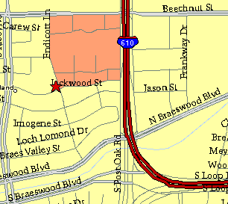

Meeting Information

Meeting Place:
St. Thomas Episcopal School
4900 Jackwood
Houston, Texas 77096

Date and Time:

Fourth Monday of the month
7:30 pm
Heather & Thistle Society Statement
And Membership Information

The Heather and Thistle Society was founded in 1953 by Scots living in Houston who wished to “cultivate an interest in and fond recollections of Scotland, its history and traditions, its literature and ideals, its minstrelsy and song, its customs and amusements, and to provide opportunities for good fellowship and social contact through typically Scottish functions, so that the blessing of our Scottish culture may never die in our new homeland”.

The Heather and Thistle Society meets 10 times a year, September through June.
Programs include music, singing, dancing, lively lectures, slide shows and movies about Scotland. The Heather and Thistle Society puts on the annual Robert Burn’s Supper and Ball in late January of each year. We are an organization that promotes our Scottish heritage, in various ways.

The Heather and Thistle Society’s monthly newsletter, “The Houston Scot” is published
from September through June. Original articles, information about Scottish or related events are welcome and should be sent to the editor, Jim Monteith, at 15703 Mound Road, Hockley, Texas 77447 or 936-931-2588.

Membership in the Heather and Thistle Society is open to all with an interest in Scottish heritage and culture. Annual dues are $15 for an individual and $20 for a family membership. Applications for membership may be obtained from our website.
http://heatherandthistle.org/documents/membership.doc
Dues are due at the beginning of the fiscal year, March 1. Completed applications and membership fees should be mailed to: Dr. Walter May
6143 Sienna Arbor Lane
Houston, Texas 77041-6038



