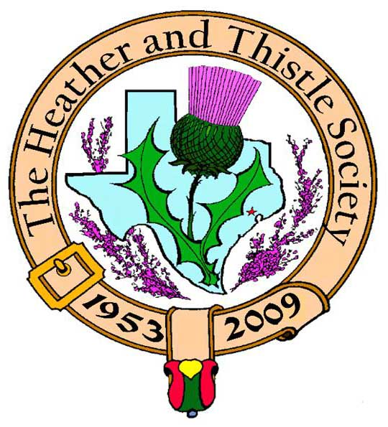

Heather & Thistle Society

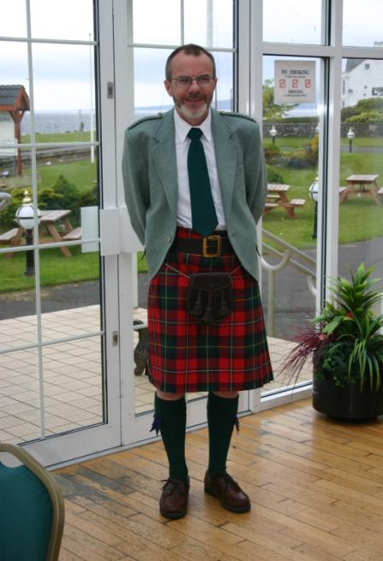 Chieftain Dr. Robert Boyd

Volume 9, Issue 8
May, 2009

Newsletter Editor:
Jim Monteith

Officers:

Chieftain – Dr. Robert Boyd
SubChieftain – Rev. Melvyn Douglass
Sgt.-at-Arms – Mark Monroe
Secretary – Carmelita Orr Treasurer – Dr. Walter May

Committee Chairs:

Sunshine-vacant
Membership-vacant
Past Chieftains-Cheryl May
Burns Supper- Ken Sorrels and
Jim Monteith
Publicity-Melvyn Douglass
Programs-vacant

Editor’s Request:
If you are currently receiving this newsletter via US mail and want to switch to email then send your email address to your editor at:
alabamascot@esagelink.com.

The Houston Scot

Chieftain’s Letter,
April Meeting called off at the last minute
We had to call off the April meeting at the last minute because of extremely heavy rain on the west side of town. As it turns out St. Thomas Episcopal School had lost power, but five members and the program presenters did show up as we were unable to contact them. Apologies to all those who were inconvenienced. We do hope to have the Building the Flag presentation later in the year.
Highland Games
Thanks to all members and friends who manned our booth at the recent Highland Games. Mark Monroe and Ardeth Brodie in particular worked way beyond the call of duty, not leaving until after 7:00 PM on the Sunday – thanks so much! We had a steady flow of folks through the booth and there was a lot of interest in the Al Campbell Piping Competition sponsored by H&T and held on Saturday this year.
Rickey Pittman most enjoyable at the May Meeting –
Louisiana-based Rickey Pittman gave a delightful program of stories and Scots songs to about 25 members and friends. We met Rickey at the Highland Games where he had been story-telling for the children; for us his stories focused on the Civil War and Clan Macleod. He presented H&T with a signed copy of his book The Scottish Alphabet which we will use as a door prize at a forthcoming event.
Next Meeting – Monday June 22 - Dr. Donna Ingham
The program at the next meeting will be a presentation about folklore and storytelling to be given by Dr. Donna Ingham of the University of Texas at Austin. We look forward to another interesting evening. Thanks to Sgt.-at-Arms Mark Monroe for organizing and sponsoring Dr. Ingham’s presentation.
Summer Barbeque July 12 to honor Arthur and Joan Down
Jack Hume’s recent presentation about the Society’s history suggested that in recent years we have lost the family aspect in our regular meetings. To remedy that the Past Chieftains’ Committee will sponsor a barbeque in July to which all members and their families are invited. Irene and I will host this event in our backyard. We now have an additional reason to have this event with the news that Past Chieftain Arthur Down and his wife Joan will be moving to California at the end of July, so we are delighted to hold the BBQ in their honor. Your invitation is included with this Newsletter and we hope to have a good attendance.
Program Items for September Onwards
We have filled our program through the June meeting, but we do need ideas for after the summer break. Our Program Chair Dr. Gordon Macleod has reluctantly had to give up this position because of his heavy work commitment at present. We thank him and look forward to seeing him at our meetings. Until a volunteer steps forward, hopefully soon, I will fill in for Gordon.
Tartan of the Month – Kerr
Arthur and Joan Down wear the Kerr, so in their honor and to wish them well in their new life in California Kerr is the Tartan of the Month for June. Check it out at www.heatherandthistle.org.
Robert Boyd
Chieftain

Upcoming Texas Scottish Events
Texas Scottish Festival and Highland Games
June 5th thru 7th 2009 at Maverick Stadium in Arlington, Texas

Burns Club Meeting
Time: Thursday, June 11 at 7:30 PM.
Place: Arthur and Joan Down, 13319 Myrtlea, Houston, TX 77079.
Topic: Departures and favourite poems.

RSVP: To Arthur and Joan. Tel. 713-468-2952 or jmdown@gmail.com

This meeting has taken on a special significance because as most of us know by now Arthur and Joan Down will be relocating to California in July. So this will be their last Burns Club meeting, and they are hosting it. Arthur along with Jack Hume was co-founder of our group, so we look forward to wishing the Downs a fond farewell and all the best in their new life.

Robert Boyd
281-558-1131 home

H&T Summer Break
The Heather and Thistle Society will be taking its annual summer break for July and August. No meeting at St. Thomas School will be held during this two month period. Please attend the June meeting if you can. We will be having a summer event this year. See the advertisement for the Barbecue at the Boyd’s residence on page three.
Heather & Thistle Society – May 18, 2009

Chieftain Dr. Robert Boyd called the business meeting to order at 7:33pm in the auditorium at St. Thomas Episcopal School. The motion was made to accept the March 2009 minutes as published in the newsletter. Motion passed.
Treasurer Report: Dr. Walter May reports the combined bank balance to be $23,798.24. Checking account balance was $1,774.61. Burn’s Supper account balance is $20,609.50. PCC Fund balance is $1414.13. Motion made and passed to accept the report.
Membership Report: Dr. Walter May reports 146 family, 36 single, and 49 life members for a total of 231 members. We are slow this year on dues payment. Please pay your dues.
Committee Reports called for by Sub-Chieftain Rev. Melvyn Douglass
Burn’s Club: Chieftain Boyd reports a meeting was held last week at the home of Joan McClure. Their next meeting will also be at Joan’s. The Boyd’s will be attending the annual meeting of the National Association in California.
Burns Supper: Ken Sorrels reports we have a contract from the Marriott Westchase. It is going to be looked at by the planning committee at their next meeting at the May’s residence.
Past Chieftains: Chair of the PCC Cheryl May reports they are looking for a more central place to meet. Unfortunately Alex and Maryann Munroe have had to drop out as hosts for the time being.
Programs: Chieftain Boyd reports that Gordon Macleod, our program chairman will be resigning due to his work load. Hoping that Jim Haggarty will take his place. Mark Monroe is sponsoring the June program which will be John Ingram presenting folklore and story telling. Sept. 2009 program will be the Masonic group on building the flag. October 2009 will be Ed Miller.
Sunshine: Chieftain Boyd reports that Alex and Maryann Munroe are struggling health wise and unable to drive. We have a report that Teresa Haines has passed away. Ian Murray, former Counsel General of Houston, passed away.
Newsletter: Editor Jim Monteith reports removing some members from the mail out due to non payment of membership dues.
Houston Grampian: Mickey Carmichael reports being part of a live web cam meeting between Houston and Aberdeen.
Houston Highland Games: Sub-Chieftain Melvyn Douglass reports seven pipe bands performed. The main PA system did not work. The president of the U.S. Piping Association competed in our Open Piping competition. More volunteers are needed. Jeanette Douglass was recognized on the program for her outstanding service to HHGA.
RSCDS: No report.
Houston Highlanders: No report.
Sergeant-At-Arms: Mark Monroe reports 20 members and 2 guests. Rickey Pittman, our entertainer tonight, was one of the guests. Allison Gray-Rainer was our other guest.
Old Business: None.
New Business: Chieftain Boyd discussed the need to add pay pal ability to our web site for paying dues and buying Burns Supper tickets. Melvyn Douglass volunteered to assist in working that out for the Societies website. Chieftain Boyd discussed changing the venue of our monthly meetings to more social events and less formal meetings. Ardeth Brodie reports the need for volunteers to staff a table at the Spec’s Liquor British Isles event on Saturday, June 20th. Four to six people will be needed for two hours each.

Business meeting adjourned at 8:02pm for refreshments.

Tonight’s performer was Rickey E. Pittman, storyteller, poet, author, musician, from Monroe, Louisiana. Mr. Pittman recited numerous poems and sang several songs that he has written.

Heather and Thistle Membership Dues
We currently have very many members that are behind on their membership dues for 2009. Please take a few minutes and re-new your membership with the Society. Dr. Walter May, our Treasurer, will be happy to receive your membership renewal at 6143 Sienna Arbor Lane, Houston, Texas 77041-6038. Annual dues are $15.00 for an individual and $20.00 for a family. You must have your membership dues up to date by the end of September in order to get Burns Supper tickets at the member discount rate. Your dues are used to fund the Societies expenses, such as publishing this newsletter, and storing the property of the Society. Your dues are also used to promote Scottish arts in the Houston area and fund our annual Burns Supper.
Clearances
Popularly identified with the eviction of the Highlanders from their traditional lands during the 18th and 19th centuries. This was to make way for agricultural improvement, mainly the grazing of sheep and deer. The term also symbolizes the destruction of what remained of the clans, clan life and Gaeldom in the aftermath of the Jacobite Rebellions of the ‘Fifteen and the Forty-Five’.
The term ‘clearance’ was never used at the time. Similar events associated with enclosure occurred in the Lowlands and elsewhere. In the wider context of capitalist modernization following the Agricultural Revolution there were many parallel experiences in Ireland and on the Continent (Norway) during the 19th century. Like the Highlands most of these regions had experienced rapid population growth, pressure on available cultivable land, and acute poverty – resulting in enforced migration. (from Collins Dictionary of Scottish History)

Al Campbell Open Piping Competition Results
Reported to H&T by Heather Vacker
Hello All!

I just wanted to send you the final results on the Heather & Thistle Society's Professional Piping Competition:

The Grand Aggregate Winner was Lyric Todkill

2nd overall was Doug MacRae
3rd overall was Jimmy Bell

The complete results are below:

Professional Piping
Aggregate Winner: Lyric Todkill
 | Piobaireachd | MSR | 6/8 March | Hornpipe/Jig
1st  2nd  3rd  4th | MacRae  Bell  Todkill  Liechti | Bell  MacRae  Todkill  Liechti | Todkill  Bell  MacRae  Liechti | Todkill  MacRae  Bell  Liechti

THANK YOU SOOOOO VERY MUCH FOR YOUR SPONSORSHIP! !!!!! I thought having it on the main stage was a wonderful change!

Just a note - we did have 5 pipers scheduled to compete, but EJ Jones had to back out at the last minute, due to some scheduling conflicts. He looks forward to competing next year, however! Cheers!
Heather Vacker VP Competitions, Houston Highland Games Association
www.houstonhighlandgames.com
713-206-5193

Summer Poolside Barbecue
Sunday, July 12, 2009

Heather and Thistle Past Chieftain’s Committee
Invites you and your family
To
A Social Gathering Honoring Arthur and Joan Down

Barbecue meal, beer-wine-soft drinks provided

Bring your swim suit and towels!!
Location:
Home of Robert and Irene Boyd

Please RSVP immediately with number of guests
Deadline for ordering food is June 3rd

Responses and Directions:
Cheryl May
713-983-8866
camaysfa@aol.com

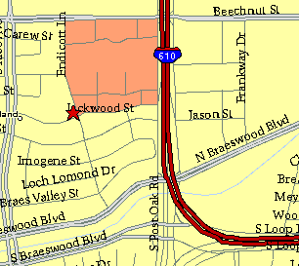

Meeting Information

Meeting Place:
St. Thomas Episcopal School
4900 Jackwood
Houston, Texas 77096

Date and Time:

Fourth Monday of the month
7:30 pm
Heather & Thistle Society Statement
And Membership Information

The Heather and Thistle Society was founded in 1953 by Scots living in Houston who wished to “cultivate an interest in and fond recollections of Scotland, its history and traditions, its literature and ideals, its minstrelsy and song, its customs and amusements, and to provide opportunities for good fellowship and social contact through typically Scottish functions, so that the blessing of our Scottish culture may never die in our new homeland”.

The Heather and Thistle Society meets 10 times a year, September through June.
Programs include music, singing, dancing, lively lectures, slide shows and movies about Scotland. The Heather and Thistle Society puts on the annual Robert Burn’s Supper and Ball in late January of each year. We are an organization that promotes our Scottish heritage, in various ways.

The Heather and Thistle Society’s monthly newsletter, “The Houston Scot” is published
from September through June. Original articles, information about Scottish or related events are welcome and should be sent to the editor, Jim Monteith, at 15703 Mound Road, Hockley, Texas 77447 or 936-931-2588.

Membership in the Heather and Thistle Society is open to all with an interest in Scottish heritage and culture. Annual dues are $15 for an individual and $20 for a family membership. Applications for membership may be obtained from our website.
http://heatherandthistle.org/documents/membership.doc
Dues are due at the beginning of the fiscal year, March 1. Completed applications and membership fees should be mailed to: Dr. Walter May
6143 Sienna Arbor Lane
Houston, Texas 77041-6038



