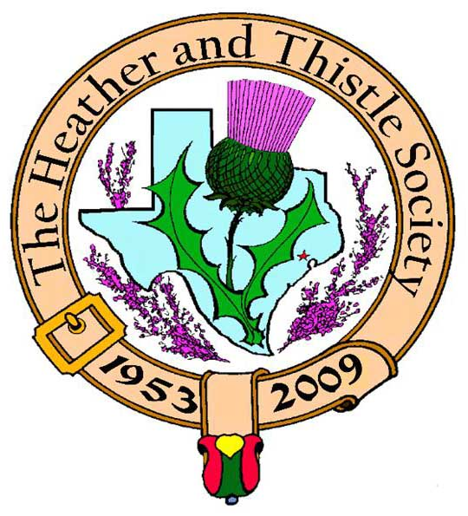

Heather & Thistle Society

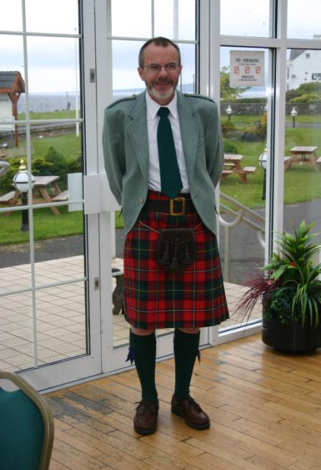 Chieftain Dr. Robert Boyd

Volume 9, Issue 7
April, 2009

Newsletter Editor:
Jim Monteith

Officers:

Chieftain – Dr. Robert Boyd
SubChieftain – Rev. Melvyn Douglass
Sgt.-at-Arms – Mark Monroe
Secretary – Carmelita Orr Treasurer – Dr. Walter May

Committee Chairs:

Sunshine-vacant
Membership-vacant
Past Chieftains-Cheryl May
Burns Supper- Ken Sorrels and
Jim Monteith
Publicity-Melvyn Douglass
Programs-Gordon Macleod

Editor’s Request:
If you are currently receiving this newsletter via US mail and want to switch to email then send your email address to your editor at:
alabamascot@esagelink.com.

The Houston Scot

Chieftain’s Letter,
Officers Installed at the March Meeting
The new team of officers was duly installed at the March meeting. Because the St. Thomas’ theatre was not available and the Ingram Room seemed a bit claustrophobic for bagpipes, for the first time ever the installation ceremony was held outdoors in the cloisters at the school, and very nice it was too. Two members of the Houston Highlanders piped in the officers and the swearing-in ceremony was handled very graciously by Jack Hume.
I am very proud to be Chieftain again for the coming year; my goal is to improve attendance at meetings and increase the membership. I took the opportunity in my acceptance speech to once again emphasize the urgent need to recruit newer younger members, and to encourage all members to aspire to executive office. This is the only way to ensure the future well-being of the Society. I am very pleased to report that already there have been some very good ideas presented as to how we might achieve this vital goal. These will be put to members at the meeting. We have a most interesting set of meetings coming up. The quality of the presentations we have is most certainly not the problem. I think the last couple of years have seen some of the best nights ever at H&T.
Volunteers Needed for Society’s Booth at the Highland Games May 16-17
We have the Highland Games coming up next month at the Farm & Ranch Club in Bear Creek Park once again, and the Society has, as usual, taken a booth at which we will promote Heather & Thistle. This is one of our best chances in the year to get exposure to potential new members, so it is important that we man the booth for the entire two days. Please sign up at the April meeting to help out. We are also sponsoring the Al Campbell Individual Professional Piping Competition at the Games. Please turn out to support this event if you can, check the Games website www.houstonhighlandgames.com for the time and location.
Next Meeting – Monday April 27 at 7:30 PM – Building the Flag
A local Masonic group will be giving a period-costumed historical presentation about how our flag developed. Please support this performance and encourage all to attend.
May Meeting – May 18 - Scottish Storyteller Rickey Pittman
The May meeting will be held a week early to steer clear of Memorial Day. This puts it right after the Games. Louisiana-based Rickey Pittman specializes in telling stories and songs about Scotland. He has appeared at Highland Games, Burns Suppers and Scottish Festivals all over the south. More details in next month’s Newsletter.
Program Items for September Onwards
We have filled our program through the June meeting, but we do need ideas for after the summer break. Please send ideas to our Program Chair Dr. Gordon Macleod at gordymacus@yahoo.com.
Tartan of the Month – Largs
Largs is a small seaside town on the west coast of Scotland about 25 miles north of Robert Burns’s birthplace. It is the hometown of the recipients of the Society’s two trophies for distinguished service by non-officers in 2008 that were presented at the Burns Supper in January. Webmaster Robin Mills won the Dixon Hedges Award for his generous work resurrecting and supporting our site and his sister and First Lassie Irene Boyd was awarded the Jack and Phemia Hume trophy for her work on the Society’s hosting of the Burns Cruise last March. Robin wore the Largs Tartan when presented with his trophy. That would be a good enough reason to have Largs as the site tartan this month, but in addition many of you know that Irene Boyd has been seriously ill since shortly after the Burns Supper. She is now on the road to better health, and having Largs as the Tartan of the Month is also to wish her a full recovery. Check it out at www.heatherandthistle.org.
Robert Boyd
Chieftain

Upcoming Texas Scottish Events
Houston Highland Games
May 16 and 17, 2009 at the Houston Farm and Ranch Club off of State Highway 6 in Harris County at 1 Abercrombie Drive. Come enjoy the fun and festivities at the annual Houston games. The H&T Society will be sponsoring the Al Campbell Open Piping Competition and will have a booth as usual.
Texas Scottish Festival and Highland Games
June 5th thru 7th 2009 at Maverick Stadium in Arlington, Texas

Marches
The term applies to the Scottish border with England, which was less clearly defined than that of Wales with England. This vague border led to long-term conflict until the signing of the Treaty of York in 1237. Alexander II gave up Scottish claims to the northern counties of England. The Scottish marches were divided into three areas of administration and control, East, Middle and West, each with wardens appointed by the Crown. As late as the 17th century the area was noted on both sides of the border for strife between rival kin groups, banditry and cattle lifting. (Collins Dictionary of Scottish History)


Heather & Thistle Society - Minutes March 23, 2009
Chieftain Dr. Robert Boyd called the business meeting to order at 8:15pm in the Ingram Room at St. Thomas Episcopal School.
Treasurer Report: Dr. Walter May reports the combined bank balance to be $25,483.82. Checking account balance was $1960.31. Burn’s Supper account balance is $22,109.50. PCC Fund balance is $1414.01. Motion made and passed to accept the report.
Membership Report: No report.
Committee Reports called for by Sub-Chieftain Rev. Melvyn Douglass
Burn’s Club: Jack Hume reports they had a nice last meeting. Their next meeting will be the 2nd Thursday in April. Good turnout for their Burns Supper.
Burns Supper: Jim Monteith reports the hotel options for next year and the Past Chieftains will be deciding what hotel to use at their next meeting.
Past Chieftains: Chair of the PCC Cheryl May reports the five Past Chieftains on the PCC will be deciding the hotel issue soon.
Programs: Chieftain Boyd reports the April program will be the Building the Flag program that had to postponed last year due to Hurricane Ike.
Sunshine: Chieftain Boyd reports Irene Boyd is still in ICU. Pete Webster passed away last Friday. Mary Walker had surgery on April 1st.
Newsletter: Editor Jim Monteith reports emailing 90 and mailing 86 copies of the March 2009 issue.
Houston Grampian: May is the Offshore Technology Conference. Their will be a breakfast at the Hyatt Post Oak Hotel. The annual general meeting will be a lunch at Steamboat House restaurant.
Houston Highland Games: Sub-Chieftain Melvyn Douglass reports the games are looking good this year. The open piping competition may be on Saturday afternoon.
RSCDS: Classes still on-going. Member numbers are decreasing. The home schoolers are doing good with demo dancing.
Houston Highlanders: Ian Martin reports the band is fairly strong now and looking good for the Highland Games. Pipe Band competition will be on Saturday afternoon.
Sergeant-At-Arms: Mark Monroe reports 24 members and 1 guest. Piper Dave Lancaster from the Houston Highlanders was our guest and assisted Ian Martin in piping in our new officers.
Old Business: Past Chieftains were urged to pay their annual dues for the good of the society.
New Business: Ardeth Brodie reports the HHGA contacted her about putting an ad in the program for the upcoming games. Members voted on a full page ad for $200.00. The ad may be on the inside front cover. A card for Ardeth’s birthday was passed around. April 6th will be the San Jacinto Tartan Day event. Melvyn Douglass will be speaking.

Tonight’s program was the installation of our 2009-2010 Society Officers. Jack Hume performed the installation ceremony. Two members of the Houston Highlanders Pipe Band graciously attended and piped in the new officers. Thanks to Ian Martin and Dave Lancaster.

The business meeting was adjourned at 8:54pm.

Houston Highlanders Pipe Band
The Houston Highlanders were formed roughly forty years ago and continues today as a band of musicians that all share a love of piping and drumming. We entertain the Houston area with a Scottish and Celtic culture that few areas of the country have. The band and some of its members have played for Royalty and prominent entertainers such as Rod Stewart and for Shuttle astronauts. We are a part of annual festivities such as the Robert Burns Supper for the Heather and Thistle Society, St. Patrick's Day Parade, Daughters of the British Empire Bazaar, and for the Royal Scottish Country Dance Society as well as the Marine Corps Ball. We are available for various functions and events.
The Highlanders meet at 7:00 PM every Monday at St. Phillip Presbyterian Church located at 4807 San Felipe Houston,Texas 77056.
PIPERS & DRUMMERS WANTED
If you play the bagpipes or drums, or are interested in learning, we are looking for you! We offer free bagpipe and drum lessons to those who will commit to play with the band. Prior musical training is helpful but not necessary. Initial expenses are minimal.
If you are interested, please contact:
Kelley Fair
(713) 869-0721
jandk@hal-pc.org
Piping teachers are Collen Steblein and Sandy MacPhee: Drumming instructors Tim Gore,Robin Hargy and Laurel Nolan.

National Anthem of Scotland
There is no official national anthem of Scotland. However, there is a complex and on-going social and political dispute amongst many contenders for the title of the nation's de jure song, which has polarised much of the public. Scotland does not possess a legally recognised or confirmed anthem of its own. The former Scottish Executive (a Labour/Liberal Democrat coalition) took the view that God Save the Queen, the national anthem of the United Kingdom as a whole, should be used for Scotland. A verse, current in the mid-eighteenth century, which included the line "Rebellious Scots to crush" summoned some condemnation for being anti-Scottish. This verse was only ever used briefly, before the song was considered an anthem, and the line was intended to refer to the Jacobites specifically rather than the Scottish nation as a whole. A separate anthem is widely supported (not simply by the supporters of independence) because in practice there are many situations (for example, sporting events) where a distinct Scottish anthem is necessary. As a result, Scotland uses a variety of compositions in varying roles and with varying levels of support for recognition. The three most popular candidates for the role according to an opinion poll are "Auld Lang Syne", "Flower of Scotland" and "Scotland the Brave" but various other songs including "Scots Wha Hae", "A Man's a Man for a' that", "Freedom Come-All-Ye, Both sides the Tweed", "Caledonia", "I'm Gonna Be (500 Miles)" and "Highland Cathedral" have some level of support. A minor complication with "Flower of Scotland" is that, when played on the bagpipes, one note in the last line (on the word "think") cannot be played correctly. It should be a C natural (when played in the key of D) but this note is not available on the bagpipes, so a C♯ is substituted. (The bagpipes are playing nominally in the key of D (actually in A Mixolydian); in fact the intonation is such that the key is E flat, or slightly higher). The use of each song is wildly different. For example "Scotland the Brave" is used by the Commonwealth team representing The Commonwealth Games Council for Scotland during the medal-receiving ceremonies of the Commonwealth Games and in the football matches in the 80's, whereas "Flower of Scotland" is played before every game of the Scottish national football team and before every game of the Scottish rugby union team. "A Man's a Man for a' that" was also sung at the opening of the Scottish Parliament by Sheena Wellington, though not for specific national anthem purposes. Despite coverage by "The Scotsman" newspaper, the Scottish Parliament has yet to convene any parliamentary debate on the issue, with Holyrood's Enterprise Committee denying a motion from Scottish National Party MSP Michael Matheson on the subject. In June 2006 the Royal Scottish National Orchestra conducted an online poll to choose the favourite song. With over 10,000 votes cast, "Flower of Scotland" came first with 41% of the votes, followed by "Scotland the Brave" with 29%. (from Wikipedia)
Texas Bluebonnet Tartan

The Texas Bluebonnet Tartan was conceived and designed by June Prescott McRoberts (1922-1999). She designed a pattern to represent the state flower, the Bluebonnet, using the colors and symmetry of the flower itself. She received much help and guidance from the Scottish Tartan Society Museum in Scotland and later registered the Bluebonnet Tartan with the STS Museum, the official register for tartans. In 1999, Ms. June McRoberts commissioned Sia LaBelle Beaton to represent the Bluebonnet Tartan and presented her with the first ladies kilt ever made in the state tartan. Sia promoted the Bluebonnet Tartan of Texas throughout her musical tour of Scotland in 1999. She continues to use every opportunity to increase awareness of the state tartan of Texas, and of Texas Scottish Heritage.

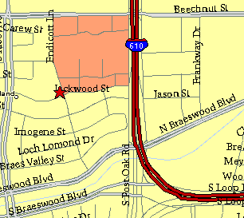

Meeting Information

Meeting Place:
St. Thomas Episcopal School
4900 Jackwood
Houston, Texas 77096

Date and Time:

Fourth Monday of the month
7:30 pm
Heather & Thistle Society Statement
And Membership Information

The Heather and Thistle Society was founded in 1953 by Scots living in Houston who wished to “cultivate an interest in and fond recollections of Scotland, its history and traditions, its literature and ideals, its minstrelsy and song, its customs and amusements, and to provide opportunities for good fellowship and social contact through typically Scottish functions, so that the blessing of our Scottish culture may never die in our new homeland”.

The Heather and Thistle Society meets 10 times a year, September through June.
Programs include music, singing, dancing, lively lectures, slide shows and movies about Scotland. The Heather and Thistle Society puts on the annual Robert Burn’s Supper and Ball in late January of each year. We are an organization that promotes our Scottish heritage, in various ways.

The Heather and Thistle Society’s monthly newsletter, “The Houston Scot” is published
from September through June. Original articles, information about Scottish or related events are welcome and should be sent to the editor, Jim Monteith, at 15703 Mound Road, Hockley, Texas 77447 or 936-931-2588.

Membership in the Heather and Thistle Society is open to all with an interest in Scottish heritage and culture. Annual dues are $15 for an individual and $20 for a family membership. Applications for membership may be obtained from our website.
http://heatherandthistle.org/documents/membership.doc
Dues are due at the beginning of the fiscal year, March 1. Completed applications and membership fees should be mailed to: Dr. Walter May
6143 Sienna Arbor Lane
Houston, Texas 77041-6038

