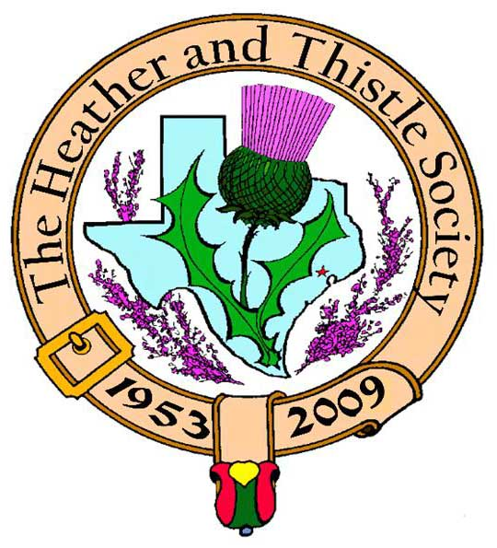

Heather & Thistle Society

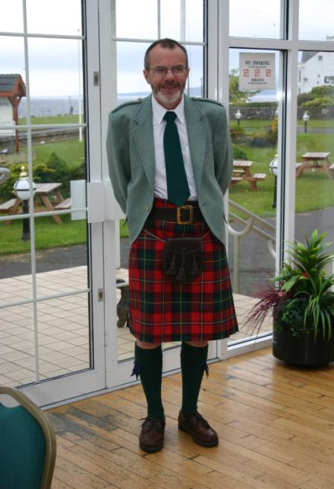 Chieftain Dr. Robert Boyd

Volume 9, Issue 6
March, 2009

Newsletter Editor:
Jim Monteith

Officers:

Chieftain – Dr. Robert Boyd
SubChieftain – Rev. Melvyn Douglass
Sgt.-at-Arms – Ardeth Brodie
Secretary – Carmelita Orr Treasurer – Dr. Walter May

Committee Chairs:

Sunshine-vacant
Membership-vacant
Past Chieftains-Cheryl May
Burns Supper-Jim Monteith
Ken Sorrels
Publicity-Melvyn Douglass
Programs-Gordon Macleod

Editor’s Request:
If you are currently receiving this newsletter via US mail and want to switch to email then send your email address to your editor at:
alabamascot@esagelink.com.

The Houston Scot

Chieftain’s Letter,
History of the Society Described at the February Meeting
Jack Hume’s presentation on the history of the Heather and Thistle Society given at last month’s meeting was most interesting. Jack is uniquely qualified to present it – he joined the Society in 1955 just two years after it was founded and has personally known all the officers (and most of the members no doubt) who ever served. The Society began essentially as a support group for young, mostly poor immigrant families arriving in Houston directly from Scotland. At the time only native-born Scots were eligible for membership. Children were very much a part of the meetings at that time and family events like picnics and all-welcome informal dances were the main focal points at meetings. Even today as Jack said you’ll hear now fifty-something members referring to other older members as “uncle” and aunt” from those days. We have lost that aspect of the Society and that might be a mistake. Jack put a lot of work and love into this presentation, as indeed he has into the Society all these years. It was great to hear him relating amusing stories of barbequing for 300 at Bear Creek Park when raccoons stole the chickens and the like. The Burns Supper back then was held every year, but was a very small event when compared with these family occasions. Now it is the only remaining H & T event other than our normal meetings, and one that we must work hard to preserve. Thanks to Jack for being a major part of an inspiring history and for presenting it so memorably.
Next Meeting – Monday March 23 at 7:30 PM
The March meeting is as usual dedicated to the installation and swearing-in of the officers for the incoming year. My team and I are honored to have been elected for a second year and will be proud to serve again. The reason we are having a re-run does however reveal a growing problem within our Society – a chronic shortage of new people coming up through the officers’ ranks. To ensure that we will be having a presentation on the centenary of the Heather and Thistle Society it is vital that members volunteer to take leadership roles. We must also place the highest priority on attract new and especially younger members. Jack’s history clearly brought out that the graying of H &T has narrowed the focus. We need to reverse that trend.
Tartan of the Month - Boyd
To mark Robert Boyd’s new year as Chieftain but more important to wish Irene Boyd a full recovery from her illness. Check it out at www.heatherandthistle.org.
April Meeting – Building the Flag
Details in the next Newsletter.
Program Items for September Onwards
We have filled our program through the June meeting, but we do need ideas for after the summer break. Please send ideas to our Program Chair Dr. Gordon Macleod at gordymacus@yahoo.com.
Robert Boyd
Chieftain
Alistair Campbell Open Piping Competition
The Heather and Thistle Society is once again sponsoring the Open Piping Competition at the upcoming Houston Highland Games. Our Society wants to increase the stature and prestige of this event. The event will be moving to Saturday afternoon in the arena. We are hoping for more advertisement from the Houston Highland Games Association in order to attract more competitors. Along with this we want to increase the prize money. H&T is seeking member donations in order to raise the prize money. Please send your monetary donations to our treasurer: Dr. Walter May, 6143 Sienna Arbor Lane, Houston, Texas 77041-6038. Please make your check out to the Houston Highland Game Association and note it is for the Alistair Campbell Open Piping Competition. Thank you. Heather & Thistle Society - Minutes February 23, 2009
Chieftain Dr. Robert Boyd called the business meeting to order at 8:00pm in the St. Thomas Episcopal School Theater.
Treasurer Report: Dr. Walter May reports the combined bank balance to be $21,878.89. Checking account balance was $2161.05. Burn’s Supper account balance is $18,303.89. PCC Fund balance is $1413.95. Motion made and passed to accept the report.
Membership Report: No report.
Committee Reports called for by Sub-Chieftain Rev. Melvyn Douglass
Burn’s Club: Jack Hume reports their Burns Supper is upcoming.
Burns Supper: Jim Monteith reports they are planning to have a wrap up meeting for the 2009 Supper.
Past Chieftains: Cheryl May reports the PCC met on Feb. 19th. Jim Monteith and Ken Sorrels will be Co-Chairing the 2010 Burns Supper. Finances for the recent supper were looked at and new

Minutes continued:

locations and sponsorships were discussed.
Programs: Chieftain Boyd reports the April program will be the Building the Flag program that had to postponed last year due to Hurricane Ike.
Sunshine: Chieftain Boyd reports Irene Boyd doing much better and thanks for everyone’s concern for her.
Newsletter: Editor Jim Monteith reports unable to produce the Feb. 2009 newsletter in time for tonight’s meeting. He advised it would be out by the end of February.
Houston Grampian: No report.
Houston Highland Games: No report.
RSCDS: No report.
Houston Highlanders: No report.
Sergeant-At-Arms: Mark Monroe reports 20 members and 1 guest (Alex Smith) present. Alex is the son of the 10th Chieftain of H&T John Smith who served 1962 – 1963.
Old Business: Chieftain Boyd advised that he was successful in tracking down the people that donated the Burns statuette to the Society. The pattern for the statuette was from the 1880’s and more can be purchased if anyone is interested.
New Business: Election of officers for 2009 – 2010 was held. Dr. Robert Boyd was re-elected as Chieftain. Rev. Melvyn Douglass was re-elected as Sub-Chieftain. Mark Monroe was elected to be Sgt.-At-Arms. Dr. Walter May was re-elected to be Treasurer. Carmelita Orr was re-elected to be Secretary.

The business meeting was adjourned at 8:17pm for refreshments.

Tonight’s program was a presentation by Jack Hume of the history of the Heather and Thistle Society.

A bit of excitement was had by members prior to the meeting when Sharon Monteith got stuck in the elevator. Houston Fire Department personnel from Stations 21 and 36 responded promptly and extricated her from her predicament. Sharon handled the episode very well.

History of Heather & Thistle by Jack Hume

To recite the history of Heather & Thistle is, I find for me, to recite my own history in Texas. To prepare for this evening there has been a memory mix of happy and sad times. Great young people experiences for the adults and almost family relationships for our children. I have the privilege of having been acquainted with everyone who has ever been an officer of Heather & Thistle. Now, so many of those of dear friends and acquaintances are no longer with us.

Heather & Thistle was two years old when I joined in 1955. We were a newly arrived Scottish-born immigrant family, and as such were eligible for membership in the society. Membership was originally limited to Scottish-born only, required sponsorship by a member, and attendance at a meeting, to be sworn in by the Chieftain, in front of the members. After joining, non-attendance at either two or three meetings was cause for dropped membership.

None of us were very affluent then, and meetings were a great opportunity to meet with “Ithers like us,” to share experiences or to cry on each “ithers” shoulders. No telephone calls back to Scotland, no jet trips home in those days. Communication with the UK by air letter to and fro only --my father-in-law had died and was buried seven days before we knew. Other members became substitute families for us—for the Aunts and Uncles, Grannies and Grandpas our kids had left behind in Scotland. It is gratifying now to hear fifty-year-olds like Graham Buchanan calling me still “Uncle Jack” and to hear my children talking of, and to, their “Aunts” and “Uncles.”

Certain members came to mind as I thought this through. First, of course, was our founding Chieftain, Andy Christie whose picture I brought with me tonight. The Society got started in 1953 when he and a couple of other Scots planned to get together for Burns Night. This got in the paper, and there was so much response that Andy’s home could not hold the crowd and a hall had to be rented. The Society soon was formed, and the by-laws and objectives written by Andy have stood the test of time. Andy was a baker for Foley’s and every week made sausage rolls and bridies you could pick up at his home, we often did so. Andy made the papers another time; as a baker he left for work in the wee sma hoors o’ the morning. One time he was held up at knife-point and robbed of all his money. In the Houston Press the next day the front page headline was “Scotsman Robbed of Three Cents.” Andy retired back to Aberdeen in the Sixties and went to work offshore as a herring fisherman. Arthur and Joan Down and I visited him for his 90th birthday party, and he visited here for two vacations with us, one of those visits as a guest of the Society. To commemorate that visit the Chieftains Christie cup was created. Another member who comes to mind was Davie Stewart, here from the Springburn area of Glasgow. He and Mrs. Stewart were already retired when they came to Houston. They stayed with daughter Ann Stewart, our first lady Chieftain. All the kids loved
Davie, or Grandpa Davie as he was known. At the meetings at the YMCA he would look after the kids—play games, and do magic tricks. The kids loved to do the Hokey Pokey with him. Davie worked as a night watchman so that he could play golf almost every day. There was just so much for the kids to enjoy in the Society then.

In the early days we had a very full schedule for the Adults: We saved our pennies for The New Year’s Eve Dance at the Rice Roof. That was a swell affair almost as grand as our Burns Suppers. The earliest Burns Supper I remember was at a Restaurant on South Main with about 60/70 attending. That was a long time ago, for at that supper Bob Bishop’s now wife Irene arrived with Ramsay Finlay, and departed with Bob Bishop. I attended their wedding, and Guida and I recently attended their 50th wedding anniversary, so you know that Burns Supper was a long time ago. The format of the Burns Supper, unchanged these many years, was put together by Chieftain Bob Officer in 1967. The Burns Supper was followed by the Installation of Officers Dance, in March at Stevens of Hollywood Dance Studio. That was a great place for the parties and dances hosted not only by Heather & Thistle but also by Eire Club. We supported each other’s functions then.

We used to spread the word about our Society at Fairs and Expositions in places like Sharpstown Mall, Market Square, Moody Hall in Galveston, and such like places. Margaret Reuter, widow of my dear departed friend, past Chieftain Brian Reuter, 1969, organized the ladies—uniforms, merchandise, foodstuffs, schedules, finances, for many, many years. Margaret also produced and mailed the newsletter, taught the Heather Belles Scottish Country Dancers, and in her spare time convinced Brian that we should have a permanent yet portable booth for above events. Brian designed, then he, Ian Paton and I constructed a 12’ X 16’ X 10’ castle booth. There is a picture of that in one of the albums up front. This was used for many years until interest waned, and the booth was given to the Arabian Horse Show. The Fathers’ Day Picnic was another large function. One year in particular at Cameron Iron Works Country Club we had a huge turnout, including two busloads from our sister organization from San Antonio. That particular year sticks out in my memory for several reasons. I was in charge of catering and by this time we had learned to cook [BBQ] vast quantities of food. We purchased from Beldens, my local store, 300 split chickens, iced them down in boxes in the back of a pickup truck This was a major undertaking considering baked potatoes, beans and corn on the cob, charcoal and all that stuff had to be transported—and that does not even include the steaks and whisky and liqueurs for our mess dinner the night before. We spent the night up there, and anticipated Orange Blossoms and Bloody Marys for breakfast. When we awoke in the morning, raccoons had got to the chickens; there were the half chickens all over the woods, dusty with a pine needle coating. WHAT TO DO? We had an executive meeting and decided to utilize the swimming pool, bathed all the chickens we could find and barbecued them. Everyone said it was the best chicken they ever ate, and we sold all the leftovers for takeaway.
In later years, the picnic became smaller and we had the picnic at Bear Creek Park. Jim McVey and I were in charge of the cooking, and we decided to camp out overnight and BBQ brisket. We found out later that we were not allowed to camp out at the park overnight. I agreed to cook the brisket at my home. This would be a snap we had remodeled our kitchen—new floor, new two-tier oven—perfect for eight briskets. I prepared them in eight aluminum pans, covered them with foil, four in the top oven and four in the bottom, and off I went to bed. Somewhere about 2:00 a.m. -----------------------I awoke to the smell of cooking - went to the kitchen to check the meat. WELL…the complete floor was covered with reddish brown gravy. The pans were overflowing all over the new oven and new floor. We did not get a divorce over that, but did get another new two-tiered oven and another new floor. And, everyone enjoyed the brisket.

During the summer, as now, we had no official functions, but house parties and weekend camping or beach housing filled out the summer—not at all unusual to have fifty or more at one beach house for the weekend. The fall season started out with the past Chieftains’ Dance, followed by both Halloween and Christmas parties, one of each for the children and one of each for the adults. Some of the costumes come to mind: Al Campbell as the Sheik, Bob Potter, Phil Robinson, and I not as the Heather Belles but as the Hairy Bellies. During the 70s and 80s and through the 90s we enjoyed a solid relationship with British Caledonian and then British Airways. All those years they were most generous in providing travel for special guests for Burns Suppers and Highland Game. This began when our Chieftains at the time served on Mayor Welch’s committee to bring direct travel from Houston to the London and on. Arthur Down maintained that close relationship with the airline for many of those years. Later through the good connections of the Gilberts, similar largesse was provided by Continental.

About 25 years ago or more Arthur Down and I used to meet for lunch about once a week—back when we were important—and talk among other things of starting a Burns Club. What followed is an active group of dedicated Burnsians—that is, a group who enjoy and have enjoyed for all these years studying the works and life and times of Robert Burns. Next Saturday we will enjoy our 21st Annual Burns Supper for Burns Club members and spouses that will be chaired by Arthur Down for the 21st consecutive year. We became affiliated with the Robert Burns World Federation and Robert Burns Association of North America. Another result of those talks was the creation of the Past Chieftains committee, our “Board of Directors”. The efforts of that group keep our Society alive. The Society through the years became involved in various charitable enterprises such as befriending and supporting Scottish seamen here t, hosting crew members of British ships, participating in the British Benevolent Fund administered by the Consulate, and better yet assisting various Scottish indigents in the city. As we became more settled here and a little bit better off, the Society organized group travel to the UK which resulted in significant savings for members.

Back in ’71, I think it was, the Society was approached to assist with a Highland Dancing program which resulted in the first Highland Games at Alief Stadium, and the Houston Highland Games was founded. Later the Society took on responsibility for the Games which put a super load on the Chieftain and committees resulting in a reluctance for people to accept nomination to office.
About thirty years ago I was visiting my doctor and as I waited to go in, an old gentleman in Homburg and spats yet was coming out talking to the receptionist, he was requesting a taxi to take him home. When the doctor was through with me, as I left, the gentleman was still there, and I asked if I could take him home. As we talked in the car on the way to his home, he remarked on my Scottishness. He said that in the late 19th century—I guessed 1890s—he used to attend Burns Suppers with his Scottish girlfriend here in Houston. That Society was the Thistle and the Rose, of which I could find no memory or trace. This was part of my thinking later, as I saw attendance and interest decline, that we needed somewhere to memorialize the importance of the Society to the immigrant community of those years And that is how the Burns Bust in Hermann Park became a reality. Thanks are due to Chieftains Hirtz and McAlister, who served on the Burns Bust committee. These I think are just some of the items in the history of the Society.
I have been so pleased to have this opportunity to reminisce and hope you were not bored. I have always been and always will be proud of my heritage and proud of my membership in the Heather and Thistle Society and proud too that I am a Texan and citizen by choice of the United States.

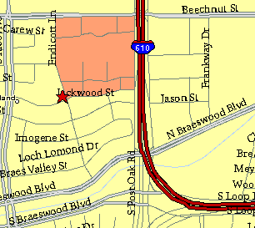

Meeting Information

Meeting Place:
St. Thomas Episcopal School
4900 Jackwood
Houston, Texas 77096

Date and Time:

Fourth Monday of the month
7:30 pm Heather & Thistle Society Statement
And Membership Information

The Heather and Thistle Society was founded in 1953 by Scots living in Houston who wished to “cultivate an interest in and fond recollections of Scotland, its history and traditions, its literature and ideals, its minstrelsy and song, its customs and amusements, and to provide opportunities for good fellowship and social contact through typically Scottish functions, so that the blessing of our Scottish culture may never die in our new homeland”.

The Heather and Thistle Society meets 10 times a year, September through June.
Programs include music, singing, dancing, lively lectures, slide shows and movies about Scotland. The Heather and Thistle Society puts on the annual Robert Burn’s Supper and Ball in late January of each year. We are an organization that promotes our Scottish heritage, in various ways.

The Heather and Thistle Society’s monthly newsletter, “The Houston Scot” is published
from September through June. Original articles, information about Scottish or related events are welcome and should be sent to the editor, Jim Monteith, at 15703 Mound Road, Hockley, Texas 77447 or 936-931-2588.

Membership in the Heather and Thistle Society is open to all with an interest in Scottish heritage and culture. Annual dues are $15 for an individual and $20 for a family membership. Applications for membership may be obtained from our website.
http://heatherandthistle.org/documents/membership.doc
Dues are due at the beginning of the fiscal year, March 1. Completed applications and membership fees should be mailed to: Dr. Walter May
6143 Sienna Arbor Lane
Houston, Texas 77041-6038



