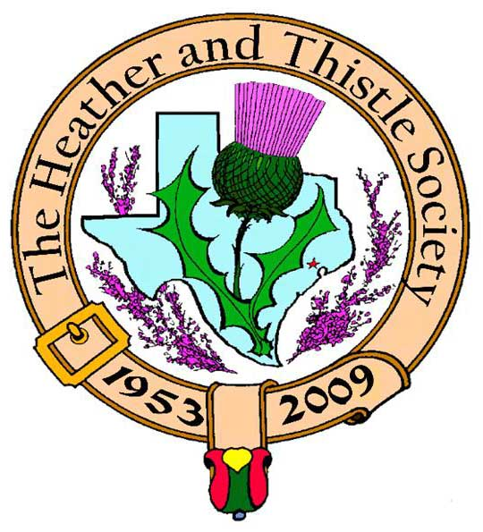

Heather & Thistle Society

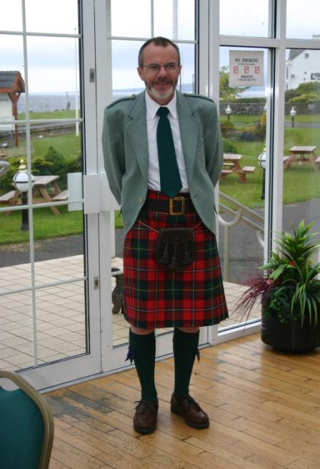 Chieftain Dr. Robert Boyd

Volume 9, Issue 5
February, 2009

Newsletter Editor:
Jim Monteith

Officers:

Chieftain – Dr. Robert Boyd
SubChieftain – Rev. Melvyn Douglass
Sgt.-at-Arms – Ardeth Brodie
Secretary – Carmelita Orr Treasurer – Dr. Walter May

Committee Chairs:

Sunshine-vacant
Membership-vacant
Past Chieftains-Cheryl May
Burns Supper-Jim Monteith
Publicity-Melvyn Douglass
Programs-Gordon Macleod

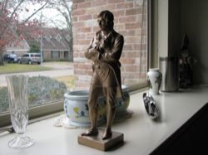 New Burns Statuette The Houston Scot

Chieftain’s Letter,
A Personal Thank-You
I’d like to thank everyone for their concern and good wishes sent to my wife during her recent illness. As many of you may know, Irene fell ill soon after the Burns Supper and was diagnosed with a serious case of pneumonia. She was in hospital for two weeks, the first of which was spent in the ICU on a tube/ventilator. Thankfully I can now report that Irene is back at home and is beginning the recovery process. Again, sincere thanks to all.
56th Annual Burns Supper a Great Success
This year’s Burns Supper presented particular difficulties for Jim Monteith and his committee. There were contractual issues with the hotel and because of the economy ticket sales were a problem. Jim’s team rose to the challenge and the event was voted one of the best ever. About 450 attended and had a great time. Thanks to Jim Monteith for his efforts and to all who helped. Thanks also to our performers Charles McKay, Charles Wharton and of course RSCDS, Houston Highlanders, St. Thomas Episcopal Pipe Band and dancers and Hugh Morrison and friends. We are already working on next year.
Burns Statuette Presented to the Society at the Burns Supper
We had a most pleasant surprise at this year’s Supper when Lance Davis, an Australian residing in Scotland, presented the Society with a beautiful statuette of Robert Burns in the size and style of an Oscar. After some digging around, we have established that Lance and his friend Dave Stuebner with their wives and guests have been attending our event for the last ten years or so. Andrew Drysdale, a friend of Lance’s runs a foundry in Scotland, one of the last, and found a pattern for the statuette dating back to the 1840s, and when he heard of the 250th Anniversary event he cast the piece and gifted it to Lance for us. We have decided that it will be given at each year’s Supper to the organizing Chairperson, and Jim Monteith is the well-deserving first recipient. Thanks so much to those who were responsible for this handsome gift.
Burns Club a Hoot in their Annual Performance
Modesty forbids me to claim that the Burns Club show at last month’s meeting was of a high standard, but we certainly had fun doing it, and judging by the reaction of the audience of over 40 members and guests present they enjoyed it too. There were particular compliments about the acting this year – lots of action! Thanks to Jack Hume and the group for their efforts putting this on once again.
Next Meeting – Monday February 23 at 7:30 PM – History of the Society
At the next meeting Jack Hume will give his personal remembrance of the Heather and Thistle Society which he joined in 1955, and this will be followed by members’ tales of what the Society has meant to them. Please do come along prepared, and bringing along memorabilia is encouraged.
Tartan of the Month - Drysdale
We are delighted to honor Drysdales Foundry for its generosity in presenting us with the Burns Oscar. Check it out at www.heatherandthistle.org.
Program Items for April and June
Please send ideas to our Program Chair Dr. Gordon Macleod at gordymacus@yahoo.com.
Robert Boyd
Chieftain

Tartan Day Activities in Texas

Sia Beaton reports there will be a very special celebration at the Alamo and Highland Games in San Antonio, as well as our first ceremony in Houston at the San Jacinto Monument to recognize all those of Scottish ancestry who fought for Texas Independence! There will be a ceremony and dancing at the State Capital Rotunda in Austin, bagpipes at a baseball game in Frisco and the ninth annual Tartan Day Ceilidh in Dallas.
I would like to extend an invitation to H&T members to attend the event on April 6th at the San Jacinto monument from 1pm to 3pm. They will need to RSVP as seating is limited, but the ceremony should be interesting and a great opportunity to network. Sam Houston IV and other direct descendents of the Battle will be there including a group from the Daughters of the Republic of Texas!
The event is free - but if your Clan Society or Scottish Association would like to be recognized during the ceremony, please RSVP to me (sbeaton@TxScot.com) or Cell: 832-659-5501, so we can include you in the program and be sure to have some reserved seats available. There will also be some other "perks" provided for those who RSVP including a complimentary viewing of the film "Texas Forever!!".
If anyone wants to attend who is a descendent of the battle veterans please let me know as we want to recognize them during the ceremony.

Get Well Soon Irene!!!



Heather & Thistle Society - Minutes January 26, 2009
Chieftain Dr. Robert Boyd called the business meeting to order at 7:35pm in the auditorium of St. Thomas Episcopal School. A motion was made to accept the December, 2008 minutes as published in the newsletter. Motion passed to accept the minutes.
Treasurer Report: Dr. Walter May reports the checking account bank balance to be $2360.70. Burn’s Supper account balance is $19,674.03. PCC Fund balance is $1413.89. Total for all accounts is $23,168.97. Motion made and passed to accept the report.
Membership Report: Dr. Walter May reports 144 family, 44 life, 34 single, for a total of 235 members.
Committee Reports called for by Sub-Chieftain Rev. Melvyn Douglass
Burn’s Club: No report.
Burns Supper: Jim Monteith explained the cost of the supper and attendance problems. Also stated his thanks for everyone helping.
Past Chieftains: Dr. Walter May announced officer nominations for 2009.
Programs: Chieftain Boyd reports the February 2009 program will be a history of the H&T Society. March program will be election of new officers. In need of a program for April. May will be a singer from Louisiana. Gordon Macleod will be staying on as program director for another year.
Sunshine: No report.
Newsletter: Editor Jim Monteith reports that just under 200 newsletters go out each month, about half by email and the other by surface mail.
Houston Grampian: No report.
Houston Highland Games: Rev. Melvyn Douglass reports a robost atheletic program is planned for this year.
RSCDS: Classes are on-going. A Valentine’s dance is upcoming.
Houston Highlanders: No report.
Sergeant-At-Arms: Ardeth Brodie reports 34 members and 3 guest’s present.
Old Business: None.
New Business: Ed Miller has a new CD of Robert Burns songs coming out. Chieftain Boyd presented the new Burns Oscar which was given to him at our recent Burns Supper. He believes it should be given to the chairman of the Burns Supper Planning Committee each year. Chieftain Boyd presented the statuette to Jim Monteith. Jim will keep it for one year and then turn it over to the next Chairman.

The business meeting was adjourned at 8:00pm.

Tonight’s program was the annual Burns Club presentation. Members were treated to a wonderful performance of “A Night at Poosie Nansie’s Inn”. The performance was introduced by Arthur Down. Performers were: Robert Boyd, Ted Hirtz, Sheila Latimer Helme, Jack Hume, Anne Fielding, Jim Haggarty, Alex Munroe, and Bob Gilbert.

Heather and Thistle Society Annual Burns Supper
The Burns Supper planning committee is seeking H&T member input concerning a new location to hold our Burns Supper. We have had many serious issues with the Marriott Westchase Hotel and we are considering moving the event. We need a ballroom that will fit 350 to 500 people. Please contact your editor Jim Monteith at 281-924-3073 or alabamascot@esagelink.com.

Burns Supper Decorations Committee
Decorations committee chair Sharon Monteith wishes to express her sincerest appreciation and gratitude to B. J. Sorrels, Becci Himes, Carmelita Orr and her daughter Savanna for their help in arranging the table center pieces for the 2009 Burns Supper. Our beautiful roses and heather this year were purchased from Sam at Northwest Florist and Gift Shop. Finally, I wish to thank God for providing the beautiful greenery from my own garden. Also a big thank you to the following members for their assistance in setting up the decorations, programs, and menu cards in the ballroom: Stephen McIntyre, Mark Monroe, Ardeth Brodie, Cheryl May, Walter May, B. J. Sorrels, Kenneth Sorrels, and Jim Monteith.

Burns Supper Tartan Set Up
Our Sgt.-At-Arms Ardeth Brodie and our future Sgt.-At-Arms Mark Monroe once again led the group setting up the tartan stands and banners used to decorate the hall and ballroom. They are very dedicated and greatly appreciated. Thanks!!!!!

Burns Supper Entertainment The Heather and Thistle Society wishes to thank the Royal Scottish Country Dance Society, the Houston Highlanders, the St. Thomas Episcopal Pipe Band and Highland Dancers, and Hugh Morrison and Friends for performing at our recent Burns Supper.

Alistair Campbell Open Piping Competition The Heather and Thistle Society is once again sponsoring the Open Piping Competition at the upcoming Houston Highland Games. Our Society wants to increase the stature and prestige of this event. The event will be moving to Saturday afternoon in the arena. We are hoping for more advertisement from the Houston Highland Games Association in order to attract more competitors. Along with this we want to increase the prize money. H&T is seeking member donations in order to raise the prize money. Please send your monetary donations to our treasurer: Dr. Walter May, 6143 Sienna Arbor Lane, Houston, Texas 77041-6038. Please make your check out to the Houston Highland Game Association and note it is for the Alistair Campbell Open Piping Competition. Thank you.

Heather MacAllister sent this in:
My parents, Boyd and Colleen Wilkes, couldn’t make the Burns Supper this year, but they didn’t miss out. They’re currently cruising on the Queen Mary II around South America. I got this e-mail from my dad:

“The Chief Engineer of the Queen Mary 2 hosted the Burns Celebration a week ago. He was resplendent in kilt and rich Scots accent. And a bar was set up with a half dozen bottles of the good stuff. They addressed the haggis and we all had a sample and neeps. We have pictures to prove. Tomorrow to Peru and to market.”

I thought it might make an interesting tidbit for the newsletter. I’m Ed and Ruth Ann MacAllister’s daughter-in-law and my sister is Allison Wilkes Stewart.

Robert Burns Bronze
Presented to the Heather and Thistle Society of Houston by Lance and Roz Davis
and Dave and Siggy Stuebner
On Sunday 26th August 1787, Robert Burns and Nicol, embarked on their Highland tour, called at the Carron Iron Works, apparently with the somewhat surprising hope of being admitted. With a diamond he recently acquired, and which he used also on the windows of inns in Stirling and Falkirk, Burns wrote on a window of the inn at Carron:
“We cam na here to view your works
In hopes to be mair wise,
But only, lest we gang to hell,
It may be nae surprise:
But when we tirl’d at your door,
Your porter dought na hear us;
Sae may, shou’d we to hell’s yetts come,
Your billy Sattan sair us!”
The Carron Ironworks, some 3 miles south of Falkirk were founded by Dr. Roebuck of Sheffield in 1760. During the Napoleonic Wars, the Ironworks turned out a useful piece of artillery known as the Carronade.
The bronze statuette is one of two cast in 2008, in the foundry of Drysdale Brothers (Larbert) Limited at Stenhousemuir, Larbert, Falkirk, Scotland. This foundry is one of the last in Scotland, in an area, which for several centuries boasted many engineering and foundry works. The Carron Ironworks, visited by Burns, was situated within one mile of the Drysdale Brothers foundry in Larbert.

The 2009 Scottish Festival Spectacular
Presented by St. Thomas' Episcopal School
Family of the Gail
Clan Na Gael
Featuring...Five-Time World Champions
St. Thomas' Pipe Band and Champion Pipers, Drummers, and Dancers
Thursday, March 12, 2009 @ 7:30 p.m.
At the Toyota Center in Houston

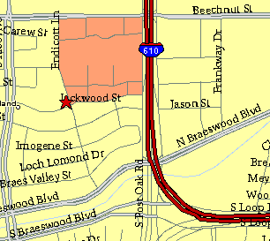

Meeting Information

Meeting Place:
St. Thomas Episcopal School
4900 Jackwood
Houston, Texas 77096

Date and Time:

Fourth Monday of the month
7:30 pm Heather & Thistle Society Statement
And Membership Information

The Heather and Thistle Society was founded in 1953 by Scots living in Houston who wished to “cultivate an interest in and fond recollections of Scotland, its history and traditions, its literature and ideals, its minstrelsy and song, its customs and amusements, and to provide opportunities for good fellowship and social contact through typically Scottish functions, so that the blessing of our Scottish culture may never die in our new homeland”.

The Heather and Thistle Society meets 10 times a year, September through June. Programs include music, singing, dancing, lively lectures, slide shows and movies about Scotland. The Heather and Thistle Society puts on the annual Robert Burn’s Supper and Ball in late January of each year. We are an organization that promotes our Scottish heritage, in various ways.

The Heather and Thistle Society’s monthly newsletter, “The Houston Scot” is published from September through June. Original articles, information about Scottish or related events are welcome and should be sent to the editor, Jim Monteith, at 15703 Mound Road, Hockley, Texas 77447 or 936-931-2588. Email to alabamascot@esagelink.com.

Membership in the Heather and Thistle Society is open to all with an interest in Scottish heritage and culture. Annual dues are $15 for an individual and $20 for a family membership. Applications for membership may be obtained from our website.
http://heatherandthistle.org/documents/membership.doc
Dues are due at the beginning of the fiscal year, March 1. Completed applications and membership fees should be mailed to: Dr. Walter May
6143 Sienna Arbor Lane
Houston, Texas 77041-6038

