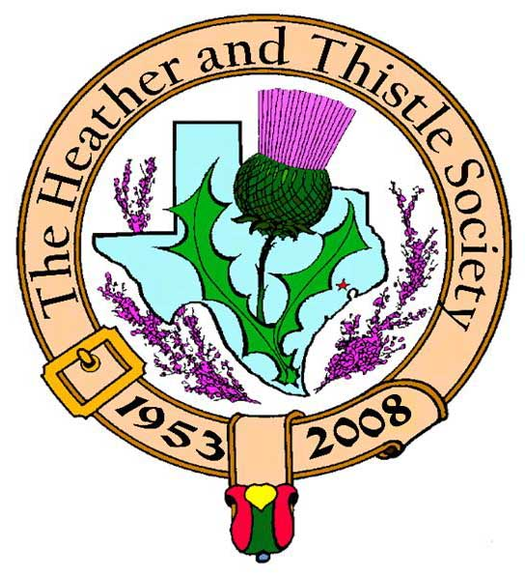

Heather & Thistle Society

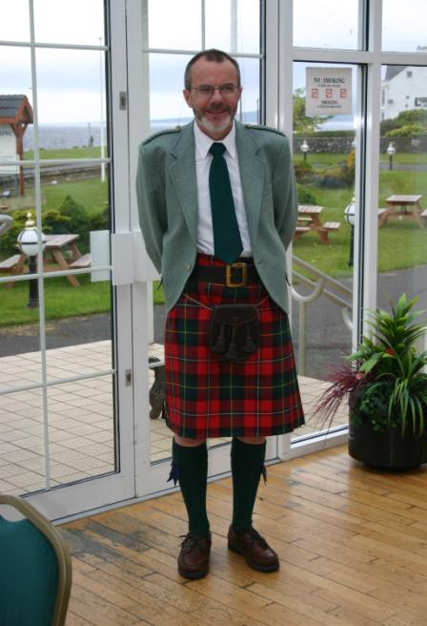 Chieftain Dr. Robert Boyd

Volume 9, Issue 4
January, 2009

Newsletter Editor:
Jim Monteith

Officers:

Chieftain – Dr. Robert Boyd
SubChieftain – Rev. Melvyn Douglass
Sgt.-at-Arms – Ardeth Brodie
Secretary – Carmelita Orr Treasurer – Dr. Walter May

Committee Chairs:

Sunshine-Eileen Moore
Membership-Eileen Moore
Past Chieftains-Cheryl May
Burns Supper-Jim Monteith
Publicity-Melvyn Douglass
Programs-Gordon Macleod

*Member Attendance*

Recent H&T member attendance at meetings has been dismal. Chieftain Boyd has addressed the issue in his letter this month. We who volunteer in the Society would love to see more member participation and attendance. We are trying to keep this Society going forward but it is getting difficult.
The Houston Scot

Chieftain’s Letter,
A Happy New Year to you everyone and good luck to you and yours for 2009!
There is still time to buy tickets for our main event of the year – the Heather and Thistle Society’s 56th Annual Burns Supper and Ball at the Marriott Westchase on January 24th. I’m looking forward to greeting members and friends old and new at what promises to be a great night. Thanks to Jim Monteith and his team for all their efforts putting the evening together. It really is a mammoth task.
Better Attendance and more Participation needed in 2009
It has to be said that attendance at our monthly meetings has been very disappointing, and we really need to boost our numbers this year. This is also the time of year when we put together our executive team for the coming year. Thanks to Cheryl May we do have a complete slate of office bearers to present to members but we still need help in other positions.
Everyone joined the Society to support its basic aim of promoting Scottish heritage in the Houston community and surrounding area. Now we need more active participation to sustain that effort. Our meetings are really interesting, and as November showed, the unexpected can happen – so please come along, and we ask that all members old and new to volunteer to take up one of these Chairs, none of which is too onerous:
Membership, Sunshine, Publicity, Hospitality
The Society needs your help, now is the time to step up!
Christmas Party - very nice gifts exchanged
This year’s Christmas Party was a fine success, although as noted above, a larger attendance would have made it even better. High-quality gifts ranging from books on Scottish and Welsh literature and kids toys all the way to (shock) wine and whisky were exchanged with quite a bit of “stealing” I can tell you.
Burns Bust Gathering – Hermann Park Sunday January 25 at 3:00 PM
Please note that the day after the Burns Supper, that is on Sunday January 25 at 3:00 PM we’ll gather at our Burns Bust in Hermann Park to honor the Bard’s 250th Anniversary. Please join us.
Next Meeting Monday January 26- Burns Club Presentation
The Society’s Burns Group will present A(nother) Night at Poosie Nansie’s Inn, a play based on the words of Robert Burns arranged by Jack Hume and introduced by Arthur Down. We have a lot of fun doing this each year, and I’ll say it again, a good attendance definitely motivates us.
Tartan of the Month
Burns – what else!
Program for February
At the February 2009 meeting we are going to have a session about the 55-year history of the Heather & Thistle Society. Jack Hume is going to prepare an overview, but the idea is that members should come prepared to talk about their perspective on H&T and everyone is encouraged to bring along memorabilia from past H&T events. Program Chair Gordon Macleod is on his feet for the first time since his accident ten weeks ago. Gordon will be at the Burns Supper and we look forward to seeing him again.
Happy Holidays to you all
Robert Boyd
Chieftain

2009 Heather & Thistle Officer Nominations
Chieftain – Dr. Robert Boyd
Sub-Chieftain – Dr. Melvyn Douglass
Sgt.-At-Arms – Mark Monroe
Treasurer – Dr. Walter May
Secretary – Carmelita Orr
We appreciate these volunteers for the time and effort supporting H&T.

2009 Celtic Festival & Gathering of the Celts Set for February 15
HOUSTON, TEXAS, January 4, 2009—The 2009 St. Andrew’s Episcopal Celtic Festival will be held in conjunction with The Gathering of the Celts on Sunday, February 15 from noon to 5:30 pm at 19th Street and Heights Boulevard in the Houston Heights. The Festival will begin immediately following the church’s 10:30 am service as bagpipers lead everyone to the “Kirking of the Celts” and on to the opening musical performance on one of two stages. The day’s scheduled performers include: the world champion St. Thomas Episcopal School Pipe Band; Jed Marum; Hugh Morrison; Constant Billy (Bill Galbraith & Emily Standish); Kristen Jensen; Ghost of a Rose; Celtic Chorus of Houston; Good Time Scottish Dancers; and Kilderkin International Dancers. In addition to musical entertainment, the afternoon will feature a wide range of artisans and craft vendors, great food and drink, plus games, crafts and activities for children of all ages. Admission: $5.00 per family, $3.00 per person, and free for children under 10. Call 713-861-5596 or www.saintandrewsepiscopal.org/celtic-festival-2009/for more details.

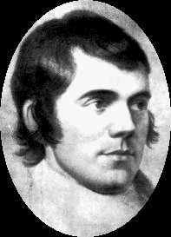

Heather & Thistle Society - Minutes December, 2008
Chieftain Dr. Robert Boyd called the business meeting to order at 7:45pm in the Ingram room of St. Thomas Episcopal School. A motion was made to accept the November, 2008 minutes as published in the newsletter. Motion passed to accept the minutes.
Treasurer Report: Dr. Walter May reports the checking account bank balance to be $2360.70. Burn’s Supper account balance is $9566.63. PCC Fund balance is $1413.83. Total for all accounts is $13,341.16. Motion made and passed to accept the report.
Membership Report: No report.
Committee Reports called for by Sub-Chieftain Rev. Melvyn Douglass
Burn’s Club: The club has a cast and script for the January presentation. Will be meeting at the Burns bust in Hermann Park on Sunday, Jan. 25th at 3:00pm.
Burns Supper: Cheryl May reports Jim Monteith is doing a great planning job and there are 9 tables left. Our ticket prices for the event are much less than other groups and comparable events. For example, tickets for the Plantation breakfast with the Southern Knights are $145.
Past Chieftains: Cheryl May reports the PCC is working on the slate of officers for next year and if anyone has any thoughts or interest in serving please contact us. New slate of officers will be announced in Jan. newsletter.
Programs: Chieftain Boyd reports that our program director, Gordon Macleod, is doing better. The February 2009 program will be a history of the H&T Society. Please bring memorabilia about the Society to the meeting.
Sunshine: No report.
Newsletter: No report.
Houston Grampian: Note: Member Bob Gilbert has taken ill and will be undergoing stress tests. Looking for more people to go to Scotland.
Houston Highland Games: Rev. Melvyn Douglass reports contracts are out. Athletic program doing much better. Games will be the 3rd weekend in May.
RSCDS: Moonyeen Weiss reports they are on winter holiday. Social dancing will start in Jan. 2009 on Tuesdays at YMCA Dad’s Club on Voss. Experianced classes start in February. A demonstration dance will be held at the upcoming Burns Supper. Dave Davies is coordinating.
Houston Highlanders: No report.
Sergeant-At-Arms: 12 members and 1 guest present.
Old Business: None.
New Business: None.

The business meeting was adjourned at 8:00pm

Tonight’s program was the annual H&T Christmas party and gift exchange.

2009 Burns Supper tickets are still available. Let’s make this year’s event a success. There are plenty of tables left unsold. Contact our ticket chairwoman, Joan McClure, and order today. Ticket prices are very reasonable if you consider the entertainment that is provided and the good company you will enjoy.

The Heather and Thistle Society
56th Annual Robert Burns Supper
Saturday, January 24, 2009
Houston Marriott Westchase , 2900 Briarpark Drive, Houston, TX 77042
Ticket Order Form
Name of Ticket Holder * | No. Tickets | Total # Member Tickets @ $65 | Total # Non-Member Tickets @ $80 | Total Dollar Amount
Mail to:
Name:
Address:
City |  | State |  | Zip
Phone # |  | E-mail
* Member tickets may be purchased by/for only those with current dues as of September 30, 2008. Tickets ordered in November must be paid for in full by December 1st. Please list names for whom member tickets are requested. Use a separate sheet for each table of ten.
Enclose a self-addressed, stamped envelope with this form and your check made payable to the Heather and Thistle Society. Mail to:
 | Mrs. Robert A. McClure (Joan)
 | 553 Brown Saddle Road
 | Houston, TX 77057-1413
 | Ph: 713-782-6707
Date received |  | Ticket Nos. | Table Nos. | Tickets Mailed
__________________ |  | _________________ | _________________ | _______________

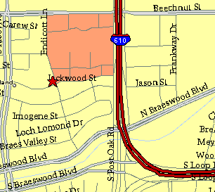

Meeting Information

Meeting Place:
St. Thomas Episcopal School
4900 Jackwood
Houston, Texas 77096

Date and Time:

Fourth Monday of the month
7:30 pm Heather & Thistle Society Statement
And Membership Information

The Heather and Thistle Society was founded in 1953 by Scots living in Houston who wished to “cultivate an interest in and fond recollections of Scotland, its history and traditions, its literature and ideals, its minstrelsy and song, its customs and amusements, and to provide opportunities for good fellowship and social contact through typically Scottish functions, so that the blessing of our Scottish culture may never die in our new homeland”.

The Heather and Thistle Society meets 10 times a year, September through June. Programs include music, singing, dancing, lively lectures, slide shows and movies about Scotland. The Heather and Thistle Society puts on the annual Robert Burn’s Supper and Ball in late January of each year. We are an organization that promotes our Scottish heritage, in various ways.

The Heather and Thistle Society’s monthly newsletter, “The Houston Scot” is published from September through June. Original articles, information about Scottish or related events are welcome and should be sent to the editor, Jim Monteith, at 15703 Mound Road, Hockley, Texas 77447 or 936-931-2588. Email to alabamascot@esagelink.com.

Membership in the Heather and Thistle Society is open to all with an interest in Scottish heritage and culture. Annual dues are $15 for an individual and $20 for a family membership. Applications for membership may be obtained from our website.
http://heatherandthistle.org/documents/membership.doc
Dues are due at the beginning of the fiscal year, March 1. Completed applications and membership fees should be mailed to: Dr. Walter May
6143 Sienna Arbor Lane
Houston, Texas 77041-6038

