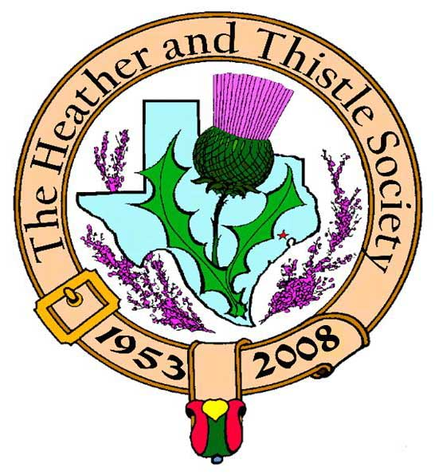

Heather & Thistle Society

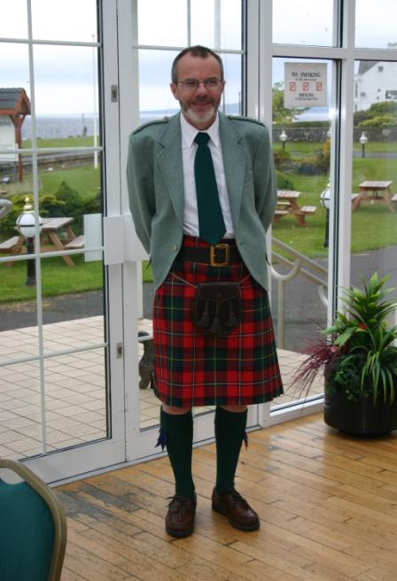 Chieftain Dr. Robert Boyd

Volume 9, Issue 3
December, 2008

Newsletter Editor:
Jim Monteith

Officers:

Chieftain – Dr. Robert Boyd
SubChieftain – Rev. Melvyn Douglass
Sgt.-at-Arms – Ardeth Brodie
Secretary – Carmelita Orr Treasurer – Dr. Walter May

Committee Chairs:

Sunshine-Eileen Moore
Membership-Eileen Moore
Past Chieftains-Cheryl May
Burns Supper-Jim Monteith
Publicity-Melvyn Douglass
Programs-Gordon Macleod

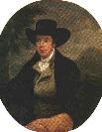
The Houston Scot

Chieftain’s Letter,
I would like to take this opportunity to wish all Society members and their families all the best for the Holiday Season and for 2009. For many of us the last few weeks of 2008 have been challenging, with the post-Ike recovery compounded by the turbulent economic times we find ourselves grappling with now. But with good Scottish grit we’ll get through this and we can still find a way to be optimistic about the New Year and maybe even hasten that with a wee dram at Hogmanay!
Wedding Held During November Meeting – a First!
One of the most pleasant surprises of the year came at the Society’s November meeting when at the last minute our Secretary Carmelita Orr asked if it would be possible for her to be married during the meeting. A somewhat surprised Sub-Chieftain Reverend Melvyn Douglass agreed to officiate and with the enthusiastic agreement of the members the event duly took place. Fortunately our meetings take place in an Episcopal School and Church, so Mel was able to find a prayer book containing the appropriate texts, and the couple was armed with a valid marriage license. Chieftain and Mrs. Boyd completed the wedding party and handed the rings over safely. So Daniel and Carmelita Orr are now husband and wife (again). They first did this 26 years ago and are now happily reunited. The newlyweds then led off the ceilidh dancing demonstration rehearsal for our Burns Supper. Thanks to Moon Weiss for organizing that.
Next Meeting – Christmas Party Monday December 15
Please bring a dish and a modestly price gift (one per person) for a White Elephant Exchange at the party. Note the earlier than usual date this month to accommodate Christmas, and also that the party will be held in the Ingram Room at St. Thomas this time.
Burns Supper Tickets on Sale to the General Public
The Society’s 2009 Burns Supper and Ball will be held on January 24th at the Marriott Westchase. Tickets are now on sale to the general public and I encourage members and friends to obtain their tickets early. An order form is available at www.heatherandthistle.org. Joan McClure, our hard-working ticket manager, advises me that sales are going well. Many of you may know that Joan was one of those particularly hard-hit by Hurricane Ike. Her home is still not back in shape, and she has been quite exhausted by the whole process. Nevertheless she has pitched in as usual to keep on top of ticket sales and above all the tricky problem of table seating.
Tartan of the Month
In honor of our newly-weds Dan and Carmelita Orr the tartan for December is Renfrewshire, the seat of the Orr family. Our webmaster tells me that he could not find an Orr tartan, but if anyone can let us know.
Program for February
At the February 2009 meeting we are going to have a session about the 55-year history of the Heather & Thistle Society. Jack Hume is going to prepare an overview, but the idea is that members should come prepared to talk about their perspective on H&T and everyone is encouraged to bring along memorabilia from past H&T events. There is better news of our Program Chair Gordon Macleod who is recovering from a serious accident. His surgeon tells him that all is healing well and he should be able to get on his feet for the first time during January. Gordon is quite cheerful, and he tells me that he has booked his table for the Burns Supper and fully intends to be there.
Happy Holidays to you all
Robert Boyd
Chieftain
56th Burns Supper - January 24, 2009
Tickets on Sale
- Member tickets on sale for $65 each
- Non-Member tickets on sale for $80 each
Entertainment will include performances by Houston Highlanders Pipe Band, St. Thomas Episcopal Pipe Band & Highland Dancers, Royal Scottish Country Dance Society, and a Ceilidh Dance featuring Hugh Morrison!!!!!!

Cut out or copy the Ticket Order Form on page 3 of this newsletter and send in to Joan McClure now!!!!!!!
Editor Request
If you move or change your address don’t forget to let your editor know so I can continue to get your ‘Houston Scot’ newsletter to you on time. Editor contact information is on the last page of this newsletter.
Get Well Gordon!!!!
Our Program Director Gordon Macleod was badly injured when a truck backed into him crushing him between vehicles.
All at Heather and Thistle Society wish you a speedy recovery from your unfortunate accident.

Robert Burns World Federation Ltd.

The Houston Heather and Thistle Society is Club #1045 in the Robert Burns World Federation, founded in 1885. It is based in Kilmarnock, Ayrshire about ten miles from Robert Burns’s birthplace. The Federation employs a full-time staff as well as volunteers to promote Robert Burns around the world. It organizes a World Conference each year which in 2009, the 250th anniversary of the birth of Robert Burns, will be held in Edinburgh, capital of Scotland. The Federation club numbers are an indication of when each club joined. The lowest numbers belong to clubs from Burns Country in Southwest Scotland and in London. We in Heather & Thistle are proud to be members and Houston delegates have attended most of the World Conferences for the past twenty-five years.

Robert Burns Memorial Bust

On Sunday, January 25, 2009 at the Rose Garden, Hermann Park, in Houston, their will be a service celebrating the 250th anniversary of Robert Burn’s birth. This is the day after our 56th Burns Supper. All are welcome to attend.

Heather & Thistle Society - Minutes November 24, 2008
Chieftain Dr. Robert Boyd called the business meeting to order at 7:35pm in the gymnasium of St. Thomas Episcopal School. A motion was made to accept the Sept.-Oct., 2008 minutes as published in the newsletter. Motion passed to accept the minutes.
Treasurer Report: Dr. Walter May reports the checking account bank balance to be $2245.70. Burn’s Supper account balance is $12,201.63. PCC Fund balance is $1413.73. Total for all accounts is $15,861.06. Motion made and passed to accept the report.
Membership Report: No report.
Committee Reports called for by Sub-Chieftain Rev. Melvyn Douglass
Burn’s Club: Chieftain Boyd reports the planning for the January program is in the early stages. Rehearsal on 12-11-08 at Chieftain Boyd’s residence.
Burns Supper: Jim Monteith reports all is going well. Next meeting will be in early January 2009. Next contract payment of $2500 is due to the host hotel on Dec. 15. All of the planned entertainment groups are on-board for the event. Event costs are very high this year as they have been for the past five years.
Past Chieftains: Dr. Walter May reports they are working on nominations for next years H&T officers.
Programs: Chieftain Boyd reports that our program director, Gordon Macleod, was crushed when a truck backed up into him. He is in the hospital and in rehab. His parents were able to come over from Scotland to assist. The February 2009 program will be a history of the H&T Society.
Sunshine: Chieftain Boyd reports Mary McNab fell and injured her shoulder and elbow.
Newsletter: Editor Jim Monteith reports emailing 95 with three returns and surface mailing 90 copies of the Houston Scot Newsletter.
Houston Grampian: Dr. Walter May reports they have been invited to Scotland in 2009.
Houston Highland Games: Rev. Melvyn Douglass reports new president Becci Himes is doing an outstanding job in early preparation for the 2009 Highland Games.
RSCDS: Moonyeen Weiss reports they are having socials on Tuesdays starting in Jan. 2009 at YMCA Dad’s Club on Voss. First week of Feb. 2009 classes begin in The Woodlands, League City, and SW Houston. See their website at www.houstonrscds.org. Home schooled kids in Tomball and Ft. Bend county will be getting lessons.
Houston Highlanders: No report.
Sergeant-At-Arms: Ardeth Brodie reports 19members and 1 guest present.
Old Business: None.
New Business: H&T Christmas meeting will be held on Dec. 15th in the Ingram Room at St. Thomas. The Jan. 2009 meeting will be on the regular 4th Monday of the month, which is Jan. 26, 2009. A believed to be first, a wedding was held at the meeting. Our Secretary Carmelita Orr remarried her former husband Daniel. Our Sub-Chieftain Rev. Melvyn Douglass performed a wonderful ceremony for the couple while Chieftain Boyd and wife Irene Boyd completed the wedding party.

The business meeting was adjourned for refreshments after the wedding.

Tonight’s program was participation Scottish dancing with Moonyeen Weiss of RSCDS.

The Heather and Thistle Society
56th Annual Robert Burns Supper
Saturday, January 24, 2009
Houston Marriott Westchase , 2900 Briarpark Drive, Houston, TX 77042
Ticket Order Form
Name of Ticket Holder * | No. Tickets | Total # Member Tickets @ $65 | Total # Non-Member Tickets @ $80 | Total Dollar Amount
Mail to:
Name:
Address:
City |  | State |  | Zip
Phone # |  | E-mail
* Member tickets may be purchased by/for only those with current dues as of September 30, 2008. Tickets ordered in November must be paid for in full by December 1st. Please list names for whom member tickets are requested. Use a separate sheet for each table of ten.
Enclose a self-addressed, stamped envelope with this form and your check made payable to the Heather and Thistle Society. Mail to:
 | Mrs. Robert A. McClure (Joan)
 | 553 Brown Saddle Road
 | Houston, TX 77057-1413
 | Ph: 713-782-6707
Date received |  | Ticket Nos. | Table Nos. | Tickets Mailed
__________________ |  | _________________ | _________________ | _______________

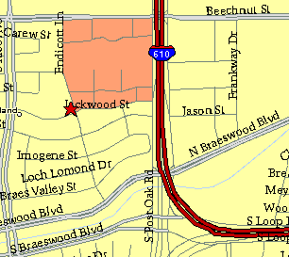

Meeting Information

Meeting Place:
St. Thomas Episcopal School
4900 Jackwood
Houston, Texas 77096

Date and Time:

Fourth Monday of the month
7:30 pm Heather & Thistle Society Statement
And Membership Information

The Heather and Thistle Society was founded in 1953 by Scots living in Houston who wished to “cultivate an interest in and fond recollections of Scotland, its history and traditions, its literature and ideals, its minstrelsy and song, its customs and amusements, and to provide opportunities for good fellowship and social contact through typically Scottish functions, so that the blessing of our Scottish culture may never die in our new homeland”.

The Heather and Thistle Society meets 10 times a year, September through June. Programs include music, singing, dancing, lively lectures, slide shows and movies about Scotland. The Heather and Thistle Society puts on the annual Robert Burn’s Supper and Ball in late January of each year. We are an organization that promotes our Scottish heritage, in various ways.

The Heather and Thistle Society’s monthly newsletter, “The Houston Scot” is published from September through June. Original articles, information about Scottish or related events are welcome and should be sent to the editor, Jim Monteith, at 15703 Mound Road, Hockley, Texas 77447 or 936-931-2588. Email to alabamascot@esagelink.com.

Membership in the Heather and Thistle Society is open to all with an interest in Scottish heritage and culture. Annual dues are $15 for an individual and $20 for a family membership. Applications for membership may be obtained from our website.
http://heatherandthistle.org/documents/membership.doc
Dues are due at the beginning of the fiscal year, March 1. Completed applications and membership fees should be mailed to: Dr. Walter May
6143 Sienna Arbor Lane
Houston, Texas 77041-6038

