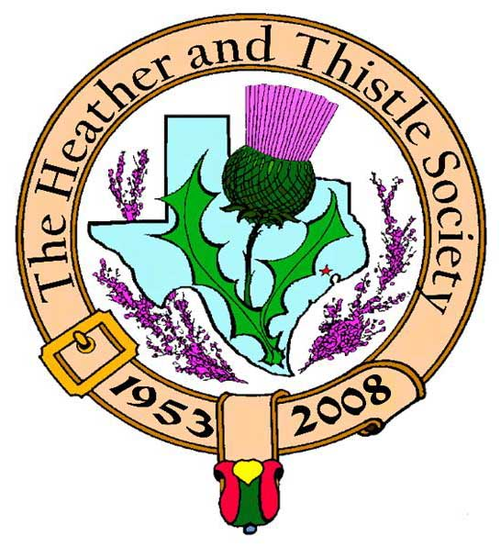

Heather & Thistle Society

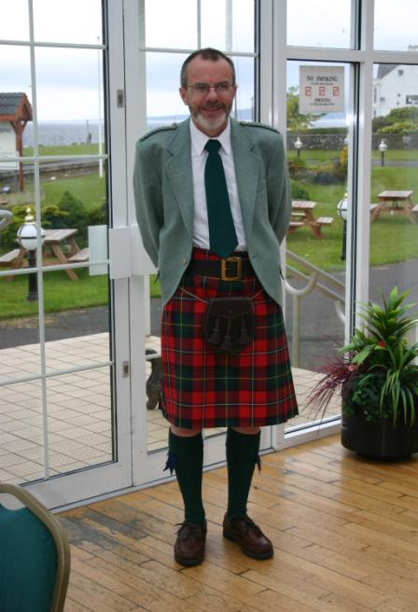 Chieftain Dr. Robert Boyd

Volume 9, Issue 2
November, 2008

Newsletter Editor:
Jim Monteith

Officers:

Chieftain – Dr. Robert Boyd
SubChieftain – Rev. Melvyn Douglass
Sgt.-at-Arms – Ardeth Brodie
Secretary – Carmelita Orr Treasurer – Dr. Walter May

Committee Chairs:

Sunshine-Eileen Moore
Membership-Eileen Moore
Past Chieftains-Cheryl May
Burns Supper-Jim Monteith
Publicity-Melvyn Douglass
Programs-Gordon Macleod

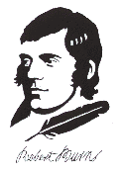
The Houston Scot

Chieftain’s Letter,
Ed Miller
An out of town business trip meant that I missed what is one of my favourite events – an Ed Miller gig. I am evidently not alone in loving Ed’s stuff, since there was a very good attendance of members at the meeting, supplemented as usual by quite a few Miller groupies. Ed did not disappoint with his usual sparkling mix of humour and of course his unique folk song collection. Thanks to Mark Monroe for sponsoring Ed’s visit and hosting him while he was in town.
Next Meeting – Monday November 24 at 7:30 PM – Scottish Country Dancing
As usual for our November meeting, Moon Weiss will lead us in a practice session for the open dance session at next year’s Burns Supper. We all look forward to tripping a measure. The participation dancing at this year’s Supper was one of the best ever, and because of that we are focusing on that and dispensing with the “big band”.
Burns Supper Tickets on Sale
The Society’s 2009 Burns Supper and Ball will be held on January 24th at the Marriott Westchase. Tickets are now on sale to the general public and I encourage members and friends to obtain their tickets early. An order form is available at www.heatherandthistle.org.
Immortal Memory to be Given by Charles McKay
The traditional address to the Immortal Memory of Robert Burns at our 2009 Supper will be given by Charles McKay. He is the son of local legal legend Neil McKay who was a long-time H&T member and a founder of the Houston Highlanders. Charles too has been a member of our Society for many years although he now lives in Dallas. He went to high school here in Houston and there met his charming wife Lynda. I met the McKays earlier this year when I helped them out at short notice when a speaker at their Burns Supper let them down. Charles also spoke at this Supper and very entertaining it was too. He definitely knows his Burns, and we are honoured that he has agreed to speak in January. Let’s be sure to give Charles and Lynda a warm welcome back to their home city.
Tartan of the Month
In honour of Ed Miller the Tartan of the Month for November is MacFarlane. Miller is a sept of Clan Macfarlane.
Gordon Macleod
Our program chair Dr. Gordon Macleod has been injured in a freak accident and will be out of commission for several months. No further details at this time. Let’s all wish Gordon a speedy recovery.
Robert Boyd
Chieftain
56th Burns Supper - January 24, 2009
Tickets on Sale
- Member tickets on sale for $65 each
- Non-Member tickets on sale for $80 each
Entertainment will include performances by Houston Highlanders Pipe Band, St. Thomas Episcopal Pipe Band & Highland Dancers, Royal Scottish Country Dance Society, and a Ceilidh Dance featuring Hugh Morrison!!!!!!

Cut out or copy the Ticket Order Form on page 3 of this newsletter and send in to Joan McClure now!!!!!!!
Celtic Thunder Concert
November 25, 2008 at Houston Reliant Arena
St. Andrews Day Celebration
November 30, 2008
McGonigel's Mucky Duck
2425 Norfolk Houston, TX
713-528-5999
- beginning 6:00 pm for $15
- performers include Ed Miller, EJ Jones and Emily Dugas

Siobhan Photo Studio
David Claros was our official photographer for the 2008 Burns Supper. The Society received an album of 130 photos taken during the evening. If anyone would like a copy of any of the photographs you may contact David directly at 281-807-5282 or email at siobhanphoto@sbcglobal.net or website: www.siobhanphoto.com

Dr. Walter May –H&T
Past Chieftain Book Release

Past Chieftain Dr. Walter May, a research scientist working in the energy field, proudly announces the publication of his book, U.S. Energy Independence – A Plan for Energy Independence by 2020. This 168 page book is intended to stimulate the reader to better understand the seriousness of our energy crisis and present possible solutions. Copies may be ordered from the publisher’s web site: www.SFAInternational.com or major book retailers. An eBook will also be available.

Heather & Thistle Society - Minutes October 27, 2008
Sub-Chieftain Dr. Melvyn Douglas called the business meeting to order at 7:36pm in the St. Thomas Episcopal School Theater. A motion was made to accept the June, 2008 minutes as published in the newsletter. Motion passed to accept the minutes.
Treasurer Report: Dr. Melvyn Douglas reports the checking account bank balance to be $2318.20. Burn’s Supper account balance is $17,201.63. PCC Fund balance is $1413.61. Total for all accounts is $20,932.44. Motion made and passed to accept the report.
Membership Report: Not available this month.
Committee Reports called for by Sub-Chieftain Rev. Melvyn Douglass
Burn’s Club: No report.
Burns Supper: Jim Monteith reports that tickets are on sale for $65 for members and $80 for non-members. BSPC meeting on Oct. 30. Tickets are printed and should be getting to Joan McClure soon. Next contract payment of $5000 is due to the host hotel on Nov. 15. Houston Highlanders and St. Thomas Pipers are on board for the event.
Past Chieftains: No report.
Programs: No report.
Sunshine: No report. Congratulations to Mr. and Mrs. Hume on their recent wedding.
Newsletter: Editor Jim Monteith reports emailing about 90 and surface mailing 90 copies of the Houston Scot Newsletter. Reports having numerous new members.
Houston Grampian: Robert Gilbert reports the trip to Aberdeen was cancelled.
Houston Highland Games: Nov. 11 there will be a fund raiser at St. Arnold brewery. HHGA web site has been updated for next years games.
RSCDS: No report.
Houston Highlanders: No report.
Sergeant-At-Arms: Ardeth Brodie reports 23 members and 14 guests present.
Old Business: None.
New Business: Jack Hume had a congratulation card for the new president of the Burns Club. Sharon Monteith will help with refreshments next month. The November meeting dance program is in conflict with a basketball game in the gym. We may be able to move the dancing to another room.

The business meeting was adjourned at 7:59pm for refreshments.

Tonight’s program was a wonderful performance by Scottish Folk Singer Ed Miller. Ed’s performance included Robert Burn’s songs in honor of his 250th birthday celebration. Thanks to member Mark Monroe for sponsoring Mr. Miller.

Burns Supper Planning Committee (BSPC) 2009
The editor, Jim Monteith, also known as the Alabama Scotsman, would like to thank the H&T members that make up the BSPC 2009 for all their volunteer time and work to make our 2009 Supper a success. Thank you to Dr. Robert Boyd, Dr. Melvyn Douglas, Dr. Walter May, Cheryl May, Robert Gilbert, Joan McClure, Becci Himes, Ken Sorrels, B.J. Sorrels, Ardeth Brodie, Moonyeen Weiss, Alex Munroe, MaryAnn Munroe, and my beautiful wife Sharon Monteith.

The Heather and Thistle Society
56th Annual Robert Burns Supper
Saturday, January 24, 2009
Houston Marriott Westchase , 2900 Briarpark Drive, Houston, TX 77042
Ticket Order Form
Name of Ticket Holder * | No. Tickets | Total # Member Tickets @ $65 | Total # Non-Member Tickets @ $80 | Total Dollar Amount
Mail to:
Name:
Address:
City |  | State |  | Zip
Phone # |  | E-mail
* Member tickets may be purchased by/for only those with current dues as of September 30, 2008. Tickets ordered in November must be paid for in full by December 1st. Please list names for whom member tickets are requested. Use a separate sheet for each table of ten.
Enclose a self-addressed, stamped envelope with this form and your check made payable to the Heather and Thistle Society. Mail to:
 | Mrs. Robert A. McClure (Joan)
 | 553 Brown Saddle Road
 | Houston, TX 77057-1413
 | Ph: 713-782-6707
Date received |  | Ticket Nos. | Table Nos. | Tickets Mailed
__________________ |  | _________________ | _________________ | _______________

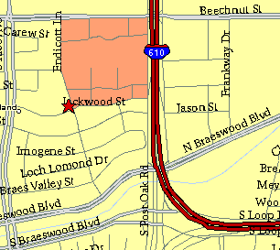

Meeting Information

Meeting Place:
St. Thomas Episcopal School
4900 Jackwood
Houston, Texas 77096

Date and Time:

Fourth Monday of the month
7:30 pm Heather & Thistle Society Statement
And Membership Information

The Heather and Thistle Society was founded in 1953 by Scots living in Houston who wished to “cultivate an interest in and fond recollections of Scotland, its history and traditions, its literature and ideals, its minstrelsy and song, its customs and amusements, and to provide opportunities for good fellowship and social contact through typically Scottish functions, so that the blessing of our Scottish culture may never die in our new homeland”.

The Heather and Thistle Society meets 10 times a year, September through June. Programs include music, singing, dancing, lively lectures, slide shows and movies about Scotland. The Heather and Thistle Society puts on the annual Robert Burn’s Supper and Ball in late January of each year. We are an organization that promotes our Scottish heritage, in various ways.

The Heather and Thistle Society’s monthly newsletter, “The Houston Scot” is published from September through June. Original articles, information about Scottish or related events are welcome and should be sent to the editor, Jim Monteith, at 15703 Mound Road, Hockley, Texas 77447 or 936-931-2588. Email to alabamascot@esagelink.com.

Membership in the Heather and Thistle Society is open to all with an interest in Scottish heritage and culture. Annual dues are $15 for an individual and $20 for a family membership. Applications for membership may be obtained from our website.
http://heatherandthistle.org/documents/membership.doc
Dues are due at the beginning of the fiscal year, March 1. Completed applications and membership fees should be mailed to: Dr. Walter May
6143 Sienna Arbor Lane
Houston, Texas 77041-6038

