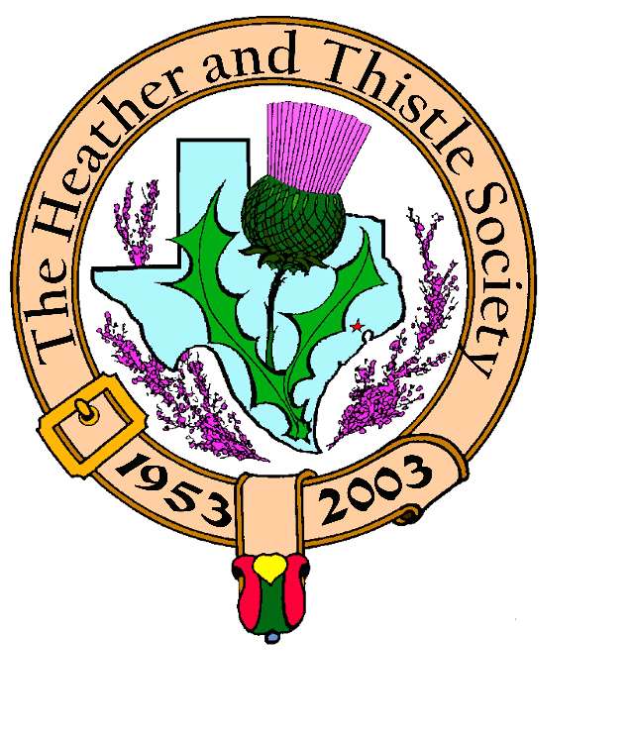

Heather & Thistle Society

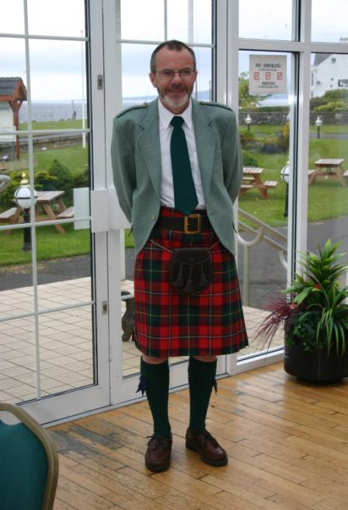 Chieftain Dr. Robert Boyd

Volume 9, Issue 1
September / October, 2008

Newsletter Editor:
Jim Monteith

Officers:

Chieftain – Dr. Robert Boyd
SubChieftain – Rev. Melvyn Douglass
Sgt.-at-Arms – Ardeth Brodie
Secretary – Carmelita Orr Treasurer – Dr. Walter May

Committee Chairs:

Sunshine-Eileen Moore
Membership-Eileen Moore
Past Chieftains-Cheryl May
Burns Supper-Jim Monteith
Publicity-Melvyn Douglass
Programs-Gordon Macleod

Get Well Melvyn!!!!!!!!!!
Past Chieftain Melvyn Douglas fell ill during our summer break and underwent major surgery. He is recuperating at home. Melvyn is widely known and loved by all.

The Houston Scot

Chieftain’s Letter,
Hurricane Ike
What began as a relatively innocuous Category 2 storm has had a devastating effect on our area, and I’m sure our upcoming meetings will be dominated by Ike stories. I hope that members and their families are well on the road to recovery and that no long-term harm came to you and yours. We were of course forced to cancel the September Meeting scheduled for the 22nd, which was a shame, and our gracious hosts St. Thomas Episcopal School did not regain power until the 24th, almost two weeks after the storm. Now we are all ready to move forward with our new session.
A Long Hot Summer
I am looking forward to welcoming members after the unexpectedly long summer break. We took our vacation in early July this year, which made the summer in Houston even before Ike seem very long and especially hot. The summer was saddened by the loss of loved ones within the Society. Past Chieftain Dr. Arthur Down and his wife Joan lost their younger son Alex at the tragically premature age of 37 as the result of a short, unexpected illness. A number of H&T and Burns Club members were among over 350 attendees at a Memorial Service held at Christ Church Cathedral downtown when Alex Down was remembered as an energetic young man who loved animals, music, computers and helping those less fortunate. Our sympathies are with his widow Kathleen and the Down family. Just two days later along with ten Past Chieftains I attended the funeral of Past Chieftain Don Whitefield. Don is remembered below in this newsletter. He and his wife Billie were always enthusiastic supporters of the Society and again our sincere sympathies are with Billie and family. August did end on a happier note when a large number of members were among over 200 who attended the wedding of Past Chieftain Jack Hume and Guida Jackson. It was great to see the newlyweds and their extended family so happy and we wish them well.
Tale of romance, tragedy, displacement and survival amazes Society at June Meeting
Local personality Helen Mann enthralled over thirty members and guests at our last meeting on June 23 with a talk on her unique family background. A young Seaforth Highlanders lance-corporal from the poor Gorbals district of Glasgow serving during World War II was sent to Shanghai where he met a young White Russian émigré. They married and Helen, their only child, was born back in the UK just after the war ended. The story really began when Helen’s maternal grandmother arrived in England from Manchuria when Helen was four years old. Her grandmother was then 69 years old and spoke Russian, Chinese, Japanese, French and German, but no English. She effectively raised Helen while the family moved around the world on military service. Helen learned Russian of necessity at this early age, and her childhood memories of strange tales from strange lands eventually came back to interest Helen. Her grandmother remained with the family for the rest of her life and is buried on the Clyde Coast of Scotland. When Helen retired after 34 years at the British Consulate in Houston and an M.B.E., she decided to devote two years to tracking down her grandmother’s family. The Society was honored to hear this first presentation of her research, and what a tale it was. Starting from a privileged life in early-twentieth-century Russia, the family went through the disruption of WWI, flight to the Manchuria region of China to escape from the Bolshevik revolutionaries, the Chinese Revolution, the invasion by Japan and the turmoil of WWII. Helen illustrated her talk with artifacts and photographs that were the prized possessions of her relatives all through this period. Everyone present was totally absorbed by the presentation and there were lots of questions. Thanks so much Helen. Good luck with the ongoing project and hopefully with your book based on it.
Next Meeting – Monday October 27 at 7:30 PM We welcome return of Austin-based Scottish folk singer Ed Miler, thanks once again to the generous sponsorship of Mark Monroe. This is always one of the highlights of the year for the society and I encourage everyone to attend and bring along as many friends as possible.
Tartan of the Month We were delighted to honor Helen Mann and her family by making Mackenzie, the tartan of the Seaforth Highlanders, Tartan of the Month for July and August. For September the Tartan of the Month is Hume in honor of the new Mr. and Mrs. Jack Hume. Check it out at www.heatherandthistle.org.
Program Items for 2009 Please send your ideas to our Program Chair Dr. Gordon Macleod at gordymacus@yahoo.com.
Robert Boyd, Chieftain
In Memoriam
Past Chieftain Donald Whitefield, 86, died July 25, 2008. Don was H&T Chieftain during 1983-1984. At the September 2007 H&T meeting Don spoke of his WWII experiences as a B-24 bomber navigator who survived 30 missions over Germany. Don was born Dec. 11, 1921 in Bellaire, Ohio. After the war he worked with his father in Ohio in the oil business. A self taught chemist, he founded Whitefield Plastics in Houston. Don was the Republican nominee for District 8 U.S. Rep. in 1974. He is survived by his wife Billie, son Bill, and daughter Patrice Schwertner.

Book Release
Past Chieftain Dr. Walter May, a research scientist working in the energy field, proudly announces the publication of his book, U.S. Energy Independence – A Plan for Energy Independence by 2020. This 168 page book is intended to stimulate the reader to better understand the seriousness of our energy crisis and present possible solutions. Copies may be ordered from the publisher’s web site: www.SFAInternational.com or major book retailers. An eBook will also be available.

St. Andrews Day Ceilidh
The Houston Highland Games Association presents on Tuesday, November 11, 2008 this gathering with traditional music at St. Arnold’s Brewery, 2522 Fairway Park Dr., Houston. Tickets are $12 for HHGA members and $15 for non-members and includes food and beer. Tickets may be purchased at the door or online at www.houstonhighlandgames.com.

Ed Miller Performance
Scottish Folk Singer Ed Miller will perform at the October 27, 2008 meeting of the Heather and Thistle Society. Ed’s performance will include Robert Burns’s songs in honor of his 250th birthday celebration. Once again we may thank member Mark Monroe for hosting Mr. Miller.
Heather & Thistle Society - Minutes June 23, 2008
Chieftain Dr. Robert Boyd called the business meeting to order at 7:30pm in the St. Thomas Episcopal School Theater. A motion was made to accept the May, 2008 minutes as published in the newsletter. Motion passed to accept the minutes.
Treasurer Report: Dr. Walter May gave a year end financial report for the Society. He reports the combined bank balance to be $23,031.97. Checking account balance is $4417.20. Burn’s Supper account balance is $17,201.63. PCC Fund balance is $1413.14. Motion made and passed to accept the report.
Membership Report: Eileen Moore reports 108family, 46 single, 33 life, 40 exempt, and 4 complimentary memberships for a total of 231 members. The motion to accept the membership report was made and passed.
Committee Reports called for by Sub-Chieftain Rev. Melvyn Douglass
Burn’s Club: Chieftain Boyd reports had meeting at Burns bust in July. Burns conference in Scotland this year.
Burns Supper: Jim Monteith reports that unfortunately the ticket prices will have to be increased for the 2009 Supper.
Programs: Chieftain Boyd reports program in Sept. will be about flags, some progress on history of society. Need ideas for Oct. and Nov. programs.
Sunshine: Eileen Moore reports talking to Teresa Haines. Sent a sympathy card to John Kennedy family in Odessa.
Newsletter: Editor Jim Monteith reports emailing about 70 and surface mailing 80 copies of the Houston Scot Newsletter.
Houston Grampian: Robert Gilbert announced he has resigned from the Houston Grampian Association. He has heard that the Abeerdeen group trip has been canceled due to lack of people.
Houston Highland Games: Melvin Douglass reports everyone was pleased with the event. HHGA had officer nominations and their election is July 9.
RSCDS: Social on Tuesdays at Dad’s Club YMCA on Voss 7:30pm-9:30pm.
Houston Highlanders: No report.
Sergeant-At-Arms: Ardeth Brodie reports 27 members and 3 guests present. Guests were Helen Mann, Guida Jackson and Alistair MacNab.
Old Business: Chieftain Boyd discussed putting together a history of the Society and a possible program. Arthur Down has offered to become our historian.
New Business: None
The business meeting was adjourned for refreshments.

Tonight’s program was Helen Mann, the voice of the British Consulate for 30 years (Vice Consul Press Affairs), who recently retired. She gave a presentation on her Russian and Scottish heritage that she has been researching.

Meeting adjourned at 9:09pm.

2009 Burns Supper tickets on sale
- Member tickets on sale October 1st – price will be $65
- Non-Member tickets on sale November 1st – price will be $80
Cut out or copy the Ticket Order Form on page 3 of this newsletter and send in to Joan McClure

The Heather and Thistle Society
56th Annual Robert Burns Supper
Saturday, January 24, 2009
Houston Marriott Westchase , 2900 Briarpark Drive, Houston, TX 77042
Ticket Order Form
Name of Ticket Holder * | No. Tickets | Total # Member Tickets @ $65 | Total # Non-Member Tickets @ $80 | Total Dollar Amount
Mail to:
Name:
Address:
City |  | State |  | Zip
Phone # |  | E-mail
* Member tickets may be purchased by/for only those with current dues as of September 30, 2008. Tickets ordered in November must be paid for in full by December 1st. Please list names for whom member tickets are requested. Use a separate sheet for each table of ten.
Enclose a self-addressed, stamped envelope with this form and your check made payable to the Heather and Thistle Society. Mail to:
 | Mrs. Robert A. McClure (Joan)
 | 553 Brown Saddle Road
 | Houston, TX 77057-1413
 | Ph: 713-782-6707
Date received |  | Ticket Nos. | Table Nos. | Tickets Mailed
__________________ |  | _________________ | _________________ | _______________

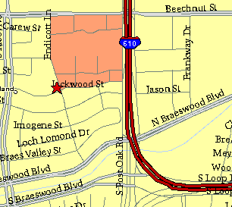

Meeting Information

Meeting Place:
St. Thomas Episcopal School
4900 Jackwood
Houston, Texas 77096

Date and Time:

Fourth Monday of the month
7:30 pm Heather & Thistle Society Statement
And Membership Information

The Heather and Thistle Society was founded in 1953 by Scots living in Houston who wished to “cultivate an interest in and fond recollections of Scotland, its history and traditions, its literature and ideals, its minstrelsy and song, its customs and amusements, and to provide opportunities for good fellowship and social contact through typically Scottish functions, so that the blessing of our Scottish culture may never die in our new homeland”.

The Heather and Thistle Society meets 10 times a year, September through June. Programs include music, singing, dancing, lively lectures, slide shows and movies about Scotland. The Heather and Thistle Society puts on the annual Robert Burn’s Supper and Ball in late January of each year. We are an organization that promotes our Scottish heritage, in various ways.

The Heather and Thistle Society’s monthly newsletter, “The Houston Scot” is published from September through June. Original articles, information about Scottish or related events are welcome and should be sent to the editor, Jim Monteith, at 15703 Mound Road, Hockley, Texas 77447 or 936-931-2588.

Membership in the Heather and Thistle Society is open to all with an interest in Scottish heritage and culture. Annual dues are $15 for an individual and $20 for a family membership. Applications for membership may be obtained from our website.
http://heatherandthistle.org/documents/membership.doc
Dues are due at the beginning of the fiscal year, March 1. Completed applications and membership fees should be mailed to: Dr. Walter May
6143 Sienna Arbor Lane
Houston, Texas 77041-6038



