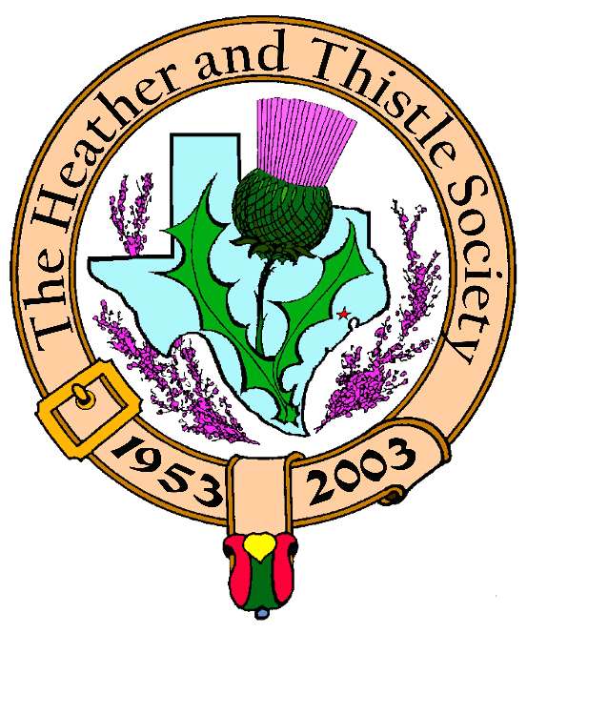

Heather & Thistle Society

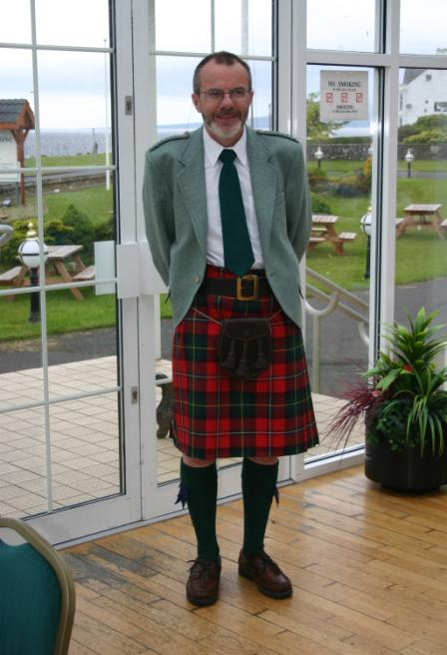 Chieftain Dr. Robert Boyd

Volume 8, Issue 10
June, 2008

Newsletter Editor:
Jim Monteith

Officers:

Chieftain – Dr. Robert Boyd
SubChieftain – Rev. Melvyn Douglass
Sgt.-at-Arms – Ardeth Brodie
Secretary – Carmelita Orr Treasurer – Dr. Walter May

Committee Chairs:

Sunshine-Eileen Moore
Membership-Eileen Moore
Past Chieftains-Cheryl May
Burns Supper-Jim Monteith
Publicity-Melvyn Douglass
Programs-Gordon Macleod

June meeting will be held on the regular schedule, i.e, the fourth Monday which is June 23, 2008.

The Houston Scot

Chieftain’s Letter,
Highland Games
The Games went extremely well this year with excellent cool weather. Congratulations to Mel and Jeanette Douglass on a great event. I would like to thank Society members Ardeth Brodie, Mark Monroe, Cheryl & Walter May and Sharon & Jim Monteith for their hard work setting up, manning and taking down the H&T booth. The effort was well worthwhile. We were in a prime location with a lot of traffic and interest as well as quite a few new members and more potential sign-ups.
Silver-tongued Scot Schmoozes Society at May Meeting
Captain Alistair Macnab’s presentation Scotland's Merchant Venturers at the June 2 meeting was extremely well-received by over thirty members and guests including a number of present and former seafarers and shipping executives. Alistair was on top form, impressing the audience with his knowledge of his topic and the way he linked it to the success of the Port of Houston with some pointers for the future. One nice aspect of the meeting was the number of questions from the audience who were clearly fascinated by the topic. Capt. Macnab fielded them all deftly. Most interestingly Rosemary McBride, native Houstonian born in 1920 came forward with a moving eye-witness account of the early days of the Port in the period before WWII when business was slow in coming.
Next Meeting – Monday June 23 at 7:30 PM
Local personality Helen Mann recently retired after over thirty years at the British Consulate here in Houston, most recently as Vice-Consul for Press Affairs. Among numerous other projects she has been researching her own unique Scottish-Russian heritage, in the course of which she has made a number of research visits to the U.K. and Russia. We are delighted that Helen has agreed to talk to us at the June meeting about her findings, no doubt illustrated with the huge range of humorous anecdotes for which she is noted! I encourage everyone to attend what promises to be a fascinating presentation.
Tartan of the Month - Macnab
We are delighted to honor Alistair Macnab for his great presentation at the last meeting by having Macnab as the June Tartan of the Month. Check it out at www.heatherandthistle.org.
History of the Society
The main discussion at the business meeting last time was the location of memorabilia related to the Society and how these should best be collected, maintained and exhibited. The idea of storing this material electronically and perhaps making it available on the website seemed to get a positive response. In particular we are keen to locate as many photo albums from past Heather & Thistle Society Burns Suppers as possible. Any thoughts and materials are welcome. This is a topic for discussion at future meetings.
Program Items for September onwards
Please send ideas to our new Program Chair Dr. Gordon Macleod at gordymacus@yahoo.com.
Robert Boyd
Chieftain
H&T Summer Break

Summer is here and our Society will be taking our annual summer break. There will be no meetings or newsletters for the months of July and August. I urge all members to renew their memberships so you will receive the member prices on the 2009 Burns Supper tickets. I have included a membership/renewal form on page 3 of this newsletter. Members receiving the newsletter by surface mail have their membership expiration date on the label. Please contact me if you have a change of address or email address. My cell phone # is 281-924-3073.

Alasdair Campbell Professional Piping
Sponsored by: Heather and Thistle Society
From the Houston Highland Games Association we have the results of our sponsored Professional Piping Competition,
a sanctioned event, monitored by three judges:
- Jimmy Bell
- Ed Neigh
- Adrian Melvin
Winners by category:
Piobaireachd [submitted 4 selections] - Lyric Todkill
M/S/R [submitted 4 selections] - Doug McRae
6/8 March [submitted 3 selections] - Doug McRae
Hornpipe/Jig [submitted 3 selections] - Doug McRae
Overall winner, or "Piper of the Day" - Doug McRae
Heather & Thistle Society - Minutes June 2, 2008
Chieftain Dr. Robert Boyd called the business meeting to order at 7:37pm in the St. Thomas Episcopal School Theater. The motion was made to accept the April, 2008 minutes as published in the newsletter. Ardeth Brodie reported that one error was made in the April minutes. She was not present at the April meeting and did not give the Sgt-at-arms report. Motion passed to accept the minutes with correction noted.
Treasurer Report: Chieftain Boyd gave the Treasurer’s report tonight. He reports the combined bank balance to be $22,407.97. Checking account balance in the beginning of May 2008 was $3279.90. H&T has received $735.00 in income and spent $62.70 for a May 2008 ending balance of $3952.20. Burn’s Supper account balance is $17,042.63. PCC Fund balance is $1413.14. Motion made and passed to accept the report.
Membership Report: Eileen Moore reports 107 family, 43 single, 33 life, 40 exempt, and 4 complimentary memberships for a total of 227 members. The motion to accept the membership report was made and passed.
Committee Reports called for by Sub-Chieftain Rev. Melvyn Douglass
Burn’s Club: Chieftain Boyd reports had meeting last month and the next meeting is June 12.
Burns Supper: Jim Monteith reports there have been two planning committee meetings so far this year. Committee assignments have been given out. Contract with the Hotel has been signed. Time line of supper will be changed. Next meeting will be in September. Supper planned for Jan. 24, 2009.
Past Chieftains: Jim Monteith reports a few short meetings have been held. Discussions concerning improving the H&T by-laws are on-going. Improvements are needed to better define financial and tax duties and responsibilities. Hopes for changes to be voted on in September.
Programs: Gordon Macleod reports Helen Mann will be presenting a talk on her Scottish-Russian heritage.
Sunshine: No report.
Newsletter: Editor Jim Monteith reports emailing about 70 and surface mailing 80 copies of the Houston Scot Newsletter. He and Dr. Walter May are upgrading and computerizing the membership roster.
Houston Grampian: Robert Gilbert announced he has resigned from the Houston Grampian Association.
Houston Highland Games: Melvin Douglass reports they sold out of beer the first day of the event. Thanks to vendors and those who helped set up.
RSCDS: Tuesdays at Dad’s Club on Voss Road and IH-10.
Houston Highlanders: No report.
Sergeant-At-Arms: Ardeth Brodie reports 29 members and 4 guests present. Guests were Savannah Orr, Nancy Saldivar, Fergus Campbell, and Alistair Macnab. New members were Anne Fielding and Sheila Helme.
Old Business: None.
New Business: New membership directory will be put out in the fall. Discussion was held concerning getting a historian for the Society. A request was made for anyone that may have memorabilia of past Society events. Discussion held about creating a written historical record of the Society. Discussion also held about copying old photos of Society events and putting them on our website. Insurance for tartan banners was brought up again.

The business meeting was adjourned at 8:07pm for refreshments.

Tonight’s program was Captain Alistair Macnab presenting a talk on Scottish Marine Commerce and the Port of Houston.

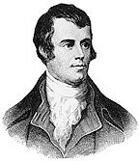 Heather and Thistle Society Presents

Our 56th Annual Robert Burn’s Supper

on January 24, 2009 at

The Marriott Westchase in Houston

Tickets go on sale to members with current membership on October 1, 2008

Tickets will be sold to non-members beginning November 1, 2008

Heather and Thistle Society Membership Application and Renewal

Date _________________

Last Name ____________________ First Name ____________________ Middle Name ________________

Spouse First Name ___________________________ Home Phone (_____) - _______ - ________

Home Address ________________________________________ City _____________State ______Zip ________

Business Address ______________________________________ City _______________ State ______ Zip ______

Business/Profession ____________________ Email Address: (Needed for monthly newsletter email)______________________

List Children under 18 if application for family membership. Children 18 and older must have their own membership.
__________________________________________ ________________________________________
__________________________________________ ________________________________________

Interests and Hobbies: ___________________________________________________________________________

Clan Tartan ______________ Sponsor:__________________ Shall we list you in our directory? [ ] Yes [ ] No

Are you interested in serving the Society in some capacity [ ] Yes, please contact me. [ ] No, not at this time.

Membership type: [ ] Family - $20.00 per year(includes family members under 18) [ ] Single - $15.00 per year

[ ] New Member [ ] Renew Membership

Please bring completed application with membership fee to the next monthly meeting held at 7:30pm on the 4th Monday of the month, September through June, or just mail it to Dr. Walter May, 6143 Sienna Arbor Lane, Houston, Texas 77041-6038.

Heather and Thistle Society meets at the St. Thomas Episcopal School at 4900 Jackwood, Houston, Tx. 77096

Applicant’s Signature _________________________________ Check No._____ Amount Paid $______ Date Paid_________

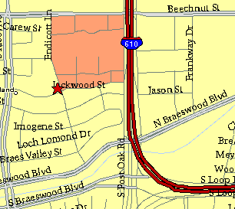

Meeting Information

Meeting Place:
St. Thomas Episcopal School
4900 Jackwood
Houston, Texas 77096

Date and Time:

Fourth Monday of the month
7:30 pm Heather & Thistle Society Statement
And Membership Information

The Heather and Thistle Society was founded in 1953 by Scots living in Houston who wished to “cultivate an interest in and fond recollections of Scotland, its history and traditions, its literature and ideals, its minstrelsy and song, its customs and amusements, and to provide opportunities for good fellowship and social contact through typically Scottish functions, so that the blessing of our Scottish culture may never die in our new homeland”.

The Heather and Thistle Society meets 10 times a year, September through June. Programs include music, singing, dancing, lively lectures, slide shows and movies about Scotland. The Heather and Thistle Society puts on the annual Robert Burn’s Supper and Ball in late January of each year. We are an organization that promotes our Scottish heritage, in various ways.

The Heather and Thistle Society’s monthly newsletter, “The Houston Scot” is published from September through June. Original articles, information about Scottish or related events are welcome and should be sent to the editor, Jim Monteith, at 15703 Mound Road, Hockley, Texas 77447 or 936-931-2588.

Membership in the Heather and Thistle Society is open to all with an interest in Scottish heritage and culture. Annual dues are $15 for an individual and $20 for a family membership. Applications for membership may be obtained from our website.
http://heatherandthistle.org/documents/membership.doc
Dues are due at the beginning of the fiscal year, March 1. Completed applications and membership fees should be mailed to: Dr. Walter May
6143 Sienna Arbor Lane
Houston, Texas 77041-6038



