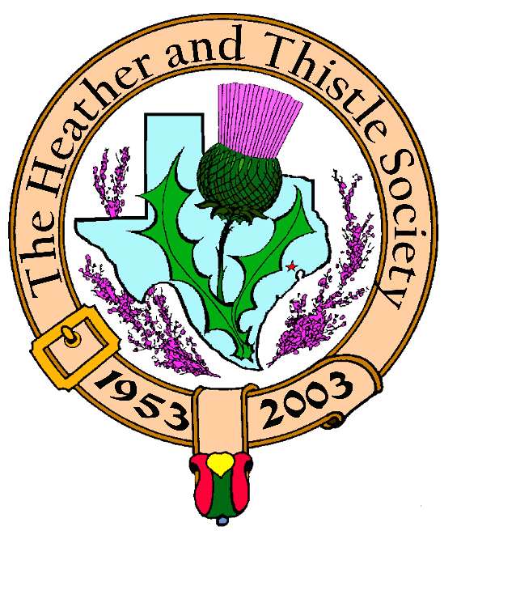

Heather & Thistle Society

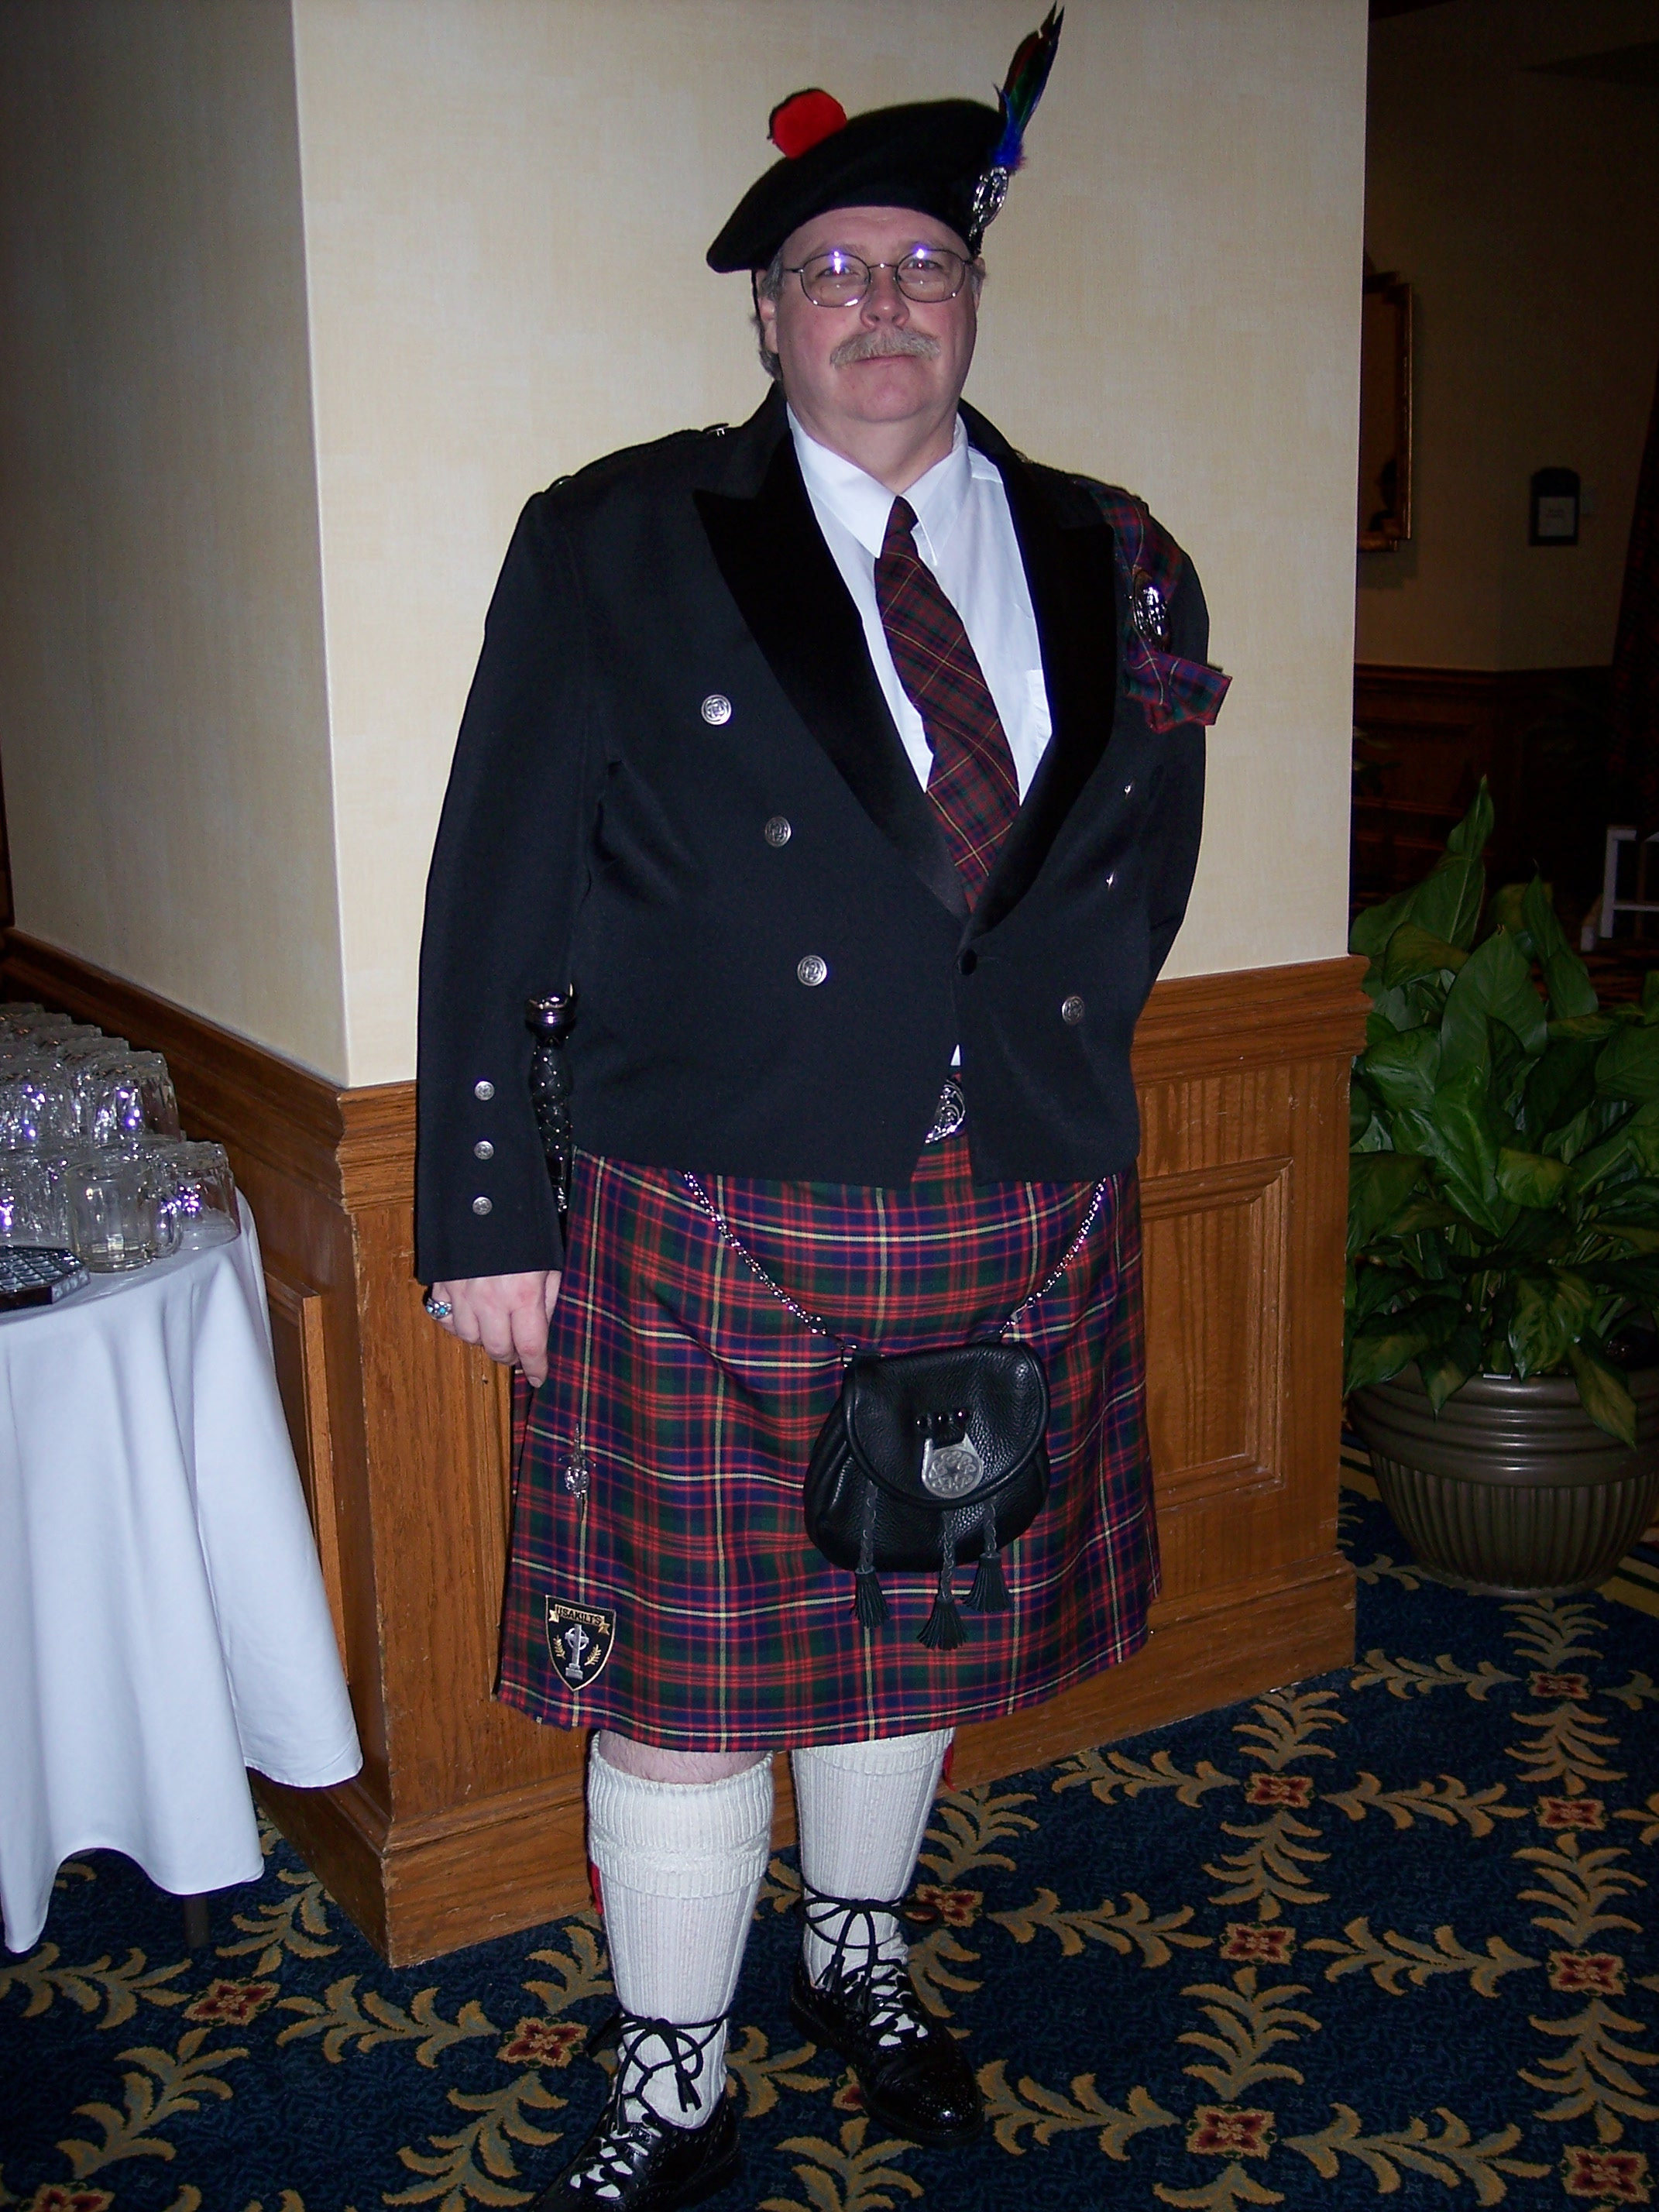
Chieftain Ken Sorrels

Volume 8, Issue 7
March, 2008

Newsletter Editor:
Jim Monteith

Officers:

Chieftain – Ken Sorrels
Sub-Chieftain – Robert Boyd
Sgt.-at-Arms – vacant
Secretary – Ardeth Brodie Treasurer - Robert Moore

Committee Chairs:

Sunshine-Eileen Moore
Membership-Eileen Moore
Past Chieftains- Walter May
Burns Supper-Cheryl May
Publicity-Melvyn Douglass
Programs-Mark Monroe

Annual Renewal:

March is the time for Heather and Thistle members to renew their memberships. Let’s all remember to contact our membership chair person and renew.

The Houston Scot

Chieftain’s Letter,

It is time to say farewell!

This will be my last Chieftain’s Letter. It has been a wonderful year and I have enjoyed it so much. It has been my honor to have been able to serve as Chieftain this last year. It is my hope that I have been able to do justice to the position. Although it seems relatively insignificant in some people’s eyes, I am proud to say that I wore a kilt to every meeting this past year. I know that everyone does not feel this way, but I think that it adds just a little bit something extra to the meeting if at least one person wears his kilt. So Robert, I extend this challenge to you, wear your kilt every meeting.

No one person is an island. If this year has been a successful one, it is due to the efforts of all those that helped me, more than my efforts alone. I must thank my officers, ya’ll make me proud. I must thank my program chairman, what a year of wonderful programs. My newsletter editor did a great job as usual. Past Chieftain’s Committee and Burns Supper Planning Committee, what an outstanding job ya’ll did. All of you that had any part in making this year successful thank you from the bottom of my heart. A special thanks to my wife for putting up with me this past year.

I want to thank the dancers and pipe band of St. Thomas Episcopal School for a wonderful performance at our February meeting. We are so blessed to have you in our lives, and to be a small part of yours.

The March meeting will be on Monday night, March 24, 2008 at St. Thomas Episcopal School at 7:30 pm. The program that night will be the installation of the 2008-2009 officers. I ask that as many of you as possible attend this meeting so that we can make Robert Boyd’s installation as Chieftain a truly memorable one. Jack Hume will conduct the installation.

That’s all for now!
See you at the March Meeting.
Your Chieftain,
Ken Sorrels

Heather & Thistle Society Elects 2008-2009 Officers

H&T members attending the February 2008 General Membership meeting elected our new slate of officers for 2008-2009. Welcome and good luck to our new officers.

Chieftain – Robert Boyd
Sub-Chieftain - Melvyn Douglass
Sgt-At-Arms – Ardeth Brodie
Secretary – Carmelita Orr
Treasurer – Walter May

Our annual installation of new officer’s ceremony will be held at the March 24, 2008 meeting. Members of the Houston Highlanders Pipe & Drum Band will lead the procession of new officers. Member Jack Hume will be conducting the swearing in of the new officers.

Irish American Heritage Assoc.
March 25, 2008 at the Harris County MUD building off the intersection of Cimmaron Pkwy and Hidden Canyon Road, Katy, Texas from 7:30pm to 9:15pm. Contact Pat McMahon at 713-271-0784 for more information.

Houston Highland Game Assoc.
-HHGA will be meeting at Saint Thomas School in the auditorium on Thursday April 3, 2008. The general membership meeting is at 8pm.

Texas Scottish Events:

National Tartan Day – April 6, 2008 will be National Tartan Day in North America. Celebrations will be going on all over starting Friday April 1st and continuing thru April 6th. Scots gather to commemorate the Declaration of Arbroath, The Scottish Declaration of Independence on April 6th, 1320 at Arbroath, Angus, Scotland. For more info. www.tartanday.com

San Antonio Highland Games
Tenth annual to be held at Helotes fairgrounds at 12210 Leslie Road, Helotes, Texas on April 5th and 6th, 2008. This year’s games will feature ‘Thor’ the world’s largest living warhorse.

Scottish Festival – the annual St. Thomas Scottish Festival will be held at the Toyota Center in Houston on April 18, 2008.

Sam Houston Folk Festival – to be held in Huntsville on the campus of Sam Houston University on May 2 thru 4, 2008.

37th Annual Houston Highland Games – to be held at the Farm and Ranch Club at Bear Creek Park on State Highway 6 in West Harris County on May 17, 18, 2008.

Heather & Thistle Society – Minutes
Date Feb. 25, 2008

Chieftain Dr. Kenneth Sorrels called the business meeting to order at 8:04 pm in the St. Thomas Episcopal School Theater. The motion was made and passed to accept the Jan. 28, 2008 minutes as published in the newsletter.
Treasurer Report: Dr. Robert Moore reports the “other” Chieftain’s Fund bank balance to be $1412.58. The “second account” bank balance is $3227.00. The motion was made and passed to accept the treasurer’s report.
Membership Report: Eileen Moore reports 99 family, 43 single, 32 life, 40 exempt, 4 complimentary memberships for a total of 218 members. The motion to accept the membership report was made and passed.
Committee Reports called for by Sub-Chieftain Dr. Robert Boyd
Burns Club: Jack Hume reported Past President of the Burns World Federation was coming on the Cruise and to the meeting. Everything was ready to go.
Burns Supper: Cheryl May reported a wrap up meeting was held on Feb. 9th. Jim Monteith is now in charge of the 2009 Burns Supper. Photographs of the 2008 Burns Supper should be available to view at the March 24th meeting. Anyone wishing to order photographs should contact David Claros personally.

Past Chieftains: Dr. Walter May is handing over the lead as head of Past Chieftain’s Committee to Becci Himes.
Programs: Sub-Chieftain appealed to the membership for a volunteer to head Programs as Mark Monroe has completed his year of service. Bob Gilbert noted that Mark had done an outstanding job in that position and the membership offered up a vigorous and spontaneous applause to Mark who was absent.
Sunshine: Eileen Moore circulated a get-well card for Jack Hume which all in the audience signed.
Newsletter: Editor Jim Monteith reported sending Newsletters via email and surface mail.
Houston Grampian: Bob Gilbert reported he is stepping down as President of the Houston Grampian Society. A new president would be elected at the next Thursday. The trip to Aberdeen the first week in September is continuing on as planned.
Houston Highland Games: President Mel Douglass reports the games this year will be held the third weekend in May.
RSCDS: Classes are being held as usual throughout the Houston area.
Houston Highlanders: No report
Sergeant-At-Arms Report 25 members and 5 guests present. Guests were Jim & Rosemary Haggarty, Wilson (Past President of the Burns Federation) & Irene Ogilvie of Dumfries, Scotland and photographer Nancy “Mc”Saldivar.
Old Business: None
New Business:
- Membership voted to purchase a $200.00 ad in the 2008 HHGA Program.
- Membership voted in the following new slate of officers for 2008 - 2009:
Chieftain Dr. Robert Boyd
Sub – Chieftain Reverend Melvyn Douglass
Sergeant – At – Arms Ardeth K. Brodie
Secretary Carmelita Orr
Treasurer Dr. Walter May
- Jack Hume thanked the membership for all the cards and letters sent during his illness

Mark Monroe sponsored this month’s program, The St. Thomas Episcopal Pipe & Drum Band and Scottish Highland Dancers. Next month’s meeting will be on March 24th, 2008. Meeting adjourned at 8:24 PM.

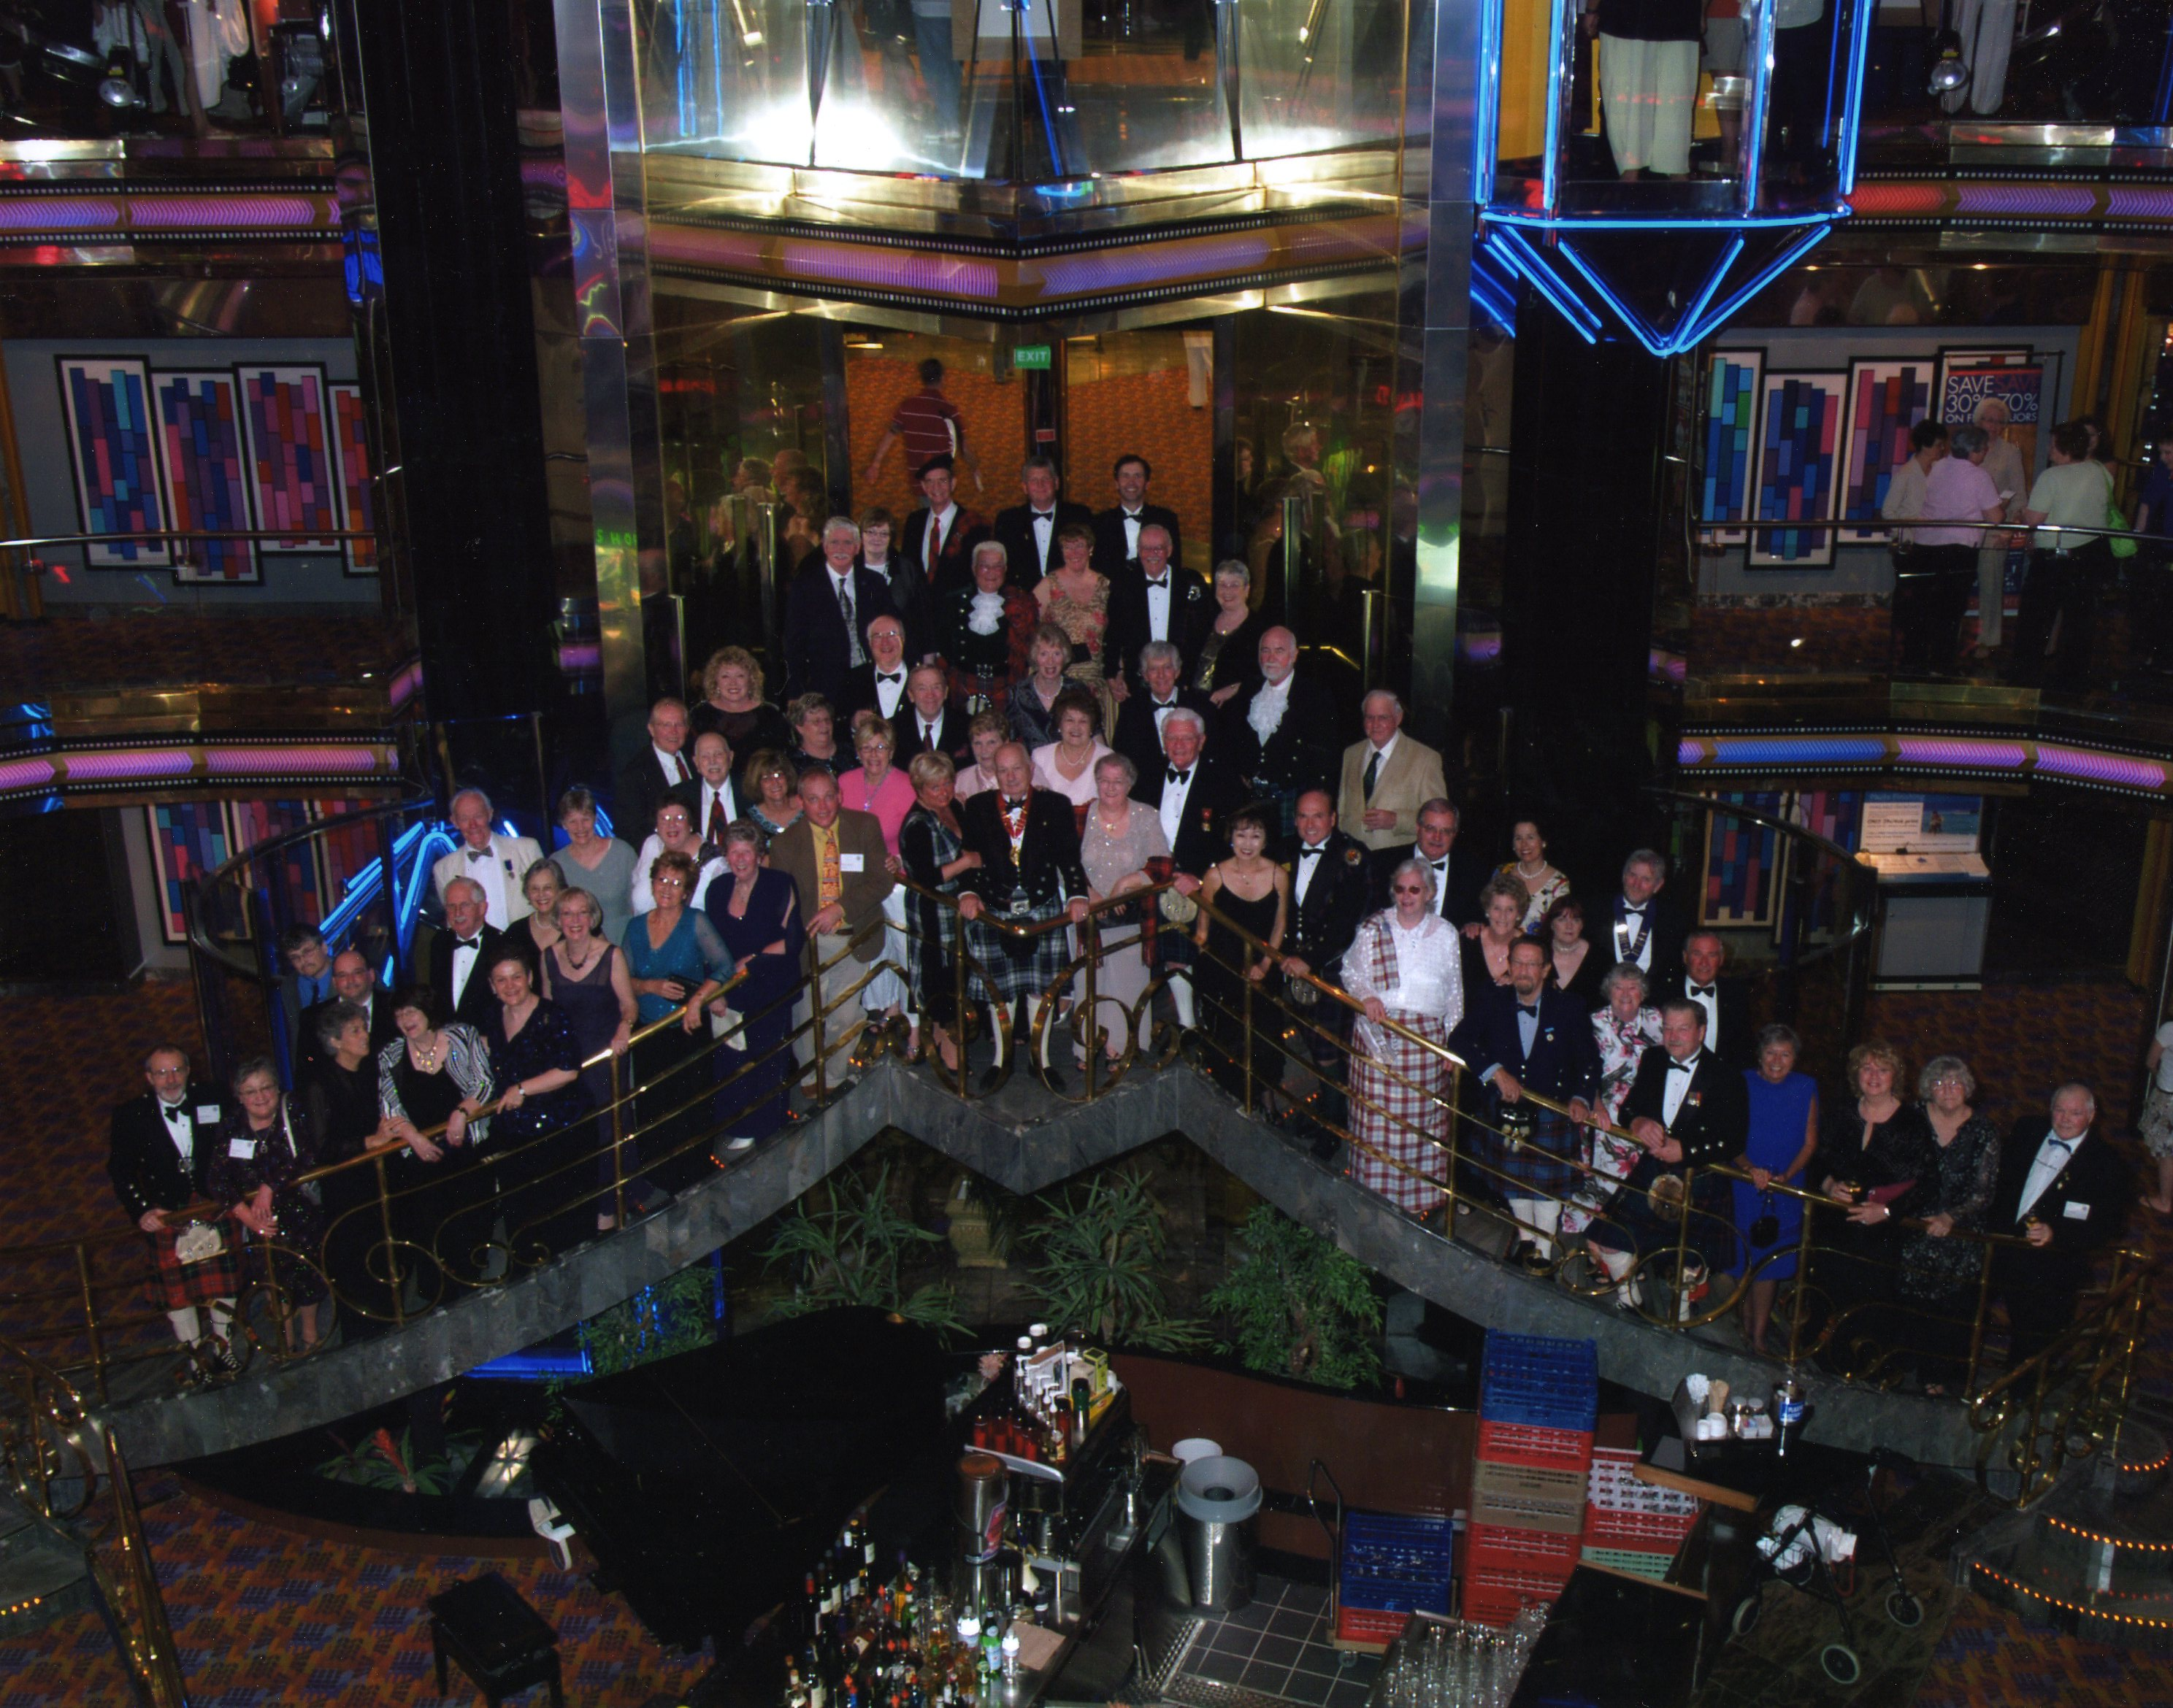Formal Dinner on Board the Cruise Ship ‘Carnival Ecstasy’

Smuggling

The national vice of the Scots, smuggling was an ancient trade long before the Union of 1707 or the English Navigation Acts. The Scots considered it a patriotic ideal to cheat the English and had a traditional dislike of customs and excise officials. Smuggling by concealment was by far the more prevalent. The favoured goods of the smuggler were spirits, wine and tobacco which were all subject to high duty. Other goods included Dutch or English textiles, sugar and salt. Cattle and corn was commonly smuggled into Scotland from Ireland. A great trade developed from Ireland and the Highlands in the products of illicit distilling. (Collins Dictionary of Scottish History)  Robert Burns Cruise Highly Successful
The Society hosted the Annual Conference and AGM of the Robert Burns Association of North America (RBANA) on the cruise ship Carnival Ecstasy March 3-8. A group of 70 attended, about half of whom traveled to Texas from the U.K. and Canada. Chieftain-Elect Robert Boyd welcomed everyone at an opening party. The first day at sea saw adverse weather with 12-15’ waves, but the business part of the conference was held without a hitch. After a day ashore at Progreso, Yucatan, Mexico, RBANA delegates met for a cocktail party addressed by the ship’s Captain and toasts followed by a formal dinner. As the group picture shows, this was an impressive sight and caused quite a frisson on the ship. Next day was ashore in Cozumel, and on the last day we steamed back towards Galveston, again in rough seas. That day was the highlight for many. We heard two distinguished speakers: Les Strachan from Virginia led a seminar on the question of Burns’s contemplated immigration to Jamaica, and Bill Dawson from Alloa Scotland, incoming President of the Robert Burns World Federation, spoke on the topic of the women in Burns’s life and their influence on his work. Both were first-class sessions. In addition the Heather & Thistle Society gave a presentation on the making of a Burns video performance. Finally Jim Cunningham from Ontario led the annual Dr. Jim Connor Memorial Robert Burns Quiz, won for the third year in succession by Les Strachan after a run-off with incoming RBANA President Frank Campbell of Florida and H&T Past Chieftain Ted Hirtz, a US Director of RBANA. A participation ceilidh and trophy presentation rounded off the official event, but hearty renditions of Flower of Scotland and Auld Lang Syne could be heard in the dining room after dinner that night!

THE TARTAN
Here’s to it!
The fighting sheen of it,
The yellow, the green of it,
The white, the blue of it,
The swing, the hue of it,
The dark, the red of it,
Every thread of it!
The fair have sighed for it,
The brave have died for it,
Foemen sought for it,
Heroes fought for it,
Honour the name of it,
Drink to the fame of it
THE TARTAN!

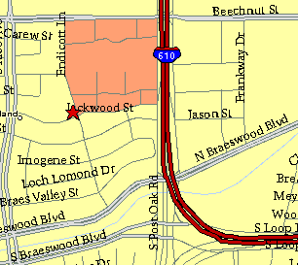

Meeting Information

Meeting Place:
St. Thomas Episcopal School
4900 Jackwood
Houston, Texas 77096

Date and Time:

Fourth Monday of the month
7:30 pm

Heather & Thistle Society Statement
And Membership Information

The Heather and Thistle Society was founded in 1953 by Scots living in Houston who wished to “cultivate an interest in and fond recollections of Scotland, its history and traditions, its literature and ideals, its minstrelsy and song, its customs and amusements, and to provide opportunities for good fellowship and social contact through typically Scottish functions, so that the blessing of our Scottish culture may never die in our new homeland”.

The Heather and Thistle Society meets 10 times a year, September through June. Programs include music, singing, dancing, lively lectures, slide shows and movies about Scotland. The Heather and Thistle Society puts on the annual Robert Burn’s Supper and Ball in late January of each year. We are an organization that promotes our Scottish heritage, in various ways.

The Heather and Thistle Society’s monthly newsletter, “The Houston Scot” is published from September through June. Original articles, information about Scottish or related events are welcome and should be sent to the editor, Jim Monteith, at 15703 Mound Road, Hockley, Texas 77447 or 936-931-2588.

Membership in the Heather and Thistle Society is open to all with an interest in Scottish heritage and culture. Annual dues are $15 for an individual and $20 for a family membership. Applications for membership may be obtained from our website
http://heatherandthistle.org/documents/membership.doc
Dues are due at the beginning of the fiscal year, March 1. Completed applications and membership fees should be mailed to: Mrs. Eileen Graham Moore
8910 Sandstone, Houston, Texas 77036-6132
For membership information please call Eileen at 713-774-0314.

