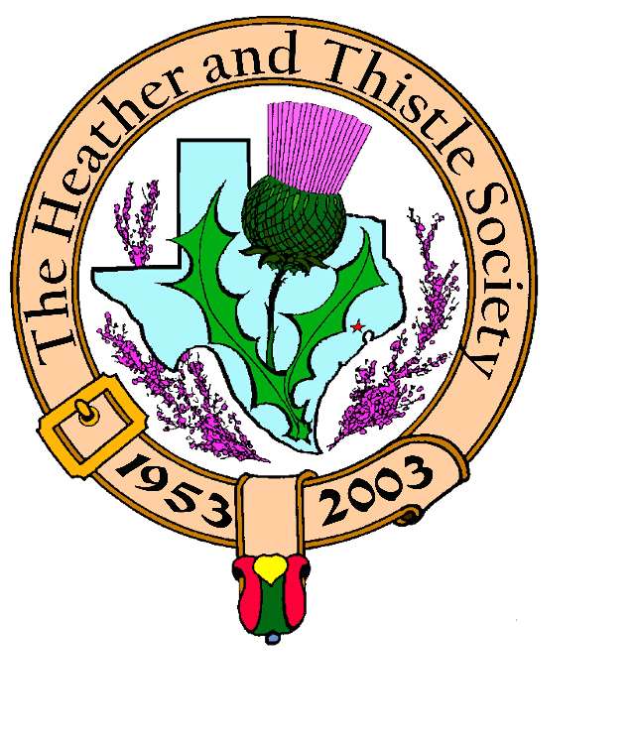

Heather & Thistle Society

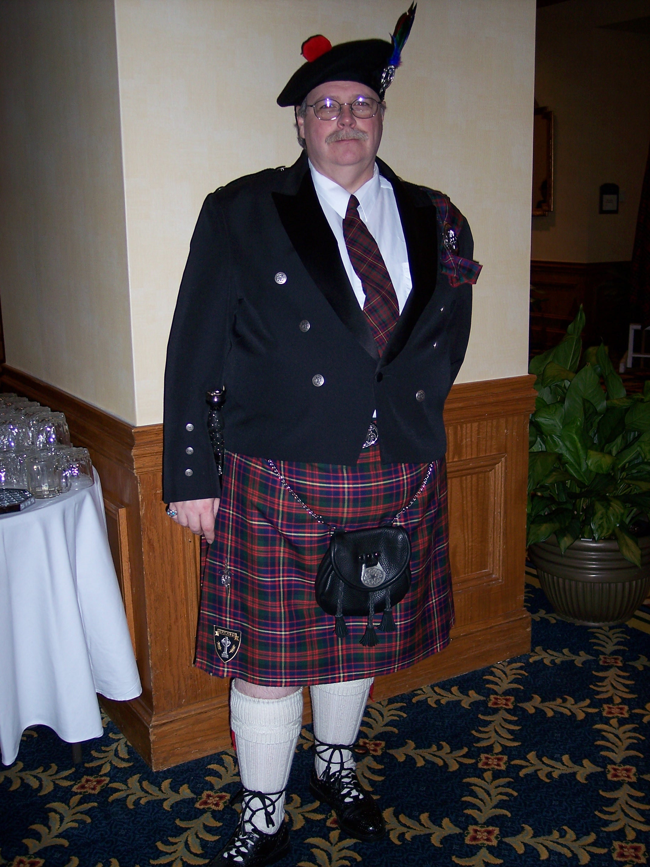
Chieftain Ken Sorrels

Volume 8, Issue 6
February, 2008

Newsletter Editor:
Jim Monteith

Officers:

Chieftain – Ken Sorrels
Sub-Chieftain – Robert Boyd
Sgt.-at-Arms – vacant
Secretary – Ardeth Brodie Treasurer - Robert Moore

Committee Chairs:

Sunshine-Eileen Moore
Membership-Eileen Moore
Past Chieftains- Walter May
Burns Supper-Cheryl May
Publicity-Melvyn Douglass
Programs-Mark Monroe

The Heather and Thistle Society would like to extend a warm welcome to our new British Consulate General HM Consul General Paul Lynch. He and his lovely wife Yoko Lynch graciously attended our recent Burn’s Supper.

The Houston Scot

Chieftain’s Letter,

The Burns’ Supper was a great success. I had a number of people come up to me during the ball and tell me that they thought this was the best Burns’ Supper that they had ever been to. I thought that it went especially well myself.
At this time I will reiterate what I said in my remarks at the Supper, the BSPC under the leadership of Cheryl May did an outstanding job of presenting the 2008 Burns’ Supper and Ball. It took a year’s worth of hard work and the whole Society owes them a debt of gratitude for their efforts.
I was particularly pleased that our special guests were able to join us that night: the British Consul-General Paul Lynch and his wife Yoko, the Canadian Consul and Trade Commissioner David McGregor and his wife Julie, and Harris County Judge Ed Emmett and his wife Gwen. Mr. Lynch was so gracious to us in his comments before he gave his toast to the President.
Charles Wharton did an excellent job as our vocalist. Many others did an excellent job also and need to be recognized. Martin Burnistan did a wonderful job as floor manager. Bob Gilbert’s excellent address to the Haggis, Robert Boyd’s Immortal Memory, Moon Weiss’s RSCDS dancers, Ardeth Brodie’s set up and take down crew, Becci Himes decorations, Joan McClure’s ticket sales, and all the rest that chipped in and helped so diligently.
With the exception of Lloyd and Jenny Lively, all of my personal guests had never been to a Burns’ Supper and they all expressed to me how impressed they were with the event. I also want to thank the Society for the opportunity that this event presented to me to be able to give “surprise” happy birthday wishes to my wife on her birthday which happened to coincide with our Burns’ Supper this year.

The February meeting will be on Monday night, February 25, 2008 at St. Thomas Episcopal School at 7:30 pm. The program that night will be a presentation by the St. Thomas Pipe Band and the Highland Dancers.

That’s all for now!
See you at the February Meeting.
Your Chieftain,
Ken Sorrels

Heather & Thistle Society Officer Elections
To Be Held at February 25, 2008 General Membership Meeting

Chieftain – Robert Boyd
Sub-Chieftain - Melvyn Douglass
Sgt-At-Arms – Ardeth Brodie
Secretary – Carmelita Orr
Treasurer – Walter May

Under Article IV of the H&T Bylaws the meeting held in February of each year shall be the Annual General Membership Meeting, at which time officers shall be elected and annual reports received. The presence of fifteen (15) members in good standing at any meeting shall constitute a quorum for the transaction of business.
The current officers and future officers of H&T urge members to attend this important meeting.



Heather & Thistle Program
February 25, 2008

The Saint Thomas Episcopal Pipe & Drum Band and the Competitive Scottish Highland Dancers perform in addition to a narrative/history of the bagpipe and traditional highland dances.

Houston Highland Game Assoc.
-HHGA will be meeting at St. Thomas School in the auditorium on Wed., March 5, 2008. The general membership meeting is at 7:15pm and the board meeting will be at 8:15pm.

British American Business Council- Southwest
- staffed by our own Becci Himes this organization facilitates, encourages and promotes bilateral trade, commerce, investment and business between the Southwest USA and the United Kingdom.

Upcoming Texas Events:

Scottish Festival – the annual St. Thomas Scottish Festival will be held at the Toyota Center in Houston on April 18, 2008.

Sam Houston Folk Festival – to be held in Huntsville on the campus of Sam Houston University on May 2 thru 4, 2008.

37th Annual Houston Highland Games – to be held at the Farm and Ranch Club at Bear Creek Park on State Highway 6 in West Harris County on May 17, 18, 2008.

Heather & Thistle Society – Minutes
January, 2008

Chieftain Dr. Kenneth Sorrels called the business meeting to order at 7:33 pm in the St. Thomas Episcopal School Theater. The motion was made to accept the Dec. 17, 2007 meeting minutes as published in the newsletter. The motion to accept the minutes was made and passed without discussion.
Treasurer Report: Dr. Robert Moore reports the Burns Account bank balance to be $1412.35, the checking account balance as $3124.25 and the Chieftain’s Fund at $24,000.00. The motion to accept the treasurer’s report was made and passed without discussion.
Membership Report: Eileen Moore reports 98 family, 38 single, 32 life, 40 exempt and, 4 complimentary memberships for a total of 212 memberships. The motion to accept the membership report was made and passed without discussion.
Committee Reports called for by Sub-Chieftain Dr. Robert Boyd
Burns Club: Is presenting this evening’s program and are looking forward to the March Cruise as they work on cruise Give-Away Bags. Jack Hume reports 80 people from across the globe have signed up for the cruise already though there is still room for interested participants.
Burns Supper: Burns Supper Chair Cheryl May reported feeling pleased with this year’s in spite of a few glitches. A deposit has been placed for the event at the same hotel for next year’s Supper at the end of the month of January. She thanked all who helped make the evening such a success. A follow up meeting will be held at the home of Alex and Maryann Munroe where Cheryl will hand over the honor of next year’s event to Past Chieftain Jim Monteith.

Past Chieftains: Nominations for next year’s officers were printed in last month’s Newsletter. Next year’s Past Chieftain’s Chair will be Becci Himes.
Programs: Mark Monroe reports in February, his last sponsored program as Chair, will be performances by the St. Thomas Episcopal School Pipe and Drum Band. This will include a narrative of the history of the bagpipe by Lyric Todkill, Master Pipe Instructor and Band Director. A narrative by their Dance Instructor, Donna Cusak, concerning the history of the dances performed, will accompany St.Thomas’s Scottish Highlander Competitive Dancers’ performance. Mark will donate a $1,000.00 honorarium to St. Thomas Episcopal School for these performances.
Sunshine: Eileen Moore thanked the membership on behalf of her family for all the concern expressed during Dr. Moore’s long hospitalizations and recuperation. She reminded the membership to please notify her when there is information concerning any past or present members need for her attention.
Newsletter: No report this month.
Houston Grampian: Bob Gilbert reports the Annual General Meeting will be held on Feb. 16th at Braeburn Country Club. Names are still being accepted for the Sept. trip to Aberdeen. The weeklong trip will begin on the 1st Saturday of Sept. and will include the Royal Highland Games at Bryn Mawr.
Houston Highland Games: Melvin Douglass reports this year’s games will be held the 3rd weekend in May. Anyone wishing to support the games are encouraged to join HHGA.
RSCDS: January is Social Dancing time at the Dad’s Club off Voss at Highway 10. Regular classes resume in February.
Houston Highlanders: No report
Sergeant-At-Arms: 21 members present and 3 guests were present at this month’s meeting. New member was Margo Spangler. Welcome Margo! Visitors were Mary H. Johnson, Savannah Orr and photographer Nancy Saldivar.
Old Business: None! New Business: None!
This meeting’s program was a video performance of selected work of Robert Burns including performances by and honoring Zoe Alexander and Wee Jimmy McVey.
Next month’s meeting date will be February 25th, 2008. The meeting adjourned at 7:45 PM.

Battle of Carham (1018)

Carham, southwest of Coldstream, was the site of one of numerous battles of the early medieval period fought between the Scots and the English. On this occasion Malcolm II, by beating a Northumbrian force, reversed the earlier defeat at Durham in 1006. The victory consolidated Scottish territory in Lothian and the Tweed came to delimit the eastern Scottish Border.
(From Collins Dictionary of Scottish History)

Sir Walter Scott (1771-1832)

Scott was born in Edinburgh, but came from Border stock and spent much of his childhood in the Borders. Scott maintained a life-long interest in literature and was a major literary figure who had a considerable historical impact. He was educated at the Royal High School and the University of Edinburgh. First published in 1802 he maintained a prodigious output for the rest of his life. Scott contributed to a revival of interest in Scottish history and culture and through his novels contributed to the maintenance of Scottish culture and nationalism during the rest of the nineteenth century. (From Collins Dictionary of Scottish History)

Succession Acts

This series of acts influenced the line of succession from the Bruce’s through to the Stewarts. The first in 1315 designated Edward Bruce, Robert I’s brother, as heir in preference to his daughter, Marjory. The second, in 1318, following the deaths of both Edward and Marjory, designated Robert Stewart, Marjory’s son, should the king himself not have issue. By the third in 1373, the succession to Robert II was restricted to his sons and their male heirs, excluding females. Later, when all legitimate male lines gave out Mary did succeed unchallenged following the death of her father, James V in 1542.
(From Collins Dictionary of Scottish History)

2008 Robert Burns Cruise and
Robert Burns Association of North America (RBANA)
AGM and Conference
March 3rd 2008 for Five Nights

From Galveston, Texas to Progreso and Cozumel, Mexico

Aboard the Carnival cruise ship “Ecstasy”

Current rates; Main Deck
Double occupancy; Outside cabin; $496.99 U.S. per person
Double occupancy; Inside cabin; $466.99 U.S. per person

All meals, gratuities, taxes and government fees included
Only alcoholic beverages and side-trips extra

RBANA Conference no fee payable

Includes Burns sessions and two dinners

Registration and/or questions; e-mail preferred, to Jack Hume

johnhume2@peoplepc.com
713-665-1431 home or 713-882-7763 cell
Travel: reservations and/or travel questions, e-mail preferred,
to Maureen Dixon
nasatravel@comcast.net

Office 281-333-3124 or cell 281-660-5721

Fifty cabins on main deck have been reserved for our group.
Accommodations at these prices will go fast.
PLEASE BOOK AS SOON AS POSSIBLE
Hosted by Heather and Thistle Society Burns Club of Houston,Texas
_________________________________________

Robert Burns Association of North America
2008 Conference
The Heather and Thistle Society
Robert Burns Club, Hosts.

Registration fee; ZERO

Please register the following;

Name _________________________________________________

Address

Phone email
____________________ _____________________

Mail or email to Jack Hume johnhume2@peoplepc.com
5307 Aspen Street
Bellaire, Texas 77401 4919
Home 713-665-1431 or cell 713-882-7763

Will book cruise thru NASA Travel ___________
Will make own cruise arrangements ____________

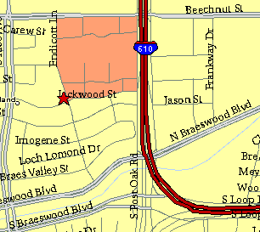

Meeting Information

Meeting Place:
St. Thomas Episcopal School
4900 Jackwood
Houston, Texas 77096

Date and Time:

Fourth Monday of the month
7:30 pm

Heather & Thistle Society Statement
And Membership Information

The Heather and Thistle Society was founded in 1953 by Scots living in Houston who wished to “cultivate an interest in and fond recollections of Scotland, its history and traditions, its literature and ideals, its minstrelsy and song, its customs and amusements, and to provide opportunities for good fellowship and social contact through typically Scottish functions, so that the blessing of our Scottish culture may never die in our new homeland”.

The Heather and Thistle Society meets 10 times a year, September through June. Programs include music, singing, dancing, lively lectures, slide shows and movies about Scotland. The Heather and Thistle Society puts on the annual Robert Burn’s Supper and Ball in late January of each year. We are an organization that promotes our Scottish heritage, in various ways.

The Heather and Thistle Society’s monthly newsletter, “The Houston Scot” is published from September through June. Original articles, information about Scottish or related events are welcome and should be sent to the editor, Jim Monteith, at 15703 Mound Road, Hockley, Texas 77447 or 936-931-2588.

Membership in the Heather and Thistle Society is open to all with an interest in Scottish heritage and culture. Annual dues are $15 for an individual and $20 for a family membership. Applications for membership may be obtained from our website
http://heatherandthistle.org/documents/membership.doc
Dues are due at the beginning of the fiscal year, March 1. Completed applications and membership fees should be mailed to: Mrs. Eileen Graham Moore
8910 Sandstone, Houston, Texas 77036-6132
For membership information please call Eileen at 713-774-0314.

