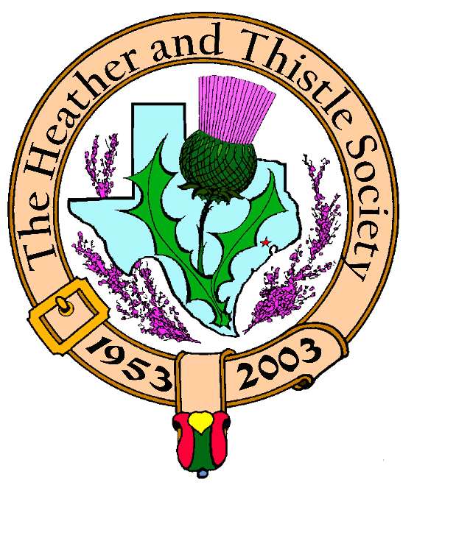

Heather & Thistle Society

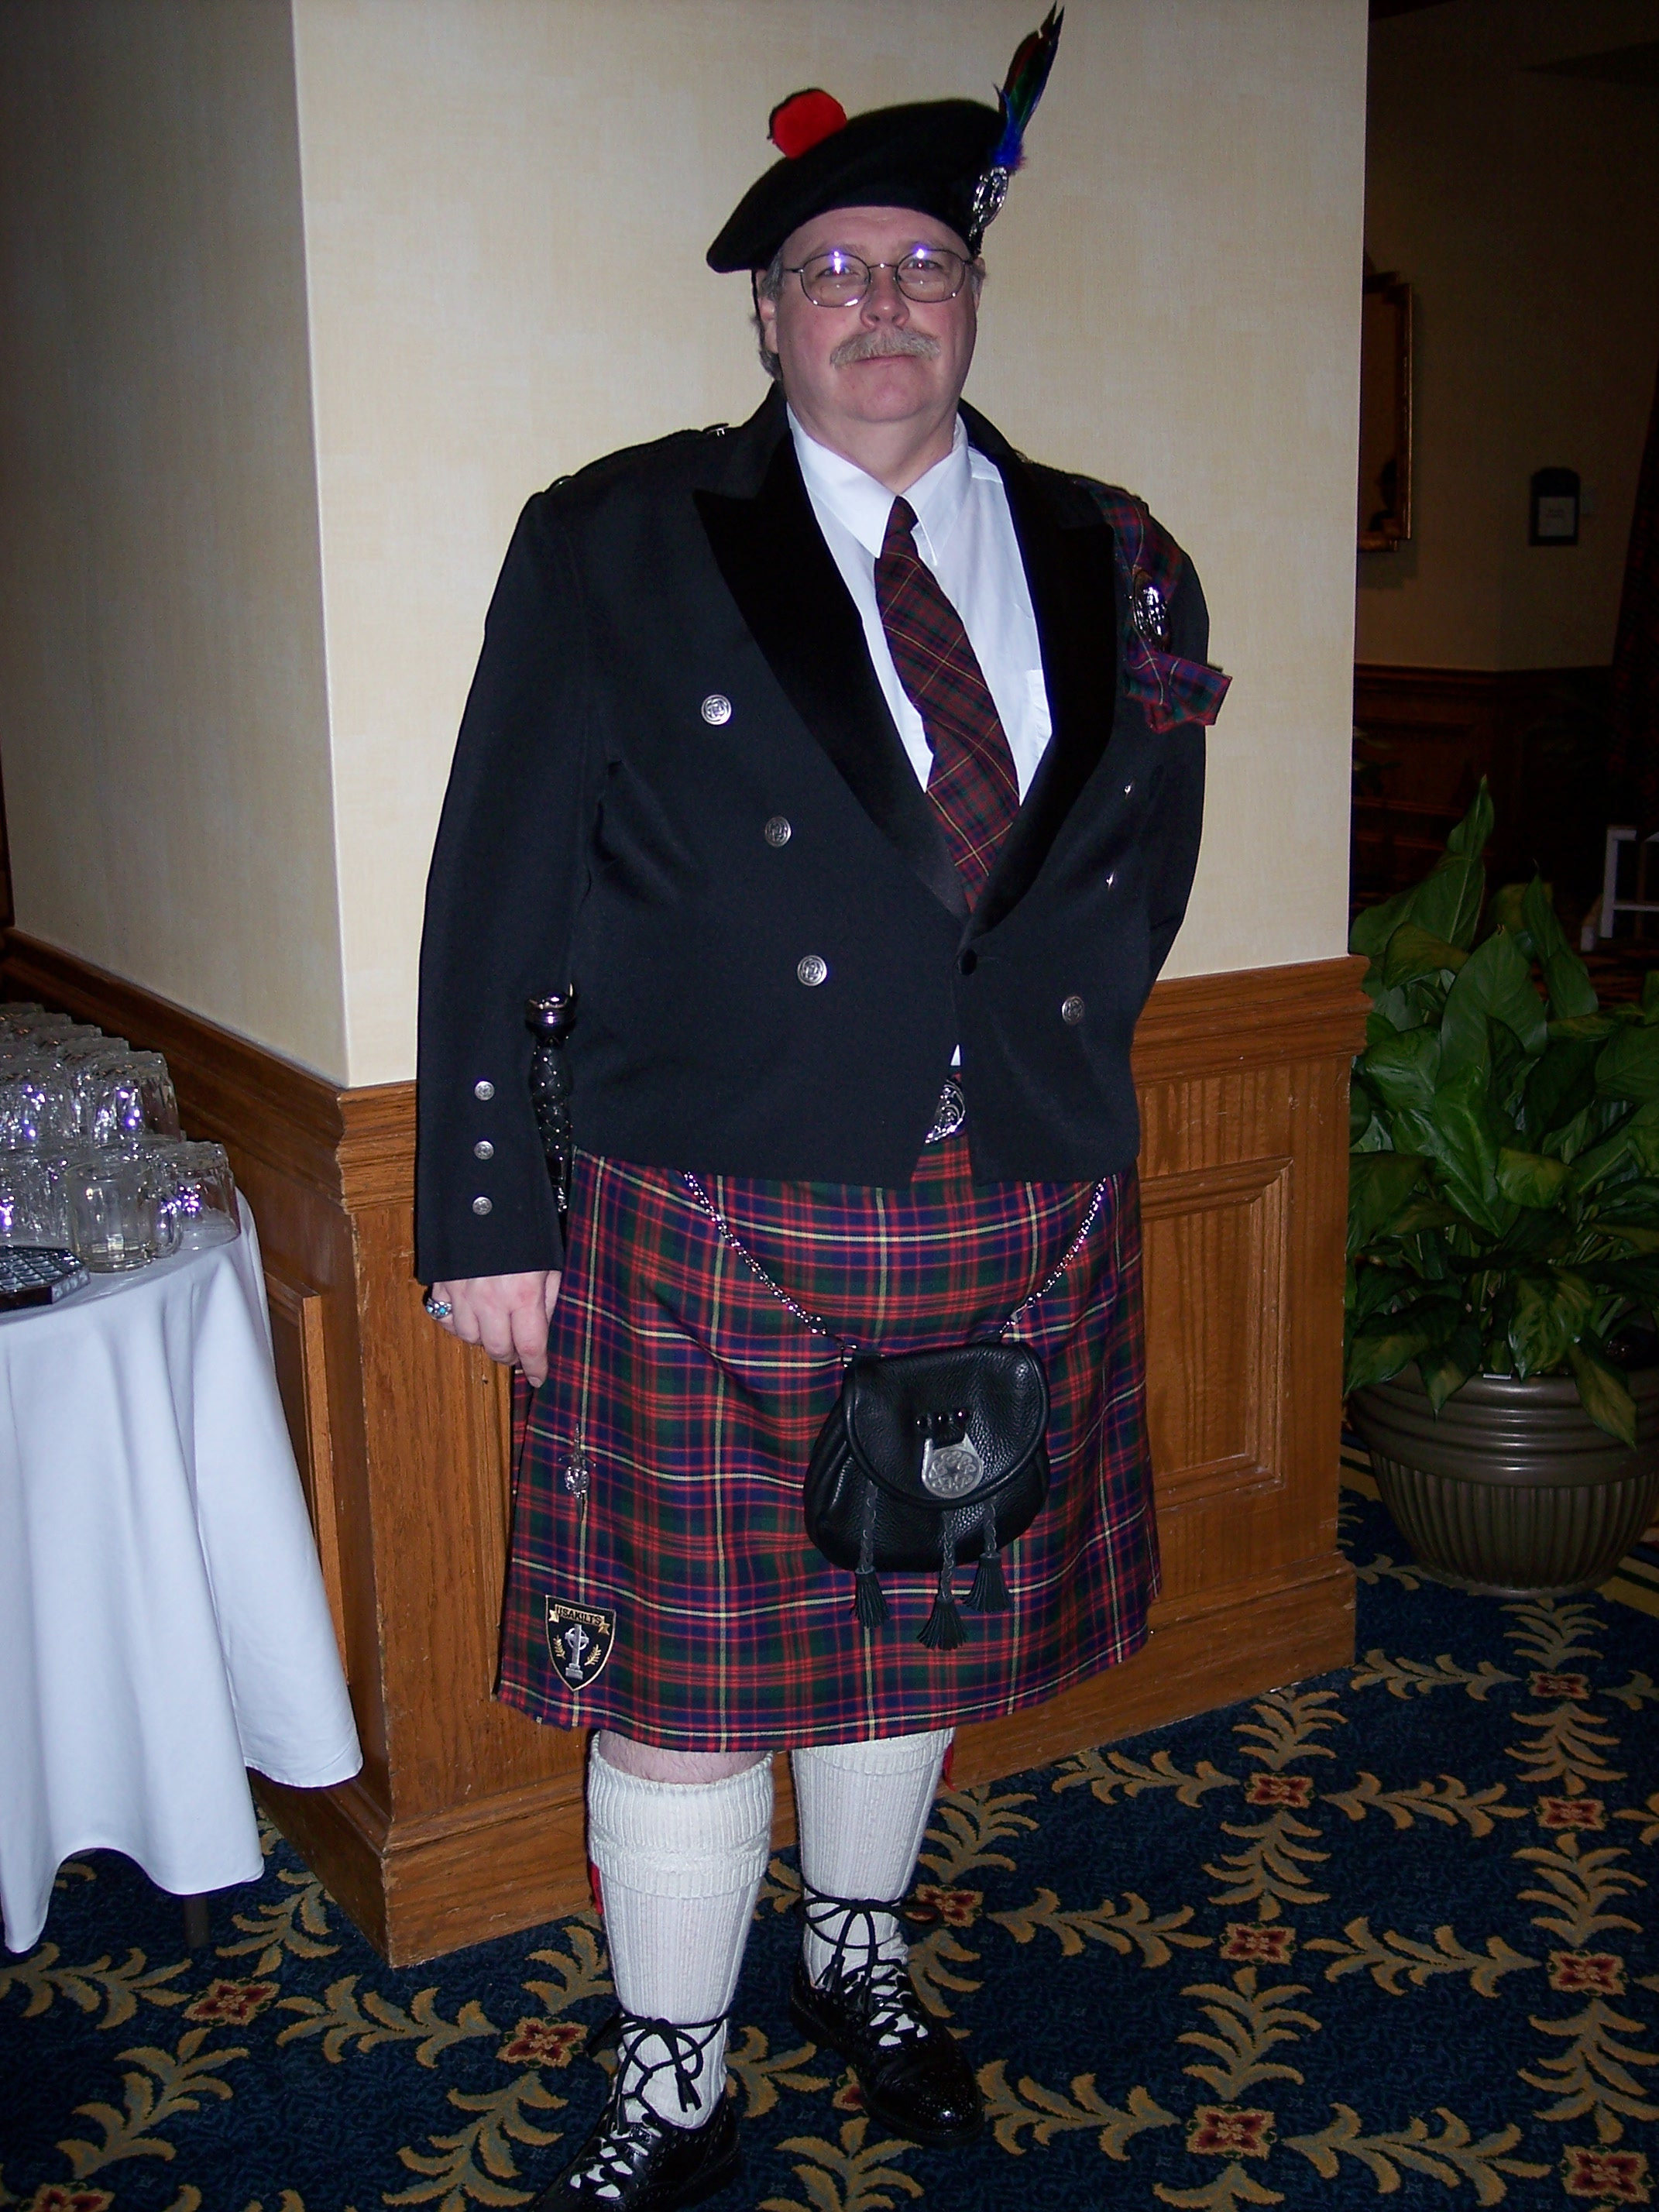
Chieftain Ken Sorrels

Volume 8, Issue 5
January, 2008

Newsletter Editor:
Jim Monteith

Officers:

Chieftain – Ken Sorrels
Sub-Chieftain – Robert Boyd
Sgt.-at-Arms – vacant
Secretary – Ardeth Brodie Treasurer - Robert Moore

Committee Chairs:

Sunshine-Eileen Moore
Membership-Eileen Moore
Past Chieftains- Walter May
Burns Supper-Cheryl May
Publicity-Melvyn Douglass
Programs-Mark Monroe



February 25th, 2008 Meeting of Heather and Thistle Society is Annual General Membership Meeting and Election of New Officers for 2008 so don’t miss it!!!!

The Houston Scot

Chieftain’s Letter,

Wow, can you believe that Christmas has come and gone and it’s a new year already?

If you missed the Christmas Party, you missed a real good time. We had wonderful refreshments and everybody was in a festive mood. Walter played the piano and we sang Christmas songs. After the Christmas sing-a-long, Catherine and Meaghan Heath performed their selection of Robert Burns’ songs. I could go on and on about how beautiful their voices were. No written description that I could give would do their performance justice. You just had to hear them to be able to fully appreciate their singing abilities.

After the program, we had the annual gift exchange/theft. This year Caterpillar had a prominent place amongst the gifts. I do not think anybody left too disappointed.

Remember, before our January meeting, we will have our annual Burns Supper. I hope you were able to get tickets because this one shapes up to be one of our best. I hope to see you Saturday, January 19th, 2008 at the Burns’ Supper.

The January meeting will be on Monday night, January 28, 2008 at St. Thomas Episcopal School at 7:30 pm. The program that night will be a presentation by our own Burns’ Club.

See ya at the Burns’ Supper

That’s all for now!
See you at the January Meeting.
Your Chieftain,
Ken Sorrels

Heather & Thistle Society’s 55th Annual Burn’s Supper & Ball, January 19th, 2008

Get your Tickets now for the upcoming Burn’s Supper!!!!!!!!!

On page 3 of this newsletter you will find the order form for Burn’s Supper tickets. There are still plenty of seats available so order soon!

Allison Wilkes to receive Dixon Hedges Award for 2007

Long time H&T member Allison Wilkes has been voted to receive the Dixon Hedges Award for 2007. This award is given annually to an outstanding member of the Heather and Thistle Society.

Zoe Alexander and Jimmy McVey in memoriam are co-winners of the Jack and Phemia Hume Honorary Service Award for 2007

The Burns Club, a close affiliate of the Heather and Thistle Society, has named Zoe Alexander and Jimmy McVey as co-winners of their award for 2007. Zoe and Jimmy, both recently deceased, were staunch supporters of the Burns Club for many years.

Heather & Thistle Society Officer Nominations for 2008

Chieftain – Robert Boyd
Sub-Chieftain - Melvyn Douglass
Sgt-At-Arms – Ardeth Brodie
Secretary – Carmelita Orr
Treasurer – Walter May

Under Article IV of the H&T Bylaws the meeting held in February of each year shall be the Annual General Membership Meeting, at which time officers shall be elected and annual reports received. The presence of fifteen (15) members in good standing at any meeting shall constitute a quorum for the transaction of business.
The current officers and future officers of H&T urge members to attend this important meeting.

2008 Robert Burns Cruise and Robert Burns
Association of North America (RBANA)
AGM and Conference
March 3rd 2008 for Five Nights aboard the Carnival Cruise Ship “Ecstasy”, from Galveston, Texas to Progreso and Cozumel, Mexico
For registration or information contact Jack Hume at 713-665-1431(home), 713-882-7763(cell), or johnhume2@peoplepc.com
For travel reservations or questions contact Maureen Dixon 281-333-3124 or 281-660-5721, or nasatravel@comcast.net

Upcoming February 2008 Event:

Royal Scot Dragoon Guards and The Band of the Coldstream Guards to perform at Jones Hall in Houston on Tuesday, February 19, 2008. Group rates are available for Heather and Thistle Society.

Heather & Thistle Society – Minutes
Date Dec. 17, 2007

Chieftain Dr. Kenneth Sorrels called the business meeting to order in the Ingram Room of the St. Thomas Episcopal School. The motion was made to accept the November 2007 minutes as published in the newsletter. Motion passed.

Treasurer Report: Dr. Robert Moore was ill and unavailable to give a report for the month. Temporary acting treasurer Dr. Walter May gave a report to the membership concerning the current bank balance. The motion was made to accept the treasurer’s report. The motion passed.
Membership Report: No report.
Committee Reports called for by Chieftan Dr. Kenneth Sorrels:
Burns Club: There are still spaces available for the March Cruise. Please contact Jack Hume for further information. Time is passing quickly so reserve your spot soon!
Burns Supper: Chair Cheryl May reports all is readying for the Burns Supper. The last meeting for the committee will be Jan. 3rd and will be held at the home of Alex and Maryann Munroe.

Past Chieftains: Chair Dr. Walter May reiterated and confirmed information concerning the progress towards the Burns Supper.

Programs: Mark Monroe reported the topics of the January and February meetings asking the Burns Club to please let him know as soon as possible whether or not they will be needing AV equipment for their presentation to the H&TS at the January meeting.

Sunshine: No report. Cards of support and caring were sent to the Moore’s on behalf of the H&TS.

Newsletter: Editor Jim Monteith reports emailing 70, surface mailing 90 copies of the Newsletter.

Houston Grampian: It was noted the Grampian’s would be going to Scotland this Fall.

Houston Highland Games: Max Triolla reports the HHGA is busy procuring their entertainment lineup for this May 2008 Houston Highland Games and promises to be wonderful as always.

RSCDS: In January all are invited to participate at the Socials to be held Tuesdays from 7:30 – 9:30 PM at the Dad’s Club on Voss Road above Highway 10. Cost is $5.00 per person. All levels of dance expertise from beginner to advanced are welcomed to participate. For further information please contact Moon or visit the RSCDS web site.

Houston Highlanders: No report

Sergeant-At-Arms: 26 members were present and 6 guests. Guests were photographer Nancy Saldivar, pianist Maryann Johnson, Audley & Catherine Heath parents of singers Meaghan and Rebecca Heath.

Old Business combined with New Business: Mark Monroe asked for clarification concerning point # 5 of the new Sergeant-At-Arms job description. The point was clarified.

This meetings program was a performance of songs of Robert Burns by Meaghan and Rebecca Heath. This wonderful performance sponsored by Mark Monroe was followed by the Annual Christmas gift exchange.

Next month’s meeting date will be January 29th . The meeting will be held in the St. Thomas Episcopal Theater.

The Heather and Thistle Society
55th Annual Robert Burns Supper
Saturday, January 19, 2008
Houston Marriott Westchase , 2900 Briarpark Drive, Houston, TX 77042
Ticket Order Form
Name of Ticket Holder * | No. Tickets | Total # Member Tickets @ $55 | Total # Non-Member Tickets @ $70 | Total Dollar Amount
Mail to:
Name:
Address:
City |  | State |  | Zip
Phone # |  | E-mail
* Member tickets may be purchased by/for only those with current dues as of September 30, 2007. Tickets ordered in November must be paid for in full by December 1st. Please list names for whom member tickets are requested. Use a separate sheet for each table of ten.
Enclose a self-addressed, stamped envelope with this form and your check made payable to the Heather and Thistle Society. Mail to:
 | Mrs. Robert A. McClure (Joan)
 | 553 Brown Saddle Road
 | Houston, TX 77057-1413
 | Ph: 713-782-6707
Date received |  | Ticket Nos. | Table Nos. | Tickets Mailed
__________________ |  | _________________ | _________________ | _______________

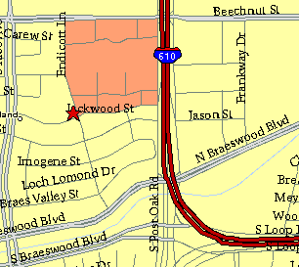

Meeting Information

Meeting Place:
St. Thomas Episcopal School
4900 Jackwood
Houston, Texas 77096

Date and Time:

Fourth Monday of the month
7:30 pm

Heather & Thistle Society Statement
And Membership Information

The Heather and Thistle Society was founded in 1953 by Scots living in Houston who wished to “cultivate an interest in and fond recollections of Scotland, its history and traditions, its literature and ideals, its minstrelsy and song, its customs and amusements, and to provide opportunities for good fellowship and social contact through typically Scottish functions, so that the blessing of our Scottish culture may never die in our new homeland”.

The Heather and Thistle Society meets 10 times a year, September through June. Programs include music, singing, dancing, lively lectures, slide shows and movies about Scotland. The Heather and Thistle Society puts on the annual Robert Burn’s Supper and Ball in late January of each year. We are an organization that promotes our Scottish heritage, in various ways.

The Heather and Thistle Society’s monthly newsletter, “The Houston Scot” is published from September through June. Original articles, information about Scottish or related events are welcome and should be sent to the editor, Jim Monteith, at 15703 Mound Road, Hockley, Texas 77447 or 936-931-2588.

Membership in the Heather and Thistle Society is open to all with an interest in Scottish heritage and culture. Annual dues are $15 for an individual and $20 for a family membership. Applications for membership may be obtained from our website
http://heatherandthistle.org/documents/membership.doc
Dues are due at the beginning of the fiscal year, March 1. Completed applications and membership fees should be mailed to: Mrs. Eileen Graham Moore
8910 Sandstone, Houston, Texas 77036-6132
For membership information please call Eileen at 713-774-0314.

