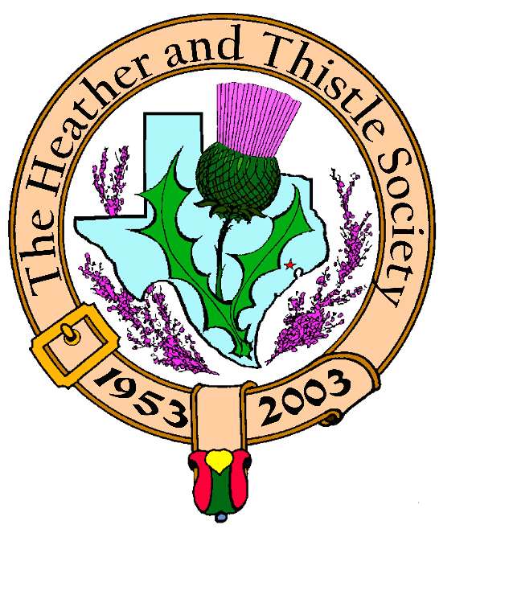

Heather & Thistle Society

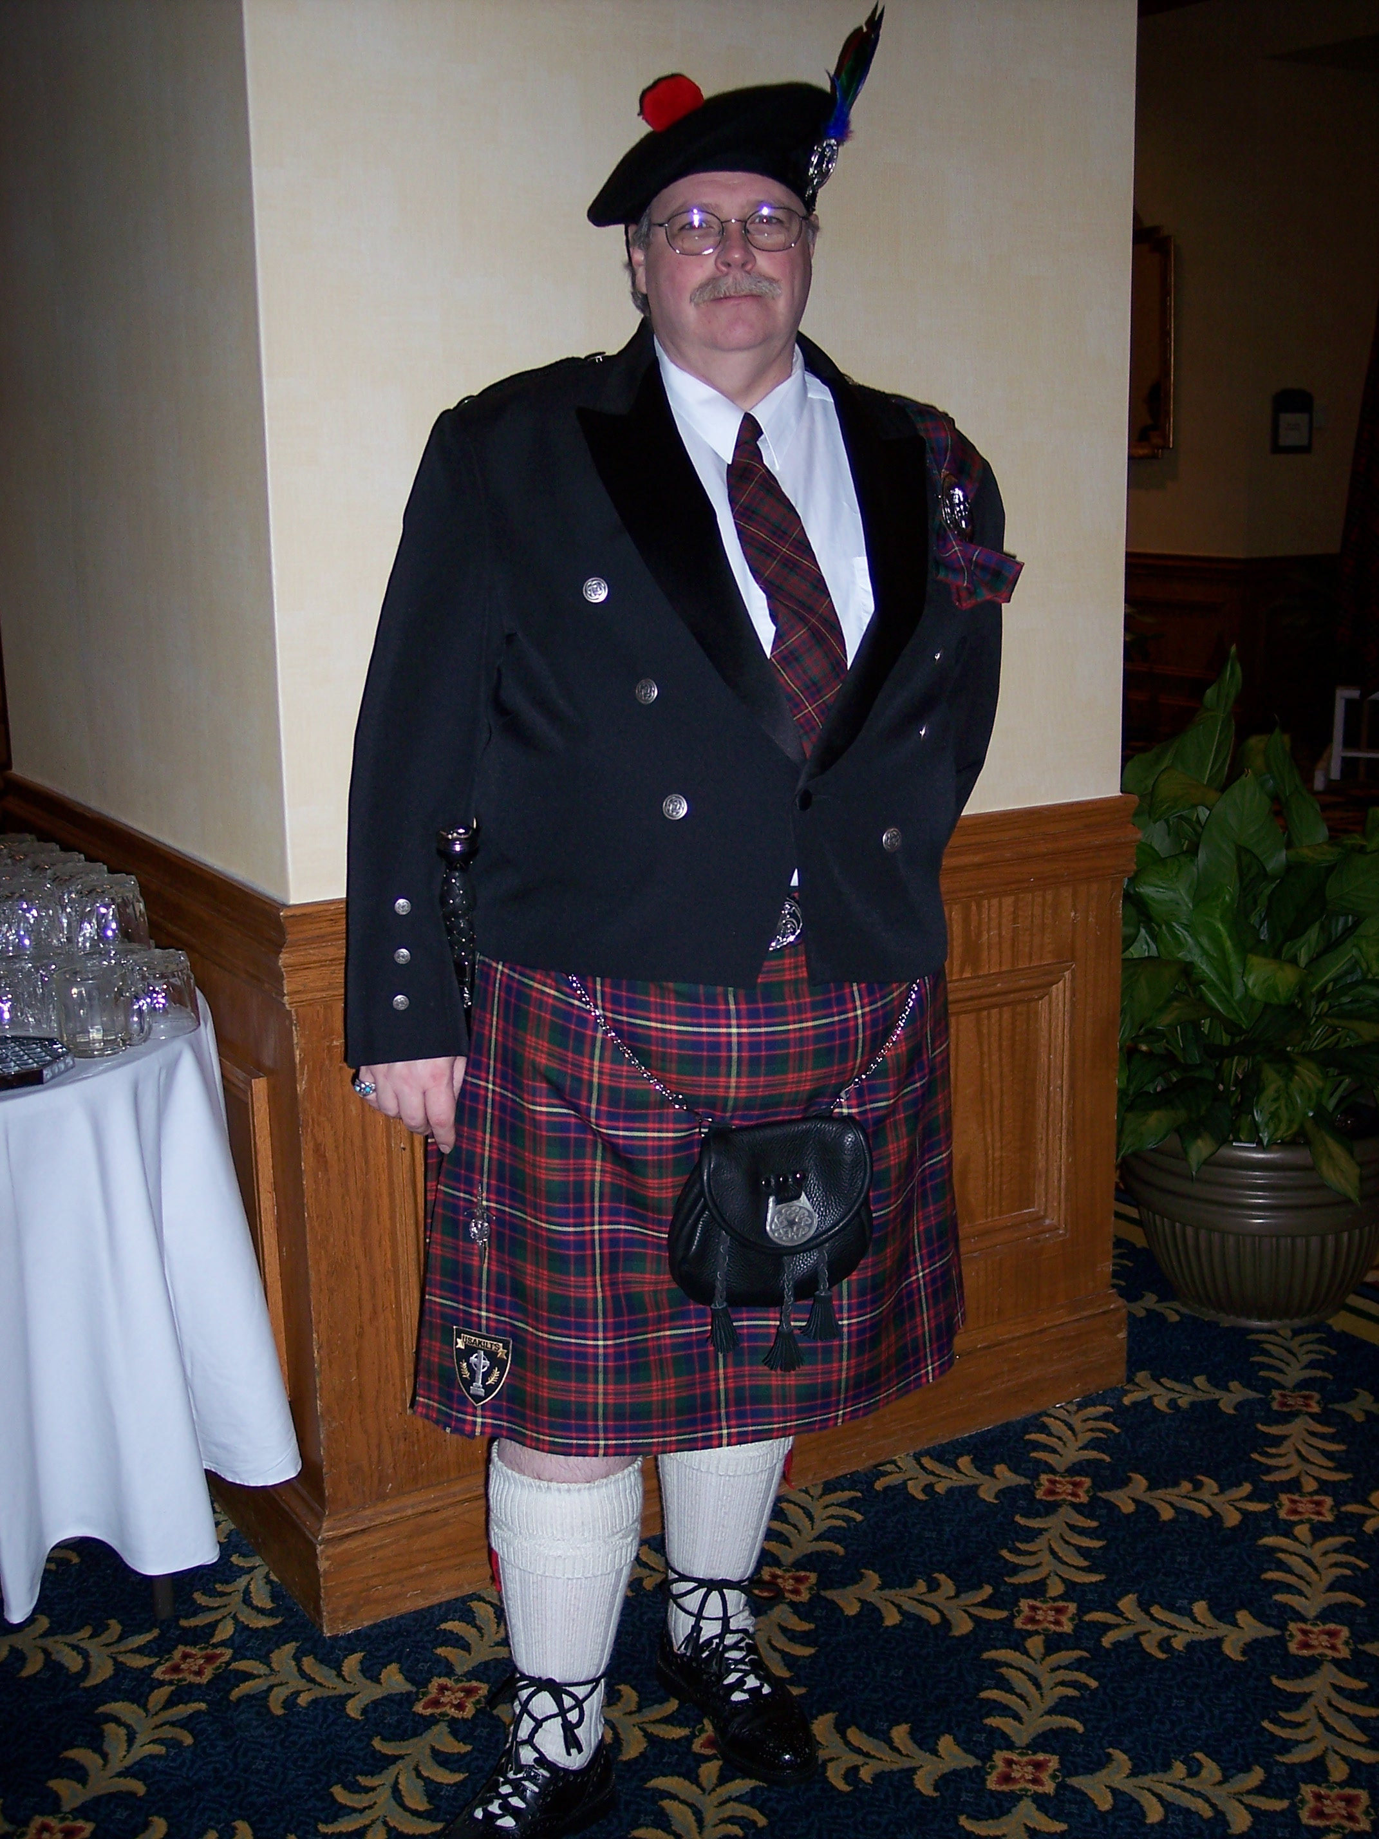
Chieftain Ken Sorrels

Volume 8, Issue 4
December, 2007

Newsletter Editor:
Jim Monteith

Officers:

Chieftain – Ken Sorrels
Sub-Chieftain – Robert Boyd
Sgt.-at-Arms – vacant
Secretary – Ardeth Brodie Treasurer - Robert Moore

Committee Chairs:

Sunshine-Eileen Moore
Membership-Eileen Moore
Past Chieftains- Walter May
Burns Supper-Cheryl May
Publicity-Melvyn Douglass
Programs-Mark Monroe



The Houston Scot

Chieftain’s Letter,

Well folks, it’s that time again. Another month has gone by.

November’s program was dance lessons from The RSCDS. Moon Weiss did a wonderful job of instruction. A good time was had by all. Just think of what Moon could have accomplished if most of her students did not have two left feet.

Our next meting will be held on December 17, 2007 in the Ingram Room. As usual, in addition to our regular monthly business, this meeting is also our annual Christmas party. Part of our entertainment that night will be a selection of songs, written by Robert Burns as performed by Catherine and Meaghan Heath. This program will be brought to you through the kind patronage of Mark Monroe. The second part of the night’s entertainment will be our customary Christmas gift exchange. Remember, you should strive to keep the cost of your gift to under $10.00. The term “white elephant” usually brings to mind the word undesirable. I must say, that rarely does a member bring a gift to the party that is not worth taking home. In fact, most gifts are stolen repeatedly. However, in the excitement and revelry of opening and stealing gifts, keep this thought in mind “Please be Kind!”

At our November meeting, Walter May on behalf of the Past Chieftain’s Committee, brought forth the recommendation that the job description of the Sergeant of Arms be altered somewhat. This change entailed decreasing the amount of manual labor required of that position. The change would decrease the “unattractiveness” of the position to the membership and make it easier for the Past Chieftains to fill the position. Walter made it in the form of a motion and it passed. Hopefully we can now have a full slate of officers for next year.

Remember, the tickets for the 2008 Burn’s Supper went on sale, for members only, on the first of November, 2007. Non-member sales started the first of December. Do not wait until the last minute to order your tickets or you might get left out.

See ya at the Party!

That’s all for now!
See you at the December Meeting.
Your Chieftain,
Ken Sorrels

Heather & Thistle Society’s 55th Burn’s Supper

Get your Tickets now for the upcoming Burn’s Supper!

On page 3 of this newsletter you will find the order form for Burn’s Supper tickets. There are still plenty of seats available so order soon!

Heather & Thistle Society – Meeting Minutes
Nov. 26, 2007

Chieftain Dr. Kenneth Sorrels called the business meeting to order at 7:35 PM in the Gym of the St. Thomas Episcopal School. The motion was made to accept the October 2007 minutes as published in the newsletter. Motion passed.

Treasurer Report: No report. Dr. Robert Moore was unavailable at the meeting having recently had gall bladder surgery. The membership expressed concern for Dr. Moore’s well being and wishes for a speedy recovery.

Membership Report: No report. Eileen Moore was also unavailable at this meeting.

Committee Reports called for by Chieftan Dr. Kenneth Sorrels

Burns Club: reports they are considering showing a video for the January meeting instead of their usual Robert Burns inspired programs. The video contains clips of both recently deceased H&TS members Jimmy McVey and former Chieftain (1994 – 1995) Zoe Alexander.

Burns Supper: Cheryl May reports the committee is still seeking a photographer for the evening, Robert Boyd will be the featured speaker, the menu will be in place next week, Becci Himes will be in charge of the decorations after the retirement of 10 year veteran Allison Wilkes, Martin Roadsen will be floor manager, tickets will be available to the public beginning Dec. 1st so members get your tickets soon!

Past Chieftains: Walter May reports that in the past the PCC has been so consumed with the Burns Supper that time for the creation of the subsequent year’s slate of officers was often rushed. This year is different. Discussions of job descriptions were considered and will be introduced and reviewed in New Business.

Programs: Mark Monroe reports the Dec. 17th meeting will be from 7 – 10 PM at the St. Thomas Episcopal School, Ingram Room on the ground floor Room No. G-2. The Annual Christmas Party will consist of 1. The monthly meeting 2. Twenty minutes of entertainment by two female vocalists singing select Robert Burns songs. The vocalists will be accompanied by a pianist 3. Refreshments 4. White Elephant Christmas Gift Exchange. NOTE: this event is not a Scottish tradition & a reminder, if you are bringing a guest to the Christmas Party please bring an exchange gift for yourself and your guest. 5. Last but not least continuation with the refreshments and casual conversation and the clean up.

Sunshine: No report

Newsletter: Editor Jim Monteith reports emailing 70 and surface mailing 90 newsletters.

Houston Grampian: Robert Gilbert reports a St. Andrews Day Celebration beginning at 6PM on Nov. 30th at the Black Lab and doing preliminary work for the trip to Aberdeen which will be during the first week of September 2008.

Houston Highland Games: no report.

RSCDS: Moon Weiss reports next week’s classes will mark the end of the semester. Social dancing begins on Tuesdays at 7:30 at the Dad’s Club at Voss Road above Highway 10 west of Beltway 8 for the month of January. Classes will resume in February on Mondays in League City, for beginners at the Dad’s Club on Tuesdays and for advanced dancers with one year or more experience in the Bellaire area. All classes begin at 7:30. For more information go to their website.

Houston Highlanders: No report

Sergeant-At-Arms report was made by Chieftain Dr. Kenneth Sorrels and included 23 members present. Three guests became new members! Welcome Jennifer Showen and Butch & Linda Boggess.

Old Business: None.

New Business: Walter May, Chair of the Past Chieftain’s Committee, reports that the PCC has addressed nominations for next year’s 2008 – 2009 slate of officers. Of concern were cumbersome physical duties and responsibilities that have accrued to the Sergeant – At – Arms position over the years. The position remained vacant 2007-2008 because of this. The PCC proposed a change in the job description of this position in the following ways:

- The Heather and Thistle Society will make available tartans and poles for four events each year. These are:
  - Burns Supper
  - Burns Memorial Ceremony
  - Houston Highland Games
  - Kirkin’ O’ the Tartans
- Because of the physical work involved, the Society voted that the Sergeant-At-Arms should manage and coordinate these events by renting a truck and hiring able bodied people to carry out the physical labor of moving the tartans, poles and holders. These people will assist with set up and tear down as needed.
- The costs associated with the Burns Supper and the Burns Memorial Ceremony (which usually occurs the day after the Supper) will be borne by the Burns Supper Planning Committee and budgeted for in their planning.
- Costs for the Houston Highland Games and one Kirkin’ O’ the Tartans will be borne by Heather and Thistle Society funds.
- The Society will be reimbursed for costs for other events by the parties requesting use of the equipment.

Questions and discussions by the membership included the clarification that the new definition of the position fits within the parameters of the H &TS Bylaws. The twenty-three members present voted in favor of the changes. There were no descenting votes.

This meeting’s program was a mini lesson in Royal Scottish Country Dancing by Moon Weiss and members of the Royal Scottish Country Dance Society

.Next month’s meeting date will be Dec. 17th from 7 - 10 PM. Meeting adjourned at 8:06pm.

The Heather and Thistle Society
55th Annual Robert Burns Supper
Saturday, January 19, 2008
Houston Marriott Westchase , 2900 Briarpark Drive, Houston, TX 77042
Ticket Order Form
Name of Ticket Holder * | No. Tickets | Total # Member Tickets @ $55 | Total # Non-Member Tickets @ $70 | Total Dollar Amount
Mail to:
Name:
Address:
City |  | State |  | Zip
Phone # |  | E-mail
* Member tickets may be purchased by/for only those with current dues as of September 30, 2007. Tickets ordered in November must be paid for in full by December 1st. Please list names for whom member tickets are requested. Use a separate sheet for each table of ten.
Enclose a self-addressed, stamped envelope with this form and your check made payable to the Heather and Thistle Society. Mail to:
 | Mrs. Robert A. McClure (Joan)
 | 553 Brown Saddle Road
 | Houston, TX 77057-1413
 | Ph: 713-782-6707
Date received |  | Ticket Nos. | Table Nos. | Tickets Mailed
__________________ |  | _________________ | _________________ | _______________

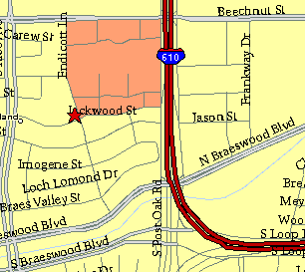

Meeting Information

Meeting Place:
St. Thomas Episcopal School
4900 Jackwood
Houston, Texas 77096

Date and Time:

Fourth Monday of the month
7:30 pm

Heather & Thistle Society Statement
And Membership Information

The Heather and Thistle Society was founded in 1953 by Scots living in Houston who wished to “cultivate an interest in and fond recollections of Scotland, its history and traditions, its literature and ideals, its minstrelsy and song, its customs and amusements, and to provide opportunities for good fellowship and social contact through typically Scottish functions, so that the blessing of our Scottish culture may never die in our new homeland”.

The Heather and Thistle Society meets 10 times a year, September through June. Programs include music, singing, dancing, lively lectures, slide shows and movies about Scotland. The Heather and Thistle Society puts on the annual Robert Burn’s Supper and Ball in late January of each year. We are an organization that promotes our Scottish heritage, in various ways.

The Heather and Thistle Society’s monthly newsletter, “The Houston Scot” is published from September through June. Original articles, information about Scottish or related events are welcome and should be sent to the editor, Jim Monteith, at 15703 Mound Road, Hockley, Texas 77447 or 936-931-2588.

Membership in the Heather and Thistle Society is open to all with an interest in Scottish heritage and culture. Annual dues are $15 for an individual and $20 for a family membership. Applications for membership may be obtained from our website
http://heatherandthistle.org/documents/membership.doc
Dues are due at the beginning of the fiscal year, March 1. Completed applications and membership fees should be mailed to: Mrs. Eileen Graham Moore
8910 Sandstone, Houston, Texas 77036-6132
For membership information please call Eileen at 713-774-0314.

