

Heather & Thistle Society

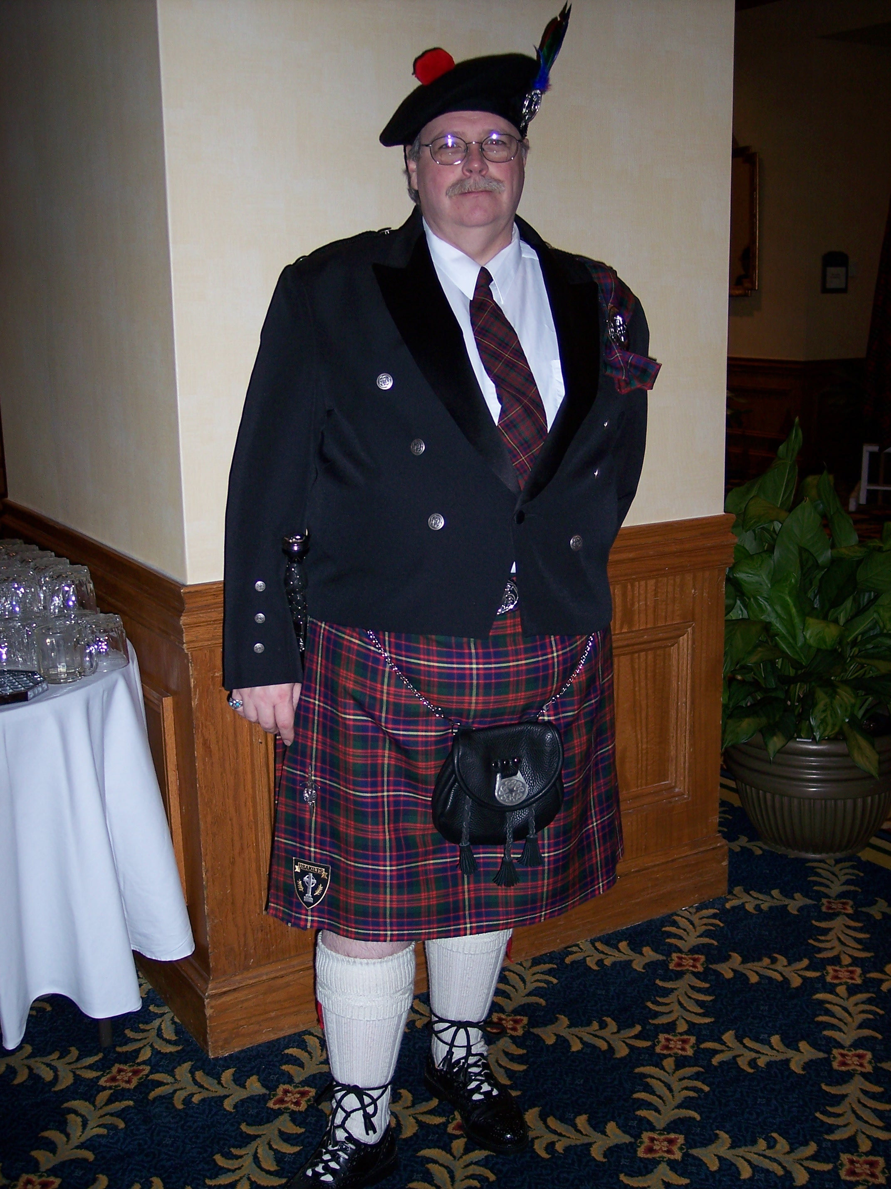
Chieftain Ken Sorrels

Volume 8, Issue 3
November, 2007

Newsletter Editor:
Jim Monteith

Officers:

Chieftain – Ken Sorrels
Sub-Chieftain – Robert Boyd
Sgt.-at-Arms – vacant
Secretary – Ardeth Brodie Treasurer - Robert Moore

Committee Chairs:

Sunshine-Eileen Moore
Membership-Eileen Moore
Past Chieftains- Walter May
Burns Supper-Cheryl May
Publicity-Melvyn Douglass
Programs-Mark Monroe

November 26th Program:

Royal Scottish Country Dance Society will be teaching us Scottish Folk dancing in the gym at St. Thomas School

The Houston Scot

Chieftain’s Letter,

Well folks, it’s that time again. Another month has gone by.

October’s program was a musical concert by Ed Miller. We almost packed the house. Ed sure does have a lot of fans out there. With good reason to, his performance of Scottish Folksongs is both entertaining as well as informative. This was his second year to perform for us and if you missed it, you missed a real Scottish blessing. However, without the generosity of our own Mark Monroe, Ed would not have been with us this year. What a wonderful program chairman Mark Monroe has been this year.

Our next meting will be held on November 26, 2007. Our program at that time will be dance lesions from The RSCDS. Come on out and learn a little more about Scottish Country Dancing. You never know, there might be a future in it for you. Just think of how you could impress your friends and step on the toes of your enemies. What a deal! What an opportunity! Moon and friends will take good care of you.

Remember, the tickets for the 2008 Burn’s Supper went on sale, for members only, on the first of November, 2007. Non-member sales start the first of December. Do not wait until the last minute to order your tickets or you might get left out.

Our last Burn’s Supper Planning Committee meeting was held at the Red Lion Pub. We are in the process of finalizing most of the details. It looks like we have another wonderful Burn’s Supper in the making. Cheryl May has done a fantastic job of heading up our Burn’s Supper Planning Committee this year.

I hope everyone had a happy Halloween. Halloween parties are so much fun, just one more opportunity to wear my kilt (not that I need one). Thanksgiving will have come and gone before our next meeting, so I want to take this time to wish everyone a Happy Thanksgiving. May we all spend some time in reflection, thinking about all the glorious blessings that God has given us for which we can be thankful.

That’s all for now!
See you at the November Meeting.
Your Chieftain,

Ken Sorrels

Kirking ‘O’ The Tartans

Member Mark Monroe has arranged a Kirkin ceremony on Saturday, November 17, 2007 at 12:15pm at Our Lady of Walsingham Roman Catholic Church, 7809 Shady Villa Lane, Houston, Texas 77055. The church is located off of Wirt Road about one mile north of IH-10. The Kirkin ceremony is scheduled one day after the feast of Saint Margaret of Scotland which is celebrated Nov. 16. Royal Scot Dragoon Guards and The Band of the Coldstream Guards

Michael Coppents of The Houston Society for the Performing Arts recently contacted your editor and advised that the above pipe and drum band will be performing at Jones Hall in Houston on Tuesday, February 19, 2008. Group rates will be available for the Heather and Thistle Society.
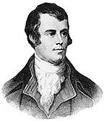
Heather and Thistle Society Presents the 55th Annual Robert Burns Supper and Gala Ball on January 19, 2008 at the Houston Marriott Westchase, 2900 Briarpark Drive, Houston, Texas 77042
Tickets for members are $55.00 each and for non-members $70.00 each.
Tickets go on sale to H&T members on November 1st, 2007 and to non-members on December 1st, 2007. Order form on page 3 of this letter.

2008 Robert Burns Cruise and Robert Burns
Association of North America (RBANA)
AGM and Conference
March 3rd 2008 for Five Nights aboard the Carnival Cruise Ship “Ecstasy”, from Galveston, Texas to Progreso and Cozumel, Mexico
For registration or information contact Jack Hume at 713-665-1431(home), 713-882-7763(cell), or johnhume2@peoplepc.com
For travel reservations or questions contact Maureen Dixon 281-333-3124 or 281-660-5721, or nasatravel@comcast.net
St. Andrews Day Nov. 30th

The Kelvin Arms Pub at 2424 Dunstan Dr., Houston will be having a St. Andrews day celebration from 3 to 9 pm on December 1st Five dollar cover charge gets you Scottish food, music and dance.
Heather & Thistle Society – Minutes
Date Oct.22, 2007

Chieftain Dr. Kenneth Sorrels called the business meeting to order at 7:37 pm in the auditorium of the St. Thomas Episcopal School. The motion was made to accept the Sept. 24, 2007 minutes as published in the newsletter. The motion passed.

Treasurer Report: Dr. Robert Moore reports the bank balance to be $3155.37. As of Oct. 1, 2007 H & TS has received $155.00 and spent $400.00. The report of the total net gain/loss was not currently available. The motion was made to accept the treasurer’s report. The motion passed.

Membership Report: Eileen Moore reports 95 family, 36 single, 32 life and 4 exempt memberships. It was reported that 22 memberships were dropped for nonpayment of dues.

Committee Reports were called for by Sub-Chieftain Robert Boyd

Burns Club: Jack Hume reported he had just returned from the Burns Conference in Carlysle. The last regular Houston meeting was held at the home of Rosemary McBride. The next meeting will be held at the home of Alex and Maryann Munroe with the date being decided later.

Burns Supper: Chair Cheryl May reviewed the known information concerning the upcoming 55th Annual Robert Burns Supper. The committee will be meeting again as soon as possible.

Past Chieftains: Chair Walter May reports the next meeting will be up coming.

Programs: Chair Mark Monroe reports the November 26th meeting, the program - a mini lesson by the Royal Scottish Country Dance Society, and refreshments will be in the Gym. The December meeting in the Ingram Room.

Sunshine: Chair Eileen Moore reports no cards have been sent for Mary E. Wagner or Ed Young. Former Chieftain Zoe Alexander’s memorial service will be held on Oct. 27th and will be a “kilt do”. More information and directions are available on the H&TS website. Carpooling was suggested.

Newsletter: Editor Jim Monteith reports emailing more newsletters than he sent via surface mail. 34 addresses were dropped from the mail out.

Houston Grampian: President Bob Gilbert just returned from Aberdeen, reported on his activities there and reported that the Scots had asked “where do the Americans want to go when they are in Scotland?”. The American group will be going to Aberdeen in September of 2008.

Houston Highland Games: No report.

RSCDS: No report.

Houston Highlanders: No report.

Sergeant-At-Arms The report was given by Sub Chieftain Robert Boyd. 36 members and 14 guests signed in though there were clearly many others who did not. Of those who did sign in new members were Alison Davidow, M.D., Russell Robinson and Nancy Winders. Welcome new members.

Old Business: Jack Hume reported not being able to coordinate a phone list of prospective members to be dropped for nonpayment of dues, without his 2007 H&TS Membership Directory.

New Business: Mark Monroe asked permission of the membership to provide a musical “gift” of a performance of the songs of Robert Burns. Vocalists Meghan and Rebecca Heath will perform. The membership voted to approve and accept the generous offer. Mark also reported he would arrange to have the piano in the Ingram Room tuned for the occasion.

This meeting’s program was folk singer and folklorist Ed Miller.

Next month’s meeting date will be Monday, Dec. 17th, 2007. The meeting adjourned at 7:59 PM.

The Heather and Thistle Society
55th Annual Robert Burns Supper
Saturday, January 19, 2008
Houston Marriott Westchase , 2900 Briarpark Drive, Houston, TX 77042
Ticket Order Form
Name of Ticket Holder * | No. Tickets | Total # Member Tickets @ $55 | Total # Non-Member Tickets @ $70 | Total Dollar Amount
Mail to:
Name:
Address:
City |  | State |  | Zip
Phone # |  | E-mail
* Member tickets may be purchased by/for only those with current dues as of September 30, 2007. Tickets ordered in November must be paid for in full by December 1st. Please list names for whom member tickets are requested. Use a separate sheet for each table of ten.
Enclose a self-addressed, stamped envelope with this form and your check made payable to the Heather and Thistle Society. Mail to:
 | Mrs. Robert A. McClure (Joan)
 | 553 Brown Saddle Road
 | Houston, TX 77057-1413
 | Ph: 713-782-6707
Date received |  | Ticket Nos. | Table Nos. | Tickets Mailed
__________________ |  | _________________ | _________________ | _______________

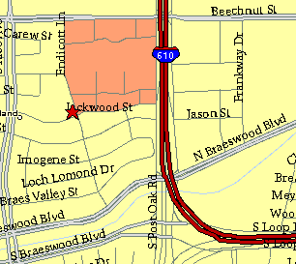

Meeting Information

Meeting Place:
St. Thomas Episcopal School
4900 Jackwood
Houston, Texas 77096

Date and Time:

Fourth Monday of the month
7:30 pm

Heather & Thistle Society Statement
And Membership Information

The Heather and Thistle Society was founded in 1953 by Scots living in Houston who wished to “cultivate an interest in and fond recollections of Scotland, its history and traditions, its literature and ideals, its minstrelsy and song, its customs and amusements, and to provide opportunities for good fellowship and social contact through typically Scottish functions, so that the blessing of our Scottish culture may never die in our new homeland”.

The Heather and Thistle Society meets 10 times a year, September through June. Programs include music, singing, dancing, lively lectures, slide shows and movies about Scotland. The Heather and Thistle Society puts on the annual Robert Burn’s Supper and Ball in late January of each year. We are an organization that promotes our Scottish heritage, in various ways.

The Heather and Thistle Society’s monthly newsletter, “The Houston Scot” is published from September through June. Original articles, information about Scottish or related events are welcome and should be sent to the editor, Jim Monteith, at 15703 Mound Road, Hockley, Texas 77447 or 936-931-2588.

Membership in the Heather and Thistle Society is open to all with an interest in Scottish heritage and culture. Annual dues are $15 for an individual and $20 for a family membership. Applications for membership may be obtained from our website
http://heatherandthistle.org/documents/membership.doc
Dues are due at the beginning of the fiscal year, March 1. Completed applications and membership fees should be mailed to: Mrs. Eileen Graham Moore
8910 Sandstone, Houston, Texas 77036-6132
For membership information please call Eileen at 713-774-0314.

