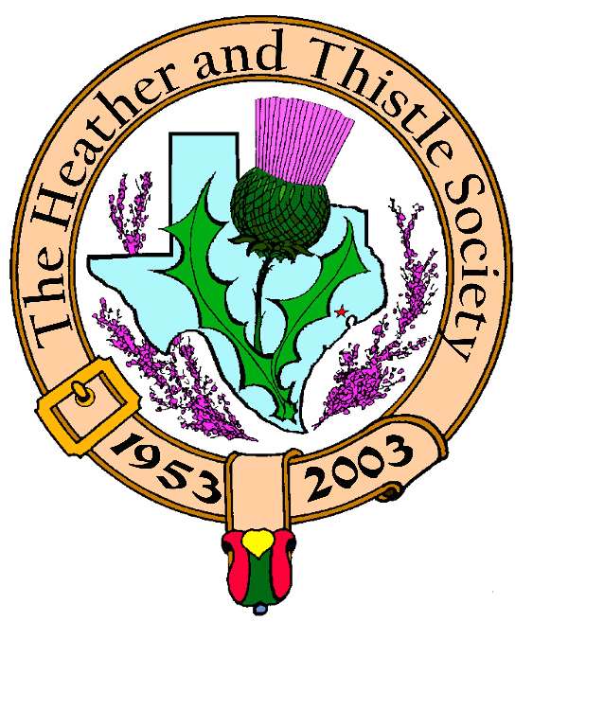

Heather & Thistle Society

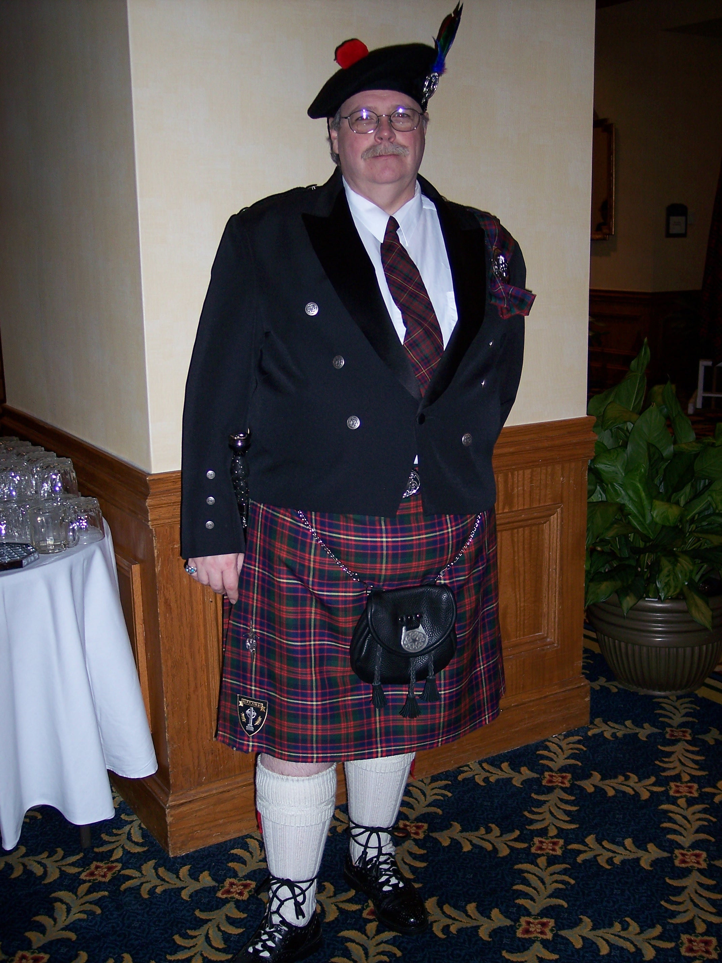
Chieftain Ken Sorrels

Volume 8, Issue 2
October, 2007

Newsletter Editor:
Jim Monteith

Officers:

Chieftain – Ken Sorrels
Sub-Chieftain – Robert Boyd
Sgt.-at-Arms – vacant
Secretary – Ardeth Brodie Treasurer - Robert Moore

Committee Chairs:

Sunshine-Eileen Moore
Membership-Eileen Moore
Past Chieftains- Walter May
Burns Supper-Cheryl May
Publicity-Melvyn Douglass
Programs-Mark Monroe

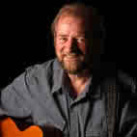
Scottish Folk Singer Ed Miller performing at October meeting

The Houston Scot

Chieftain’s Letter,

Well folks, it’s that time again. Another month has gone by.

September’s program on the Kassel raid and the involvement of Past Chieftain Don Whitefield was very enlightening. The presentation of the program was very affective and very well attended. Jack Hume’s presentation of a model of a B-24 bomber to Don Whitefield was very touching. All in all, it was one of our better programs.

Our next meeting will be held on October 22, 2007. Our program at that time will be a second visit by Ed Miller. As many of you know, Ed Miller is originally from Edinburgh and is now a resident of Texas. Those of you, who attended the meeting last year, were treated to a wonderful selection of Scottish folksongs. I am sure Ed has lined up an impressive performance for us again this year. The only way Ed Miller could make his show more entertaining is if he played the bagpipes also. Well, nobody is perfect. You can’t afford to miss this one, let’s pack the room for him.

Remember, the tickets for the 2008 Burn’s Supper go on sale, for members only, on the first of November, 2007. Non-member sales start the first of December. Do not wait until the last minute to order your tickets or you might get left out.

Our last Burn’s Supper Planning Committee meeting was cancelled at the last minute due to a death in Cheryl May’s family. The Heather and Thistle Society want to extend our well wishes and our deepest sorrow to Cheryl over her loss.

A point of housekeeping is in order at this time. Prior to our two month break we were unable to schedule a presentation of checks to the St. Thomas Pipe Band and the St. Thomas Highland Dancers. I was not comfortable holding the checks for a prolonged period of time. Therefore, at the end of August or the first of September, I took both checks down to St. Thomas’s school office.

That’s all for now!
See you at the October Meeting.
Your Chieftain,
Ken Sorrels

Heather & Thistle Society – Minutes
24 September 2007
Chieftain Dr. Kenneth Sorrels called the business meeting to order at 7:33 pm in the auditorium of the St. Thomas Episcopal School. The motion was made to accept the June 25, 2007 minutes as published in the newsletter. Motion passed.
Discussion: A correction to the corrections reported from May’s meeting was made when it was noted Dr. Arthur Down was not mentioned in the May meeting minutes. One can guess the reported misspelling was from the 2007 updated Membership Directory.

Treasurer Report: Dr. Robert Moore reports the bank balance to be $3493.04. As of 9/24/07 H & TS has received $745.00 and spent $139.69. “The Burns Supper Committee” account has $1411.41 and has received $1.50 in interest. The motion was made to accept the treasurer’s report. The motion passed.
Discussion: It was noted by Jack Hume that the “The Burns Supper” account mentioned by Dr. Moore is in fact “The Past Chieftain’s Reserve Account”.

Membership Report: Eileen Moore reports 107 family, 45 single, 33 life, 40 exempt, 4 complimentary memberships for a total of 229 members. The total number of non-paid memberships is 45. The deadline for membership payment allowing discounted Burns Supper ticket purchase is Sept. 30, 2007. It was further reported that unpaid members would be dropped from the Membership Directory rolls. The motion to accept the membership report was made and passed.
Discussion: Jack Hume expressed concern for the 45 non renewing members.

Committee Reports called for by Sub-Chieftan Robert Boyd

H&T Minutes continued:

Burns Club: Jack Hume reports the Burns Club is this year’s sponsor of the Robert Burns Association of North America 2008 Conference. The conference is a cruise on the “Carnival Ecstasy”, departing from Galveston and will be a 5-night voyage in the Gulf of Mexico from March 3 –8, 2008. 37 people have already signed up for the cruise. For further information refer to the H&TS website or contact johnhume2@peoplepc.com.

Burns Supper: Chair Cheryl May reported as of the Sept. 12, 2007 meeting much has been accomplished including, procurement of a band, finalizing the Jan. 19, 2008 date and prices, members $55.00 nonmembers $70.00, location Westchase Marriott and the decision that the Houston Highlanders and members of the RSCDS will receive members priced tickets. Joan McClure will begin accepting member ticket requests on Nov. 1st with all payments due by Nov. 30. Nonmembers may begin purchasing tickets on Dec. 1st.

Past Chieftains: Chair Dr. Walter May reports the PC Committee, whose members include himself, Cheryl Duthie May, Jim Monteith, Becci Himes and Paul Ross for Aaron Buchanan, officially began working this month in conjunction with the Burns Supper Committee on the annual event.

Programs: Mark Monroe reports the following programs will be offered: Oct. 22, 2007 Scottish folksinger and folklorist Ed Miller; Nov. 26, 2007 Royal Scottish Country Dance Society demonstration and mini lesson; Dec. 17, 2007 H&TS Annual Christmas Party with White Elephant Gift Exchange; Jan. 28, 2008 presentation of poems and songs of Robert Burns presented by the Robert Burns Club of Houston; Feb. 25, 2008 a narrative/history of the bagpipe and traditional dances by the 2006 World Champion St. Thomas Episcopal Pipe & Drum Band and the Competitive Scottish Highland dancers.

Sunshine: Eileen Moore reports Mary E. Walker’s grandson was killed in Iraq and she will send a card from our membership to extend our condolences.

Newsletter: Editor Jim Monteith reports emailing 70 newsletters & sending 91 by surface mail.

Houston Grampian: Bob Gilbert reports the Grampians will be going to Aberdeen in 2008 at the end of August or the first week of September.

Houston Highland Games: Melvyn Douglass reports HHGA received start-up seed money from the Houston Arts Council for the 2008 games and that their final budget for the new year is prepared. Scottish singer Jim Malcolm will be performing at a House Concert at the home of Ros and Paul Shepherd on Nov. 3, 2007. They may be contacted thru the HHGA.

RSCDS: Reece Wyant reports the beginning dance classes are held at the Dad’s Club at Voss Rd. and Highway 10, the advanced
H&T Minutes continued:

classes are held at the King Dance Studio in Bellaire. On Monday an all level class is held in League City at 550 Illinois of Main Street. All classes are from 7:30p – 9:30p. The RSCDS of Texas will hold its business meeting and dance at the Dad’s Club in Houston the first week end in October. Business meetings will be held during the day on Friday and Saturday. After Saturdays meeting there will be a dance. For times and further information call Carol Palmer at 713-776-8531 or Moonyeen Weiss at 713-899-4929.

Houston Highlanders: Kelly Fair reports a busy upcoming schedule for the Houston Highlanders including: St. John Vianney Annual Parish Festival Sunday ca.3 –5PM 10/14, Clear Lake Celtic Music Festival at Clear Lake Park 10/20 in the afternoon they will play for Diana Shipman’s dancers; St. Philip Presbyterian Church 10/28 11 AM processional & recessional; 11/10 Daughter’s of the British Empire Annual Christmas Charity Sale at Fluor Corp. in Sugarland at 10AM, at lunchtime and when Scottish Country Dancers perform; US Marines Birthday Party 11/10 PM performance at private party. The Houston Highlanders meet Mondays at 7 PM at St. Philip Presbyterian Church. For more information contact Kelly Fair at jandk@hal-pc.org or 713-869-0721.

Sergeant-At-Arms report given by Sub-Chieftain Robert Boyd stating there were 33 members and 6 guests present. Guests included Gov. D.L. Clements, Janeal Whitefield, Sam Wilson, Scott Riggins, Bob Smith and Kelly Fair. There are 4 new members as of this meeting. Present was Gordon MacLeod. Other new members were Camille & Rodney Armstrong, Arthur & Anita Brodie, Meg (Margaret) Dee & Joe MacIntyre. Welcome new members and guests!

Old Business: None reported.

New Business: Mark Monroe requested the use of H &T S tartans and associated items for a Kirkin’ o the Tartans at Our Lady of Walsingham Catholic Church, 7809 Shadyvilla Lane in Houston on Saturday, Nov. 17th, 2007 at a 12:15 mass. The service is in honor of the feast of St. Margaret our Lady of Scotland. The Pipers from St. Thomas Episcopal School will perform. OLW is an Anglican use Roman Catholic Parrish and is located just north of I 10 off Wirt Road. The request was voted on and approved by the membership.

Sub-Chieftain Robert Boyd reported his brother-in-law, Robin Mills, has volunteered to be H&TS website master for a while. He has been able to bring the site up to date and left the format unchanged under a different internet address. The membership voted (happily) to allow this change to occur.

After a Robert’s Rules of Order clarification by Mark Monroe, Secretary Ardeth Brodie requested the time of the Annual Christmas party be extended from the usual 7:30 – 9:30 PM to 7 - 10 PM. Membership voted and will allow the change FOR THE CHRISTMAS MEETING ONLY! Arrangements were cleared with St. Thomas.

Jack Hume offered to make certain those 45 non-renewing members were contacted, asking that this effort precede their removal from H & TS membership documents. Membership Chair Eileen Moore and Treasurer Dr. Robert Moore agreed to the suggestion.

Melvyn Douglass reported that Ed Young has died. Sunshine Committee chair Eileen Moore will extend H & T S condolences via a card.

The business meeting adjourned at 8:11 PM.

This month’s program, arranged and sponsored by Jack Hume, followed the business meeting and was a video and discussion of the WWII Kassel bombing raid on Germany. The film featured both the American and the German perspectives. Don Whitefield and Lyman Matheson (former Chieftains and Capt. and Lt. respectively) spoke to the audience concerning their WWII experiences.

Next month’s meeting date will be Oct. 22, 2007.

2008 Robert Burns Cruise and Robert Burns
Association of North America (RBANA)
AGM and Conference
March 3rd 2008 for Five Nights aboard the Carnival Cruise Ship “Ecstasy”, from Galveston, Texas to Progreso and Cozumel, Mexico
For registration or information contact Jack Hume at 713-665-1431(home), 713-882-7763(cell), or johnhume2@peoplepc.com
For travel reservations or questions contact Maureen Dixon 281-333-3124 or 281-660-5721, or nasatravel@comcast.net

Heather and Thistle Society Presents the 55th Annual Robert Burns Supper and Gala Ball on January 19, 2008 at the Houston Marriott Westchase, 2900 Briarpark Drive, Houston, Texas 77042
Tickets for members are $55.00 each and for non-members $70.00 each.
Tickets go on sale to H&T members on November 1st, 2007 and to non-members on December 1st, 2007.

Kirking ‘O’ The Tartans

Member Mark Monroe has arranged a Kirkin ceremony on Saturday, November 17, 2007 at 12:15pm at Our Lady of Walsingham Roman Catholic Church, 7809 Shady Villa Lane, Houston, Texas 77055. The church is located off of Wirt Road about one mile north of IH-10. The Kirkin ceremony is scheduled one day after the feast of Saint Margaret of Scotland which is celebrated Nov. 16.
Past Chieftain Zoe Alexander

Barbara Zoe(Bagby) Alexander (1948 – 2007) age 59, of Smithsville, Texas, passed away from injuries received in a car crash on Thursday, October 4, 2007. She was driving home from work in Austin last Thursday evening when a car crossed the
highway median and slammed into the driver's door of her van, killing her instantly.
She was a paralegal in Austin, Texas at the time of her death. Previously living in Rio Hondo she was a 1967 graduate of Rio Hondo High School. She loved working in her yard, making jewelry, singing, and Renaissance Festivals.

Zoe Alexander, Past Chieftain of the Heather and Thistle Society (1994-1995) and a stalwart performing member of the Burns Club group. For those who did not Zoe, she was a real live-wire and a talented artist in many ways. To see her work go to her website at www.renaizance.com.
Barbara is survived by her two sons, Richard Ferrell (Jennifer) of Austin, TX and Robert Ferrell (Nancy) of the Woodlands, TX; three grandsons, David and Michael Ferrell of The Woodlands, and Ian Ferrell of Austin, TX; two granddaughters, Maddie and Valerie Ferrell of Austin, TX; her mother and step-father; JuaNita and John Brodecky of Rio Hondo; her father, Clyde Bagby Jr., of Seaside, OR; three sisters, Claudia Cox (Doug) of Combes, TX, Christine Heinrich of Pagosa Springs, CO, and Renee Bagby of Fredricksburg, TX; two nieces, Melanie Heinrich of Houston, TX and Heather Cox of San Marcos, TX; two nephews, John –David and Patrick Heinrich of Fredricksburg, TX.

Zoe is to be cremated and there will be a memorial service at her lovely home which she named “Avalon on Lake Nowanthen” on Saturday October 27, 2007. Contact Mary Walker at walker_mary_e@hotmail.com for directions or go to the Scottish Council website at scottishcouncil@yahoogroups.com. You may also call 512-360-4888 or 713-818-4799 for directions. It is hoped her friends from the Scottish community in Houston will be able to attend, wearing their kilts and full regalia. The family is in need of a piper and if you know of anyone who would like to come and honor the memory of this great lady with their piping skills please contact the family.

Those desiring to do so may make memorial donations to P.A.W.S. in her name or the charity of choice. For further information email ricjenfer@hotmail.com and we will contact you as soos as possible.

Ed Miller Performing
Ed Miller, originally from Edinburgh, Scotland, is based in
Austin. He is one of the finest singing products of the Scottish folk revival, having progressed from Edinburgh folk clubs and pubs to being in great demand throughout North America. Ed’s repertoire of Scottish folksongs covers the whole spectrum from Robert Burns to 20th century songwriters. He has 6 CD’s to his credit that all highlight a rich and appealing voice “as strong and satisfying as a good single malt whisky”. Texas Scottish Events:
Clear Lake Celtic Music Festival, Oct. 20th, 2007 at Landolt Pavilion at Clear Lake Park, Noon to 10pm, Nasa Road One
Austin Celtic Festival, Nov. 3 and 4th, 11am – 8pm, Fiesta Gardens on Town Lake in Austin
Jim Malcolm – Scottish Folk Singer performing a house concert at the home of Ros and Paul Shepherd on Nov. 3rd. More information available thru Houston Highland Games Association
46th Salado Scottish Clan Gathering & Highland Games, Nov. 9 thru 11, located 8 miles south of Belton on IH-35 or 50 miles north of Austin at the Robertson Ranch.
St. Andrew’s Day, November 30th

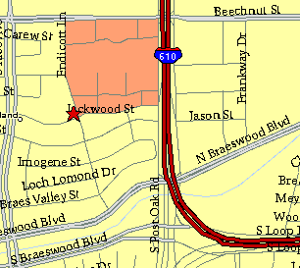

Meeting Information

Meeting Place:
St. Thomas Episcopal School
4900 Jackwood
Houston, Texas 77096

Date and Time:

Fourth Monday of the month
7:30 pm

Heather & Thistle Society Statement
And Membership Information

The Heather and Thistle Society was founded in 1953 by Scots living in Houston who wished to “cultivate an interest in and fond recollections of Scotland, its history and traditions, its literature and ideals, its minstrelsy and song, its customs and amusements, and to provide opportunities for good fellowship and social contact through typically Scottish functions, so that the blessing of our Scottish culture may never die in our new homeland”.

The Heather and Thistle Society meets 10 times a year, September through June. Programs include music, singing, dancing, lively lectures, slide shows and movies about Scotland. The Heather and Thistle Society puts on the annual Robert Burn’s Supper and Ball in late January of each year. We are an organization that promotes our Scottish heritage, in various ways.

The Heather and Thistle Society’s monthly newsletter, “The Houston Scot” is published from September through June. Original articles, information about Scottish or related events are welcome and should be sent to the editor, Jim Monteith, at 15703 Mound Road, Hockley, Texas 77447 or 936-931-2588.

Membership in the Heather and Thistle Society is open to all with an interest in Scottish heritage and culture. Annual dues are $15 for an individual and $20 for a family membership. Applications for membership may be obtained from our website
http://heatherandthistle.org/documents/membership.doc
Dues are due at the beginning of the fiscal year, March 1. Completed applications and membership fees should be mailed to: Mrs. Eileen Graham Moore
8910 Sandstone, Houston, Texas 77036-6132
For membership information please call Eileen at 713-774-0314.

