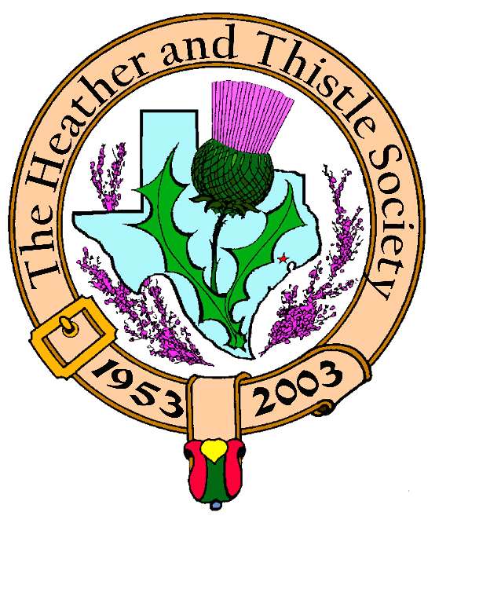

Heather & Thistle Society

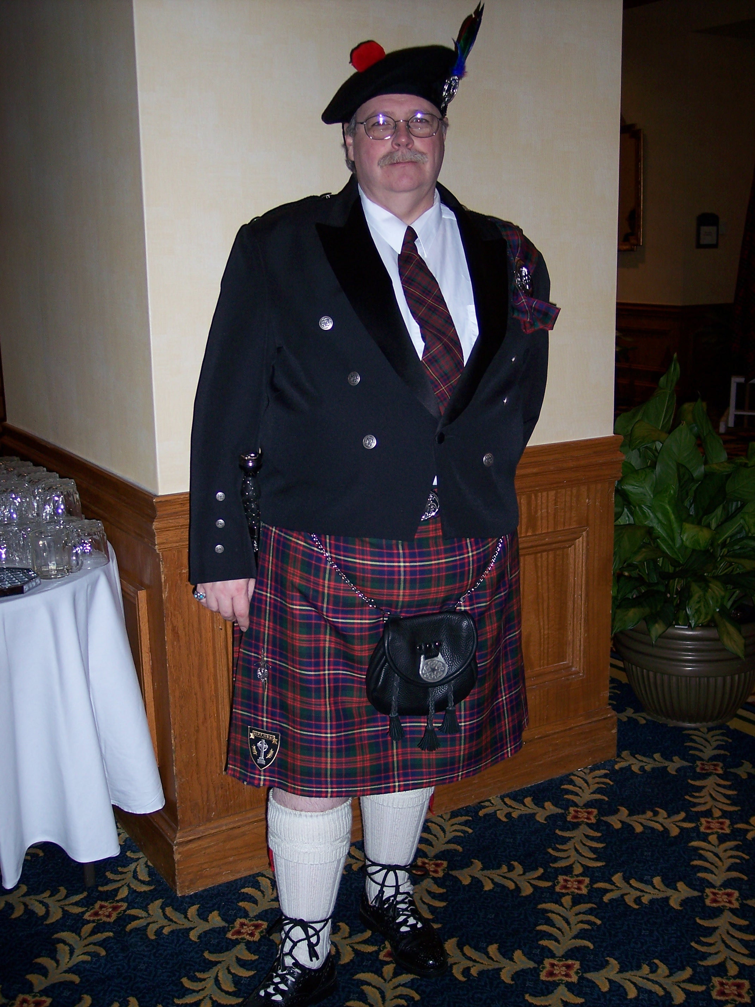
Chieftain Ken Sorrels

Volume 8, Issue 1
September, 2007

Newsletter Editor:
Jim Monteith

Officers:

Chieftain – Ken Sorrels
Sub-Chieftain – Robert Boyd
Sgt.-at-Arms – vacant
Secretary – Ardeth Brodie Treasurer - Robert Moore

Committee Chairs:

Sunshine-Eileen Moore
Membership-Eileen Moore
Past Chieftains- Walter May
Burns Supper-Cheryl May
Publicity-Melvyn Douglass
Programs-Mark Monroe

*H&T members must have membership dues paid up in full for the year by Sept. 30, 2007 in order to get the $55.00 member price tickets for the upcoming 2008 Burns Supper.

The Houston Scot

Chieftain’s Letter,

Well folks, summer vacation is over. In the famous words of Gene Autry, it is time to get “Back in the Saddle Again.”

As I sit here composing this letter, it is 9/11. Six years have passed since that terrible day, but to me it still seems like it just happened. I hope that none of our members lost anyone that day. However, we all lost something that day. We all feel more vulnerable and less secure than we once did. We were forced into the realization that we in this country are not untouchable. We may be able to be hurt, but unless we lose our conviction, unless we lose sight of the lessons we have learned, we can not be defeated. NEVER FORGET!

June’s program on the career of General Douglas McArthur was a great success. Judging from the number of questions that were asked, it was enjoyed by all.

After 2 months off, I will enjoy seeing all of you again. While we were gone, Ardeth Brodie went to Scotland (boy am I jealous) and Walter May had a birthday, with party. (It was a surprise to!) Those of you that missed Walter’s birthday party missed out on a real good time. Boy, Cheryl pulled out all the stops on this one. In addition to all that good food, there was a haggis procession, complete with piper, haggis bearer, scotch bearer, and sword bearer. Bob Gilbert did the honors of addressing the haggis and we toasted the haggis with a wee dram of Glenlivet. Then Walter invited anyone who had never tasted haggis to come up and try some. There were a few that took him up on the offer.

In the last Chieftain’s Letter, I mentioned that there were several members that at that time had not paid their membership dues. Well, that deadline by which you have to have your dues paid if you want to get membership prices on Burns Supper tickets will be here before you know it. Do not let it slip by you!

Let us set a goal to have record attendance at our last four meetings this year. Smoky the Bear said, “Only You Can Prevent Forest Fires.” Well, I don’t know about forest fires, but why don’t we all get on fire for our Heather and Thistle Society!

That’s all for now!
See you at the September Meeting.
Your Chieftain,
Ken Sorrels
September 24, 2007 Heather and Thistle Program
(from Jack Hume)

Please plan to attend a VERY special meeting of the Heather and Thistle Society, and bring as many guests as you can. Monday, September 24th we will be honoring veterans of all services, from all countries. Veterans and family members are requested to attend wearing some uniform item, or other token of your, or a loved one’s service.
That evening we will feature a film of a “World War Two” bombing raid. It is an understatement that our side did not do well on this day-light bombing of Germany. Both US and German footage of the action is included. This film and that raid have special significance for Heather and Thistle Past Chieftain Don Whitefield. Captain Whitefield was navigator of his B24 bomber, it being one of only two of thirty five planes in his group to survive. He was right and the lead planes navigator was wrong which led to this catastrophe; the largest group loss in 8th Air force history.
We owe a great deal to those who serve, or have served; particularly those killed or maimed; and the carnage still goes on!
Member Mary Walker’s Grandson, has just been killed in Iraq.

From Helen Mann:

And a Scottish joke that I recently got from friends in Glasgow:

A Scottish man walking through a field sees a man drinking water from a pool with his hand.

The Scottish man shouts "Awa ye eijit, can yeh no tell that's foo o coos keich". (Translation: You fool Stop at once! Don't drink the water, it's full of cow s **t.)

The man shouts back "I'm English, Speak English, I don't understand you".

The Scottish man shouts back "Use both hands, you'll get more in."

From Ardeth Brodie:

Beginning with the Sept. 24th, 2007 H&TS meeting we will maintain a memory book/photo album of the society’s activities. The album will be present and updated at all meetings and will be available for all members and visitors to view and enjoy. Anyone taking photos (in addition to the “official” ones made monthly) or wishing to be included in creating this new project please contact Ardeth Brodie 281-639-1036 (cell) or 713-740-0688 (work).

Clear Lake Celtic Music Festival Oct. 20th, 2007 12 noon – 10 PM at Clear Lake Park, Landolt Pavilion. Admission $10.00.

Heather & Thistle Society – Minutes
June 25, 2007

Tonight’s program was presented first this evening. The 20 members present were treated to an excellent presentation of the life of General Douglas MacArthur by our guest speaker, retired General John Bradley.

Chieftain Dr. Kenneth Sorrels called the business meeting to order at 8:55 pm in the theater of the St. Thomas Episcopal School. The motion was made to accept the May 2007 minutes as published in the newsletter. Motion passed. There were two errors in the minutes from May that were mentioned. Member Arthur Down’s last name was misspelled and new member Carmelita Orr’s first name was misspelled.
Treasurer Report: Dr. Robert Moore reports the H&T checking balance to be $2215.35 H&T savings account balance is $1410.70. H&T Burns Supper account has a balance of $25,818.45. For fiscal year 2007 H&T had $34,432 in total income and $35,671.97 in total expenses. The motion was made to accept the treasurer’s report. The motion passed.
Membership Report: Eileen Moore reports 102 family, 47 single, 33 life, 40 exempt, 4 complimentary memberships for a total of 226 members. The total number of unpaid memberships is 38. The motion to accept the membership report was made and passed.

Committee Reports called for by Sub-Chieftain Robert Boyd.

Burns Club: The Burns Club is out for their summer break. Several members are going to Winnepeg in August for a joint meeting of the World and North American Burns Federations. Our Burns Club will be hosting the 2008 North American summer meeting and it will be held on a cruise ship starting March 3, 2008. More details will be forthcoming at future H&T meetings.
Burns Supper: Cheryl May reports a lot of time has been spent arranging the date of the 2008 Supper. The Hotel has had several management changes and then they leased the room to a larger group. The Supper will be on January 19, 2008. Planning committee next meeting is July 17 and Joan McClure’s.

Past Chieftains: Walter May reports the H&T fiscal year ended May 31. H&T has never had annual reporting but will start now. The PCC is working on the taxes and fiscal reporting. A lot of H&T’s funds are donated to other organizations.
Programs: Mark A. Monroe reports the September meeting will be sponsored by Jack Hume and will be a documentary film of a United States bombing raid on Germany during World War II.
Sunshine: Eileen Moore reports she sent a card to Dr. Arthur Down who has been ill and in the hospital.
Newsletter: Editor Jim Monteith reports emailing 75 copies and mailing 90 hard copies.
Houston Grampian: No report
Houston Highland Games: No report.
RSCDS: Reece Wyant reports meetings are on Thursdays at the YMCA Dad’s Club.
Houston Highlanders: No report
Sergeant-At-Arms: Sub-Chieftain Robert Boyd reports 20 members present.
Old Business: None.
New Business: None.

Meeting adjourned at 9:15 PM.

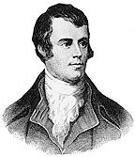

Heather and Thistle Society Presents the 55th Annual Robert Burns Supper and Gala Ball on January 19, 2008 at the Houston Marriott Westchase, 2900 Briarpark Drive, Houston, Texas 77042

Tickets for members are $55.00 each and for non-members $70.00 each.

Tickets go on sale to H&T members on November 1st, 2007 and to non-members on December 1st, 2007.

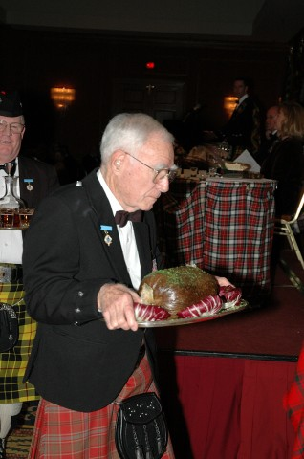 2008 Robert Burns Cruise and
Robert Burns Association of North America (RBANA)
AGM and Conference
March 3rd 2008 for Five Nights

From Galveston, Texas to Progreso and Cozumel, Mexico

Aboard the Carnival cruise ship “Ecstasy”

Current rates; Main Deck
Double occupancy; Outside cabin; $496.99 U.S. per person
Double occupancy; Inside cabin; $466.99 U.S. per person

All meals, gratuities, taxes and government fees included
Only alcoholic beverages and side-trips extra

RBANA Conference no fee payable

Includes Burns sessions and two dinners

Registration and/or questions; e-mail preferred, to Jack Hume

johnhume2@peoplepc.com
713-665-1431 home or 713-882-7763 cell
Travel: reservations and/or travel questions, e-mail preferred,
to Maureen Dixon
nasatravel@comcast.net

Office 281-333-3124 or cell 281-660-5721

Fifty cabins on main deck have been reserved for our group.
Accommodations at these prices will go fast.
PLEASE BOOK AS SOON AS POSSIBLE
Hosted by Heather and Thistle Society Burns Club of Houston,Texas
_________________________________________

Robert Burns Association of North America
2008 Conference
The Heather and Thistle Society
Robert Burns Club, Hosts.

Registration fee; ZERO

Please register the following;

Name _________________________________________________

Address

Phone email
____________________ _____________________

Mail or email to Jack Hume johnhume2@peoplepc.com
5307 Aspen Street
Bellaire, Texas 77401 4919
Home 713-665-1431 or cell 713-882-7763

Will book cruise thru NASA Travel ___________
Will make own cruise arrangements ____________

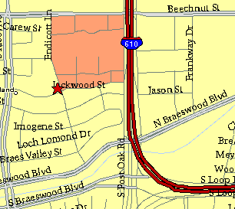

Meeting Information

Meeting Place:
St. Thomas Episcopal School
4900 Jackwood
Houston, Texas 77096

Date and Time:

Fourth Monday of the month
7:30 pm


Heather & Thistle Society Statement
And Membership Information

The Heather and Thistle Society was founded in 1953 by Scots living in Houston who wished to “cultivate an interest in and fond recollections of Scotland, its history and traditions, its literature and ideals, its minstrelsy and song, its customs and amusements, and to provide opportunities for good fellowship and social contact through typically Scottish functions, so that the blessing of our Scottish culture may never die in our new homeland”.

The Heather and Thistle Society meets 10 times a year, September through June. Programs include music, singing, dancing, lively lectures, slide shows and movies about Scotland. The Heather and Thistle Society puts on the annual Robert Burn’s Supper and Ball in late January of each year. We are an organization that promotes our Scottish heritage, in various ways.

The Heather and Thistle Society’s monthly newsletter, “The Houston Scot” is published from September through June. Original articles, information about Scottish or related events are welcome and should be sent to the editor, Jim Monteith, at 15703 Mound Road, Hockley, Texas 77447 or 281-924-3073.

Membership in the Heather and Thistle Society is open to all with an interest in Scottish heritage and culture. Annual dues are $15 for an individual and $20 for a family membership. Applications for membership may be obtained from our website
http://heatherandthistle.org/documents/membership.doc
Dues are due at the beginning of the fiscal year, March 1. Completed applications and membership fees should be mailed to: Mrs. Eileen Graham Moore
8910 Sandstone, Houston, Texas 77036-6132
For membership information please call Eileen at 713-774-0314.

