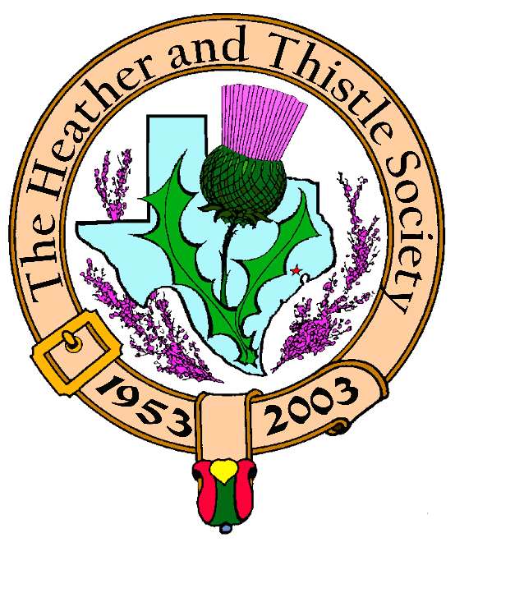

Heather & Thistle Society

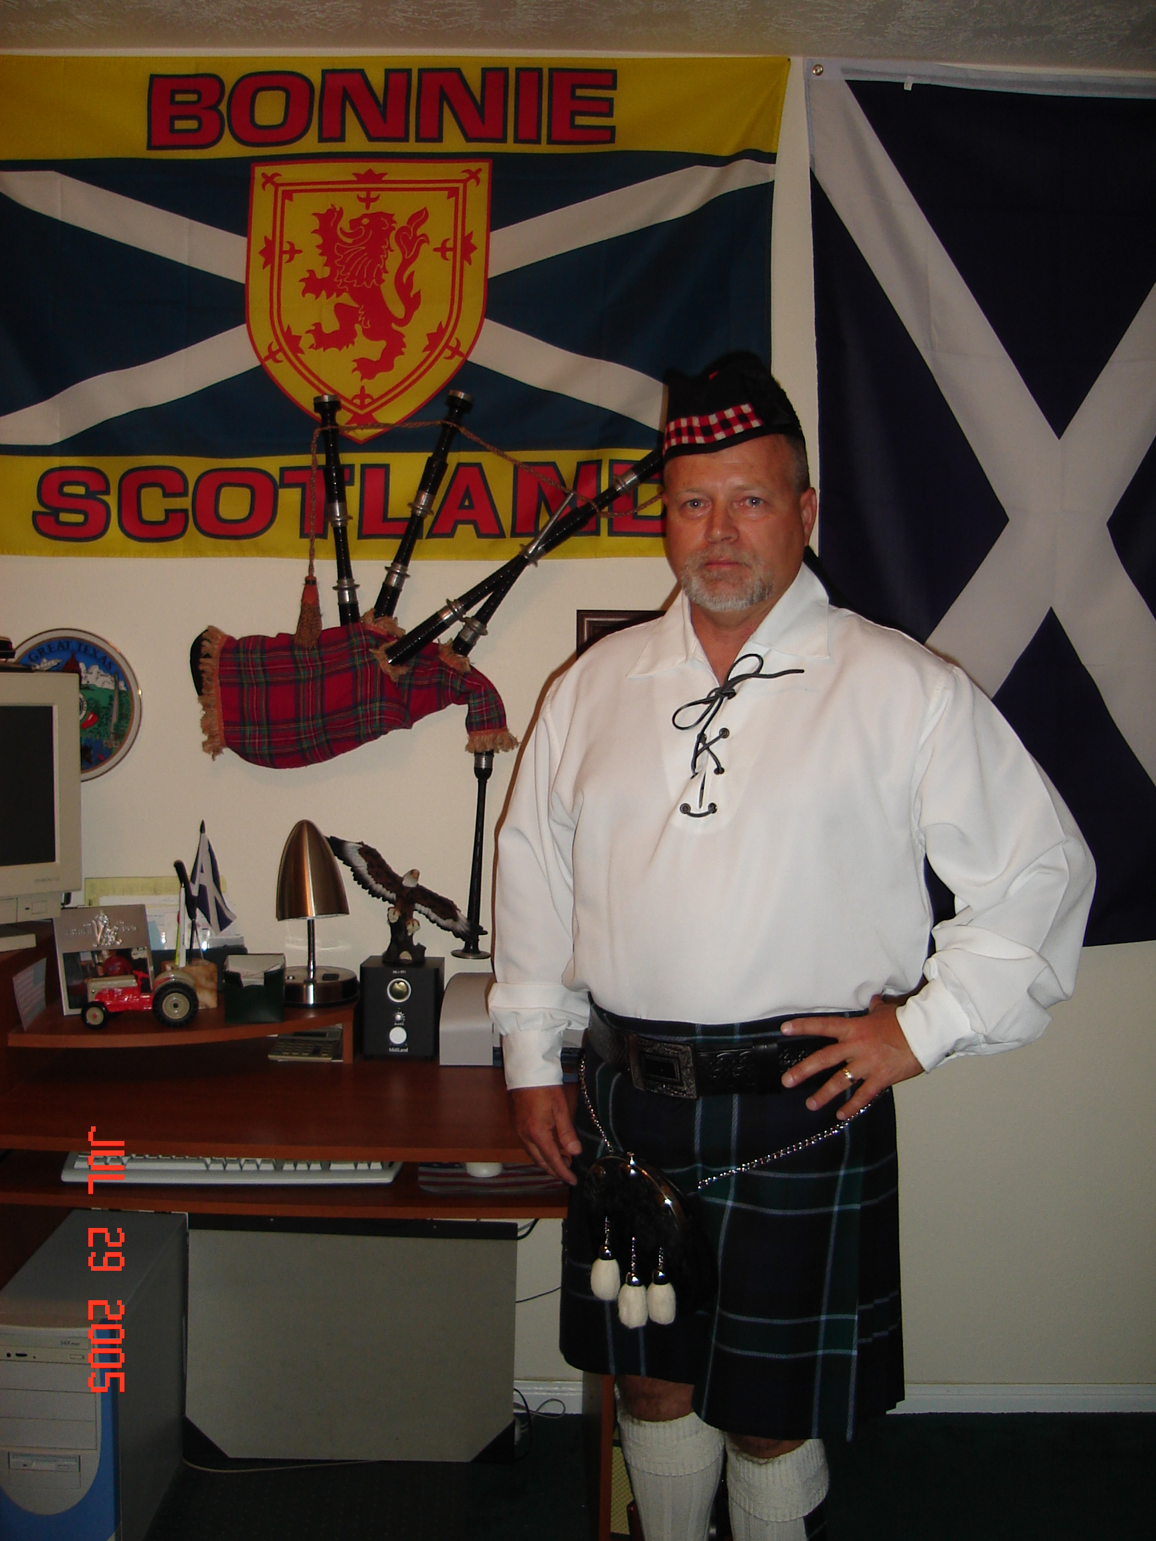
Chieftain Jim Monteith

Volume 7, Issue 2
October, 2006

Newsletter Editor:
Jim Monteith

Officers:

Chieftain – Jim Monteith
Sub-Chieftain – Ken Sorrels
Sgt.-at-Arms – Chuck Monteith
Secretary - Sharon Monteith Treasurer - Robert Moore

Committee Chairs:

Sunshine-Eileen Moore
Membership-Eileen Moore
Past Chieftains-vacant
Burns Supper-Walter May & Becci Himes
Publicity-Melvyn Douglass
Programs-Cheryl May



The Houston Scot

Chieftain’s Letter,

Fall at last! Hopefully, no more summer heat for awhile. It’s finally getting to be Highland wear season in Houston again.

We had a pretty good member turnout for our September 2006 meeting. Twenty eight members and fifteen guests attended and enjoyed the musical performance of the “Celtaire String Band”. I would like to thank all the members that brought snacks and goodies for our refreshment break. I think our guests were happy and impressed. Once again, thanks to member Mark Monroe, for having Celtaire perform for our Society. I think Mark is going places with this organization. A future Chieftain, I hope.

Eileen Moore informed members at our September 2006 business meeting that a Chinese buffet will be available for about $3.00 per person after our fall Kirkin O’ the Tartans at St. Paul’s Presbyterian Church. I will need an approximate head count on attendance at the Kirking. Please contact me by phone or email and advise me if you plan on attending the Kirking. St. Paul’s Presbyterian is at 7400 Bellaire Blvd. in Houston. The Reverend Dr. Kevin Boyd will be delivering the service on November 12, 2006. Eileen and Dr. Robert Moore have attended this church for many years and it is my understanding that Rev. Boyd has been ill recently. I would like to send our regards and prayers to Rev. Boyd and hope he is well soon.

I hope the visit of the Aberdeen Scots went well for the Houston Grampian Association. I know many of our members were very busy making their trip enjoyable.

We have another fantastic musical performance coming up at our October, 2006 meeting. Scottish Folk Singer and Musician Ed Miller will be performing for our Society. Member Mark Monroe is sponsoring Mr. Miller. Ed is a very fine, world class, Scottish Folk Music performer. Invite friends and family for this event. We have plenty of room in the auditorium at St. Thomas. Let’s fill it up! Members please bring plenty of snacks and goodies for our guests. Our November 2006 meeting program will be dancing with RSCDS. Our annual Christmas party is slated for our December 2006 meeting. In 2007, member Mark Monroe, has been lining up some interesting speakers. I think Mark would make a good program director. I wonder if he is trying to get Cheryl May’s job. I’m sure she would not mind.

I am getting concerned about our membership renewals. Dr. Moore has recently removed around seventy members from the rolls due to non-payment of annual dues. I hope this trend soon reverses. See y’all at the October meeting.

Chieftain Jim Monteith
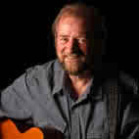 Don’t miss Ed Miller’s performance!!!!!!!!
Scottish Historical Events
For September

Sept. 1, 1643 – Battle of Tippermuir – Highland army under Montrose defeats larger army of Covenanters despite the latter’s battle cry of “Jesus and No Quarter.”
Sept. 3, 1650 – Battle of Dunbar, Scotland. Cromwell’s victory over Scottish Covenanters.
Sept. 3, 1801 – Alexander Shanks, Scottish inventor of the lawnmower, born.
Sept. 5, 1750 – Robert Fergusson, Scottish poet, born
Sept. 6, 1715 – First Jacobite Rising begins as the standard of James III is raised at the Braes of Mar, Aberdeenshire, Scotland.
Sept. 7, 1736 – Porteous Riots against English taxation, Edinburgh.
Sept. 8, 1820 – John Baird and Andrew Hardie, leaders of 1820 Scottish revolt, executed.
Sept. 9, 1513 – James IV of Scotland killed at the Battle of Flodden.
Sept. 9, 1758 – Alexander Nasmyth, “the father of Scottish landscape painting,” born.
Sept. 10, 1890 – Mortimer Wheeler, Scottish archaeologist of Celtic Britain and Brittany, born.
Sept. 11, 1297 – Victory of Wallace at Stirling Bridge, Scotland.
Sept. 11, 1997 – Scottish referendum approves proposal for a Scottish Parliament
Sept. 12, 1715 – Battle of Sheriffmuir, Scotland.
Sept. 12, 1855 – “Fiona MacLeod” (William Sharp), Scottish poet and prose writer, born.
Se[t. 13, 1645 – Montrose defeated at Philiphaugh, Scotland.
Sept. 13, 1912 – In a speech at Dundee, Winston Churchill announces his support of devolution for Ireland, Scotland, and Wales.
Sept. 18, 1812 – Kirkpatrick MacMillan, Scottish inventor of the pedal bicycle, born.
Sept. 18, 1905 – George MacDonald, Scottish fairy tale author died.
Sept. 20, 1842 – James Dewar, Scottish inventor of the steel vacuum flask called a “dewar”, born.
Sept. 28, 1396 – Battle at the North Inch of Perth, Scotland.


Heather & Thistle Society – Minutes
Sept 25, 2006

Our program tonight was a musical performance of the “Celtaire String Band. The band played a wonderful assortment of Scottish Folk Music. Much thanks to member Mark Monroe for arranging their performance.

Chieftain Monteith called the business meeting to order at 8:55 pm in the auditorium of the St. Thomas Episcopal School. Motion was made to accept the June, 2006 minutes as published in the newsletter. Motion passed.
Treasurer Dr. Robert Moore reports a $2,238.25 bank balance. Dr. Moore brought up the Washington Mutual Bank charges our Society has been incurring every month. Jack Hume has been checking into this situation and believes we will be refunded soon.
Membership Chairperson Eileen Moore reports we have 80 family, 40 single, 32 life, 39 exempt, and 4 complimentary, for a total of 195 members. There are very many members past due.

Committee Reports called for by Sub-Chieftain Ken Sorrels.

Burns Club: Jack Hume reports that the Robert Burns Association of America met in Nova Scotia during the summer and has accepted our invitation to have their conference in Houston in 2008.
Burns Supper: Becci Himes reports tickets go on sale Nov. 1st to paid up members. Supper will we held at the Marriott Westchase again.
Past Chieftains: Becci Himes reports the committee is working on the Burns Supper.
Programs: Member Mark Monroe reports Scottish Folk Singer Ed Miller will be performing at our October 2006 meeting. November 2006 meeting will be dancing with RSCDS. December 2006 will be our annual Christmas Party. Member Mark Monroe has been lining up several speakers for 2007.
Sunshine: Eileen Moore reports Mary Ross had surgery.
Newsletter: Editor Jim Monteith reports he has changed his email address and it is posted on the Heather and Thistle website.
Houston Grampian: Cheryl May asked the Chieftain to announce the schedule for the Aberdeen visitors and request H&T members to attend if possible.
Houston Highland Games: Scheduled for May 11, 12, and 13th of 2007.
RSCDS: No report.
Houston Highlanders: No report.

Sergeant-At-Arms Chuck Monteith reports 28 members present and 15 guests. Most of the guests left after the musical performance. Arthur and Carina Trull stayed for the business meeting. Mr. Trull is Chieftain Monteith’s father-in-law. Mr. Trull related a story from his youth when he watched his grandfather play the bagpipes in Leesville, Louisiana. He stated his grandfather was usually drunk when he played and Arthur was scared of the bagpipes and thought they were a big spider.
Old Business: None.
New Business: Kirking O’ the Tartans date has been changed to November 12, 2006. Location will still be at St. Paul’s Presbyterian on Bellaire at Hwy. 59. A Chinese lunch will be available after the Kirking for $3.00 per person. Member Ardeth Brodie announced that on Saturday, October 21, 2006 the Clearlake Celtic Festival will be held. She also advised of the Dicken’s on the Strand Festival on the first weekend of December. Sub-Chieftain Ken Sorrels stated that a half dozen pipe bands will be performing at Dicken’s on the Strand and admission is free if you dress in proper period costume, which includes Highland wear. Ed Miller will be visiting Ms. Brodie’s school , where she teaches, on the Tuesday after he performs at our October 2006 meeting. The school is Pearl Hall Elementary.

Meeting adjourned at 9:25 PM.

Scottish Historical Events
For October

Oct. 1, 1283 – Invasion of Scotland by Haakon, King of Norway, aatacked on the beaches by gathering Scottish forces, beginning the Battle of the Largs.
Oct. 2, 1854 – Patrick Geddes, Scottish botanist, born.
Oct. 3, 1842 – Henry Gray Graham, Scottish historian, born.
Oct. 4, 1780 – Alexander Laing, Scottish explorer of Africa, born.
Oct. 5, 1283 – Norwegians abandon invasion of Scotland, leaving ships and wounded men on the beach.
Oct. 9, 1900 – Alastair Sim, Scottish actor, born.
Oct. 9, 1935 – Archibald Thorburn, Scottish ornithologist and painter, died.
Oct. 11, 2000 – Donald Dewar, new Scottish Parliament’s first First Minister, died.
Oct. 14, 1322 – Victory of Robert the Bruce of Scotland, Yorkshire.
Oct. 15, 1686 – Alan Ramsey, Scottish poet, born.
Oct. 16, 1774 – Robert Fergusson, Scottish poet, born.
Oct. 17, 1346 – King David of Scotland captured at Neville’s Cross
Oct. 20, 1938 – Angus MacDonald, instructor and virtuoso of the Scottish bagpipes, born.
Oct. 23, 1921 – John Boyd Dunlop, Scottish inventor of the pneumatic rubber tire, died.
Oct. 26, 1911 – Somhairle MacGhilleathain (Sorley MacLean), Scottish Gaelic poet, born.
Oct. 27, 1736 - James Macpherson, Scottish “translator” of Ossianic poems, born.
Oct. 29, 1740 – James Boswell, Scottish biographer, born.
Oct. 30, 1300 – Edward of England signs truce and abandons invasion of Scotland.
Oct. 31 – NOS CALAN GAEF – Celtic New Year’s Eve.
KIRKING O’ THE TARTANS

Heather & Thistle’s annual Kirking coming up soon – November 12, 2006 10:30am at St. Paul’s Presbyterian, 7400 Bellaire Blvd., Houston
-contact Chieftain if attending

Upcoming Texas Scottish Events

Clear Lake Celtic Music Festival
Landolt Pavillion at Clear Lake Park
October 21, 2006 from Noon till 9PM
Nasa Road 1, Houston

Austin Celtic Festival
November 4 and 5th, 2006
Fiesta Gardens
2102 Bergman Drive, Austin, Texas

Texas Renaissance Festival
8 weekends from October thru November
9 AM till Dusk
Highland Fling themed weekend Nov. 4, 5, 2006

El Paso Celtic Festival and Highland Games
November 18, 2006
Entrepreneur Center
8455 Alamea, El Paso

Salado Scottish Clan Gathering and Highland Games
November 10, 11, 12, 2006
Central Texas Area Museum, Salado (near Waco)
ED Miller - Scotland to Texas
(performing at upcoming October H&T meeting)
Ed Miller, originally from Edinburgh, Scotland, is based in
Austin. He is one of the finest singing products of the Scottish folk revival, having progressed from Edinburgh folk clubs and pubs to being in great demand throughout North America. At the University of Texas, he completed a PhD in Folklore in the 1980’s. He has since graduated to taking his songs, stories, and droll humor to festivals, clubs, concerts and Highland Games all over the country. In Austin, he hosts the “Folkways” show on KUT-FM, highly popular with Texas folk music lovers.
He has also established a reputation as a fine teacher at events like Swannanoa Gatherings in N.C., Alasdair Fraser’s famous Valley of the Moon Fiddle Camp, and the Rocky Mountain Fiddle Camp. In the summer of 2003, Ed was selected as a presenter & performer at the D.C. Smithsonian Folk Life Festival honoring
Scotland.
Ed’s repertoire of Scottish folksongs covers the whole spectrum from Robert Burns to 20th century songwriters. He has 6 CD’s to his credit that all highlight a rich and appealing voice “as strong and satisfying as a good single malt whisky”. 54th Annual Robert Burns Supper

Saturday, January 27, 2007 at Houston Marriott Westchase
2900 Briarpark Drive, Houston, Texas 77042
-tickets available November 1st to H&T members
-tickets available December 1st to non-H&T members

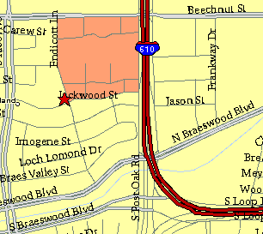

Meeting Information

Meeting Place:
St. Thomas Episcopal School
4900 Jackwood
Houston, Texas 77096

Date and Time:

Fourth Monday of the month
7:30 pm

Heather & Thistle Society Statement
And Membership Information

The Heather and Thistle Society was founded in 1953 by Scots living in Houston who wished to “cultivate an interest in and fond recollections of Scotland, its history and traditions, its literature and ideals, its minstrelsy and song, its customs and amusements, and to provide opportunities for good fellowship and social contact through typically Scottish functions, so that the blessing of our Scottish culture may never die in our new homeland”.

The Heather and Thistle Society meets 10 times a year, September through June. Programs include music, singing, dancing, lively lectures, slide shows and movies about Scotland. The Heather and Thistle Society puts on the annual Robert Burn’s Supper and Ball in late January of each year. We are an organization that promotes our Scottish heritage, in various ways.

The Heather and Thistle Society’s monthly newsletter, “The Houston Scot” is published from September through June. Original articles, information about Scottish or related events are welcome and should be sent to the editor, Jim Monteith, at 15703 Mound Road, Hockley, Texas 77447 or 936-931-2588.

Membership in the Heather and Thistle Society is open to all with an interest in Scottish heritage and culture. Annual dues are $15 for an individual and $20 for a family membership. Applications for membership may be obtained from our website
http://heatherandthistle.org/documents/membership.doc
Dues are due at the beginning of the fiscal year, March 1. Completed applications and membership fees should be mailed to: Mrs. Eileen Graham Moore
8910 Sandstone, Houston, Texas 77036-6132
For membership information please call Eileen at 713-774-0314.

