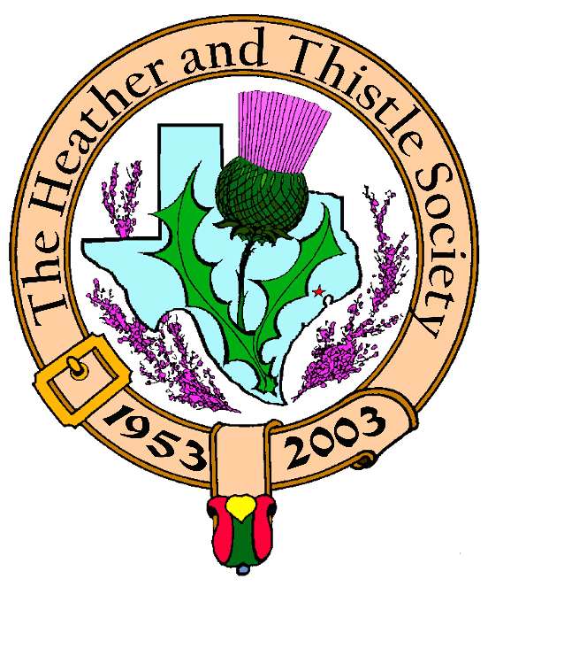

Heather & Thistle Society

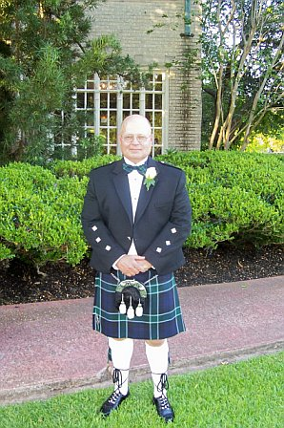
Chieftain Jim Monteith

Volume 7, Issue 1
September, 2006

Newsletter Editor:
Jim Monteith

Officers:

Chieftain – Jim Monteith
Sub-Chieftain – Ken Sorrels
Sgt.-at-Arms – Chuck Monteith
Secretary - Sharon Monteith Treasurer - Robert Moore

Committee Chairs:

Sunshine-Eileen Moore
Membership-Eileen Moore
Past Chieftains-Wayne Barton
Burns Supper-Aaron Buchanan
Publicity-Melvyn Douglass
Programs-Cheryl May



The Houston Scot

Chieftain’s Letter,

Hello everyone! Hope y’all had a good summer. Too hot in Texas during these summers. I wish we could import some nice, cool, Scottish weather for a change. Hopefully the cool fronts will start early this year and keep coming.

We have a wonderful music program coming up at our September 25, 2006 meeting. A big thank you goes out to member Mark Monroe for arranging the upcoming performance of the Celtaire String Band. Be sure to invite friends and relatives to attend so we can fill up the auditorium. Celtaire String Band plays period music from early Texas, America, and Scotland. They performed at the May Houston Highland Games where many of our members enjoyed their music. Mr. Monroe has also arranged for Scottish Folk Singer Ed Miller to perform at our October 23, 2006 meeting. Mr. Monroe has also contacted Program Director Cheryl May and I about arranging for several interesting speakers to appear in 2007. Our November program will be dancing with the Royal Scottish Country Dance Society and in December we will have our annual Christmas party.

The 2007 Burns Supper Planning Committee met on September 5, 2006. Co-Chairs Walter May and Becci Himes have everything on schedule and under control. Unfortunately, it looks like ticket prices for the Burns Supper will be going up, due mostly to Hotel meal prices.

Our fall annual Kirkin O’ the Tartans has now been scheduled for November 12, 2006. Reverend Dr. Kevin Boyd of Saint Paul’s Presbyterian Church will be our host again for this worship service. The church is located at 7400 Bellaire Blvd. in Houston. Let’s have a good member turnout for this event.

Past Chieftain Wayne Barton and wife Brenda Barton announced at the recent Burns Supper Planning Committee meeting that they are moving to the Kerrville area to start a business. The Barton’s have contributed much to our Society over the years and they will be missed. Good luck from all of us on your new venture. We hope you will continue to visit.

In the May 2006 ‘Houston Scot’ member Ellen Johnson’s death was announced. I was notified of two errors in that announcement. Ellen was found expired on March 27, 2006 in her home and not March 24 and Ellen’s birth city was El Campo, Texas and not Victoria.

At our last meeting in June I was advised by our membership director that we had 50 members that were overdue on their membership dues. Our Society has always gone by the rule of having dues paid by the end of September in order to qualify for the membership rate on ticket prices for the Burns Supper.

Chieftain Jim Monteith
*St. Thomas Episcopal Pipe and Drum Band wins 5th World Championship in Scotland. Highland Dancers also place well at the World Championships.
Members of the H&T Society, representatives of the City of Houston, and Harris County officials, friends and family gathered at Bush Intercontinental Airport to welcome home the victorious St. Thomas School group on August 25 as they arrived home from Scotland. The day was pronounced as St. Thomas day by a representative of the County Judge’s office.
Scottish Historical Events
For July & August

July 2, 1266 – Treaty of Perth, Norway renounces claim on Hebrides and the Isle of Mann, ceding them to Scotland.
July 2, 1745 – Prince Charels Edward Stuart sails for Scotland from Nantes, Brittany with seven companions.
July 2, 1782 – Repeal of the proscription Act of 1746.
July 3, 1544 – The Battle of the Shirts, Scotland
July 5, 1295 – “The Auld Alliance” signed between Scotland and France.
July 7, 54 BC – Julius Caesar launches second (failed) invasion of Britain.
July 7, 1930 – Arthur Conan Doyle, Scottish author, died.
Jul7 8, 1988 – Publication of A Claim of Right for Scotland reopens campaign for a Assembly.
July 11, 1274 – Robert the Bruce of Scotland born.
July 15, 1835 – Louisa Stevenson, Scottish women’s rights activist, born.
July 17, 1689 – Battle of Killiecrankie, Scotland. Victory (and death) of “The Bonnie Dundee” leading Jacobite clansmen against forces of William of Orange.
July 19, 1896 – Archibald Joseph Cronin, Scottish author and the original “Dr. Findlay,” born.
July 20, 1912 – Andrew Lang, Scottish historian, died.
July 21, 1796 – Robert Burns, Scottish poet, died.
July 22, 1298 – Battle of Falkirk, Scotland: William Wallace defeated.
July 22, 1976 – Mortimer Wheeler, Scottish archaeologist of Celtic Britain and Brittany, died.
July 24, 1567 – Mary Queen of Scots forced to abdicate throne by English-backed nobility.
July 25, 1843 – Charles Macintosh, Scottish inventor of rubberized fabric raincoat (the Macintosh), died.
August 5, 1745 – Charles Edward Stuart land at Borradale, Scotland.
August 13, 1881 – Alexander Fleming, Scottish discoverer of penicillin, born.
August 8, 1503 – “Marriage of the Thistle and the Rose”: James IV of Scotland marries Margaret Tudor.
August 10, 1316 – Battle of Athenry, Irish rising in support of Edward Bruce of Scotland.
August 11, 1746 – Proscription Act – wearing of kilts or tartans and the playing of bagpipes in Scotland banned by England.
August 11, 1892 – Hugh MacDiarmid (Christopher Murray Grieve), poet and Scottish nationalist, born.

Continued on next page

Heather & Thistle Society – Minutes
June 26, 2006

Our program tonight was member Janet Brown giving a tartan weaving demonstration. Janet has recently moved from Virginia to Houston.

Chieftain Monteith called the business meeting to order at 8:20 pm in the auditorium of the St. Thomas Episcopal School. Motion was made to accept the May, 2006 minutes as published in the newsletter. Motion passed.
Treasurer Dr. Robert Moore reports a $2,065.65 bank balance.
Membership Chairperson Eileen Moore reports we have 102 family, 52 single, 32 life, 39 exempt, and 4 complimentary, for a total of 229 members. 50 members are overdue on their memberships for 2006. .

Committee Reports called for by Sub-Chieftain Ken Sorrels.

Burns Club: No report.
Burns Supper: Aaron Buchanan will soon be moving to Dallas with his job. Walter May and Becci Himes will be taking over as Co-Chairmen of 2007 Burns Supper planning Committee. The Committee will meet in September. No word yet from Becci Himes on the photographs taken at this years Burns Supper.
Past Chieftains: Walter May advised that a replacement for Aaron Buchanan on the Past Chieftain’s Committee has been found but needs to be voted on by the Committee before releasing the name.
Programs: Cheryl May introduced member Mark Monroe who advises our Sept. 2006 program will be the Celtaire String Band. Scottish Folk Singer Ed Miller will probably be our October 2006 program. The November 2006 program will be dancing with the Royal Scottish Country Dance Society and our December 2006 program will be our annual Christmas party.
Sunshine: No report.
Newsletter: Editor Jim Monteith reports email version of newsletter has been sent out. He is running late on the printed version which will be out this week. The editor found a nice dictionary of Scottish History while in Austin.
Houston Grampian: Walter May advises that our sister city people will be coming over in September. In Scotland the Association is called Grampian Houston and it is 27 years old.
Houston Highland Games: Next meeting will be July 13th here at St. Thomas.
RSCDS: Dancing Thursday nights at the YMCA on Voss and IH-10.
Houston Highlanders: No report.

Sergeant-At-Arms Chuck Monteith reports 16 members present and four visitors. Guests were Elizabeth Maynard, Michael Reed, Jack Boggs, and Ardeth Brodie.

Old Business: None.

New Business: Kirking O’ the Tartans tentatively planned for October 8, 2006 at St. Paul’s Presbyterian Church on Bellaire.
Celtaire String Band
Performing live at our September 25, 2006 meeting
Invite your friends and relatives
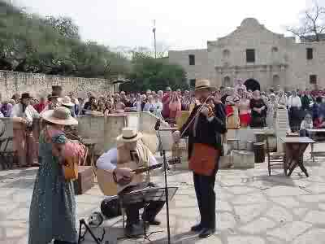 Celtaire perfoming at the Alamo

Scottish Historical Events
For July & August

August 13, 1880 – Mary Reid Anderson, Scottish women’s labor leader, born.
August 14, 1040 – Duncan I of Scotland killed in battle by MacBeth at Pitgavney.
Ausut 15, 1057 – Macbeth killed by Malcolm, son of Duncan I, at Lumphanan Mar, Scotland.
August 15, 1388 – Battle of Otterburn, Scotland – Scottish victory over larger English force.
August 15, 1645 – Battle of Kilsyth, Scotland: Montrose-MacColla victory.
August 15, 1771 – Walter Scott, Scottish author, born.
August 17, 1714 – George Mackenzie, Scottish patron of books, died.
August 18, 1746 – William Boyd of Kilmarnock, Scottish Jacobite leader, executed by the English.
August 18 1773 – James Boswell drags Samuel Johnson on famous “Tour of the Hebrides.”
August 19, 1745 – Jacobite standard raised at Glenfinnan, Scotland, starting the ’45 Rising.
August 21, 1689 – Battle of Dunkeld – high point of Scottish Jacobite rising.
August 21, 1937 – Donald Dewar, promoter of Scottish devolution, born.
August 22, 1847 – Alexander Campbell Mackenzie, Scottish composer, conductor and violinist, born.
August 23, 1305 – William Wallace, Scottish patriot, hanged, disemboweled, beheaded and quartered in London.
August 24, 1565 – Earl of Murray’s rebellion against Mary Queen of Scots failed.
August 25, 55 BC – Julius Caesar launches first (failed) invasion of Britain.
August 25, 1765 – Thomas Muir, Scottish patriot and United Irishman, born.
August 25, 1778 – Last pagan sacrifice conducted publicly in the Celtic world, at Loch Maree, Scotland.
August 26, 1875 – John Buchan, Scottish author of The Thirty-nine Steps, born.
August 27, 1825 – William Balkie, Scottish explorer of Africa, born.
August 27, 1957 – Johnny Cunningham, Scottish fiddler, born.
August 29, 1892 – William Forbes Skene, Scottish Celtic scholar, died.
August 30, 1820 – James Wilson, Scottish patriot, hanged for his role in the Rising of 1820.

Song List for Celtaire’s Performance Sept. 25, 2006
1) Charley is my Darling (R. Burns) 9) Amazing Grace
2) Scotsman’s Kilt 10) Soldiers Joy
3) Charley, Will Ye No Come Back again 11) Saint Ann’s Reel
4) Red is the Rose/Loch Lomand/Scotland the Brave 12) Hundred Pipers
5) Flow Gently Sweet Afton (R. Burns) 13) My Love is Like a Red, Red Rose
6) Will Ye Go Lassie Go 14) Parting Glass
7) Flowers of Edinburgh 15) Auld Lang Syne (R. Burns)
8) White Cockade
If time permits they will also play Dainty Davie and Lizzie Lindsey.
Song booklets and CDs will be available for purchase.

Houston Highlanders Pipe and Drum Band
(a what’s going on by band drummer Scott McPhee)

Hi Jim, good to hear from you. We don't have much planned other that possible trip to Chapel Hill for the Scarecrow Festival in October. Been kinda hot to be wandering around Houston in a kilt. We did a family reunion for the Stuart Family last month and had a great time. Daughters of the British Empire is coming up but I believe that is in November. Also we can't forget Salado Texas "Gathering of the Clans" also November. I don't think we are going as a band. Bayou City Pipes and Drums will be there competing and having all around fun time. Salado is really nice to attend usually the weather is cooler and a nice wee town. Might be a cool thing to get the Heather and Thistle to plan a trip as a group. Bob Smith with the Highlanders owns the Caledonian Bus Lines if you didn't know. He could probably schedule a charter. Just a thought. I hope all is well on your end. I am sorry to not make any of the meetings but they are on band night and if you ever heard me play you would know that I need all the practice that I could get! Well one day I hope to be accomplished or there about's. Anyway it’s all about fun which we have plenty of. I'll keep you posted of anything that pops up and as always it was great to hear from you.

Royal Scottish Country Dance Society
Member Moonyeen Weiss reports that the Scottish Country Dance Basic class is being taught at Dad’s Club (YMCA), 1006 Voss Road, Houston, in Studio A on Tuesday evenings from 7:30pm to 9:30 pm. It is a fun and friendly group! Don’t be left out!

Editor’s Notes:
I have recently changed Internet Service Providers and have a new email address. Uncontrollable spam and technical problems forced me to leave EV1.net. I am now with Sage Telecom. I have learned to be more guarded about giving out my email address. H&T members that receive the email newsletter will have my address. It will be posted on H&T’s website at www.heatherandthistle.org.
If you want to receive the email version of ‘The Houston Scot’ please contact me and give me your email address. As usual, member biographies, articles, and interesting tidbits are welcome.

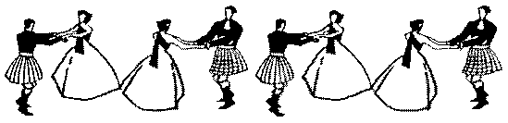

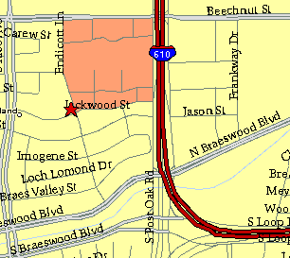

Meeting Information

Meeting Place:
St. Thomas Episcopal School
4900 Jackwood
Houston, Texas 77096

Date and Time:

Fourth Monday of the month
7:30 pm

Heather & Thistle Society Statement
And Membership Information

The Heather and Thistle Society was founded in 1953 by Scots living in Houston who wished to “cultivate an interest in and fond recollections of Scotland, its history and traditions, its literature and ideals, its minstrelsy and song, its customs and amusements, and to provide opportunities for good fellowship and social contact through typically Scottish functions, so that the blessing of our Scottish culture may never die in our new homeland”.

The Heather and Thistle Society meets 10 times a year, September through June. Programs include music, singing, dancing, lively lectures, slide shows and movies about Scotland. The Heather and Thistle Society puts on the annual Robert Burn’s Supper and Ball in late January of each year. We are an organization that promotes our Scottish heritage, in various ways.

The Heather and Thistle Society’s monthly newsletter, “The Houston Scot” is published from September through June. Original articles, information about Scottish or related events are welcome and should be sent to the editor, Jim Monteith, at 15703 Mound Road, Hockley, Texas 77447 or 936-931-2588.

Membership in the Heather and Thistle Society is open to all with an interest in Scottish heritage and culture. Annual dues are $15 for an individual and $20 for a family membership. Applications for membership may be obtained from our website
http://heatherandthistle.org/documents/membership.doc
Dues are due at the beginning of the fiscal year, March 1. Completed applications and membership fees should be mailed to: Mrs. Eileen Graham Moore
8910 Sandstone, Houston, Texas 77036-6132
For membership information please call Eileen at 713-774-0314.

