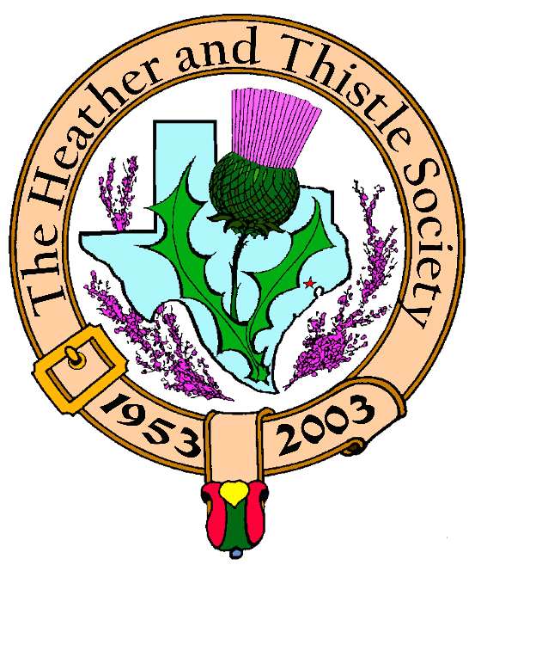

Heather & Thistle Society

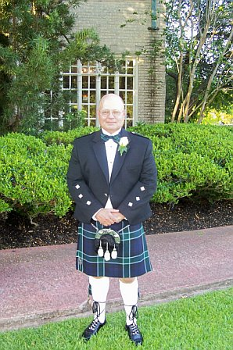
Chieftain Jim Monteith

Volume 6, Issue 10
June, 2006

Newsletter Editor:
Jim Monteith

Officers:

Chieftain – Jim Monteith
Sub-Chieftain – Ken Sorrels
Sgt.-at-Arms – Chuck Monteith
Secretary - Sharon Monteith Treasurer - Robert Moore

Committee Chairs:

Sunshine-Eileen Moore
Membership-Eileen Moore
Past Chieftains-Wayne Barton
Burns Supper-Aaron Buchanan
Publicity-Melvyn Douglass
Programs-Cheryl May

Be Sure to come to our June 26th meeting on Monday at St. Thomas.

The Houston Scot

Chieftain’s Letter,

We had a good turn out for the May meeting. Twenty six members made it to enjoy our speaker, Reverend Dr. Douglas Harper Jr. He provided us with a very entertaining and interesting overview of the Scottish Reformation. Once again, thanks to our Program Director Cheryl May for arranging this program.

Welcome back to Janet Johnson who has recovered well enough from her hip surgery to attend our meetings. We are all so sorry for her on the loss of her daughter Ellen. They have been staunch supporters of our Society for years and hardly ever missed a meeting.

The Kirkin O’ the Tartans at Timber Ridge Presbyterian Church went well. Thanks to our Sgt.-at-Arms, Chuck Monteith, for transporting and setting up our tartans and stands. The Church members greatly appreciated our efforts. It is a very nice Church and they are planning on making it an annual event I believe. Hopefully more of our members will be attending next year.

Sorry for being late on getting the newsletter out this month. My job caused me to be out of town training new trooper recruits in Austin for basically three weeks and then I took a couple of days off. I know I am falling down on the job as editor, but I work cheap and eventually get the job done. We are coming up on our summer break and there will not be a July or August issue of ‘The Houston Scot’.

As editor of the newsletter I was reminded at the May meeting to remind members who are past due on their membership to hurry up and get your money in so you will still qualify for the member prices on our Burn’s Supper tickets. The Past Chieftains and Burns Supper Committee have advised that Burn’s Supper ticket prices are probably going to be increasing. Everything is going up these days it seems. Membership dues are used primarily to pay for this newsletter and storage costs for our Society’s property. The email version of the newsletter does not cost anything to send out but as editor I spent about $85 to $90 per month to print and mail out just 125 newsletters.

We have some new members and my email newsletter list is growing. Please let me know if you want to start receiving your newsletter electronically. Receiving the newsletter by email saves money for the Society and time for your poor editor.

I know we have a number of members who are unable, for various reasons, to get to our meetings on their own now. It would be great to see these members get a ride to our meetings with other members. Please contact me if you need a ride and I will try to find someone to help you.

Your Chieftain,

Jim Monteith

Heather and Thistle Society Annual
Kirking of the Tartans

Our Fall Kirking has been tentatively planned for October 29, 2006 at Saint Paul Presbyterian Church at 7400 Bellaire Blvd. in Houston. Dr. Kevin Boyd will once again be leading the worship. An informal luncheon will be held afterward at an area restaurant.

Scottish Historical Events
For June

June 2, 1581 – James Douglas, Scottish inventor of the guillotine (the Maiden), guillotined.
June 3, 1726 – James Hutton, Scottish geologist born.
June 5, 1723 – Adam Smith, Scottish author of The Wealth of Nations, born.
June 5, 1868 – James Connolly, Irish revolutionary hero, born in Edinburgh, Scotland.
June 7, 1329 – Robert the Bruce of Scotland died.
June 8, 1333 – Edward III of England orders seizure of the Isle of Mann from the Scots.
June 8, 1753 – Dr. Archibald Cameron, Scottish conspirator in Jacobite Elibank Plot, executed.
June 8, 1772 – Robert Stevenson, Scottish lighthouse builder, born.
June 9, 1981 – William MacTaggart, Scottish landscape painter, died.
June 10, 1719 – Battle of Glenshiel, Scotland. Spanish invasion in support of Jacobite rising checked.
June 12, 1298 – William Wallace routs the English at the Battle of Black Ironside.
June 14, 1946 – John Logie Baird, Scottish inventor of television, died.
June 18, 1639 – Pacification of Berwick. Charles I forced to withdraw from Scotland and recognize an independent Scottish Parliament.
June 19, 1566 – James VI of Scotland born.
June 23 – Mid Summer’s Eve – ancient solar feast celebrated with bonfires throughout the Celtic lands.
June 24, 1314 – Victory of Robert the Bruce at Bannockburn, Scotland.
June 25, 1999 – Angus MacDonald, instructor and virtuoso of the Scottish bagpipes, died.
June 26, 1695 Scottish East India Company organized to break English monopoly over East Asian trade.
June 26, 1824 – William Thompson Kelvin, Scottish-Irish scientist, born.
June 28, 1746 – Charles Edward Stuart and Flora MacDonald escape over the sea to Skye.



Heather & Thistle Society – Minutes
May 22, 2006

Chieftain Jim Monteith introduced Heather Vacker of the Houston Highland Game Association. Heather expressed her thanks to H&T for supporting the Games and sponsoring the Open Piping Competition. Chieftain Monteith then turned the floor over to Program Director Cheryl May who introduced tonight’s speaker. Reverend Dr. Douglas Harper Jr. presented a very interesting and informative talk on the Scottish Reformation.
Chieftain Monteith called the business meeting to order at 8:27 pm in the auditorium of the St. Thomas Episcopal School. Motion was made to accept the April, 2006 minutes as published in the newsletter. Motion passed.
Treasurer Dr. Robert Moore reports a $1,429.88 bank balance.
Membership Chairperson Eileen Moore reports we have 99 family, 53 single, 32 life, 39 exempt, and 4 complimentary, for a total of 227 members. 62 members have not renewed their memberships for 2006. These members will be dropped off the rolls in June.

Committee Reports called for by Sub-Chieftain Ken Sorrels.

Burns Club: Jack Hume presented Chieftain Monteith with H&T’s official invitation letter to Joan Turner, President of the Robert Burns Association North America, regarding our hosting their 2008 conference. Sub-Chieftain Sorrels read the letter to the membership.
Burns Supper: Walter May reports that Aaron Buchanan will soon be moving to Dallas with his job. Walter May and Becci Himes will be taking over as Co-Chairmen of 2007 Burns Supper planning Committee.
Past Chieftains: Walter May advises that he will be working on revising the H&T by-laws.
Programs: Cheryl May reports that member Mark Monroe is working on more folk music entertainment possibly in September and October. We hope to have RSCDS again in November.
Sunshine: Eileen Moore reported on the passing of member Ellen Johnson. Her mother, Janet Johnson, was able to attend tonight’s meeting. Janet thanked everyone for their concern. Member Carolyn Sherry who recently was injured was sent a card.
Newsletter: Editor Jim Monteith reports still holding at around 75 members receiving newsletters by email. Articles and biographies of members are welcome.
Houston Grampian: Walter May reports that the OTC breakfast went well.
Houston Highland Games: Melvyn Douglas reports the 2006 Games weekend was a great success. The Open Piping competition on Friday night and Sunday’s Kirkin service were wonderful. The 2006 Games were dedicated to the memory of Al Campbell and the 2006 Program was dedicated to the memory of Edward Brodie. Max Triola reported that an educational element was added to the children’s games. Jack Hume reports only one woman showed up for the genealogy workshop.
RSCDS: Reece Wyant reports they are on summer break.
Houston Highlanders: Chieftain Jim Monteith reports that he had a nice conversation with H&T member Scott McPhee at the recent Highland Games. Scott is a member of the Houston Highlanders and is willing to keep us informed about their performances.

Sergeant-At-Arms reports 26 members present.

Old Business: None.

New Business: Chieftain Jim Monteith discussed how the Societies Tartan banners appeared to be a big attraction for people attending the recent Highland Games. He suggests that next year we put up as many of our tartans as we can. Motion made by Eileen Moore to change the quorum needed to conduct a business meeting from 20 members to 15 members. This vote was announced in the April 2006 newsletter as required. Motion was seconded. Vote was held and the motion passed. Discussion was held about the need to improve the by-laws. Alex Munroe brought up recent low attendance at the meetings and made comments about meeting at a more central location. Past Chieftain (1986-87) Melvyn Douglas announced Past Chieftain Cheryl May’s recent appointment to the mayor’s International Committee. The May’s will be visiting China in the near future.

Meeting adjourned for refreshments at 9:15 pm.

Timber Ridge Presbyterian Kirkin O’ the Tartans

Virginia Staat sent this thank you note to our Society:

Now that I am back home, I wanted to take a few moments to thank you and the entire Heather and Thistle Society for all of your time and efforts in making Timber Ridge's Kirkin' a joyous experience for all. The tartan banners have come to mean so much to us and our Kirkin'. That wave of tartan banners is such a splendid beginning to our service! I appreciate your kindness and generosity in sharing your time with us. It was also wonderful to see you and your family again.
I hope that we can continue to share this wonderful Kirkin' celebration with you and the Heather and Thistle Society members in the future. Thanks again for everything.

Warm wishes,
Virginia

Cattle – Historically, cattle were important indicators of wealth – especially among the Highland Clans and in the Borders. Cattle ‘lifting’ or rustling were age-old activities, generating much lawlessness. Later both cattle and cattle trade were vital elements in the development of both agriculture and the export economy during the seventeenth and eighteenth centuries. Pastoral agriculture was always important in the west of Scotland and in the Highlands and islands, but became a major economic activity after the Union in 1707. Early enclosure in the Lowlands was directed at cattle feeding. A significant trade developed during the 18th century from the Highlands to the Lowlands –and further south across the Border to markets in England – invariably
over drove roads linking the major ‘trysts’, or market places, such as that at Falkirk. The later development of steam shipping and ultimately of the railways put an end to the droving trade – but nevertheless pastoral agriculture (both cattle and sheep) remained the mainstay of farming in many parts of Scotland. (from The Collins Scottish Dictionary)

Houston Highlander Pipe Band

Houston Highlander drummer Scott McPhee recently sent your editor some information about his band and other local pipe bands. I know everyone in the Society loves these pipe bands and wants to know more about them. I have printed his letter to me here.

Hi Jim,
It was a pleasure to have met you. We all had a great time at the Highland Games. As you were asking about the piping community I can share with you of what I know what's going on with some of the bands in the Houston area. They are all open for anyone that has a desire to learn the bagpipes. Here are a few opportunity's that are available through these bands. Keep in mind that some are offering instruction in drumming as well. Darryl Hadsell, Palmer Pipes & Drums (email is dhadsell@bcm.tmc.edu) who is a former Pipe Major of the Highlanders has a beginning pipe class on Monday nights from 5:30 to 7:00 at Palmer Episcopal church on the corner of Main and MacGregor. It is open to anyone who wishes to learn the Highland bagpipe. Starter kits which include the practice chanter and a music book are available from Aberdeen Bagpipe Supply (Terri or Jim Hudgins) 713-781-8546. And as always the Houston Highlanders practice is also welcome to anyone who wishes to learn. Contact Kelly Fair jandk@hal-pc.org They meet at 7:00 on Mondays at St Phillips Presbyterian Church on San Felipe by 610. The Bayou City Pipes and Drums, Pipe Major Tom O’Brien meet on Tuesday nights from 7:00 to 9:00 at the Houston Police Officer’s Union, at 1602 State St Houston For those interested in learning to play please contact Tom O’Brien by e mail tom@texasbagpipes.com or phone 832-723-2388 We will keep you posted on performances and up coming events which might interest the Heather and Thistle Society and its members.

Sheriff – A key figure in the judicial system since the twelfth century. By the sixteenth century it had become an hereditary appointment with the extensive duties that it involved, including outlawing criminals, settling territorial disputes or enforcing taxation, being undertaken by various deputies. The Crown rarely tampered with the hereditary aspect of the system and when Charles I (1600-49) did deprive the Gordons and certain other families of their hereditary sheriffdoms it was a highly unpopular action. Thus it was not until the aftermath of the Jacobite Rebellion in 1745-46 that heritable jurisdictions were finally abolished in 1747. Thereafter the country was organized into a series of principal sheriffships with sheriff-substitutes designated for every county town. Today the sheriff-substitute remains the judge before whom both civil and criminal cases are initially heard with more serious charges ultimately being referred to the High Court.
(from The Collins Dictionary of Scottish History)

Militia Act – While law and order was threatened by radical ideas after the French Revolution, it was not until the Franch Revolution and the Napoleonic Wars that Britain was physically threatened by invasion. During the period 1793-97 the French had achieved a number of successes, while Britain experienced mixed fortunes. There was civil unrest – notably in Ireland – and this was aggravated by naval mutinies among the fleet at Spithead, the Nore, and at Yarmouth. The danger of invasion was ever present and to counter this the government implemented a series of emergency measures, including the Militia Act, the Scottish Militia being formed in 1797. The act enforced conscription by ballot for men between eighteen and twenty-three and provoked serious disorder. This arose from the fact that militiamen could be drafted overseas and that most of the middle and upper classes were either Volunteers (and thus exempt from conscription) or could afford to buy themselves out. Anti-militia disturbances broke out in many places, as ‘Scotland went stark mad’, according to one contemporary. Schoolmasters, who had to draw up lists of men for the militia ballot had their homes ransacked and parish registers destroyed. The most serious riot occurred at Tranent, East Lothian, where colliers and salters resisted the ballot. The disturbance was ruthlessly suppressed by troops, with eleven person killed and several wounded. Order was restored by the end of the year and further inducements of favourable pay and pensions offered to those who would enlist. The quotas for the Scottish Militia were eventually fixed in March 1798, but it was not until 7 months later that all of the 6,000 men were at last mobilized. (from The Collins Scottish Dictionary)

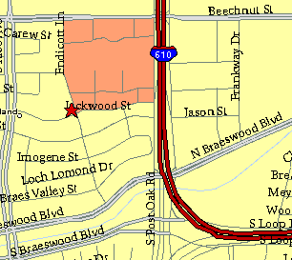

Meeting Information

Meeting Place:
St. Thomas Episcopal School
4900 Jackwood
Houston, Texas 77096

Date and Time:

Fourth Monday of the month
7:30 pm

Heather & Thistle Society Statement
And Membership Information

The Heather and Thistle Society was founded in 1953 by Scots living in Houston who wished to “cultivate an interest in and fond recollections of Scotland, its history and traditions, its literature and ideals, its minstrelsy and song, its customs and amusements, and to provide opportunities for good fellowship and social contact through typically Scottish functions, so that the blessing of our Scottish culture may never die in our new homeland”.

The Heather and Thistle Society meets 10 times a year, September through June. Programs include music, singing, dancing, lively lectures, slide shows and movies about Scotland. The Heather and Thistle Society puts on the annual Robert Burn’s Supper and Ball in late January of each year. We are an organization that promotes our Scottish heritage, in various ways.

The Heather and Thistle Society’s monthly newsletter, “The Houston Scot” is published from September through June. Original articles, information about Scottish or related events are welcome and should be sent to the editor, Jim Monteith, at 15703 Mound Road, Hockley, Texas 77447 or 936-931-2588 or jmonteith@ev1.net.

Membership in the Heather and Thistle Society is open to all with an interest in Scottish heritage and culture. Annual dues are $15 for an individual and $20 for a family membership.
Applications for membership may be obtained from our website at:
http://heatherandthistle.org/documents/membership.doc
Dues are due at the beginning of the fiscal year, March 1. Completed applications and membership fees should be mailed to: Mrs. Eileen Graham Moore
8910 Sandstone, Houston, Texas 77036-6132
For membership information please call Eileen at 713-774-0314.

