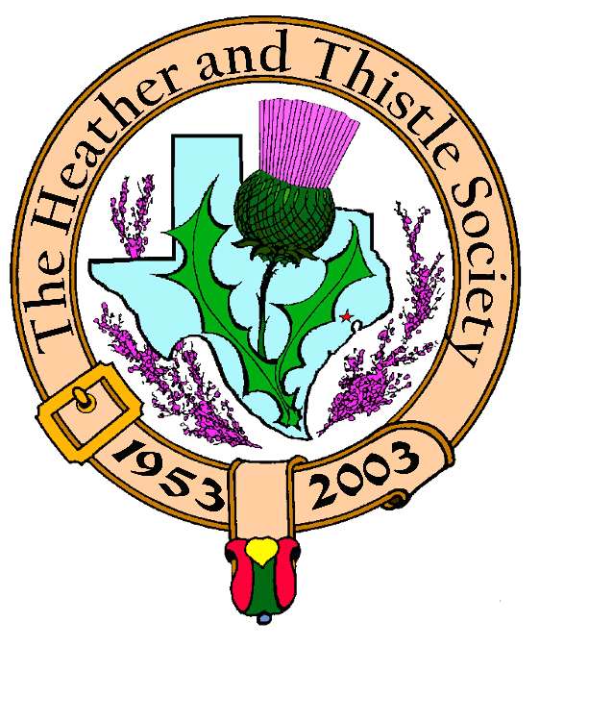

Heather & Thistle Society

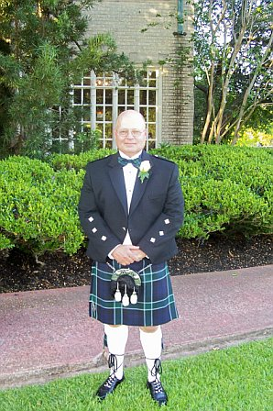
Chieftain Jim Monteith

Volume 6, Issue 9
May, 2006

Newsletter Editor:
Jim Monteith

Officers:

Chieftain – Jim Monteith
Sub-Chieftain – Ken Sorrels
Sgt.-at-Arms – Chuck Monteith
Secretary - Sharon Monteith Treasurer - Robert Moore

Committee Chairs:

Sunshine-Eileen Moore
Membership-Eileen Moore
Past Chieftains-Wayne Barton
Burns Supper-Aaron Buchanan
Publicity-Melvyn Douglass
Programs-Cheryl May



The Houston Scot

Chieftain’s Letter,

OK Members!!!. I am officially worried about the member turnout at the last two H&T meetings. Only 15 members showed up for our March meeting and then only 16 showed up for our April meeting. Is it me or what? Our April program featuring cowboy poet and story teller Scott Baumgardner was excellent. Thanks, to our Program Director Cheryl May for working so hard. See what you members are missing out on, excellent entertainment and free food. How can you beat that?

I was saddened earlier this month when I learned that member Ellen Johnson had died at home unexpectedly. Her mother, Janet Johnson, fell and suffered a broken hip in early March and is recovering in an area nursing home. Also, member Ed MacAllister, suffered a broken hip and was hospitalized. Our thoughts and prayers go out to these members and their families.

Former member Virginia Staat’s church, Timber Ridge Presbyterian, is having their second Kirkin O’ the Tartans on May 21 in The Woodlands. H&T will be supplying tartans for this event. I will try to talk her into rejoining our Society when I see her there. Maybe we can start a new tradition of a Kirkin in the Spring.

Our May 2006 meeting has been moved to the 3rd Monday of May due to the Memorial Day Holiday being on the fourth Monday. So don’t forget to show up on May 22. Our May program will be Reverend Dr. Douglas Harper Jr. speaking on The Reformation. Doug is presently Associate Pastor at Grace Presbyterian Church. He is retired from St. Paul’s Presbyterian Church where he served for many years. He was best friends with Past Chieftain Ed Brodie.

The Houston Highland Games appear to have had another successful year. Our Society sponsored an open bag piping competition on Friday, May 12th at the host hotel. Officers of H&T awarded $1000.00 in prize money to five pipers that competed. Many thanks to Chuck Monteith, Ken and B.J. Sorrels, Mark Monroe and my wife Sharon Monteith for being troopers and manning the H&T booth both Saturday and Sunday. Lots of present and past members of H&T stopped by the booth to visit. We had a refreshment budget this year and we passed out water, soda, and snacks to prospective members. This year H&T had a free drawing for a nice gift on both days. On Saturday Jere L. Wilson Jr. won a free membership to the Houston Fine Arts Museum. Included with this gift was a mug, a ball cap and a book about the Museum. On Sunday, Jeff Burns won a Sunday brunch for four at the Marriott Houston Westchase. The tartans of our Society, which represent the families past and present who have supported Heather and Thistle, were displayed proudly around the arena and at our booth and were the topic of many interested families.

Your Chieftain,
Jim Monteith

Heather & Thistle May 2006 meeting:

Will be on the 3rd Monday, May 22, 2006 due to the Memorial Day Holiday being on our usual 4th Monday date.
Scottish Historical Events
For May

May 1, 1690 – Jacobite defeat at the Haughs of Cromdale, Scotland.
May 2, 1779 – John Galt, Scottish novelist and emigration promoter, born.
May 3, 1758 – James Taylor, Scottish inventor of the steamboat, born.
May 4, 1645 – Battle of Auldcarn, Scotland – Montrose victory.
May 7, 1906 – Henry Grey Graham, Scottish historian, author of Social Life of Scotland in the 18th Century, died.
May 7, 1999 – First elections held for new Scottish Parliament and the Welsh Assembly.
May 9, 1645 – Battle of Auldearn, Scotland – Montrose victory.
May 10, 1559 – John Knox’s sermon launches Scottish religious revolution.
May 10, 1809 – Andrew Bell, Scottish engraver and co-founder with Colin MacFarquhar of the Encyclopedia Britannica, died.
May 12, 563 – Community of Iona founded in Scotland by Colum Cille and followers from Ireland.
May 17, 1810 – Robert Tannahill, Scottish songwriter, died.
May 18, 1313 – Robert the Bruce lands on the Isle of Mann to wrest it from English rule.
May 18, 1689 – “The Bonny Dundee” gathers forces in Lochaber, Scotland.
May 19, 1692 – French invasion fleet supporting James VII defeated at Battle of Cape Barfleur.
May 19, 1795 – James Boswell, Scottish biographer of Samuel Johnson, died.
May 20, 685 – Battle of Nechtansmere. Northumbrian invasion of Scotland (then Pictland) defeated by Pictish King Bruide.
May 21, 1650 – James Graham (Montrose), Scottish Royalist, executed by Cromwellian government.
May 22, 1859 – Arthur Conan Doyle, Scottish author, born.
May 25 – Flitting Day – day on which leases were up in Scotland. Tenants decided if they would sign another lease or move – to sit or flit.
May 25, 1315 – Irish ally, Edward Bruce of Scotland, arrived in Ireland.
May 26, 1799 – James Burnet, Lord Monboddo, Scottish precursor of Darwin, died.

Heather & Thistle Society – Minutes
April 24, 2006

Chieftain Jim Monteith announced that tonight, before the meeting was called to order, we would have the installation of our new Sub-Chieftain Ken Sorrels. Past Chieftain Walter May performed the ceremony.
Chieftain Monteith called the business meeting to order at 7:38 pm in the auditorium of the St. Thomas Episcopal School. Motion was made to accept the March, 2006 minutes as published in the newsletter. Motion passed.
Dr. Robert Moore our Treasurer was not at the meeting tonight. His wife Eileen Moore reports a $1,572.30 bank balance. Eileen reported that past due membership statements are going to be mailed out.
Membership Chairperson Eileen Moore reports we have 99 family, 52 single, 32 life, 39 exempt, and 4 complimentary, for a total of 226 members.

Committee Reports called for by Sub-Chieftain Ken Sorrels.

Burns Club: Alex Munroe reports plans underway for next meeting. Chieftain Monteith reports that Burns Club member Alistair MacNab’s house burned down on Sunday night. They are OK.
Burns Supper and Past Chieftains: Walter May reports a Planning Committee meeting was held earlier this month. The number of tables at the next supper will be cut back due to overcrowding at the 2006 Supper. A Past Chieftains committee meeting will be held May 11 instead of a Burns Supper Planning committee meeting.
Programs: Cheryl May says we are fortunate to have Scott Baumgardner tonight. Rev. Dr. Dough Harper speaking on the Reformation of Scotland will be May’s program.
Sunshine: Eileen Moore reports a get well card was sent to Rosemary McBride. She also advised that member Ed MacAllister broke his hip and is in Memorial SW hospital.
Newsletter: Editor Jim Monteith reports 75 email newsletters going out and 130 being mailed out by USPS.
Houston Grampian: Walter May reports that the OTC breakfast is this Saturday and tickets are $40.00. Planning the visit of the Scots at the end of September.
Houston Highland Games: Max Triola passed around a brochure about the children’s games this year. Volunteers will be needed.
RSCDS: Reece Wyant reports still dancing Thursday nights at the YMCA Dad’s Club on Voss at IH-10.
Houston Highlanders: No report.

Sergeant-At-Arms reports 16 members present. Three guests were present tonight. They were Stephen Allen, Jerry Mantooth, and Scott Baumgardner.

Old Business: None.

New Business: Chieftain Jim Monteith passed around a copy of the Heather and Thistle ad that will be placed in the Highland Games program. Plans are to have a full page ad this year. Discussion was held about booth space rental, table and number of chairs needed at the games. Chieftain Monteith spoke about improving the Society By-Laws.

Meeting adjourned for refreshments.

Tonight’s Program: Cheryl May introduced Scott Baumgardner, a well known cowboy poet and story teller. Mr. Baumgardner is a lifetime member of the Houston Rodeo speakers committee and won the State Champion Louisiana Liars award. Mr. Baumgardner entertained members with several tall tales and cowboy poetry.

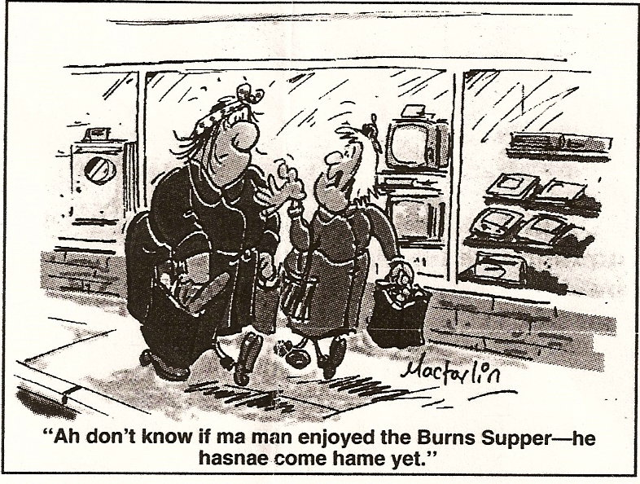

Kirking of the Tartans:
Timber Ridge Presbyterian Church, Sunday May 21, 2006 in The Woodlands

Heather and Thistle Society members are invited to the Second Annual Kirking of the Tartans at Timber Ridge Presbyterian Church, 7575 Alden Bridge Drive, The Woodlands on May 21 at 11:00 am. Virginia Staat, a former H&T member, has asked our Sgt.-at-Arms Chuck Monteith to provide H&T tartans for the event. Chieftain Jim Monteith and wife Sharon will be attending. H&T members are encouraged to attend. Last years kirking was very nice and they had a fantastic piper.
To get to Timber Ridge from I-45, take the Research Forest exit and travel west approx. 5 miles. Take a right onto East Alden Bridge Drive. On East Alden Bridge, travel approx. ½ mile. Timber Ridge is located on the left, just past Alden Bridge Park at 7575 Alden Bridge Drive.
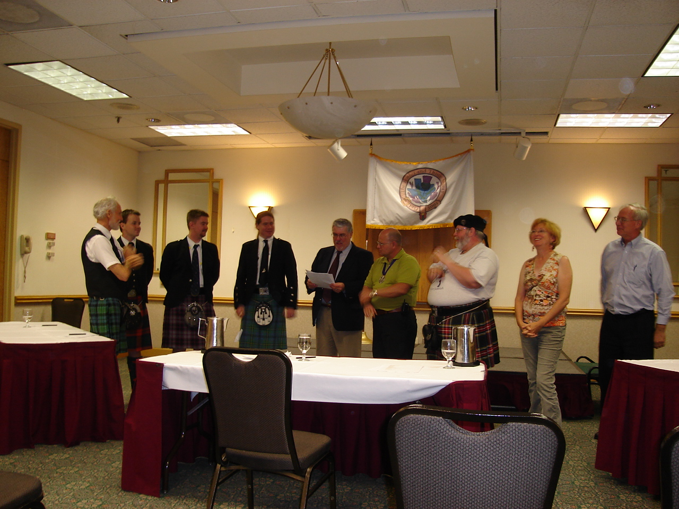H&T Officers presenting checks to winning Pipers at the open piping competition.

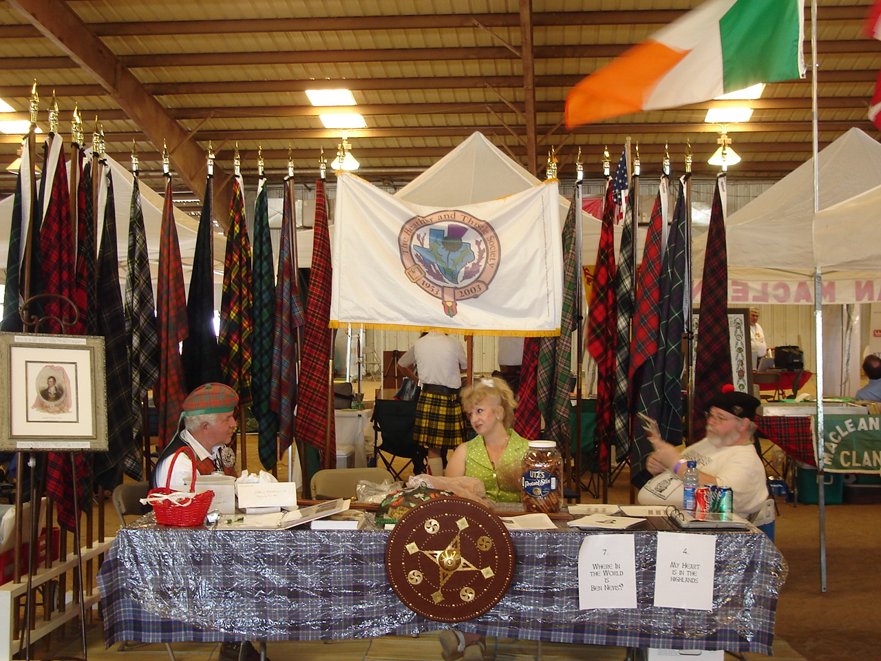Manning the H&T booth at the Houston Highland Games. Member Profile: George and Martha Graham

Martha and I moved to Tomball from North Kingstown, Rhode Island last April to be near our son Robert and his family. Rob is a Geo-Scientist for ExxonMobil. I am a retired VP of Engineering, formerly employed by Hallmark Sweet/Stern Leach, a Division of Cookson International, a British owned company. Martha is a retired kindergarten schoolteacher. She retired from the North Kingstown school system. We have another son, Scott, who chose to stay in Rhode Island. Scott is an artist specializing in bronze sculpture.

I have traced my Scottish heritage back to my great great grandfather, William Graham who was born in Campsie Scotland, year unknown at this time. My great grandfather Robert was born in Old Kilpatrick in 1825, my grandfather George was born in Campsie Scotland in 1864 and my father Robert was born in East Greenwich, Rhode Island in 1898.

Martha received her B.A. and M.A. from Rhode Island College in Providence, Rhode Island and I received my BSME from Roger Williams College (now University) in Bristol, Rhode Island.

Martha served as a Vista Volunteer for four years organizing and working with various church and social groups as an advocate for the poor. She also helped to establish a community Health Center in North Kingstown that was created to help the lower income people of the area.

I was an elected Town Councilman in the Town of North Kingstown for 16 years. I served as President for 4 years, and served as chairman of the North Kingstown Budget Advisory Committee two years, the Qounset/Davisville Management Corporation for 4 years and the High School Recreation advisory committee for two years. I also served as President and as Vice President of the North Kingstown Soccer Association for 8 years and coached for 10 years. I was the Vice President of the Rhode Island Soccer Association, Vice President of North Kingstown Recreation International, a group that visited Russia in 1985, Vice-President of the Wicford Lions Club and I a lifetime member of the East Greenwich Volunteer Firemen's Association. I am also a four year veteran of the United States Air Force.

Written by George Graham.

In Memoriam

Ellen Elizabeth Johnson, born November 1, 1959, found expired March 24, 2006 at home. An autopsy was performed and results will be forth coming. Ellen was a regular at our H&T meetings along with her mother Janet Johnson. Ellen was also a member and supporter of the Houston Highland Games Association and had recently gotten interested in joining the Houston Grampian Association. Ellen grew up in the Catholic faith and had recently begun attending a Methodist Church with her mother. Ellen was a nurse’s aid and worked in area hospitals and nursing homes. Ellen was cremated and her mother Janet hopes to take her ashes to her birth city of Victoria, Texas.

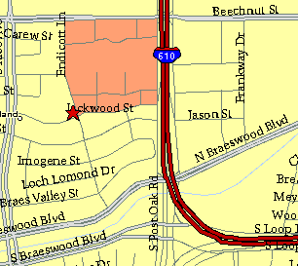

Meeting Information

Meeting Place:
St. Thomas Episcopal School
4900 Jackwood
Houston, Texas 77096

Date and Time:

Fourth Monday of the month
7:30 pm

Heather & Thistle Society Statement
And Membership Information

The Heather and Thistle Society was founded in 1953 by Scots living in Houston who wished to “cultivate an interest in and fond recollections of Scotland, its history and traditions, its literature and ideals, its minstrelsy and song, its customs and amusements, and to provide opportunities for good fellowship and social contact through typically Scottish functions, so that the blessing of our Scottish culture may never die in our new homeland”.

The Heather and Thistle Society meets 10 times a year, September through June. Programs include music, singing, dancing, lively lectures, slide shows and movies about Scotland. The Heather and Thistle Society puts on the annual Robert Burn’s Supper and Ball in late January of each year. We are an organization that promotes our Scottish heritage, in various ways.

The Heather and Thistle Society’s monthly newsletter, “The Houston Scot” is published from September through June. Original articles, information about Scottish or related events are welcome and should be sent to the editor, Jim Monteith, at 15703 Mound Road, Hockley, Texas 77447 or 936-931-2588 or jmonteith@ev1.net.

Membership in the Heather and Thistle Society is open to all with an interest in Scottish heritage and culture. Annual dues are $15 for an individual and $20 for a family membership.
Applications for membership may be obtained from our website at:
http://heatherandthistle.org/documents/membership.doc
Dues are due at the beginning of the fiscal year, March 1. Completed applications and membership fees should be mailed to: Mrs. Eileen Graham Moore
8910 Sandstone, Houston, Texas 77036-6132
For membership information please call Eileen at 713-774-0314.

