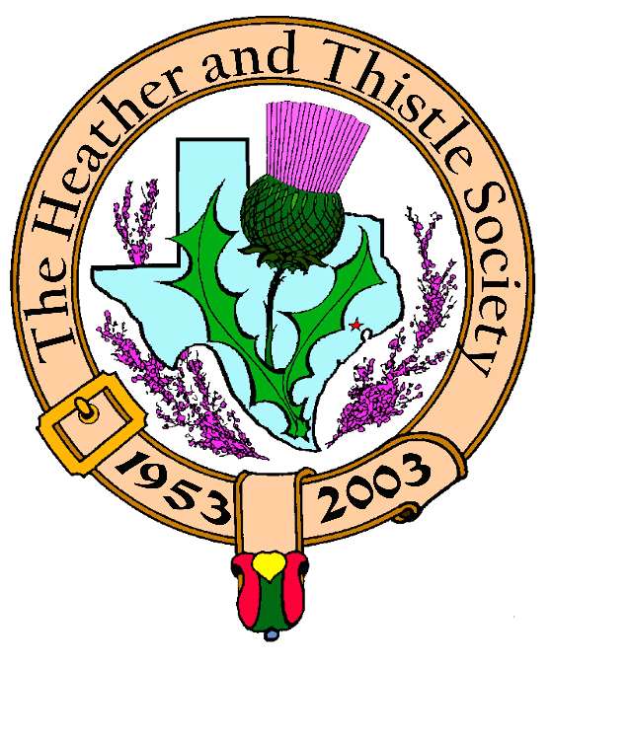

Heather & Thistle Society

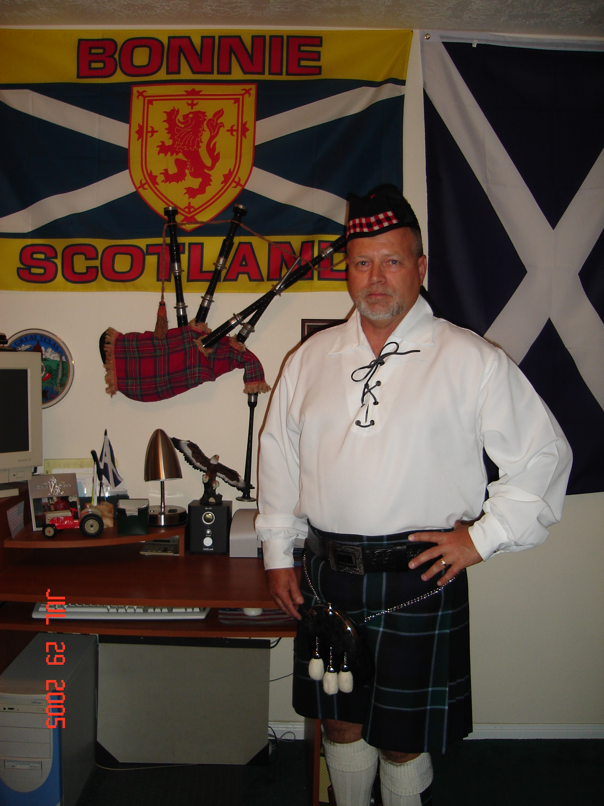
Chieftain Seamus Callum Monteith
(that’s Jim Monteith in English)

Volume 6, Issue 8
April, 2006

Newsletter Editor:
Jim Monteith

Officers:

Chieftain – Jim Monteith
Sub-Chieftain – Ken Sorrels
Sgt.-at-Arms – Chuck Monteith
Secretary - Sharon Monteith Treasurer - Robert Moore

Committee Chairs:

Sunshine-Eileen Moore
Membership-Eileen Moore
Past Chieftains-Wayne Barton
Burns Supper-Aaron Buchanan
Publicity-Melvyn Douglass
Programs-Cheryl May

Houston Highland Games

The Games are here again folks.
May 12th, 13th and 14th at the Bear Creek Farm and Ranch Club on State Highway 6 in Harris County. Come out and enjoy Houston’s Scottish culture.

The Houston Scot

Chieftain’s Letter,

It’s good to be Chieftain. Even though the turnout for our new officer installation was poor, I enjoyed my moment in the limelight. My wife Sharon and I joined the Society 5 years ago. I guess we showed up at too many meetings because within two years I was asked to participate as the Sgt.-at-Arms. Since I had only one hobby at the time (mowing grass) I was talked into it. Now Heather and Thistle is my second hobby. It’s loads of fun to wear The Kilt. Every time I wear it I get to drink Scotch and get fed. Thank you to our new officers who have also volunteered to be elected. Sub-Chieftain Ken Sorrels could not be present at the March meeting, so he will be installed at the upcoming April meeting. I want to take time now to thank all of our volunteers that keep the Heather and Thistle Society active and running. Cheryl May has agreed to once more chair the Program Committee. Melvyn Douglas is back as Publicity Chairman. Eileen Moore heads up the Membership and Sunshine committees. Our new chairman of the Past Chieftain’s Committee is Wayne Barton. Aaron Buchanan takes over as Burns Supper Committee Chairman. Wow!! That’s a lot of volunteers helping out. More volunteers will be needed during the coming year in order for our Society to successfully put on our own events and to participate in other organizations events.

The Houston Highland Games is coming up in May over the weekend of the 12th, 13th and 14th. We will need volunteers to staff the Heather and Thistle booth on Saturday and Sunday. Let one of the officers know if you wish to assist or just show up at the booth at the Games location on State Hwy 6 at the Bear Creek Farm and Ranch Club Facility. It would be nice to have a good member turnout for the Grand Opening Parade on Saturday morning at the Games. Our Society will be sponsoring the Piping Competition and will be putting up $1000.00 for this.

At a recent Burns Supper Planning Committee meeting that I attended, several Past Chieftains Committee Members mentioned their desire to improve and clarify our Society’s Bylaws. The Bylaws have not undergone any changes since December 1992. The Heather and Thistle Society has changed over the years and many of the activities of the Society members that are required to run the organization were not defined in the original Bylaws. The Past Chieftain’s Committee has become an important guiding institution within our Society and its functions should be more clearly stated in the Bylaws. The Burns Supper Planning Committee, now an essential institution within our Society, is not even mentioned in our Bylaws. The way the Society handles its financial business is not defined within the Bylaws. A Historical Committee was established, but has not functioned in years. The roles of the officers within the Society have changed. Our Sgt.-at-Arms has many responsibilities now days due to the amount of property he must control and move, whereas the Sub-Chieftain has very little responsibility. In recent years the Sub-Chieftain has become more active in coordinating and assisting the Sgt.-at-Arms in his efforts. Perhaps this should be formally addressed in the Bylaws. The problem of having 20 members present at the monthly meetings has become an issue. 20 members in good standing are required for a quorum for the transaction of business. The Past Chieftain’s Committee desires to change this from 20 members to 15 members needed for a quorum. At the regular meeting on May 22, 2006 this proposal to change from 20 members to 15 members for a quorum will be made, discussed and voted on.

As Past Chieftain Cheryl May did during her year of service I wish to emphasize recruitment of new members during my term. I also, guess what, wish to emphasize the spirit of volunteering in our organization. The Heather and Thistle Society is in its 54th year. Let’s make it great one!!!!!!!!!!

Your Servant, Chieftain Jim Monteith

Scottish Historical Events
For April

April 1, 1820 – Scottish Insurrection of 1820 begins.
April 3, 1603 – Banning of the Clan MacGregor by act of James VI of Scotland.
April 3 1617 – John Napier, Scottish inventor of logarithms, born.
April 4, 1880 – William Russell Flint, Scottish landscape artist, born.
April 5, 1820 – Cathkin Braes – First battle of the Scottish Insurrection.
April 6, 1320 – Declaration of Arbroath (Aberbrothock), Scotland.
April 6, 1985 – Willie McRae, Sec. of the Scottish Nationalist Party, dies in mysterious circumstances, believed assassinated.
April 7, 1767 – Henry Bell, Scottish steampower pioneer, born.
April 9, 1139 – Second Treaty of Durham, King David I of Scotland recognized by the Normans.
April 9, 1919 – Rupert Ian Kay Moncreiffe, Scottish herald and genealogist, born.
April 12, 1700 – Abanonment of Scotland’s New World colony, New Caledonia, at Darien on the Isthmus of Panama.
April 12, 1820 – Scottish rebels storm Greenock prison, freeing five members of the Scottish Provisional Government.
April 14, 1582 – University of Edinburgh founded.
April 15, 1710 – William Cullen, Scottish physicist, born.
April 16, 1966 – Contingents from Welsh, Breton, Manx, Cornish and Scottish lib eration movements march behind IRA at 50th Anniversary of Easter Week.
April 16, 1746 – Battle of Culloden, Scotland
April 17, 1341 – Edinburgh Castle taken from the English, reversing English encroachments against independent Scotland.
April 17, 1882 – The Battle of the Braes, Skye. Beginning of the Scottish “Crofters’ War.”
April 20, 1934 – Scottish National Party founded.
April 26, 1711 – David Hume, Scottish philosopher, born.
April 27, 1852 – Robert Lochore, Scots poet, died.
April 30, 418 – Pelagius, champion of the Celtic view of Christianity, banned by Roman political enemies in the Church.

Heather & Thistle Society – Minutes
March 27, 2006

The night began with the installation of our newly elected officers. Piper Steven McIntyre piped in the procession of new officers. Long time member and Past Chieftain Bob Gilbert performed the installation ceremony for Jim Monteith, Chieftain, Chuck Monteith, Sgt.-at-Arms, Robert Moore, Treasurer, and Sharon Monteith, Secretary.
Chieftain Jim Monteith called the business meeting to order at 7:46 pm in the auditorium of the St. Thomas Episcopal School. Motion was made to accept the February 2006 minutes as published in the newsletter. Motion passed.
Dr. Robert Moore our Treasurer reports $1,469.45 in the bank. Dr. Moore advised that the Society currently has 101 past due members on their annual dues.
Membership Chairperson Eileen Moore reports as of this night we have 101 family, 50 single, 32 life, 39 exempt, and 4 complimentary, for a total of 225 members.

Committee Reports called for by Sgt.-at-Arms Chuck Monteith.

Burns Club: Jack Hume reports the Burns Club annual Burns Supper was very nice. The Burns Club meets the second Thursday of each month. Cheryl May also said the Supper was wonderful.
Past Chieftains: Walter May reports that the Burns Supper Planning Committee met last Tuesday night. Next years Supper (2007) will be at the Marriott Westchase and the number of tickets will be held to be about 562. The event will possibly be on the 27th of January and ticket prices probably will go up $10.00. Aaron Buchanan has taken over as the Chairman of the Burns Supper Planning Committee.
Programs: Cheryl May reports that the April program will be cowboy poetry.
Sunshine: Eileen Moore reports a get well card was sent to MaryAnn and Alex Munroe. A sympathy card was sent to the family of Al Campbell. Cheryl May sent a beautiful spray of red roses on behalf of the H&T Society to Al’s memorial service.
Houston Grampian: The week of Sept. 25, 2006 to Oct. 1st 2006 will be when 25 to 40 residents of Houston’s sister city Aberdeen, Scotland come to Houston to visit. The HGA costs $50.00 per year to join. The Grampian Mountains are near Aberdeen. April 29, 2006 will be hosting a Scottish Breakfast for the Offshore Technology Conference at 9am at the Hilton Post Oak Hotel.
Houston Highland Games: This year’s games coming up the weekend of May 12th thru the 14th at Bear Creek Farm and Ranch Club on State Hwy. 6 in Harris County. The recent St. Patrick’s day parade in Houston was dedicated to Al Campbell. Cheryl May suggests the Society may want to participate in this annual parade.
RSCDS: No report.
Houston Highlanders: No report.
Newsletter: Email newsletters are up to 75 per month and hand mailing 130 per month.

Sergeant-At-Arms reports 15 members present. One guest tonight, Mr. Steven Allen.

Old Business: Jack Hume is still working on getting the Society a refund from Washington Mutual Bank on the $12.00 service charge they have been charging us.

New Business: Bob Gilbert suggests that an email be sent out to members reminding them of our monthly meetings a few days before the meeting. The hope is to get more members to show up at the meetings. Jack Hume related an interesting story on how the St. Andrews cross became the flag of Scotland. Jack also passed around a photograph he took that shows a St. Andrews cross in the morning sky here in Houston. Walter May reports that Houston Mayor White has established a cultural committee on which Cheryl May will be serving.

Houston Grampian Association Student Nurse Exchange

The Houston Grampian Association sponsors a Student Nurse Exchange visit annually, with two nurses going to Aberdeen in June and two nurses coming from Aberdeen in October. The nurses stay about 10 days in each others countries where they observe medical procedures. Mary Metz of the HGA is the coordinator for this program. Long time H&T member and Past Chieftain Bob Gilbert is a founding member of the Houston Grampian Association.

The Darien Venture: Scotland’s attempt at colonizing foreign soil

Three recently found 300 year old letters from Darien shed new light on Scotland’s failed attempt to colonize The Isthmus of Panama in the late 17th century. The colonizing effort cost 2000 lives and lost about half of Scotland’s wealth. The collection of three letters, recently were rediscovered at the National Archives of Scotland after the archives catalogue was computerized. The failed attempt to create a wealthy Scottish empire in the jungle led many Scots to support the Act of Union and abolition of the first Scottish Parliament of 1707. The letters were written from Darien in 1699 by a Scottish settler named George Douglas. The site of the colony was on the north coast of Panama and ruins still exist today. The venture began as an ambitious scheme to establish Scotland as a colonizing power in the world but ended in loss of life and financial ruin.

A state of crisis existed in Scotland at the end of the Seventeenth Century. Seven years of famine and decades of warfare had driven Scots from their homes, choking the cities with homeless vagrants, starving in the streets. Scotland’s industries and trade had been ruined by England’s continual wars against continental Europe. Something had to be done to revive Scotland’s fortunes. A trading colony scheme was hatched by William Paterson, a Scot who had made his name as a director of the Bank of England. Scotland would become the major broker of trade across the Pacific Ocean. The alleged paradise called Darien on the Isthmus of Panama would become the site of the trading colony. Goods could be ferried form the Pacific across Panama and loaded onto ships in the Atlantic bypassing the dangerous and long trip round Cape Horn while making the colonists a big commission for the privilege. Darien was supposed to have rich, fertile land, a sheltered bay and friendly Indians. The only problem was that Spain claimed control of that part of Panama.

The Company of Scotland Trading to Africa and the Indies was founded in June 1695. English investors would not support the venture so the Company turned to the Scottish people. Rich and poor Scots subscribed to the venture and within 6 months 400,000 pounds had been raised. Five ships were fitted for the colonizing expedition, The Dolphin, Unicorn, Endeavour, Caledonia, and the St. Andrew. England, fearing losing their monopoly on trade to the Indies, threatened to embargo any merchants who traded with the new company. The false stories of Darien being the land of milk and honey gave the Company an unrealistic vision of what they faced. Thousands of combs and mirrors, wigs, and other useless items were loaded onto the ships.

On July 4th, 1698 the ships set sail from Leith harbour under the command of Captain Robert Pennecuik. 1200 settlers were on this first expedition. Darien was reached on November 2, 1698, having lost only 70 people during the trip. The settlers named the peninsula New Caledonia and began to build a settlement. Two months were wasted attempting to build on an unsuitable site. A new location was found and named Fort St. Andrew. Within the fort walls, the settlers began to erect the huts of New Edinburgh. They soon found the Indians were not interested in trading with them and the land was unsuited to agriculture. Torrential rain and disease arrived in the Spring of 1699. By March there were more than 200 dead colonists and the dead were accumulating at more than 10 per day. Attempts were made by the ships to trade for supplies but found that the King of England had forbidden other colonies and ships to trade with Darien. The Dolphin was captured by the Spanish and its crew imprisoned. Famine came and disease continued despite the colonists hard work and efforts. News came that the Spanish were planning an attack on the colony. The settlers panicked and took to the sea abandoning the colony. Of the four ships that left only one, the Caledonia made it back to Scotland with less than 300 people on board. A second expedition, knowing nothing about the fate of the first, left Scotland in August, 1699. Three ships this time, carrying 1302 settlers, led by the ship The Rising Sun. 160 settlers perished this time during the crossing. Upon arrival at Darien they found the colony abandoned. They set about rebuilding it but fared no better than the first expedition. Captain Alexander Campbell of Fonab led a preemptive strike against the Spanish forces massing at Toubacanti on the mainland. The attack was successful but brought the Spanish into concerted action against the colonists. A massive Spanish fleet and army besieged Fort St. Andrew, which finally surrendered in March 1700. The surviving colonists were allowed to leave aboard their remaining ships. Only a handful ever made it back to Scotland.

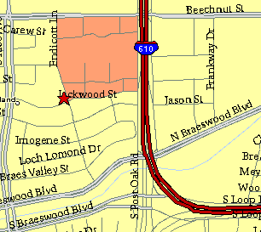

Meeting Information

Meeting Place:
St. Thomas Episcopal School
4900 Jackwood
Houston, Texas 77096

Date and Time:

Fourth Monday of the month
7:30 pm

Heather & Thistle Society Statement
And Membership Information

The Heather and Thistle Society was founded in 1953 by Scots living in Houston who wished to “cultivate an interest in and fond recollections of Scotland, its history and traditions, its literature and ideals, its minstrelsy and song, its customs and amusements, and to provide opportunities for good fellowship and social contact through typically Scottish functions, so that the blessing of our Scottish culture may never die in our new homeland”.

The Heather and Thistle Society meets 10 times a year, September through June. Programs include music, singing, dancing, lively lectures, slide shows and movies about Scotland. The Heather and Thistle Society puts on the annual Robert Burn’s Supper and Ball in late January of each year. We are an organization that promotes our Scottish heritage, in various ways.

The Heather and Thistle Society’s monthly newsletter, “The Houston Scot” is published from September through June. Original articles, information about Scottish or related events are welcome and should be sent to the editor, Jim Monteith, at 15703 Mound Road, Hockley, Texas 77447 or 936-931-2588 or jmonteith@ev1.net.

Membership in the Heather and Thistle Society is open to all with an interest in Scottish heritage and culture. Annual dues are $15 for an individual and $20 for a family membership.
Applications for membership may be obtained from our website at:
http://heatherandthistle.org/documents/membership.doc
Dues are due at the beginning of the fiscal year, March 1. Completed applications and membership fees should be mailed to: Mrs. Eileen Graham Moore
8910 Sandstone, Houston, Texas 77036-6132
For membership information please call Eileen at 713-774-0314.

