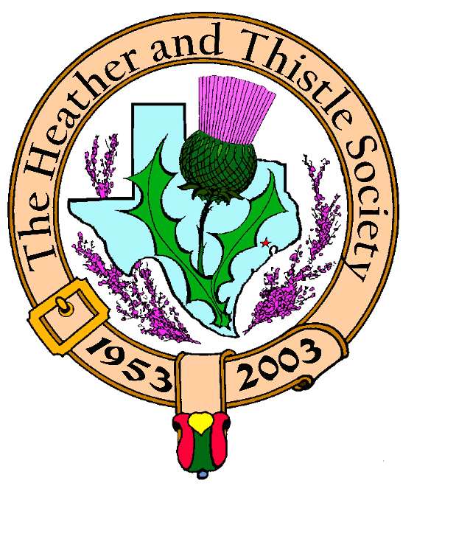

Heather & Thistle Society

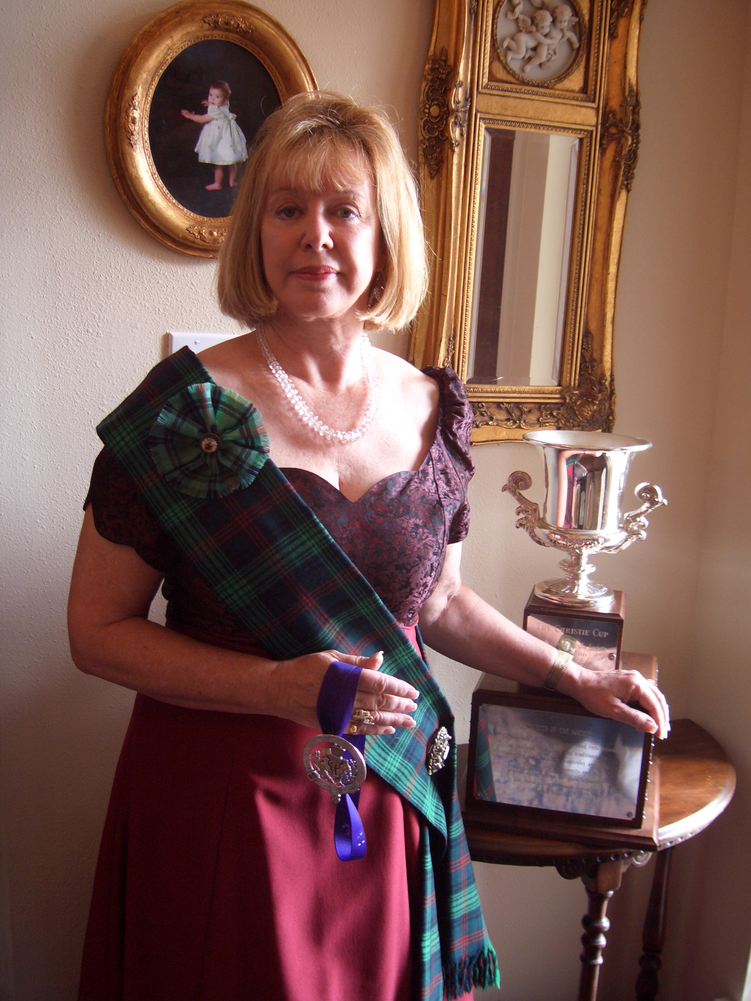
Chieftain Cheryl May

Volume 6, Issue 7
March, 2006

Newsletter Editor:
Jim Monteith

Officers:

Chieftain – Cheryl May
Sub-Chieftain – Jim Monteith
Sgt.-at-Arms – Victor Carsrud
Secretary - Sharon Monteith Treasurer - Robert Moore

Committee Chairs:

Sunshine-Eileen Moore
Membership-Eileen Moore
Past Chieftains-Wayne Barton
Burns Supper-Aaron Buchanan
Publicity-Melvyn Douglass
Programs-Cheryl May

The Houston Scot

Chieftain’s Letter,

This is my last letter to you as Chieftain. Although sad to relinquish this special time as head of H&T, I am happily turning over the gavel to my friend, Jim Monteith. I know he will do an outstanding job as your Chieftain. I had fun taking a few last minute photos of myself as Chieftain, and gave Jim two to publish in February and March.

The calendar is full. We are looking forward to the Scottish Festival tomorrow night. It is always spectacular. This evening, Walter and I had a wonderful Burns Supper with The Burns Club. We enjoyed all the formalities of a Supper, but concluded with the singing of many a favorite song. The camaraderie was great. We also celebrated the countdown to Arthur’s Down’s 90th birthday and James Haggerty’s 60^{th.} Ted Hirtz and I got honorable mention as we both celebrated significant birthdays on March 6th Ted turned 70 and I ….well, as a woman, I can tattle on the men, but am excused from telling my age. Pity the poor person who publishes the truth about mine! However, I will relate that my family went overboard to dress me in purple and red, and then presented me with a beautiful DVD capturing my childhood forward in music and photos. I cannot fully express my appreciation for all their effort and the special gift. What a way to end my Chieftainship and start a new decade! I feel so blessed. It has been a wonderful year.

Programs:

February Program. If you missed the performance of Jim and Margaret Fox, you missed one of the best programs we have had. Everyone was raving about the program: “The History of Texas Music (Steppin’ Back in Time) 1821-1865. Thanks again to Mark Monroe for sponsoring this program.

March – Officer Installation. Please join us as we install our new officers in March. Steve McIntyre will entertain us with his bagpipe…and naturally, we will celebrate afterwards….place TBD.

April Program. My good friend Scott Bumgardner will be entertaining you in April with Cowboy Poetry. You have enjoyed Scott once before as the “Hero” in the melodrama that my Speaker’s Committee of the Houston Livestock show performed a few years back. Scott is a lively critter and I know you will enjoy his Tall Tales.

Alastair Campbell. February 16, 1931 – March 4, 2006. I was very saddened to have to announce the passing of our friend and piper, Al Campbell. The Heather & Thistle Society sent a beautiful “Red Rose” spray to his services. Al was an integral part of our organization for so many years. He always piped in the newly elected officers. I am privileged to have the memory of Al piping me before you last March. We send our deepest condolences to Betsy and family. Al will always be remembered in our hearts.

Scottish Historical Events
For March

March 2, 1316 – Birth of Robert II of Scotland ensures royal succession of Robert the Bruce.
March 3, 1847 – Alexander Graham Bell, Scottish inventor of the telephone, born.
March 5, 1790 – Flora MacDonald, Scottish patriot, died.
March 6, 1725 – Last claimant to the Stuart throne, Henry I of Scotland (Henry IX of England), younger brother of Charles Edward Stuart, born.
March 8, 1899 – Eric Linklater, Scottish writer, born in Wales.
March 9, 1566 – David Riccio, advisor to Mary, Queen of Scots, murdered.
March 9, 2002 – Hamish Henderson, Scottish songwriter, author of “the Freedom Come All Ye,” died.
March 12, 1708 – French-Jacobite invasion of Scotland aborts landing at Firth of Forth.
March 13, 1395 – John Barbour, Scottish poet, author of “The Bruce” died.
March 13, 1708 – French fleet abandons attempted Jacobite invasion of Scotland.
March 14, 1689 – Convention of Estates meets in Edinburgh without royal representation.
March 17, 1328 – Scottish independence recognized by England.
March 18, 1258 – Scottish earls pledge common cause with Llywelyn ap Gruffydd against the English.
March 19, 1286 – Alexander III of Scotland died.
March 19, 1927 – James “Scott” Skinner, renowned Scottish fiddler, died.
March 20, 1724 – Duncan Bain MacIntyre, Scottish Gaelic poet, born.
March 25, 1306 – Robert the Bruce crowned at Scone.
March 26, 1797 – James Hutton, Scottish geologist who pioneered the study of the earth’s age, died.
March 26, 1894 – Alexander Thom, Scottish megalithic archaeologist, born.
March 27, 1625 – James VI of Scotland, died.
March 29, 1813 – Dr. David Livingston (“I presume”), Scottish explorer, born.
March 30, 1808 – George Mealmaker, United Scotsman, died.
March 31, 1844 – Andrew Lang, Scottish historian, born.

Heather & Thistle Society – Minutes
February 27, 2006

Chieftain Cheryl May called the meeting to order at 7:37 pm in the auditorium of St. Thomas Episcopal School. Motion was made to accept the January 2006 minutes as published in the newsletter. Motion passed.

Dr. Robert Moore our Treasurer reports $1,575.63 in the bank. Checks in the amount of $65.00 are still outstanding.

Membership Chairperson Eileen Moore reports as of February 2006 we have 100 family, 50 single, 33 life, 38 exempt, and 4 complimentary, for a total of 225 members.

Committee Reports called for by Sub-Chieftain Jim “Alabama Scotsman” Monteith.

Burns Club: Jack Hume reports the Burns Club’s planned Burns supper was not held and has been rescheduled for the 16ht of March at his residence.
Burns Supper: No report.
Newsletter: Editor Jim Monteith advises 130 newsletters are being mailed out. Membership director Eileen Moore gave several new email addresses to the editor recently.
Past Chieftains: No report.
Programs: Cheryl May announced the March meeting will be the installation of our new officers followed by a cowboy poetry program. Trying to arrange a reformation movement religion program for April.
Sunshine: Eileen Moore reports a sympathy card was sent to Wayne & Brenda Barton on the passing of Wayne’s father. Jack Hume reports Al Campbell is not doing well and should be sent a card. Alex and MaryAnn Monroe are reported to be ill.
Houston Grampian: Jim Monteith reported that during the Offshore Technology Conference coming up in May that the Robert Gordon University of Aberdeen, Scotland will be having an alumni reception.
Houston Highland Games: No report.
RSCDS: Reece Wyant reports beginners classes are on Tuesday and general class is on Wednesday at the YMCA Dad’s Club on 1006 Voss Road. Also a class is held in The Woodlands on Mondays. Cost $6.00 per class.
Houston Highlanders: No report.

Acting Sergeant-At-Arms Chuck Monteith reports 24 members present. Guests were Shazia Petrolito and Jim and Margaret Fox.

Old Business: Jack Hume requests a letter of authority to represent the H&T Society in the Washington Mutual Bank affair. He wants to rectify the $12.00 per month service charge that this bank has been charging H&T for this account. The original agreement with the bank was that there would be no service charge. Jack Hume also requested a letter of invitation be written to the North American Burns Federation. H&T’s Burns Club will be hosting the 2008 Burns Conference in Houston. Chieftain May reports a tartan sash as been found and needs an owner.

New Business: Chieftain Cheryl May announced this months meeting is the vote for the new slate of officers as published in the newsletter. Voice vote was called for and the new slate was elected. Jim Monteith will be Chieftain, Ken Sorrels elected Sub-Chieftain, Chuck Monteith for Sgt.-at-Arms, Robert Moore elected Treasurer, and Sharon Monteith elected Secretary. Member Margaret Reuter asked about photographs from the recent Burns Supper. Becci Himes will have to be contacted to find out when they are ready. Mark Monroe reports the photographer he hired has not finished preparing the photo albums yet and when he does one will be presented to the Society. Members will be able to order photographs from this album. Chieftain May thanked all for their efforts with the recent Burns Supper and reports this will be her last meeting as Chieftain.

Tonight’s Program: Member Mark Monroe, who arranged for tonight’s performance, introduced the musicians. Jim and Margaret Fox performed numerous selections from the time period of 1821 to 1865 using whistles, flute, fiddle and guitar. Jim Fox provided lively and humorous historical commentary on this time period and the music that was played. An excellent performance was enjoyed by members. 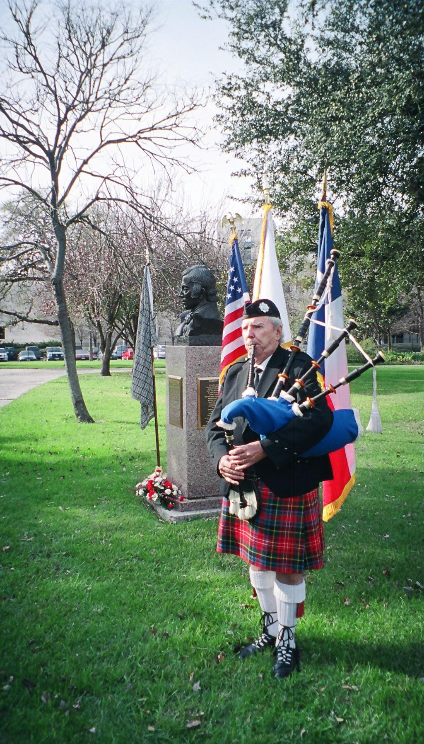Al Campbell at 2004 Burns Memorial

In Memoriam

ALASTAIR “AL” CAMPBELL, February 16, 1931 – March 3, 2006
Long time Heather and Thistle member and our piper for many years at H&T events. Al was born in Glasgow, Scotland and was a veteran of the British Merchant Navy. A member of the Houston Highlanders Pipe Band for many years where he was a Past Pipe Major. Al was also a member of the Houston Grampian Society. He was a Marine Engineer where he pioneered and developed the method of optical alignment for turbo machinery. He worked 20 years with Dresser Industries and later retired from GE/Bently Nevada. Al is survived by his loving wife Betsy Campbell; his children Laura Campbell, Kenny Campbell and his wife Tracy, and Ann Campbell, his grandchildren Mackenzie and Tyler, his sister Moira MacKenzie, and numerous other loving family members and a host of friends. A memorial service celebrating Al’s life was held Wednesday, March 8, 2006 at the Holy Spirit Episcopal Church on 12535 Perthshire. The Heather and Thistle Society was well represented at the memorial service and our own Jack Hume provided a eulogy. The Houston Highlanders Pipe Band performed magnificently before, during, and after the service.
Royal Scottish Country Dance Society

Put your dancing shoes on and come to a Saturday Social, April 1st (no fooling) ! All are welcome... and fun begins at 7:30 pm

The Annual General Meeting with a Social to follow will be held Saturday, May 6th, at 7:30 pm.

The demo dancers are looking forward to performing for the Travel Show, on Sunday, April 2nd, at Reliant Center and at the Houston Highland Games on May 13th.

Spring Semester classes will conclude the end of April, with Summer Socials scheduled once a week beginning in May. Fall Semester classes will begin in September, date and locations to be announced. We will offer both Basic and General classes in Central Houston, as well as the Woodlands and Clear Lake area.

The Children's classes continue at the Sugar Land Community Center, each Monday and will conclude for this semester in May and will resume in September.

Please check our web site – houstonrscds.org for additional information.

Upcoming Texas Scottish Events
San Antonio Highland Games
-April 8,9, 2006 at the Helotes Festival Grounds, 12210 Leslie Rd.
-website www.sahga.org

Kilgore Celtic Heritage Festival
-April 22, 23, 2006 at Kilgore Intermediate School
-website www.texcelt.com

Sam Houston Folk Festival and
Trinity Scottish Festival
-April 21,22,23, 2006 on the campus of Sam Houston University
-website www.shsu.edu

Houston Highland Games
-May 12,13,14, 2006 at the Houston Farm & Ranch Club on State Hwy. 6 in west Harris county.
-website www.houstonhighlandgames.com

Texas Scottish Festival and
Highland Games
-June 2,3,4 2006 at Maverick Stadium on the UTA campus in Arlington, Texas
-20th anniversary of this event
-1-800-363-scot
www.texasscottishfestival.com



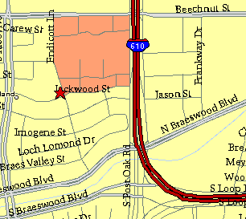

Meeting Information

Meeting Place:
St. Thomas Episcopal School
4900 Jackwood
Houston, Texas 77096

Date and Time:

Fourth Monday of the month
7:30 pm

Heather & Thistle Society Statement
And Membership Information

The Heather and Thistle Society was founded in 1953 by Scots living in Houston who wished to “cultivate an interest in and fond recollections of Scotland, its history and traditions, its literature and ideals, its minstrelsy and song, its customs and amusements, and to provide opportunities for good fellowship and social contact through typically Scottish functions, so that the blessing of our Scottish culture may never die in our new homeland”.

The Heather and Thistle Society meets 10 times a year, September through June. Programs include music, singing, dancing, lively lectures, slide shows and movies about Scotland. The Heather and Thistle Society puts on the annual Robert Burn’s Supper and Ball in late January of each year. We are an organization that promotes our Scottish heritage, in various ways.

The Heather and Thistle Society’s monthly newsletter, “The Houston Scot” is published from September through June. Original articles, information about Scottish or related events are welcome and should be sent to the editor, Jim Monteith, at 15703 Mound Road, Hockley, Texas 77447 or 936-931-2588 or jmonteith@ev1.net.

Membership in the Heather and Thistle Society is open to all with an interest in Scottish heritage and culture. Annual dues are $15 for an individual and $20 for a family membership.
Applications for membership may be obtained from our website at:
http://heatherandthistle.org/documents/membership.doc
Dues are due at the beginning of the fiscal year, March 1. Completed applications and membership fees should be mailed to: Mrs. Eileen Graham Moore
8910 Sandstone, Houston, Texas 77036-6132
For membership information please call Eileen at 713-774-0314.

