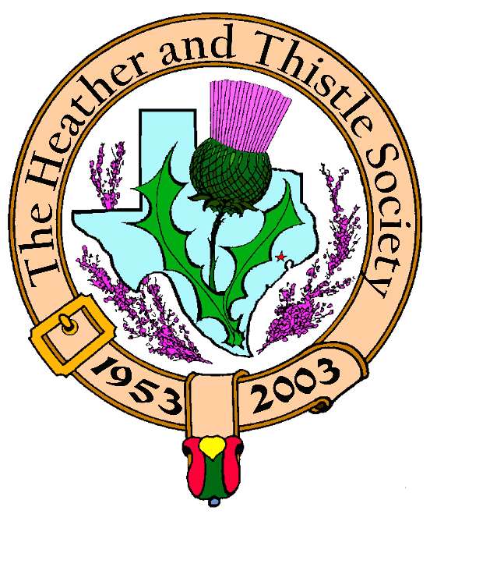

Heather & Thistle Society

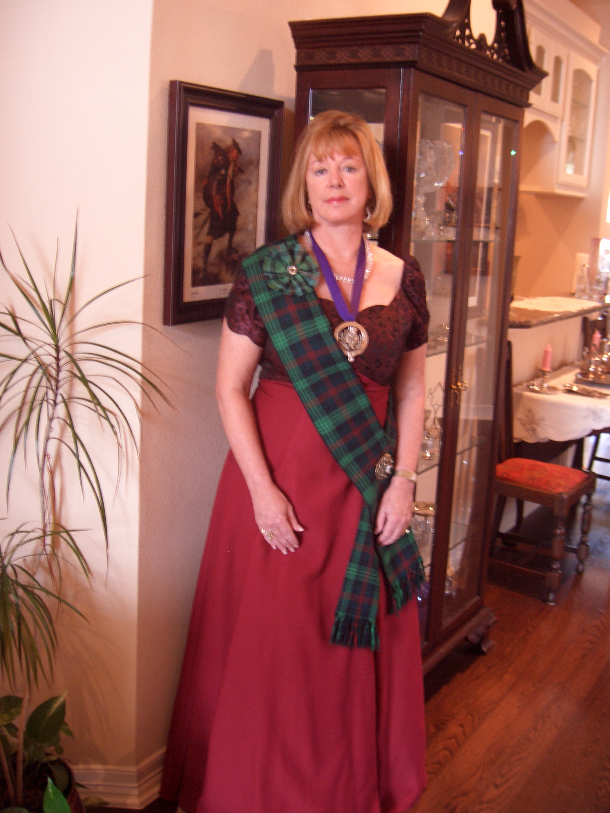
Chieftain Cheryl May

Volume 6, Issue 6
February, 2006

Newsletter Editor:
Jim Monteith

Officers:

Chieftain – Cheryl May
Sub-Chieftain – Jim Monteith
Sgt.-at-Arms – Victor Carsrud
Secretary - Sharon Monteith Treasurer - Robert Moore

Committee Chairs:

Sunshine-Eileen Moore
Membership-Eileen Moore
Past Chieftains-Ed Biddle
Burns Supper-Aaron Buchanan
Publicity-Melvyn Douglass
Programs-Cheryl May


The Houston Scot

Chieftain’s Letter,

What a wonderful night we enjoyed together on January 28th! I want to thank everyone who worked so hard to make this a very special evening. The planning committee spent a year working on every detail for the pleasure of our members and guests. Becci Himes deserves a round of applause for a job well done. We thank Jack Hume for gifting us with The Immortal Memory. Now Past Chieftain Aaron Buchanan will take over the reigns as we start the process for 2007. We had a sold out event, and I sincerely hope we will always have a full house. Never miss an opportunity to tell people about our Burns Supper. I know there are Houstonians who have never attended and would enjoy this evening with us. I will always have very special memories of The 2006 Robert Burns Supper and Red, Red Rose Ball. It was my honor to serve as your Chieftain throughout the evening. My feet were so delighted when I finally took off those fancy, high heels!

Programs:

January Program. The Burns Club entertained us January 23rd with The Travels of Robert Burns. All of us received a detailed map of the various locations in Scotland that Robert Burns visited, and we were able to follow along on his journey with associated poems recited by members of The Burns Club. The meeting was well attended and enjoyed by all.
.
February Program. Plans are set for Jim and Margaret Fox to entertain us on February 27th with the “History of Texas Music (Steppin’ Back in Time) 1821-1865. The Foxes will be traveling from San Antonio to visit with us. Please come and enjoy this special musical presentation courtesy of Mark Monroe.

Future Programs. In March, our newly elected officers will be installed. This is usually followed by a celebration gathering at one of our local taverns. In April, a good friend of mine, Scott Bumgardner, will present a program on Cowboy Poetry. Scott is well known in the Houston area for his Cowboy Poetry. In Louisiana, he just won the state’s Liar’s Award for some of his tall tales. We are used to poetry with a Scottish accent. His poetry will have a country drawl! I am also working on a program regarding Religion and the Reformation Movement in Scotland. The invitation to speak has been made, and I am awaiting confirmation on this program. We have an offer to do a program and demonstration on tartan weaving which will truly be unique. I will be adding this to the line up. Jim Monteith has asked me to continue as program chair, and I welcome any suggestions or ideas.

2006 Scottish Festival Spectacular. Mark your calendar for Friday night, March 17, 2006 at 8 p.m. The St. Thomas Pipers, Drummers and Dancers will hold their annual performance at the Toyota Center. If you have never attended this fabulous event, you have missed one great evening. Tickets can be purchased from St. Thomas or through Ticket Master. For updates and more details go to www.scottishfestival.net. Reserved seats are $25.00 and General Admission is $15.00.

On behalf of The Heather & Thistle Society, I would like to extend my condolences to Past Chieftain Wayne Barton on the loss of his father on February 8th. A memorial service was held in Kerrville, and a graveside service was held in Houston on Monday, February 13th at the San Jacinto Memorial Cemetery. Our prayers are with Wayne, Brenda and their family.

Scottish Historical Events
For February

Feb. 2, 1645 – Battle of Inverlochy, Scotland: Montrose-MacColla victory.
Feb.3, 1749 – William Shaw, Scottish Gaelic dictionary compiler, born.
Feb. 4, 1716 – James VIII of Scotland escapes to France, concluding the Jacobite Rising of 1715.
Feb. 5, 1840 – John Boyd Dunlop, Scottish inventor of the pneumatic rubber tire, born.
Feb. 5, 1881 – Thomas Carlyle, Scottish historian and essayist, died.
Feb. 7, 1313 – Robert the Bruce captures Dumfries, Scotland.
Feb. 7, 1823 – George Washington Wilson, Scottish artist and pioneer photographer, born.
Feb. 8, 1587 – Mary Stuart, Queen of Scots, executed by the English.
Feb. 9, 1292 – First Scottish Parliament assembles at Scone.
Feb. 10, 1306 – Robert the Bruce slays John “the Red” Comyn at Greyfriars Kirk, Dumfries, Scotland.
Feb. 11, 1847 – Macvey Napier, a Scottish author of the Encyclopedia Britannica, died.
Feb. 13, 1692 – Massacre of Glencoe, Scotland.
Feb. 20, 1436 – James I of Scotland assassinated.
Feb. 20, 1847 – The Great Hunger in Scotland: at Wick, Caithness, a starving crowd tried to prevent departure of grain ship but were held back by soldiers.
Feb. 23, 1874 – Hugh Stevenson Robertson, Scottish composer of Songs of the Isles, born.
Feb. 24, 1303 – English invasion of Scotland annihilated at the Battle of Roslin.
Feb. 27, 1545 – Douglases defeat English at Ancrum Moor.
Feb. 28, 1912 – Scottish Home Rule Bill, patterned on Irish bill, introduced in English Parliament.

The Robert Gordon University Alumni Office

The Robert Gordon University of Aberdeen, Scotland will be holding an alumni reception in Houston this year on the 3rd of May during the Offshore Technology Conference. Please contact Jenny Brown at j.brown1@rgu.ac.uk. You can visit their website at www.rgu.ac.uk/alumni

Heather & Thistle Society – Minutes
January 23, 2006

Chieftain Cheryl May tonight introduced Dr. Arthur Down of the Burns Club. Dr. Down introduced tonight’s program “The Journeys of Robert Burns” and discussed the formation of the Burns Club in 1985. The first performance for the Society was in 1989. Tonight will be the groups eighteenth performance.
Refreshments were had after the Burns Club performance.
Chieftain Cheryl May called the business meeting to order at 8:35 pm in the auditorium of the St. Thomas Episcopal School. Motion was made to accept the December 2005 minutes as published in the newsletter. Motion passed.
Dr. Robert Moore our Treasurer reports $1,429.88 in the bank. Dr. Moore advised members of a $12.00 bank fee per month that one of our accounts has been incurring. Jack Hume advised the bank should not be doing that and he would look into the matter.
Membership Chairperson Eileen Moore reports as of Jan. 22, 2006 we have 98 family, 49 single, 33 life, 39 exempt, and 4 complimentary, for a total of 223 members. Janet Brown, a guest from Galveston was introduced. A new membership directory will be published in the next three months. She will need any changes and email addresses.

Committee Reports called for by Sub-Chieftain Jim Monteith.

Burns Club: Jack Hume reports they will be having a Burns Supper at the Black Labrador on Feb. 9th.
Burns Supper: Walter May reports a great supper coming up. All tickets have been sold and there is a waiting list. Let someone know if any tickets become available.
A raffle will be held this year with the grand prize being round trip tickets to London. Activities begin at 5:30 pm. The hotel should have a special rate of $79.00 listed under Burns Supper. Hotel also reports last year their supply of Scotch was exhausted. Jim Walters, the supplier of the frozen haggis this year, will be at the Supper and double portions are promised.
Newsletter: Editor Jim Monteith advises 129 newsletters are being mailed out now and the rest are going out as email. Margaret Reuter asked if she could be put on the snail mail list.
Past Chieftains: Walter May announced the new officer slate for the upcoming election in February. Jim “Alabama Scotsman” Monteith for Chieftain, Dr. Ken Sorrels for Sub-Chieftain, Chuck Monteith for Sgt.-at-Arms, Robert Moore for Treasurer, and Sharon Monteith for Secretary.
Programs: Cheryl May thanked everyone for tonight’s performance by the Burns Club. The Feb. 2006 program will be a musical performance arranged by member Mark Monroe. The March meeting will be the installation of new officers. In April we will have cowboy poetry and great liars from Louisiana. Working on a future program on religion. Janet Brown, guest and new member, is a tartan weaver.
Sunshine: No report.
Houston Grampian: A Grampian group will be coming from Scotland in Sept. 2006.
Houston Highland Games: Melvyn Douglass reports the games will be the 2nd weekend of May. They have received a cultural arts grant. Had a recent fund raiser/pub crawl. Fund raiser on the evening of Feb. 22 at St. Arnold’s Brewery. Ed Brodie’s books have been donated for the silent auction.
RSCDS: Reece Wyant reports a new location at the YMCA Dad’s Club on 1006 Voss Rd. starting Feb. 9.
Houston Highlanders: Jack Hume reports that Al Campbell will become the bands Drum Major.

Sergeant-At-Arms reports 29 members present. Several guests were present.

Old Business: None

New Business: Jack Hume reports the Church Elders at his Church would love to have another Kirking of the Tartans. Eileen Moore advised Reverend Boyd of her church would also love to host the Kirking again. Jack Hume spoke of a Robert Burns portrait that he brought saying it was the best true likeness of the poet known. Cheryl May reports that tonight is our Sgt.-At-Arms Victor Carsrud’s last meeting. He and his wife have moved to Austin where he will be working as a new Doctor of Chiropractic Medicine. There will be Memorial Service on Sunday Jan. 29th at the Burns Bust in Hermann Park at 3 pm. Sub-Chieftain Jim Monteith asked Past Chieftain Committee for permission to rent an enclosed trailer in order to carry the tartans, stands and poles to the Burns Supper. Bob Gilbert announced today was his wife, Sheila Gilbert’s birthday.

Upcoming Texas Scottish Events

2006 Scottish Festival Spectacular
-Friday, March 17, 2006 at the Toyota Center in Houston at 8 pm.
-Annual festival by The St. Thomas Episcopal Church.
-order tickets by phone at
713-666-3111
-website www.scottishfestival.net

San Antonio Highland Games
-April 8,9, 2006 at the Helotes Festival Grounds, 12210 Leslie Rd.
-website www.sahga.org

Kilgore Celtic Heritage Festival
-April 22, 23, 2006 at Kilgore Intermediate School
-website www.texcelt.com

Sam Houston Folk Festival and
Trinity Scottish Festival
-April 21,22,23, 2006 on the campus of Sam Houston University
-website www.shsu.edu

Houston Highland Games
-May 13,14,15, 2006 at the Houston Farm & Ranch Club on State Hwy. 6 in west Harris county.

Texas Scottish Festival and
Highland Games
-June 2,3,4 2006 at Maverick Stadium on the UTA campus in Arlington, Texas
-20th anniversary of this event
-1-800-363-scot
www.texasscottishfestival.com

Happy Birthday

Ann Stewart, Heather and Thistle’s 12th Chieftain celebrated her 82nd birthday on 2-20-06.

Heather & Thistle Elections

Under Article IV of the H&T Bylaws the meeting held in February of each year shall be the Annual General Membership Meeting, at which time officers shall be elected and annual reports received. The presence of twenty (20) members in good standing at any meeting shall constitute a quorum for the transaction of business.
The current officers and future officers of H&T urge members to attend this important meeting.

Heather and Thistle Society Former Chieftains

1. Andrew Christie 1953 – 1954
2. Gordon Baxter 1954 – 1955
3. Jack O’Donnell 1955 – 1956
4. Jack Keith 1956 – 1957
5. Bob Bishop 1957 – 1958
6. Alan Baxter 1958 – 1959
7. Jack Buchanan 1959 – 1960
8. Andrew Christie 1960 – 1961
9. George Watters 1961 – 1962
10. John Smith 1962 – 1963
11. Andrew Christie 1963 – 1964
12. Ann Stewart 1964 – 1965
13. George Watters 1965 -1966
14. Jack Buchanan 1966 – 1967
15. Robert Officer 1967 – 1968
16. Robert Potter 1968 – 1969
17. Brian Reuter 1969 – 1970
18. Ian Taylor-Small 1970 – 1971
19. Phil Robinson 1971 – 1972
20. Bill Ramsay 1972 – 1973
21. Jack Hume 1973 – 1974
22. Bryan Kilgore 1974 – 1975
23. Murray Baird 1975 – 1976
24. Dave Guest 1976 – 1977
25. Dan Smith 1977 – 1978
26. Jack Hume 1978 – 1979
27. Arthur Down 1979 – 1980
28. Gordon White 1980 – 1981
29. Micky Carmichael 1981 – 1982
30. Bob Gilbert 1982 – 1983
31. Don Whitefield 1983 – 1984
32. Arthur Marshall 1984 – 1985
33. Owen BcBride 1985 – 1986
34. Melvyn Douglas 1986 – 1987
35. Tom Murphy 1987 – 1988
36. Edward Brodie 1988 – 1989
37. Lyman Matheson 1989 – 1990
38. Alex Munroe 1990 – 1991
39. David McLane 1991 – 1992
40. Ted Hirtz 1992 – 1993
41. Ed MacAllister 1993 – 1994
42. Zoe Alexander 1994 – 1995
43. Douglass Moore 1995 – 1996
44. Paul Ross 1996 – 1997
45. David Haring 1997 – 1998
46. Heather Lawson 1998 – 1999
47. Edgar Biddle 1999 – 2000
48. Edgar Biddle 2000 – 2001
49. Wayne Barton 2001 – 2002
50. Walter May 2002 – 2003
51. Becci Himes 2003 – 2004
52. Aaron C. Buchanan 2004 – 2005

Chieftain Cheryl May – 53rd Chieftain of H & T

On behalf of the members of the Heather and Thistle Society the editor would like to thank Cheryl May for her service to our Society. During the past year our Society increased its membership significantly and all of the Society’s events were great successes. Chieftain May exhibited the highest standard of dedication and enthusiasm during her Chieftainship.

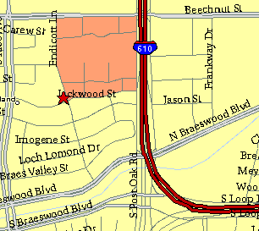

Meeting Information

Meeting Place:
St. Thomas Episcopal School
4900 Jackwood
Houston, Texas 77096

Date and Time:

Fourth Monday of the month
7:30 pm

Heather & Thistle Society Statement
And Membership Information

The Heather and Thistle Society was founded in 1953 by Scots living in Houston who wished to “cultivate an interest in and fond recollections of Scotland, its history and traditions, its literature and ideals, its minstrelsy and song, its customs and amusements, and to provide opportunities for good fellowship and social contact through typically Scottish functions, so that the blessing of our Scottish culture may never die in our new homeland”.

The Heather and Thistle Society meets 10 times a year, September through June. Programs include music, singing, dancing, lively lectures, slide shows and movies about Scotland. The Heather and Thistle Society puts on the annual Robert Burn’s Supper and Ball in late January of each year. We are an organization that promotes our Scottish heritage, in various ways.

The Heather and Thistle Society’s monthly newsletter, “The Houston Scot” is published from September through June. Original articles, information about Scottish or related events are welcome and should be sent to the editor, Jim Monteith, at 15703 Mound Road, Hockley, Texas 77447 or 936-931-2588 or jmonteith@ev1.net.

Membership in the Heather and Thistle Society is open to all with an interest in Scottish heritage and culture. Annual dues are $15 for an individual and $20 for a family membership.
Applications for membership may be obtained from our website at:
http://heatherandthistle.org/documents/membership.doc
Dues are due at the beginning of the fiscal year, March 1. Completed applications and membership fees should be mailed to: Mrs. Eileen Graham Moore
8910 Sandstone, Houston, Texas 77036-6132
For membership information please call Eileen at 713-774-0314.

