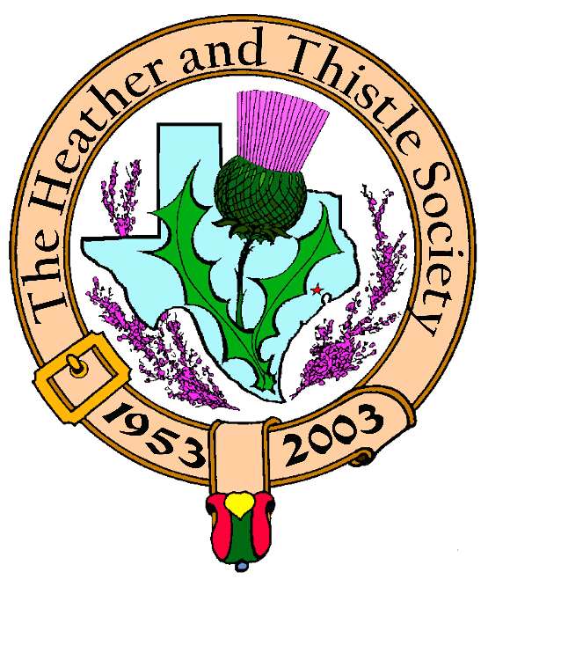

Heather & Thistle Society

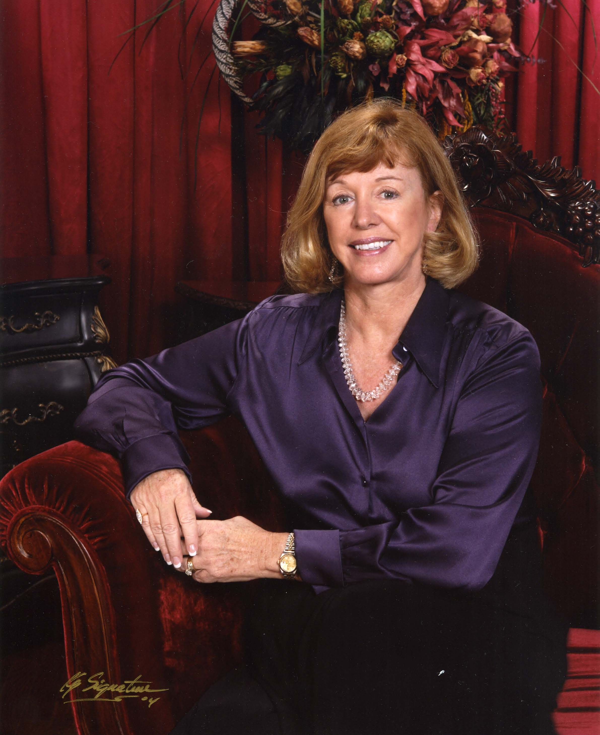

Chieftain Cheryl May

Volume 6, Issue 5
January, 2006

Newsletter Editor:
Jim Monteith

Officers:

Chieftain – Cheryl May
Sub-Chieftain – Jim Monteith
Sgt.-at-Arms – Victor Carsrud
Secretary - Sharon Monteith Treasurer - Robert Moore

Committee Chairs:

Sunshine-Eileen Moore
Membership-Eileen Moore
Past Chieftains-Ed Biddle
Burns Supper-Becci Himes
Publicity-Melvyn Douglass
Programs-Cheryl May

In This Issue

Chieftain’s Letter ----------1
Minutes ---------------------2
Scottish Events ------------2
Jack Hume Biography ----2
Arthur Down Biography—3
2006 Officer Nominations-3 The Houston Scot

Chieftain’s Letter,

The excitement is building for H&T’s 53rd annual Burns Supper & Ball. I look forward to this fabulous event knowing that we will all have a grand time. We should be prepared – at least to dance - thanks to the special lessons given to all of us at the November meeting. We certainly appreciated RSCDS coming to try to train our dancing toes. We had a great time and some good laughter; and hopefully we will remember what they taught! And Ladies, don’t forget to help your man gather all his necessities: the hose, garters, flashes, flypleid, sporran, belt, sgian dubh, broche, etc. Last year I had great fun with my “Reply to the Laddies.” Let us hope the kilt has not shrunk another inch or two!
The Burns Supper. The planning committee is at the finish line of their annual assignment. The good news is that we will have a full house. The bad news is that there is a waiting list and unfortunately, we may not be able to accommodate everyone who did not purchase a ticket early. If for some reason, you have tickets that will not be used, please call Joan McClure at 713-782-6707. Several people have contacted me through our web site regarding tickets. Some folks have recently moved here or just heard about the Supper and would love to attend. I hope we don’t have an empty seat at the hotel!
Don’t forget to buy a raffle ticket. The money will benefit St. Thomas Episcopal School or Scottish Arts programs, and you may be a lucky winner of some very nice prizes.
Programs:
Christmas Party. Everyone was in a festive mood for our party except for Sharon & Jim Monteith who called me a couple hours before the event with the sobering news that they picked up a bad, bad bug and didn’t wish to give that as a gift to the rest of us. I pre warned my Sergeant-At-Arms, Victor and his wife, Jeni, NOT to steal my gifts this year during our White Elephant Exchange. Everyone was merciless, however, and anyone who opened spirits was robbed immediately. Moon couldn’t hold onto a gift if she tried. We all went home happy and at least 1,000 calories were added to the holiday count.
January Program. We are delighted to have our Burns Club present The Travels of Robert Burns to us on January 23rd. We are looking forward to this annual presentation. The Burns Club has invited The English Speaking Union organization as our special guests for the evening. We welcome them and hope they will join us frequently.
Future Programs. On February 27th, Mark Monroe has made arrangements to treat us to an evening of “History of Texas Music (Steppin’ Back in Time) 1821-1865 by Jim Fox and his love wife, Margaret. They reside in San Antonio. Don’t miss this special musical performance.
Heather & Thistle Officer Nominations. I congratulate everyone who has been selected to serve H&T in 2006 and beyond. I know you will give them your generous support as they pledge to serve our organization in the near future.
Community Outreach. I want to thank everyone who brought food to our meetings after Katrina and Rita. I took 13 pounds of food to WHAM (West Houston Assistance Ministries). Each year WHAM assists over 13,000 individuals with food, clothing and financial help. WHAM is an ecumenical ministry and a coalition of 10 churches. They were extremely taxed to meet the needs of all the hurricane victims. At our Christmas party, there was a stack of gifts brought by our members to give to our deserving Veterans. It was my pleasure to take the gifts to the VA Hospital with the hopes of adding a little holiday cheer to someone’s Christmas. I appreciate your support during my leadership to contribute to these worthwhile endeavors.

Scottish Historical Events
For January

Jan. 1, 1766 – King James VIII of Scotland (the Old Pretender) died in exile.
Jan. 2, 1877 – Alexander Bain, Scottish inventor of the electric clock, died.
Jan. 3, 1590 – Robert Boyd, prominent statesman of independent Scotland, died.
Jan. 5, 1984 – Ronald MacDonald Douglas, prominent Scottish nationalist, died.
Jan. 6, 1158 – Norse fleet defeated at the Battle of the Epiphany, Scotland. Jan. 9, 1804 – James “Balloon” Tytler, Scottish patriot & pioneer balloonist, died.
Jan. 17, 1746 – Last Jacobite victory at the Battle of Falkirk, Scotland.
Jan. 19, 1736 – Jaems Watt, Scottish steam engine inventor, born.
Jan. 21, 1987 – Seumas Mac A’Ghobhainn, Scottish nationalist, historian & co-author of The Scottish Insurrection of 1820, died.
Jan. 22, 1788 – George Gordon (Byron), Scottish poet and author of Don Juan, born.
Jan. 25, 1759 – Robert Burns, Scottish poet, born.
Jan. 26, 1316 – Edward Bruce and Irish allies engage English forces at the Battle of Ardscull, Ireland.
Jan. 27, 1784 – Their enlistments expired, the men of the 77th Highland Infantry mutiny against their English officers.
Jan. 28, 1881 – James Miln, Scottish excavator of Carnac, Brittany, died.
Jan 29, 1716 – Scottish Jacobite army begins retreat, resorting to scorched-earth tactics to delay advancing Anglo-Dutch forces.
Jan 30, 2001 – John Prebble, Scottish historian, author of Culloden and The Glencoe Massacre, died.
Jan. 31, 1734 – Rob Roy MacGregor, Scottish Jacobite and legendary outlaw, died.
Heather & Thistle Society – Minutes
December 19, 2005

The meeting was called to order by Chieftain Cheryl Duthie May at 7:43 PM. The meeting was held in the Ingraham Room at St. Thomas Episcopal High School.

The November meeting minutes were approved as published in the December Newsletter.

The Treasurer reported $1,687.48 in the bank. The Kirking of the Tartans luncheon November 20th showed a net profit of $73.00. We had expenditures of $246 for storage and $251.50 for newsletter costs balanced against $235 in deposits for dues.

The Sergeant-At-Arms reported twenty-two in attendance with one visitor.

Sub Chieftain Jim Monteith and Secretary Sharon Monteith were ill and unable to attend. Chieftain May appointed Walter May Acting Secretary and called for organization reports in the Sub Chieftains absence.

Bob Gilbert reported on the Houston Grampian Association. HGA held a St. Andrew’s Day Dinner on 30-Nov-05. HGA will host up to 40 Scots in September 2006 for the quadrennial visit.

Eileen Moore reported that we have 99 memberships, 47 single, 33 life, 4 complementary and 39 exempt memberships for a total of 222. This is up two since 24-Oct-05. Eileen reported for the Sunshine Committee that she sent a card to Allison Wilkes who had minor heart surgery.

Mark Monroe presented a new flag stand holder based on a design contributed by Jack Hume. It will hold 12 flags.

Walter May reported on the Burns Supper Planning Committee. The Supper has only a few seats unsold with no complete tables remaining. The Supper will begin at 5:30 PM with pre-dinner entertainment. This entertainment will consist of the Houston Highlanders and the Royal Scottish Dance Society. Seating will be at 6:30 with the procession beginning at 6:45 PM. St. Thomas Episcopal High School dancers and pipers will play later in the evening.

There will be a raffle with 75% of the proceeds benefiting St. Thomas. The remaining 25% will be distributed to societies supporting Scottish Arts and Traditions in Houston. There are five gifts in the raffle including British Air roundtrip tickets from Houston to Gatwick. Everyone who had not purchased tickets was urged to do so immediately.
The January meeting program will be the annual presentation by the Burns Club. The February program will be on the history of music.

JACK HUME;

Jack was born at Greenock, Scotland; SOME LONG TIME AGO!
He was exposed to the poetry of Robert Burns at an early age.
He was athletic as a YOUNG MAN, rowed for Loch Lomond Rowing Club, and with his crew was Scottish Champion in coxed fours.
He proudly served with Scotland’s only cavalry regiment,
The Royal Scots Greys, British Army of the Rhine.

continued on page three

Jack with his young wife Phemia, and daughter Margie, came from Scotland to Texas in 1955.
Other daughter Mary, Bellaire born, says; “To be a TEXAN and a Scot is not a bad thing”

Jack soon joined Heather and Thistle Society, Rising thru the ranks to CHIEFTAIN,
He is a founding member and Past President of Grampian Association ,
Founding member and Past President of Houston Highland Games,
Founding member and Leader of the Houston Burns Club.

For many years Jack has proposed the toast ;
“The Immortal Memory of Robert Burns” all over from Albuquerque to Atlanta
And is particularly delighted to do so for Heather and Thistle Society.

Though proud of his Scottish birth and Scottish interests,
Jack says, he is more proud to be,
A Texan, and citizen of the United States of America!

ARTHUR L. DOWN 22nd CHIEFTAIN
VOTED BY PEERS TO RECEIVE

“THE JACK AND PHEMIA HUME HONORARY SERVICE AWARD”

Dr. Arthur L. Down was born in London, March 25th 1916. His Father was a west countryman whilst his Mother, a Lewis, was born in the Midlands, the family having a Scottish background. He was educated in Maidstone at a school founded in 1348, becoming a King Edward V1 Grammar School in 1549, and at Imperial College of Science and Technology, founded by the Prince Consort. He spent two years researching the composition of the organic matter in Scottish oil shales and related materials, spending the summers working in the industry in Midlothian. In July 1939, Trinidad Leaseholds recruited him for a refinery expansion project funded by the Ministry of Aircraft Production to maximize aviation fuel production. Texaco bought the company in 1953 and Dr. Down headed up a 300 per cent refinery expansion. He was transferred to New York in 1961 as a General Manager and to Houston in February 1975 as V.P. Chemical Operations. On retirement from Texaco in 1981 he became a consultant to the Central Region of Scotland, Sterling.

In Houston Arthur lost no time in joining the Heather & Thistle Society, and when his wife, Joan, joined him in mid-year, they joined the Scottish Country Dancers. In the fall of 1977, the Society complained of a lack of program. Chieftain Dan Smith appointed Arthur Program Chairman. He was elected Sgt. At Arms in February 1978, succeeding to Sub-Chieftain in December when Ron Glennie was transferred to the West Coast and elected Chieftain in 1979. As Chieftain and in following years on the Burns Supper Committee and Past Chieftain’s Committee, he sought to streamline the Burns Supper Program and introduced the idea of having a well know Burnsian from Scotland give the Immortal Memory three out of every four years. He was responsible for bringing to Houston the first eleven speakers.

The concept of The Burns Club was first discussed over lunch with Jack Hume. It was not until 1984 that a club was formed from members of the H&T Society. The Club made its first annual presentation to the society in 1989 with Anne Gaw, President of the Burns Federation, in attendance. Since 1989 the Burns Club has held their own Burns Supper with Arthur in the Chair. Last January, we all enjoyed his annual performance with The Burns Club at our H&T meeting.

Arthur Down will celebrate his 90th birthday in March. The Society wishes him a very Happy Birthday, and we are grateful to have the opportunity to thank him for his many years of devoted service.

Nominations for Officers of Heather and Thistle Society 2006

The Past Chieftain’s committee and our Chieftain have been working hard to come up with nominations for our Officers for 2006. And they are:
Jim “Alabama Scotsman” Monteith for Chieftain
Dr. Ken Sorrels for Sub-Chieftain
Chuck Monteith for Sergeant At Arms
Dr. Robert Moore for Treasurer
Sharon Monteith for Secretary

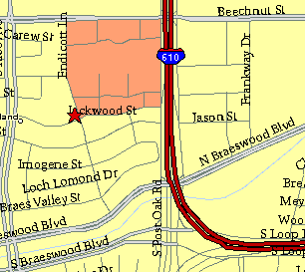

Meeting Information

Meeting Place:
St. Thomas Episcopal School
4900 Jackwood
Houston, Texas 77096

Date and Time:

Fourth Monday of the month
7:30 pm Heather & Thistle Society Statement
And Membership Information

The Heather and Thistle Society was founded in 1953 by Scots living in Houston who wished to “cultivate an interest in and fond recollections of Scotland, its history and traditions, its literature and ideals, its minstrelsy and song, its customs and amusements, and to provide opportunities for good fellowship and social contact through typically Scottish functions, so that the blessing of our Scottish culture may never die in our new homeland”.

The Heather and Thistle Society meets 10 times a year, September through June. Programs include music, singing, dancing, lively lectures, slide shows and movies about Scotland. The Heather and Thistle Society puts on the annual Robert Burn’s Supper and Ball in late January of each year. We are an organization that promotes our Scottish heritage, in various ways.

The Heather and Thistle Society’s monthly newsletter, “The Houston Scot” is published from September through June. Original articles, information about Scottish or related events are welcome and should be sent to the editor, Jim Monteith, at 15703 Mound Road, Hockley, Texas 77447 or 936-931-2588 or jmonteith@ev1.net.

Membership in the Heather and Thistle Society is open to all with an interest in Scottish heritage and culture. Annual dues are $15 for an individual and $20 for a family membership.
Applications for membership may be obtained from our website at:
http://heatherandthistle.org/documents/membership.doc
Dues are due at the beginning of the fiscal year, March 1. Completed applications and membership fees should be mailed to: Mrs. Eileen Graham Moore
8910 Sandstone, Houston, Texas 77036-6132
For membership information please call Eileen at 713-774-0314.
