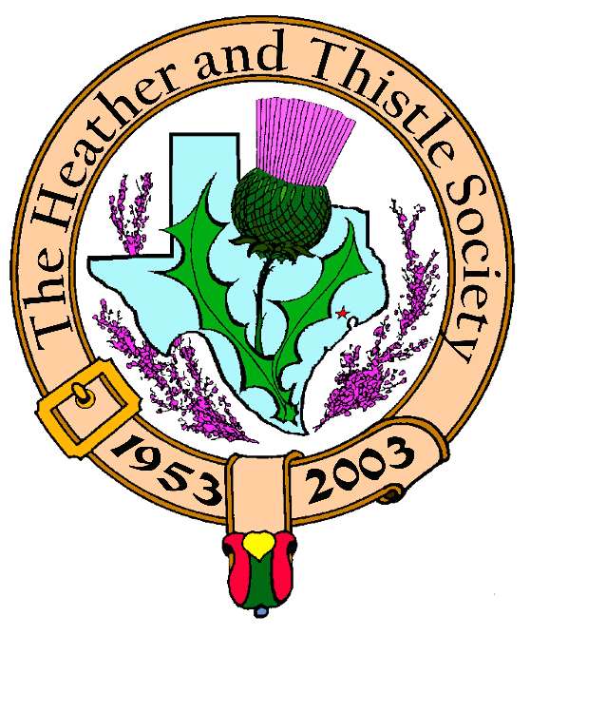

Heather & Thistle Society

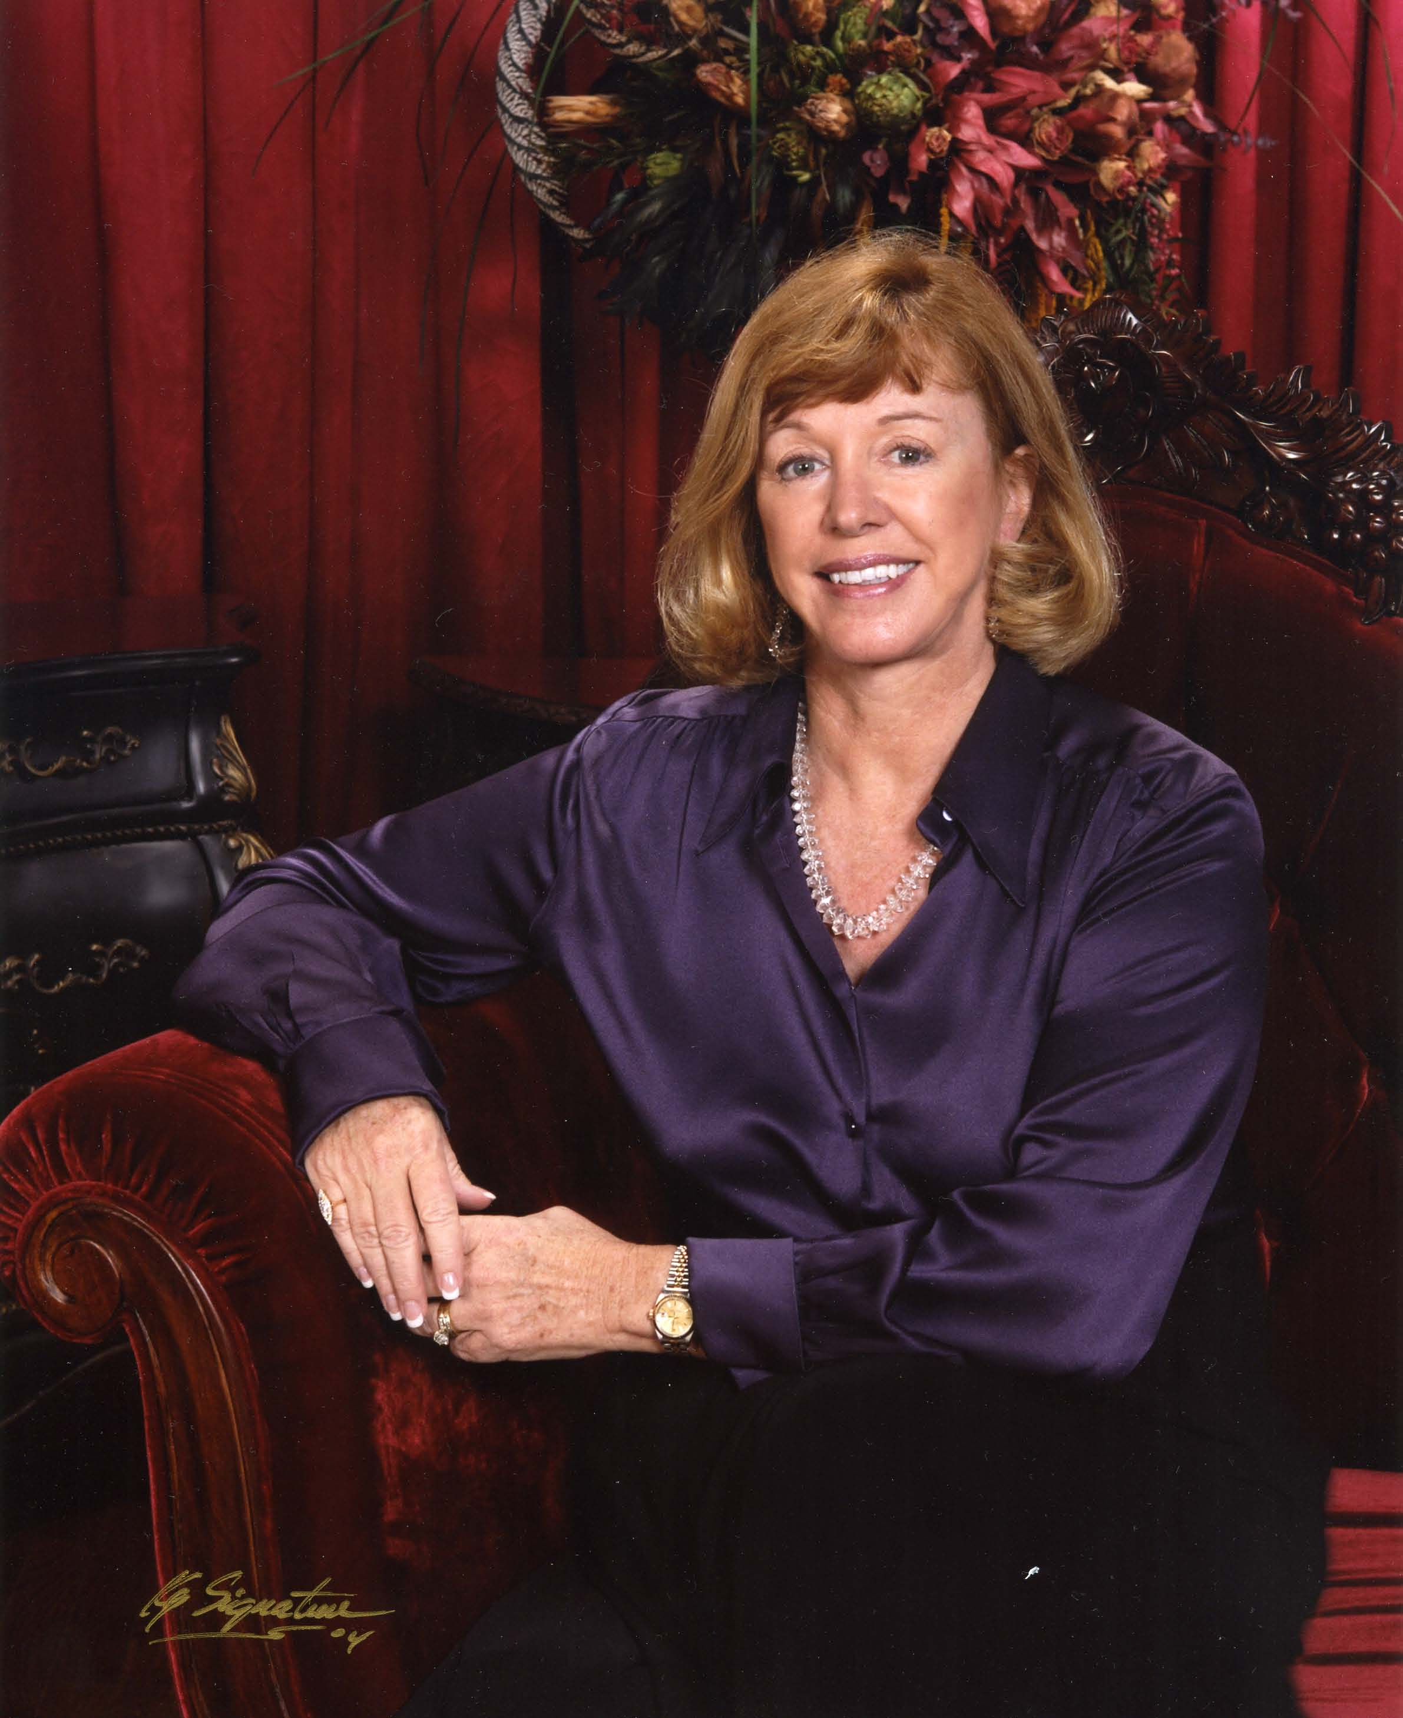

Chieftain Cheryl May

Volume 6, Issue 4
December, 2005

Newsletter Editor:
Jim Monteith

Officers:

Chieftain – Cheryl May
Sub-Chieftain – Jim Monteith
Sgt.-at-Arms – Victor Carsrud
Secretary - Sharon Monteith Treasurer - Robert Moore

Committee Chairs:

Sunshine-Eileen Moore
Membership-Eileen Moore
Past Chieftains-Ed Biddle
Burns Supper-Becci Himes
Publicity-Melvyn Douglass
Programs-Cheryl May

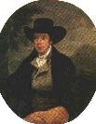

The Houston Scot

Chieftain’s Letter,

Although the stores have tried to prepare us for the Christmas season starting in early Fall, I still find it hard to believe that December has arrived. Last year it snowed Christmas Eve. My grandsons were ecstatic as they gathered snow to build “Frosty.” I made a quick trip to Kemah to witness their creation before the boys decided it was just as much fun to tear him down. Having raised girls, I was a little dumbfounded; but Walter informed me it made perfect sense. Children add such a sense of delight to the Christmas Holidays. And grandchildren….well, what a gift!

The Burns Supper. The word is out about what a grand evening H&T has planned on January 28th. Becci Himes, our Burns Supper chairman, the Past Chieftain’s Committee, Joan McClure and everyone involved are doing their utmost to create a fabulous night for all of us. I do hope that all members who planned to attend have purchased your tickets because as I understand the event is almost sold out. The hotel was able to add a few more tables, but it is possible that we may have to start a wait list. We are certainly looking forward to The Red, Red Rose Ball.

This year The Heather & Thistle Society will be selling raffle tickets and the winners will be announced during the evening. Proceeds from the event will be given to St. Thomas Episcopal School and Houston’s Scottish Arts Programs. Tickets are $10 each. British Air has kindly donated a trip for two to London. The Marriott Westchase, our host hotel, has donated a delicious brunch for four. Becci is busy gathering donations that will be included. We will be happy to sell you tickets prior to the Supper. St. Thomas Pipers and Dancers will be offering tickets the night of the Supper, and we certainly hope everyone buys at least one.

Christmas Party. Be sure to join us for our annual Christmas party Monday, December 19th. As usual, it will be held at 7:30 pm in the Ingra ham Room at St. Thomas. In addition to bringing goodies to pass, be sure to bring your “White Elephant” gift….wrapped…for our fun exchange. As part of our out reach into the community, I would also like to ask everyone to bring a small gift to be taken to needy Veterans in our community. Socks, handkerchiefs, a warm blanket or shirt would be greatly appreciated. If anyone is available to help me deliver these items, please let me know.
.
Future Programs. I know The Burns Club is busily preparing for their annual program at our January meeting. Since this is before The Burns Supper, we won’t be able to “advertise” it in our program. Be sure to mark your calendars for January 23rd, and bring your friends!

Heather & Thistle Officer Nominations. As announced at our last meeting, The Past Chieftain’s Committee would like anyone who might be interested in becoming an officer to contact their Chairman, Ed Biddle. Ed will be happy to answer any questions you might have about service to H&T. It takes many volunteers to make this a successful organization.

May you have a very blessed Christmas and a New Year filled with good health and happiness.

The Dixon Hedges Memorial Badge Box

For many years, Dixon, as custodian of the Heather and Thistle Badge Box and Guest Book, greeted everyone who ever attended a meeting.

Dixon Hedges 1916-1997
Sadly Missed

H&T Member Profile

James Malcolm Monteith
Born on April, 20, 1954 in
Birmingham, Alabama. Called Jim since the 4th grade he grew up in the hills of West Birmingham. His father was interested in history, genealogy, and Scottish culture. He grew up with two sisters and one older brother. The family vacationed every summer camping out or staying with relatives all over the Eastern and Southern USA. Attended the Highland Games at Grandfather Mountain in North Carolina in the 60’s. Jim played baseball and football in the YMCA program in elementary school. In high school he was on the wrestling team. Jim got a motorcycle at age 17 after begging for three years to his parents.
Attended Auburn University for two years from 1972 to 1974. Transferred to Univ. of Alabama in Birmingham and received a B. S. in Geology there in 1979. Hobbies in his 20’s and early 30’s were sport skydiving and hang gliding. Despite his mother’s fears of his hobbies
she handmade him a custom jumpsuit. His father had him sign a life insurance policy just in case he had a bad day at the drop zone or mountain.
Moved to Houston the day he got his diploma where he entered into the oil business as a seismic geophysicist. Lived in Bakersfield, California for one year in 1981 where he continued his flying hobby by training for his private pilot’s license. Returned to Houston in 1982 still in the oil business where he weathered the down turn until 1985 when he was laid off. Unemployed for nearly a year he attended an aircraft mechanics school. In December 1986 he was hired by the Dallas Police Department where he began his career in law enforcement as a patrol officer in NW Dallas in April, 1987. In September 1989 Jim was hired by the Texas Dept. of Public Safety. He trained at their academy for 22 weeks and became a State Trooper in the Highway Patrol. Jim has been stationed in the West or Northwest Harris and Waller Counties since hitting the road with the DPS Highway Patrol.
Jim continued his flying hobby in small planes and helicopters actively until 1995 when he decided he spent too much money on this hobby. He bought some land in NW Harris County and began plans to build a house on it one day.
He currently is in the Commercial Vehicle Enforcement service of the Highway Patrol where he is engaged in Federal and State inspections of commercial vehicles. Jim is married to Sharon Monteith, H&T Secretary, and he has a 223year old daughter and almost 11 year old son. Jim and Sharon built their house in the country in 1999. Jim and Sharon have been Society members since 2001. Jim currently serves as the Society’s Sub-Chieftain and Editor of the monthly newsletter, ‘The Houston Scot’.

Heather & Thistle Society – Minutes
November 28, 2005

Chieftain Cheryl May called meeting to order at 7:32 pm in the gymnasium of St. Thomas School. Motion made to accept October’s minutes as published in the newsletter. Motion seconded and passed.

Treasurer Robert Moore reports $1,770.08 balance.

Membership Chairman Eileen Moore was out sick tonight. Her husband Robert Moore reports 97 family, 48 single, 33 life, 4 complimentary, 39 exempt, for a total of 221 members.

Committee Reports called for by Sub-Chieftain Jim Monteith:

Burns Club: Jack Hume reports he attended the North American Burns Federation meeting in Milwaukee. At the next Burns Club meeting the topic will be the Journeys of Robert Burns. Jack reports a 1000 lb. donation was made to the Federation.
Burns Supper: Becci Himes displayed an advertisement poster/flyer of the upcoming 53rd Burns Supper. She promised double portions of haggis at the supper.
Newsletter: 75 members receiving e-mail version now. Mailed out 129. Newsletter editor Jim Monteith passed around a Celtic Calendar that he received from an organization called the Celtic League American Branch in New York.
Past Chieftains: Walter May reports Burns Supper moving along well. Nominees for next year’s officers was discussed.
Programs: Chieftain Cheryl May reminded members of our annual Christmas party and White Elephant Gift Exchange. Also, remember to bring goodies to eat.
Sunshine: No report tonight due to chairman Eileen Moore out sick.
Houston Grampian: Bob Gilbert reports they are having their St. Andrews dinner on Wednesday, November 30th. The event takes place at the Marriott Westchase. Haggis will be served and tickets are still available.
Houston Highland Games: There is going to be a silent auction to benefit the Games at the Mucky Duck.
RSCDS: Moonyeen Weiss reports fall classes being held at Memorial Drive Presbyterian and St. Luke’s. Will advise newsletter editor of winter schedule.
Houston Highlanders: No report.
Sergeant-at-Arms: Sgt.-at-arms Victor Carsrud reports 26 members signed in and four guest. Guests were George Keiller, Risa Keiller, Julie Horn, and Pamela Duthie. Pamela is Chieftain Cheryl May’s sister visiting from North Dakota.

New Business: Jack Hume reports that Clan Hume has purchased Clan Hume Castle. He also thanked everyone who attended the Kirking ceremony at his church. Chieftain Cheryl May stated that she sincerely appreciated our members participation at the recent Kirking. Chieftain reports that the St. Thomas Pipe Band will be performing at the upcoming Burns Supper. Bob Gilbert will be giving the address to the haggis. Jack Hume says thanks for all the cards, flowers, and prayers he received and states he feels better than he has felt in years. Chieftain announced that the H&T officers have voted to award the Dixon Hedges Memorial award to Joan McClure. The Society is very proud of all her hard work in handling the ticket sales for the Burns Suppers. Joan stated that she enjoyed the work.

Old Business: None.

Meeting adjourned at 7:50 pm.

Tonight’s program was member participation Scottish folk dancing with instruction provided for by members of the Royal Scottish County Dance Society.

Days of the Week in Scottish

Sunday Di-Domhnaich
Monday Di-Luain
Tuesday Di-Mairt
Wednesday Di-Ciadain
Thursday Di-Ardaoin
Friday Di h-Aoine
Saturday Di-Sathurna


Christmas Party 2005

Members remember to attend our annual Christmas Party on December 19th, 2005. It will be held in the Ingram Room on the campus of St. Thomas.
Please bring a $10 gift for the White Elephant Gift Exchange and also remember to bring lots of goodies to eat.

Celtic Calendar 2006

The Celtic League American Branch recently sent your editor a Celtic Calendar for 2006. “ An historical and mythological calendar representing the Celtic year: November 1, 2005 to October 31, 2006. “ It is a beautiful calendar filled with historical information from all the Celtic countries. They also have a website that is filled with information concerning Celtic lands. Their website is located at www.celticleague.org. For information on the calendar contact Tom Cullinan at 1-800-626-CELT.

Scottish Historical Events for December

--Dec. 2, 1837 Joseph Bell, noted Scottish surgeon and inspiration for Sherlock Holmes, born
--Dec. 3, 1894 Robert Louis Stevenson, Scottish author, died
--Dec. 4, 1795 Thomas Carlyle, Scottish historian, born
--Dec. 5, 1189 Quitclaim of Canterbury: Richard I of England surrendered feudal superiority over Scotland
--Dec. 8, 1524 Mary Stuart, Queen of Scots, born
--Dec. 14, 1542 James V, last King of independent Scotland, died
--Dec. 16, 1707 Act of Union with England receives assent of Scots Parliament
--Dec. 17, 1745 James “Balloon” Tytler, Scottish aviator, born
--Dec. 25, 1836 Domhnail MacEacharn, Scots Gaelic poet, born

H&T Designates Joan McClure

Recipient of 2005 Dixon Hedges Award

The officers of The Heather & Thistle Society have selected Joan McClure as their choice for the 2005 Dixon-Hedges award.

This award is presented annually to a non-officer who has generously contributed their time and talent to our Society. It was established in order to recognize those individuals who have served us well. It is always announced and displayed at The Burns Supper.

Joan claims Clan MacLeod by marriage and Ferguson by descent. Both families were early Texas settlers and listed in First Families of Texas. Joan’s Ferguson was from Virginia and was a Revolutionary Patriot Soldier. Both families followed the Scottish migration pattern – Virginia and North Carolina, across thru Tennessee into Arkansas and then Texas.

Joan taught school while her husband, Bob was in medical school, and then worked as a secretary to the Chief, Professional Services at the VA Hospital in Houston while Bob was in residency. She “retired” to have a family and also kept active as president of the county medical society auxiliary and later of the state medical auxiliary. She has been a docent at Bayou Bend since 1979 and has served as General Chairman of the docent organization. She has served her DAR chapter as Registrar for four years. She is also a member of DRT and UDC.

Joan and Bob were members of the Scottish Heritage Society and served as board members. That group dissolved sometime around 1990.

Their son is a district attorney in San Antonio. He has a daughter who is a junior at Rhodes College in Memphis and a son who is a sophomore at Saint Mary’s Hall in San Antonio. Joan’s daughter is a police officer in the Plano department and teaches many training classes. She has a son who has just returned from three years overseas in the Air Force and a daughter who is working.

For the past six years, Joan has taken charge of handling the tickets sales for The Burns Supper. She participates in all the planning meetings to ensure that all flows smoothly.
Joan has also hosted many dinners for our “Immortal Memory” speaker. Joan regularly attends our H&T meetings, and is active in The Burns Club.

Congratulations Joan McClure for a job well done.

Previous Dixon Hedges Memorial Recipients

Year 2000-2001 ------Alastair J. Campbell

Year 2001-2002 ------ Eileen Graham Moore

Year 2002-2003 ------ Linda Laxton Biddle

Year 2003-2004 ------ Maryann Munroe

Year 2004-2005 ------ Stephen E. McIntyre

53rd Annual Robert Burns Supper

Burns Supper Committee Chairman Becci Himes reports that the upcoming Burns Supper to be held January 28, 2006 has been sold out. Wine for each table can be pre-ordered from the Marriott Westchase Hotel

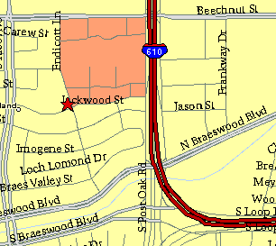

Meeting Information

Meeting Place:
St. Thomas Episcopal School
4900 Jackwood
Houston, Texas 77096

Date and Time:

Fourth Monday of the month
7:30 pm
Heather & Thistle Society Statement
And Membership Information

The Heather and Thistle Society was founded in 1953 by Scots living in Houston who wished to “cultivate an interest in and fond recollections of Scotland, its history and traditions, its literature and ideals, its minstrelsy and song, its customs and amusements, and to provide opportunities for good fellowship and social contact through typically Scottish functions, so that the blessing of our Scottish culture may never die in our new homeland”.

The Heather and Thistle Society meets 10 times a year, September through June. Programs include music, singing, dancing, lively lectures, slide shows and movies about Scotland. The Heather and Thistle Society puts on the annual Robert Burn’s Supper and Ball in late January of each year. We are an organization that promotes our Scottish heritage, in various ways.

The Heather and Thistle Society’s monthly newsletter, “The Houston Scot” is published from September through June. Original articles, information about Scottish or related events are welcome and should be sent to the editor, Jim Monteith, at 15703 Mound Road, Hockley, Texas 77447 or 936-931-2588 or jmonteith@ev1.net.

Membership in the Heather and Thistle Society is open to all with an interest in Scottish heritage and culture. Annual dues are $15 for an individual and $20 for a family membership.
Applications for membership may be obtained from our website at:
http://heatherandthistle.org/documents/membership.doc
Dues are due at the beginning of the fiscal year, March 1. Completed applications and membership fees should be mailed to: Mrs. Eileen Graham Moore
8910 Sandstone, Houston, Texas 77036-6132
For membership information please call Eileen at 713-774-0314.

