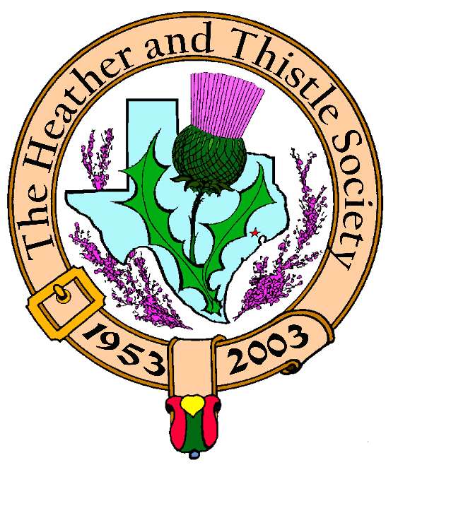

Heather & Thistle Society

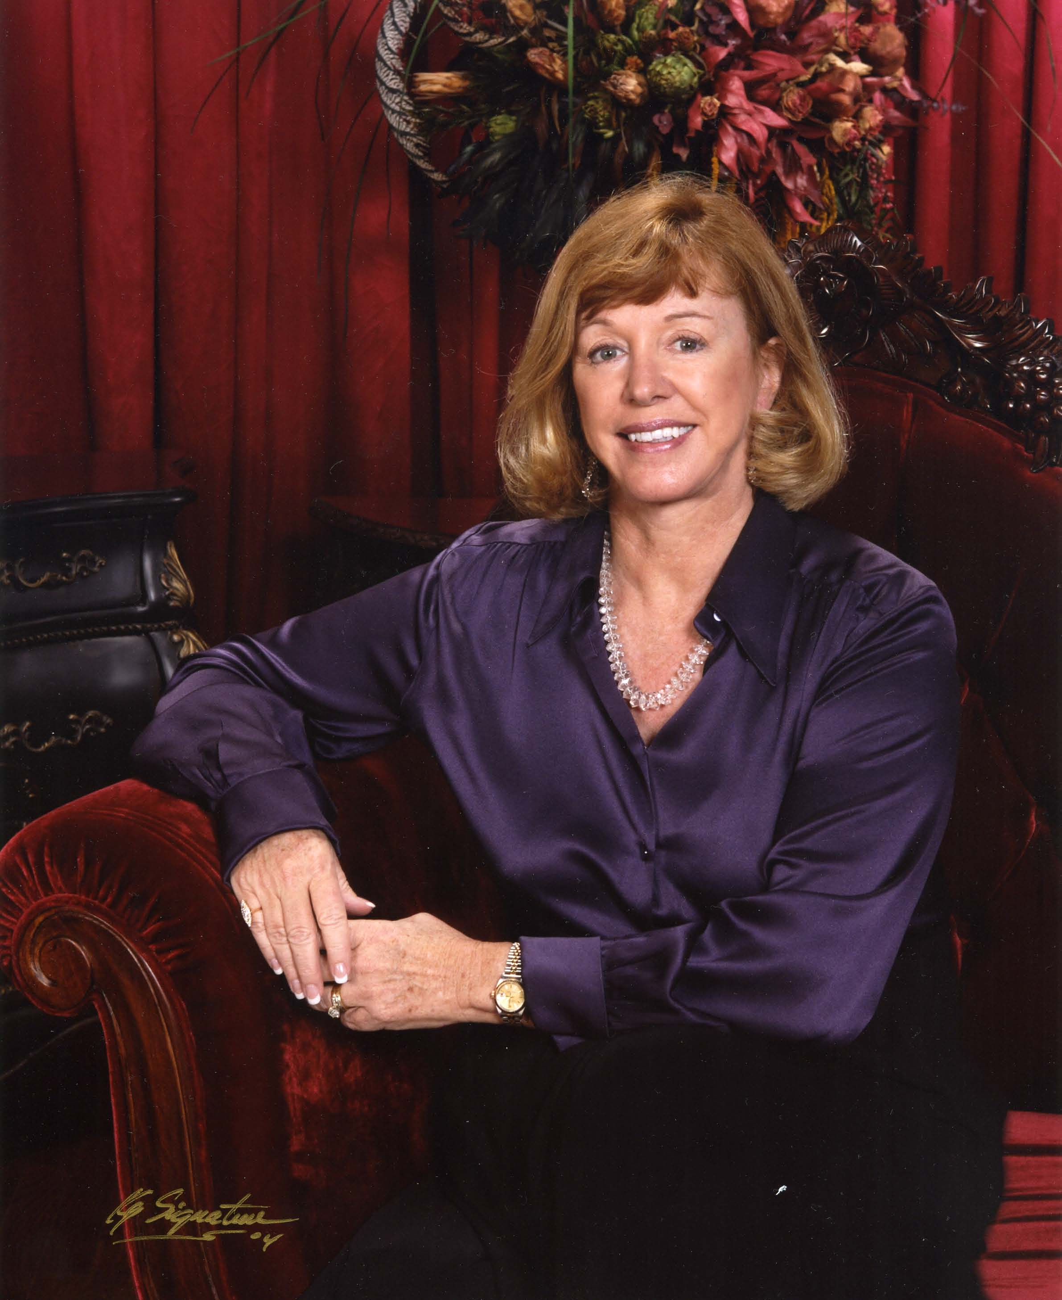

Chieftain Cheryl May

Volume 6, Issue 3
November, 2005

Newsletter Editor:
Jim Monteith

Officers:

Chieftain – Cheryl May
Sub-Chieftain – Jim Monteith
Sgt.-at-Arms – Victor Carsrud
Secretary - Sharon Monteith Treasurer - Robert Moore

Committee Chairs:

Sunshine-Eileen Moore
Membership-Eileen Moore
Past Chieftains-Ed Biddle
Burns Supper-Becci Himes
Publicity-Melvyn Douglass
Programs-Cheryl May



The Houston Scot

Chieftain’s Letter,

Happy Thanksgiving to all! This time of year I always remember my sweet mother-in-law who managed to figure out 1001 ways to prepare the leftovers from Thanksgiving. I extend warm wishes to all our members as we begin the holiday season.

I want to thank both The Houston Highlanders and Jay Dooling for making our October meeting special. We started our program year with the wonderful sound of bagpipers. Jay gave us insight into visiting Scotland’s Celtic neighbor, Ireland. Everyone enjoyed the beautiful slides. Our members were treated to a special evening.

By the time you receive this newsletter, we will have celebrated our Kirking service and catered luncheon at St. Stephen Presbyterian Church. We are grateful to the Reverend Patricia Clark and everyone at St. Stephen who worked so very hard to make this a very memorable event. I appreciate all of you who were able to attend. My special thanks goes to steadfast member, Eileen Moore, who personally made the Scottish boutonnières for everyone. It was our intention to make this service meaningful for all parishioners at St. Stephen, and we thought the non-Scottish folks would enjoy wearing “the plaid and thistle.” Thanks to Jack Hume for sharing his church with us.

November 28th Meeting. Is everyone prepared to learn a reel or two? Get out those dancing shoes. RSCDS is going to do their best to prepare us for The Burns Supper. Our program will combine a demonstration and dance lessons. Bring a partner and a neighbor or two. RSCDS promises to help those of us with two left feet to be on our toes at the end of the evening. Remembering all may be the challenge.

Future Programs. Next month we will have our annual Christmas Party and “White Elephant” exchange. Start thinking about the little gift to share. The Burns Club will present our program in January. Mark Monroe has generously offered to sponsor a music program by Jim and Margaret Fox that covers Texas music during the period 1821-1865. We will be working on a date for that performance.

The Burns Supper. If you have not ordered your Burns Supper tickets, do so immediately. Tickets will go on sale to the general public on December 1st. If you need a ticket form, go to our web site: heatherandthistle.org and download the ticket form which is under the caption Robert Burns.

Pantry Donations. I was delighted to discover that several members brought donations for Houston’s food bank. Thank you very much. Thanksgiving reminds us of our many blessings, and I encourage all of you to remember those who need our prayers and help.

God bless our Veterans!

North America Burns Federation Conference

The Burns Club subsection of The Heather & Thistle Society wishes to host the 2008 North America Burns Conference in Houston. The Burns Club members have voted to support this idea, and have committed to provide the necessary time and effort to support this conference. The Heather and Thistle Society is the registered member of the Burns Federation and therefore must make the formal offer to host. H&T will discuss and vote on this proposal at the November 28, 2005 meeting.

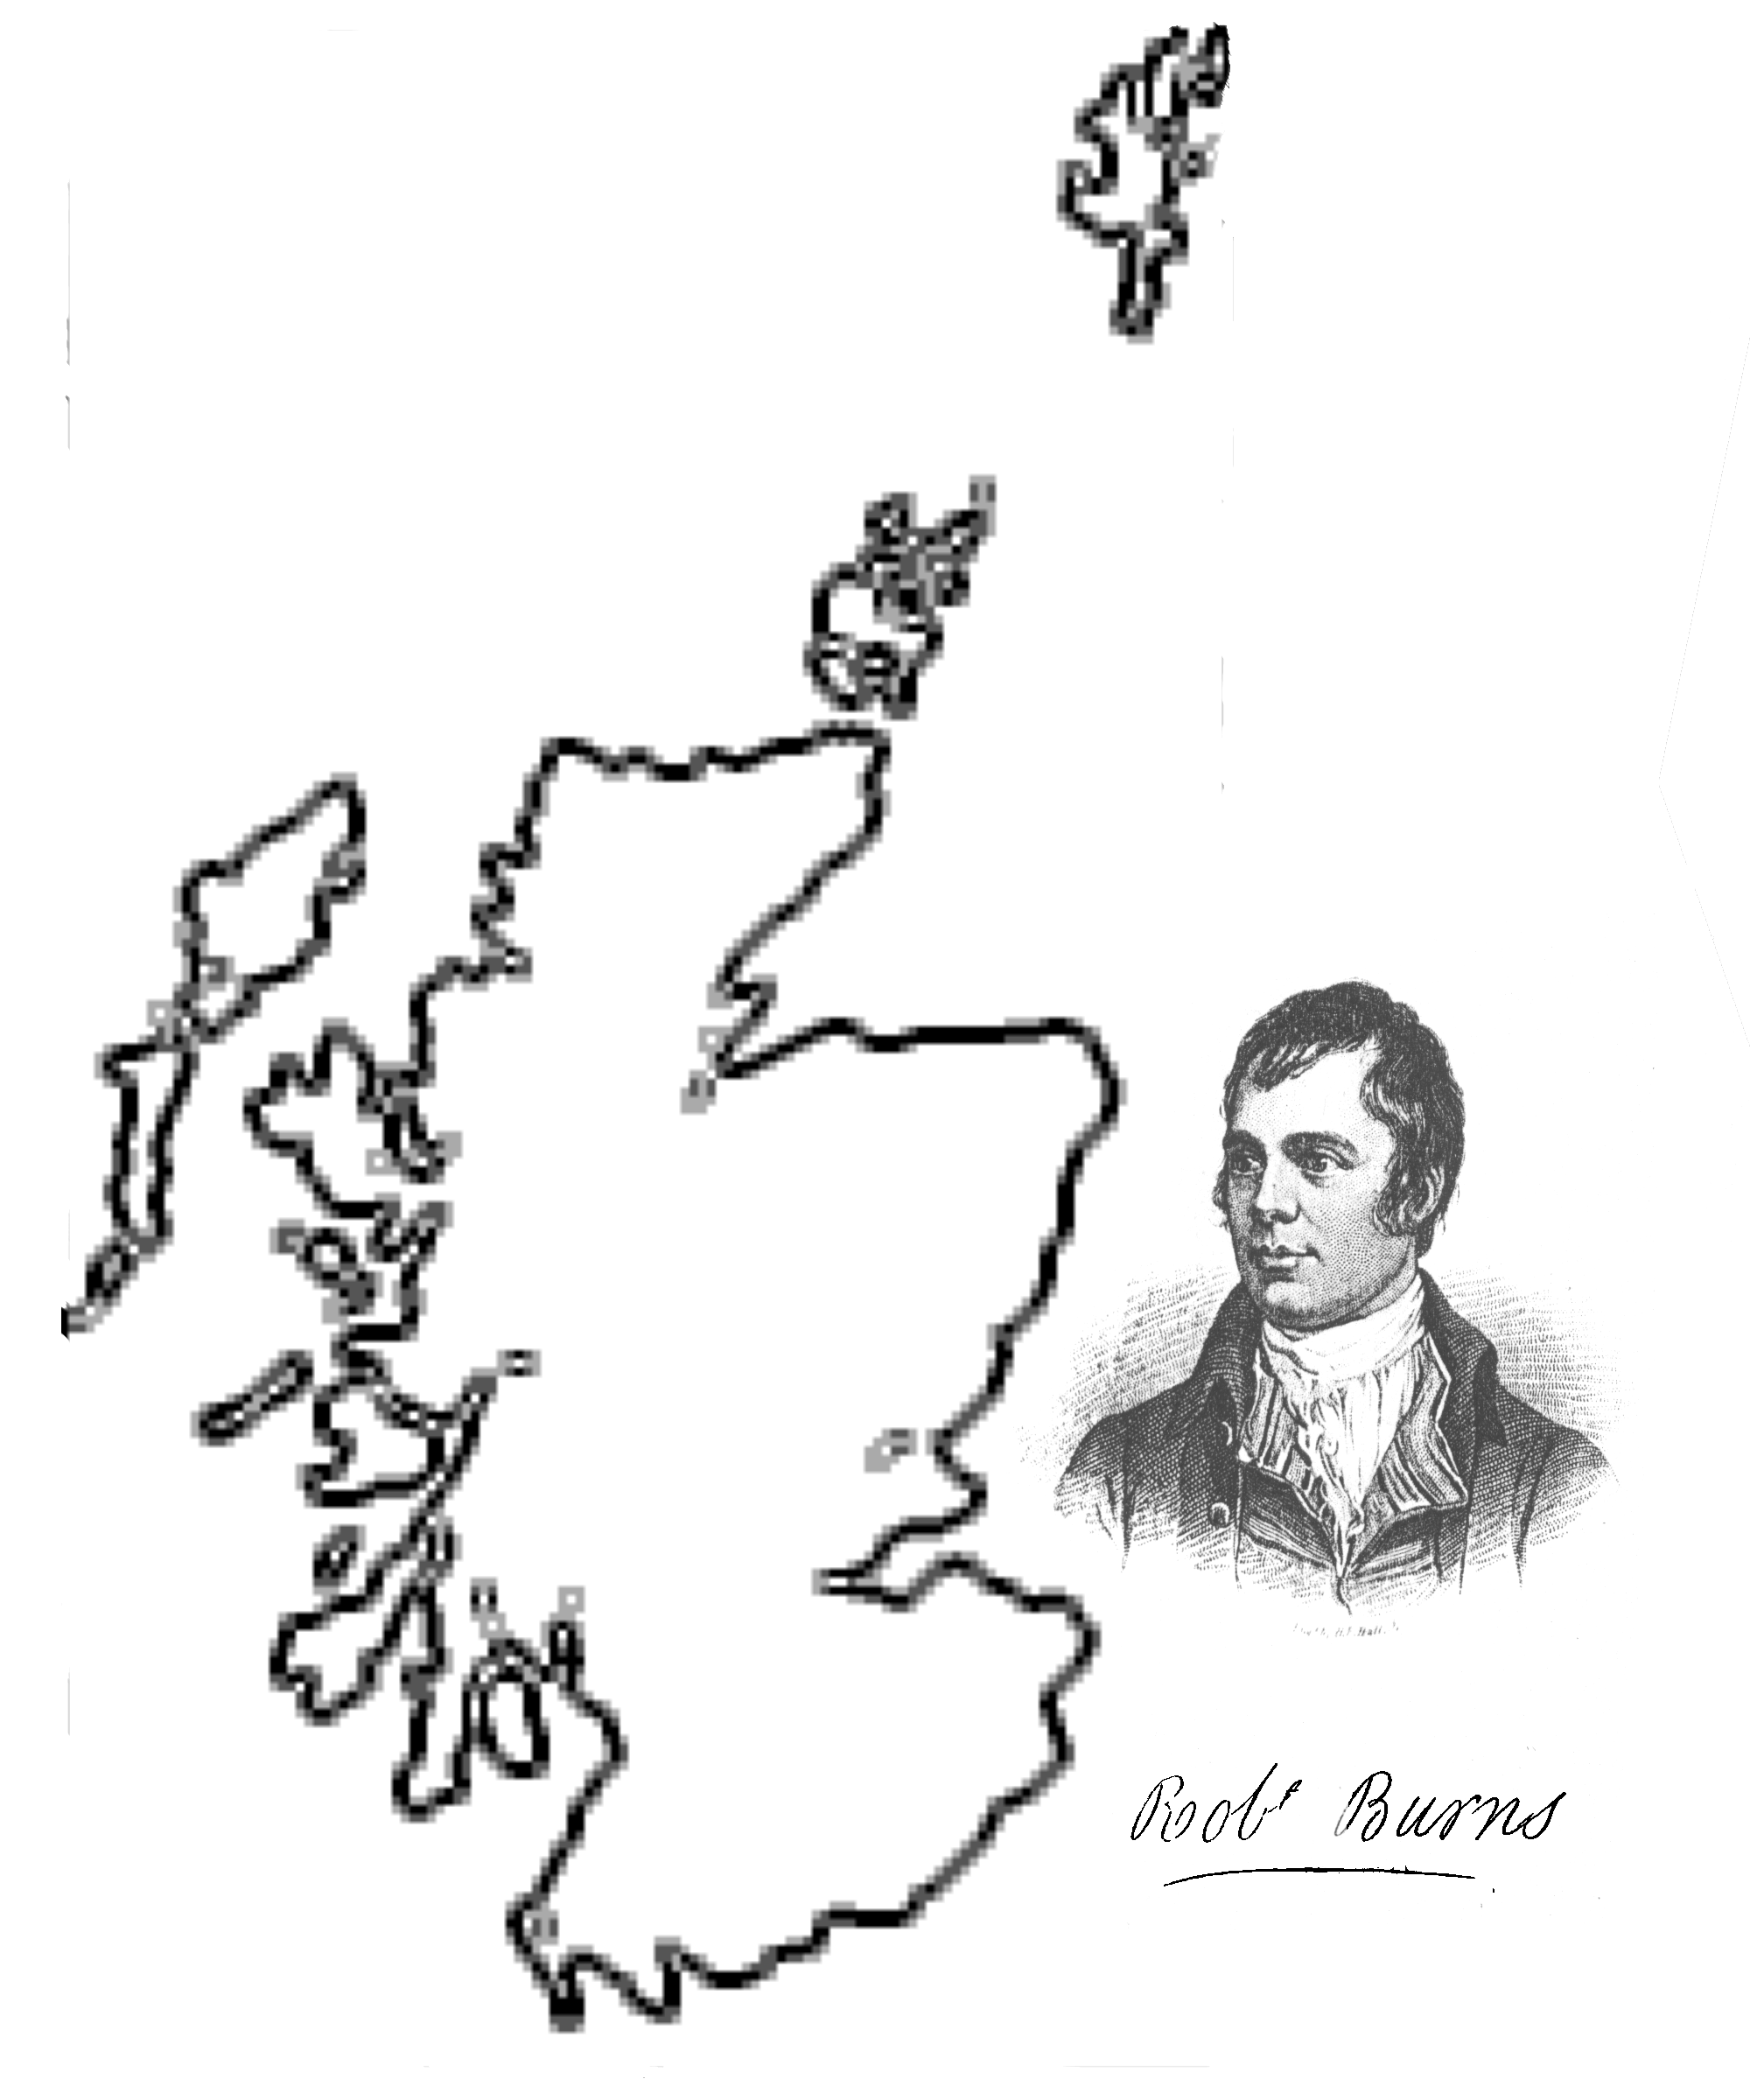2006 Burns Supper

Tickets on sale now!!!!!!!!!!!!!!!!!!!!!!! Fill out order form on page 3 of this newsletter and mail today before its too late!!!!!!!!!!!!!!!!!!!!!

Heather & Thistle Society presents the 53rd Burns Supper to be held on Saturday, January 28, 2006 at the Houston Marriott Westchase, 2900 Briarpark Drive, Houston, Texas.

Musical performances by The Houston Highlanders Pipe Band and The Saint Thomas Episcopal School Pipe Band.

Dance performances by The Royal Scottish Country Dance Society and The Saint Thomas Episcopal School Highland Dancers.



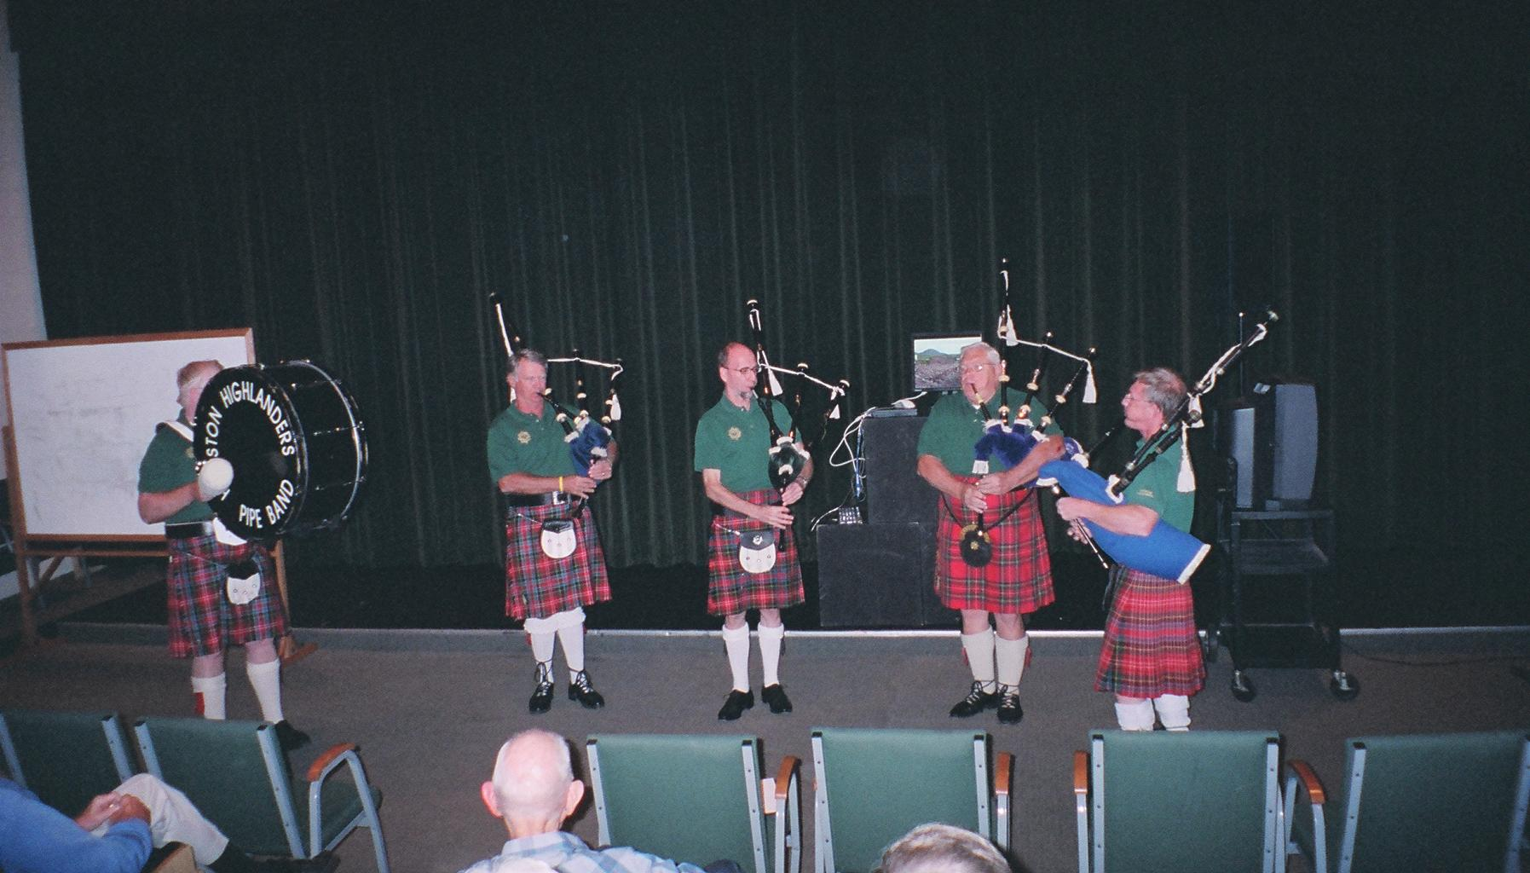
Houston Highlanders at Oct. meeting

Heather & Thistle Society – Minutes
October 24, 2005

Chieftain Cheryl May announced that the Houston Highlanders Pipe Band would perform for us first tonight due to their busy schedules, then a short business meeting would be held and then Jay Dooling would give his program on Ireland.

Chieftain Cheryl May called meeting to order at 7:51 PM in the auditorium of St. Thomas School. Motion made to accept June’s minutes as published in the newsletter. Motion seconded and passed.

Treasurer reports $1635.98 balance.

Membership chairman reports 96 family, 50 single, 32 life, 4 complimentary, 38 exempt, for a total of 220 members.

Committee Reports called for by Sub-Chieftain Jim Monteith:

Burns Club: Bob Gilbert reports the last meeting was held on October 13 and members discussed Halloween related poems of Burns. Also discussed was the desire of the Burns Club to host the 2008 North American Burns Conference here in Houston. Derek MacLeod provided a copy of the email sent to our Chieftain from the Burns Club concerning this desire. Sub-Chieftain Monteith read the request to the membership.
Newsletter: 75 members receiving e-mail version now. Mailed out 144.
Past Chieftains: Walter May reports all went well at there last meeting.
Programs: Chieftain Cheryl May reports the Royal Scottish Country Dance Society will present there traditional dance program. This program will be moved to one of St. Thomas dance floor rooms. December will be the annual Christmas party.
Sunshine: Eileen Moore reports she talked to Jack Hume and his daughter Mary. Jack is doing OK, his voice is strong and his color is good. Margaret Reuter reports Past Chieftain Bill Robinson was hospitalized and had surgery.
Houston Grampian: Bob Gilbert reports they held a recent dinner for the Nurse Exchange program. Two nurses from Northeast Scotland had been in Houston for two weeks and two nurses from Houston had been in Aberdeen.
Houston Highland Games: No report.
RSCDS: Reece Wyant reports he has been out due to an operation. Dance socials still going on at same locations.
Houston Highlanders: Performing tonight and on the road.
Burns Supper: Becci Himes advises members reserving tables must pay for them by December 1st.
Sergeant-at-Arms: Stand-in Sgt.-at-arms Ken Sorrels reports 23 members signed in and one guest, Ann Cunningham, present.

New Business: Kirking of the Tartans coming up on November 20, 2005. St. Andrews Day dinner to be held Nov. 30th at the Marriot. Mike Cusack may be performing at the dinner.
Old Business: None.

Meeting adjourned at 8:22 PM for refreshments.

After returning to the auditorium Mark Monroe introduced a photographer that he has hired to work the upcoming Burns Supper. Bob Gilbert advised the members of a Daughters of the British Empire event being held this coming Saturday at the Shriner’s Temple on N. Braeswood.

Jay Dooling presented his Ireland program.

Scottish Rite Dormitory

At The University of Texas in Austin, in 1920, it was recognized that there was a lack of suitable housing for young women who were attending. Samuel P. Cochran, the Executive Head of the Scottish Rite Masonry in Texas asked the Scottish Rite Bodies in Texas to donate the necessary funds to build a dormitory. In 1922, the dormitory opened, a gift of Scottish Rite Masons in tribute to, and in interest of, aspiring young women. The Charter states the dormitory was built to provide a home-like atmosphere for the young women attending UT at Austin.

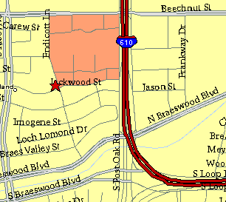

Meeting Information

Meeting Place:
St. Thomas Episcopal School
4900 Jackwood
Houston, Texas 77096

Date and Time:

Fourth Monday of the month
7:30 pm
Heather & Thistle Society Statement
And Membership Information

The Heather and Thistle Society was founded in 1953 by Scots living in Houston who wished to “cultivate an interest in and fond recollections of Scotland, its history and traditions, its literature and ideals, its minstrelsy and song, its customs and amusements, and to provide opportunities for good fellowship and social contact through typically Scottish functions, so that the blessing of our Scottish culture may never die in our new homeland”.

The Heather and Thistle Society meets 10 times a year, September through June. Programs include music, singing, dancing, lively lectures, slide shows and movies about Scotland. The Heather and Thistle Society puts on the annual Robert Burn’s Supper and Ball in late January of each year. We are an organization that promotes our Scottish heritage, in various ways.

The Heather and Thistle Society’s monthly newsletter, “The Houston Scot” is published from September through June. Original articles, information about Scottish or related events are welcome and should be sent to the editor, Jim Monteith, at 15703 Mound Road, Hockley, Texas 77447 or 936-931-2588 or jmonteith@ev1.net.

Membership in the Heather and Thistle Society is open to all with an interest in Scottish heritage and culture. Annual dues are $15 for an individual and $20 for a family membership.
Applications for membership may be obtained from our website at:
http://heatherandthistle.org/documents/membership.doc
Dues are due at the beginning of the fiscal year, March 1. Completed applications and membership fees should be mailed to: Mrs. Eileen Graham Moore
8910 Sandstone, Houston, Texas 77036-6132
For membership information please call Eileen at 713-774-0314.
