

Heather & Thistle Society

Volume 6, Issue 2
October, 2005

Newsletter Editor:
Jim Monteith

Officers:

Chieftain – Cheryl May
Sub-Chieftain – Jim Monteith
Sgt.-at-Arms – Victor Carsrud
Secretary - Sharon Monteith Treasurer - Robert Moore

Committee Chairs:

Sunshine-Eileen Moore
Membership-Eileen Moore
Past Chieftains-Ed Biddle
Burns Supper-Becci Himes
Publicity-Melvyn Douglass
Programs-Cheryl May

Kirking of the Tartans and Luncheon

Where: St. Stephen Presbyterian Church 2217 Theta Street, Houston
Phone:713-946-4006
Time: 10:15 am
Location: I-45 South toward Galveston. Take exit #35 toward Clearwood Dr./Edgebrook Dr. Turn left on Edgebrook (under freeway). Go 0.7 miles to Theta St. Turn left on Theta St. Go 0.3 miles. Pass old Spanish Church. St. Stephen is on right – about 100 yards back from street.
Dress: Scottish Attire
Luncheon: Catered Meal. $10.00 per person. Please mail check to:
Chieftain Cheryl May
6143 Sienna Arbor Lane
Houston, Tx. 77041-6038
Note: Luncheon meal must be paid in advance to give caterer correct meal count.

Menu: Main Dish: Cheddar Chicken with Rice and Mushrooms, Spring Salad, Green Beans, Sliced Begat, Cookies & Coffee/Ice Tea.

The Houston Scot
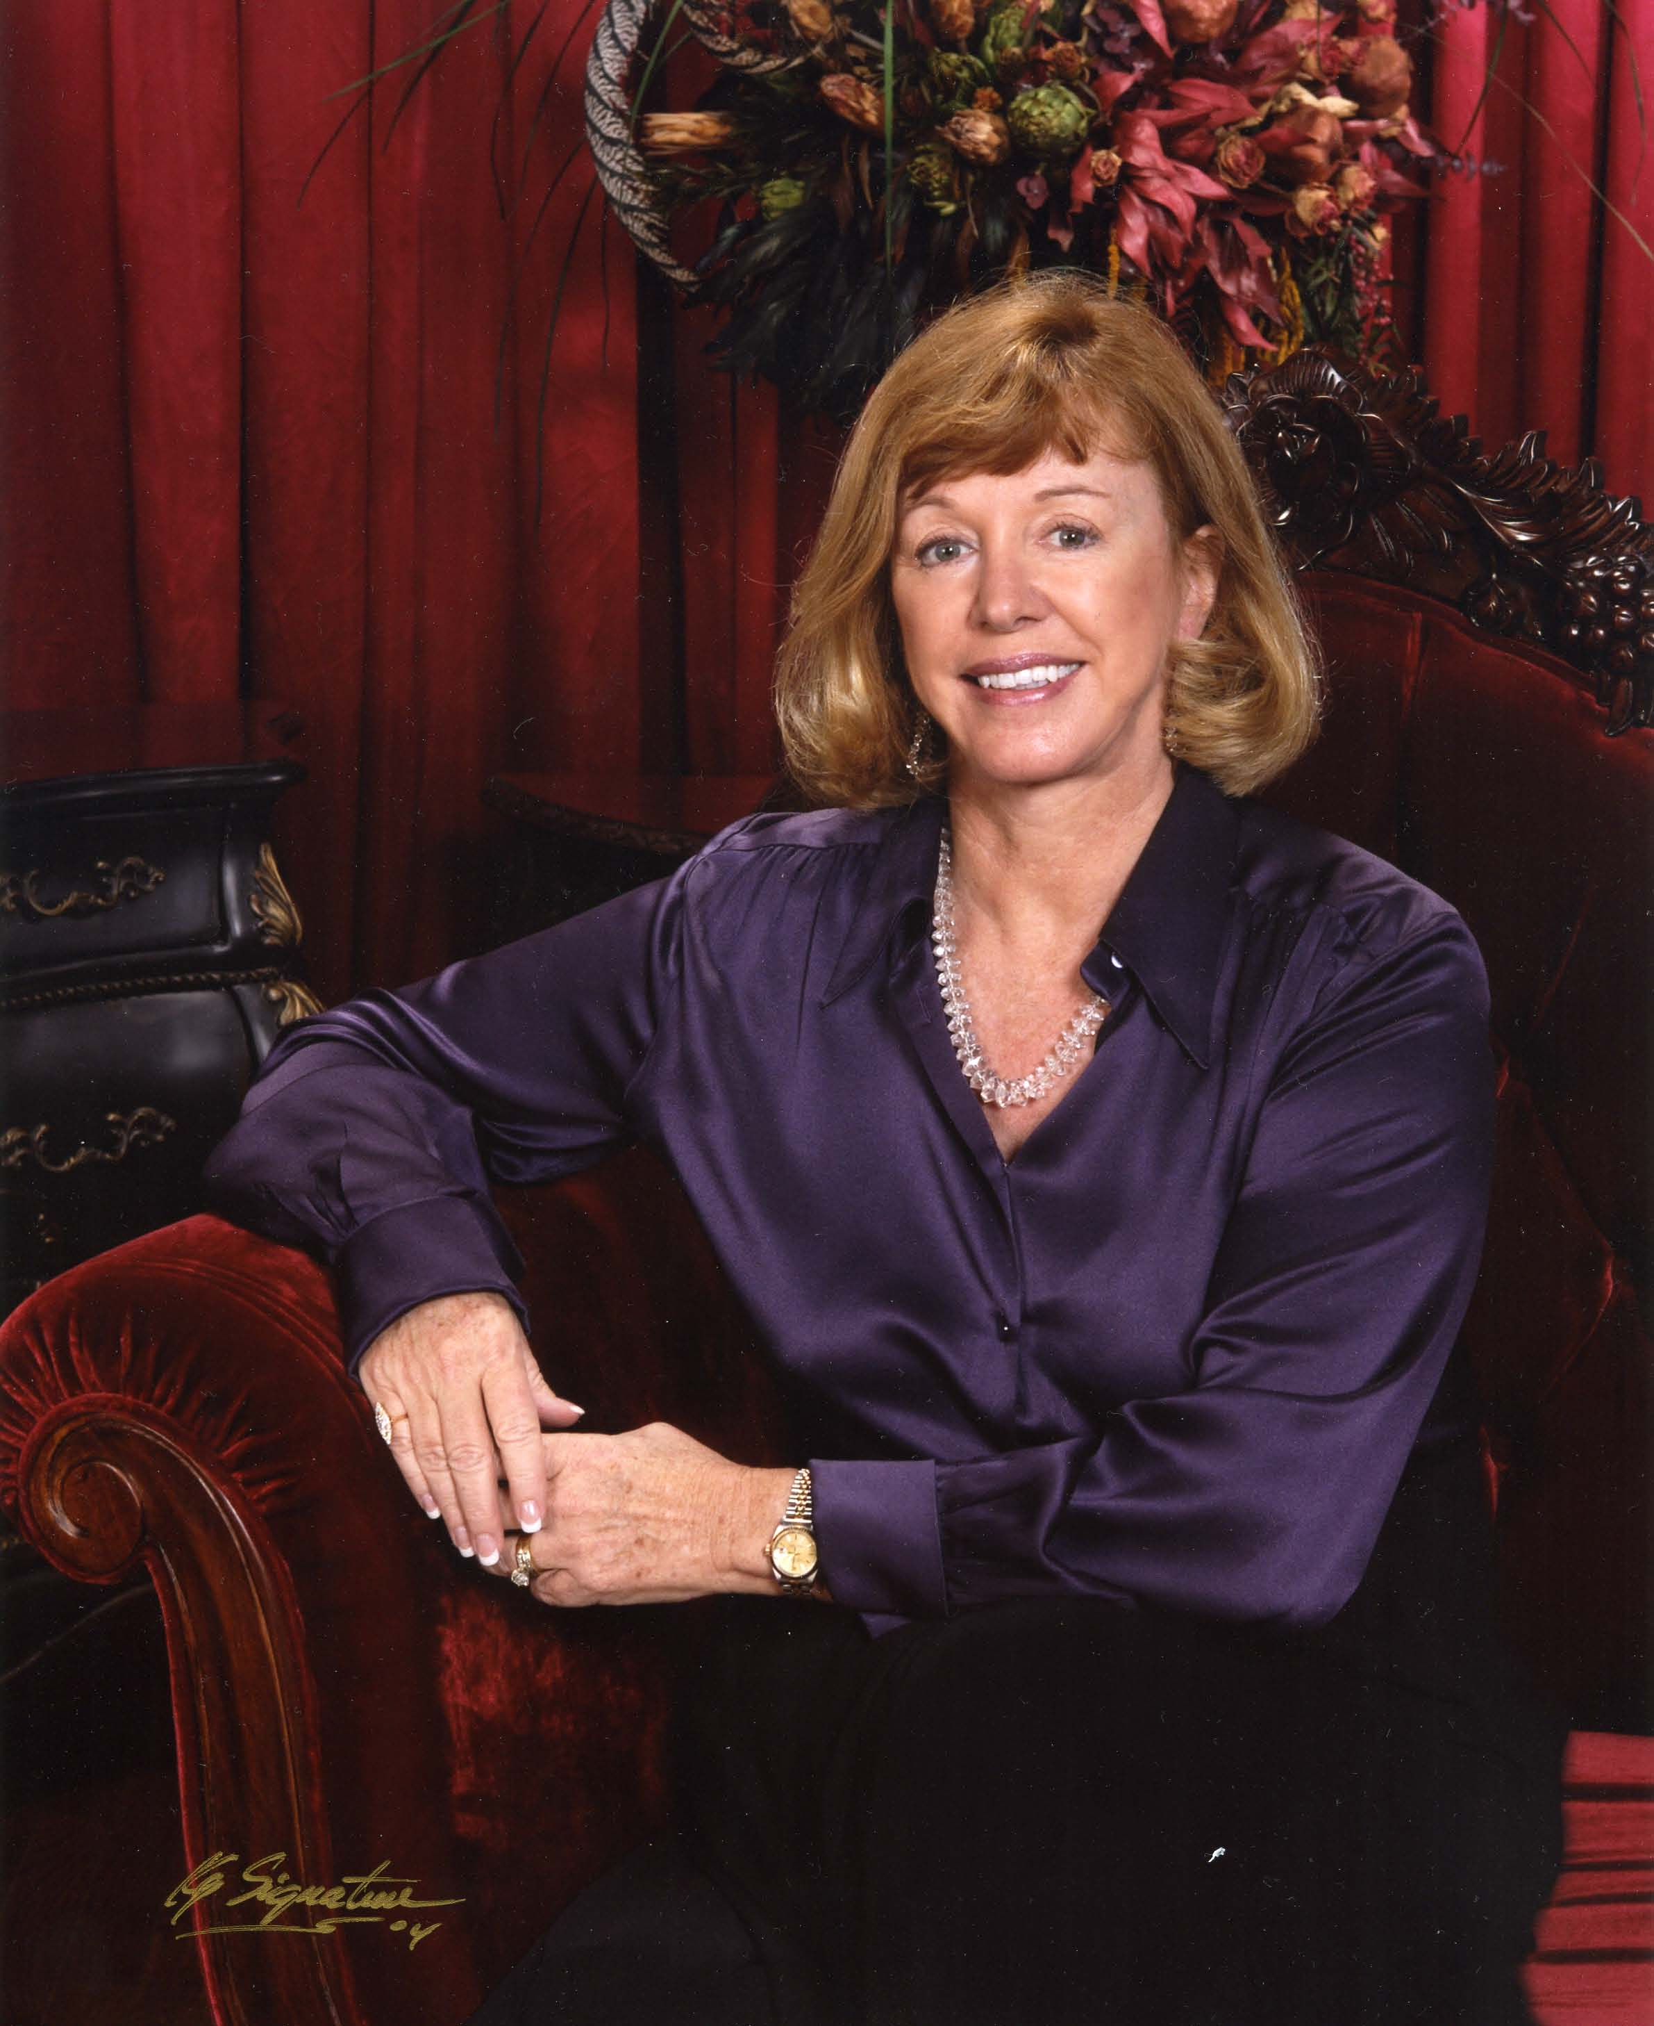

Chieftain’s Letter,

When Rita was heading towards Houston, I decided it was
prudent to cancel our September meeting. The cancellation
was sent by e-mail, and I apologize if some of you did not
receive the notice. Derek MacLeod has done a great job
with announcements on our website, so be sure to check
out: www.heatherandthistle.org, if possible, for Heather
and Thistle news.
Does everyone have their fingers, toes, arms and legs crossed
with the hope that our hurricane season is over? I imagine
we all will have our own personal stories to tell for many
years to come. Walter and I – plus two cats and a bird –
spent 10 hours in the car (without a break I might add)
headed towards Austin to be with our family. We left at 10am
and by 8pm had traveled approximately 35 miles. Listening to the radio, the mayor announced that Rita was downgraded to a 3 – headed for Port Arthur, and requested that only those in low lying areas evacuate. I held onto my seat as Walter turned the car around and headed home. It took 40 minutes to return. I don’t know who was more relieved – the humans or the pets! Fortunately, our family sustained only minor wind damage. I hope all of you survived the evacuation and storm with minor affliction. Please remember those less fortunate in your prayers.

October 24th Meeting. We are fortunate that Jay Dooling has agreed to give his cancelled September Irish program at our October 24th meeting. Depending on scheduling, we may also have a few pipers from the Houston Highlanders perform for us. Please come to enjoy all.

November 20th Kirking Service. Everyone is invited to attend the Kirking service to be held at St. Stephen Presbyterian Church. Scottish dress is encouraged. This is Jack Hume’s church, and we plan a memorable event. We are having a catered luncheon after the service for members and guests. Please mark your calendar. The luncheon cost is $10.00 per person prepaid. Refer to the printed information in this newsletter for details. Be sure to send me your check as soon as possible so that you can enjoy the luncheon after the service. The service normally starts at 10:30 am, so please arrive by 10:15 am.

Dixon-Hedges Award. My officers and I have made our selection for this years honoree for the Dixon-Hedges award. Annually, a non-officer who has contributed greatly to our Society is selected by the Chieftain and officers to receive this deserved recognition. The individual’s name will be announced at The Burns Supper and the trophy is displayed for all to view. We hope to announce our selection at the October meeting.

Future Programs. We are looking forward to our Royal Scottish Country Dancing Society exhibition and dancing lessons at our November meeting. This should prepare everyone for The Burns Supper. In December, we will have our annual Christmas party and we look forward to The Burns Club presentation in January.

The Burns Supper. Don’t forget to mark your calendar for January 28, 2006! Encourage your friends to attend. Everyone is hard at work to make this a grand evening. Our very own Jack Hume will be giving the Immortal Address.

Pantry Donations. I think it is important that our Society join with the many other societies, churches and organizations who have helped our community in time of need. We obviously were not able to bring items to the September meeting, so please remember to bring some pantry items to the October meeting. The shelves need replenishing. Refer to the printed list for suggestions. I thank you in advance.

Hopefully, in the next newsletter, we will all be basking in the glory of an Astros World Series win! Go Astros!!!!!!!!!

Pantry Needs: canned beans, tomato sauce, spaghetti sauce, canned meats, fish, beef stew, instant mashed potatoes, peanut butter, jelly, cookies, small sugar, flour, coffee, toothpaste, small shampoo, conditioner, lotion, deodorant, combs

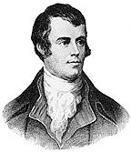

My Heart’s in the Highlands
( Robert Burns )

My heart’s in the Highlands, my heart is not here
My heart’s in the Highlands, a chasing the deer
A chasing the wild deer, and following the roe
My heart’s in the Highlands wherever I go.

Farewell to the Highlands, farewell to the North
The birth-place of Valour, the country of Worth
Wherever I wander, wherever I rove
The hills of the Highlands for ever I love.

Farewell to the mountains, high-cover’d with snow
Farewell to the straths and green valleys below
Farewell to the forests and wild-handing woods,
Farewell to the torrents and loud-pouring floods.

My heart’s in the Highlands, my heart is not here
My heart’s in the Highlands, a-chasing the deer
A-chasing the wild deer, and following the roe
My heart’s in the Highlands wherever I go.
THE HEATHER & THISTLE
SOCIETY OF HOUSTON, TEXAS
PRESENTS THE
53RD ANNUAL BURNS SUPPER
TO BE HELD ON
SATURDAY JANUARY 28, 2006
AT THE
HOUSTON MARRIOTT WESTCHASE
2900 BRIARPARK DRIVE
HOUSTON, TEXAS

TICKETS ON SALE TO H&t MEMBERS NOVEMBER 1, 2005 @ $50 EACH
AND TO NON-MEMBERS
DECEMBER 1, 2005 @ $65 EACH

Featuring performances by
The Houston highlanders pipe band
Royal Scottish country dance society and
The saint Thomas Episcopal school highland dancers

( see ticket order form for instructions on ordering )

SCOTLAND YARD

The popular name for London’s Metropolitan Police Force headquarters. In 1829 the Metroploitan Police Force was reorganized by the British statesman Sir Robert Peel. At this time the headquarters was moved to a small area where a medieval palace once stood. This palace is where the kings and queens of Scotland resided during state visits to London. The custom of referring to the headquarters and its officers as Scotland Yard began soon after the reorganization and move. The headquarters remained at this location until 1890 when it was moved to a new building which was built on the Thames Embankment. This location became known as New Scotland Yard. The present headquarters location, a modern 20-story building, was built in 1967 and is situated near the Houses of Parliament.

Scotland Yard is famous around the world and its Criminal Investigation Department (CID) is well known for its extensive investigative techniques and activities. Many modern police forces including the U.S. Federal Bureau of Investigation used its fingerprint division as a prototype. In addition to its work in crime detection, Scotland Yard directs all metropolitan police activities, including traffic control.
MCGREGOR, JOHN (1808-1836). John McGregor, Alamo defender, was born in Scotland in 1808 and lived in 1836 in Nacogdoches, Texas. He took part in the siege of Bexar^{qv} and later served in the Alamo garrison as a second sergeant of Capt. William R. Carey's^{qv} artillery company. It is said that during the siege of the Alamo, McGregor engaged in musical duels with David Crockett,^{qv} McGregor playing the bagpipes and Crockett the fiddle. McGregor died in the battle of the Alamo^{qv} on March 6, 1836.
BIBLIOGRAPHY: Daughters of the American Revolution, The Alamo Heroes and Their Revolutionary Ancestors (San Antonio, 1976). Daughters of the Republic of Texas, Muster Rolls of the Texas Revolution (Austin, 1986). Bill Groneman, Alamo Defenders (Austin: Eakin, 1990).

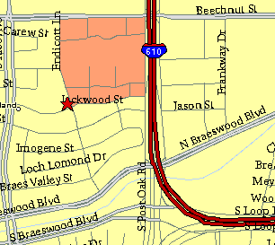

Meeting Information

Meeting Place:
St. Thomas Episcopal School
4900 Jackwood
Houston, Texas 77096

Date and Time:

Fourth Monday of the month
7:30 pm
Heather & Thistle Society Statement
And Membership Information

The Heather and Thistle Society was founded in 1953 by Scots living in Houston who wished to “cultivate an interest in and fond recollections of Scotland, its history and traditions, its literature and ideals, its minstrelsy and song, its customs and amusements, and to provide opportunities for good fellowship and social contact through typically Scottish functions, so that the blessing of our Scottish culture may never die in our new homeland”.

The Heather and Thistle Society meets 10 times a year, September through June. Programs include music, singing, dancing, lively lectures, slide shows and movies about Scotland. The Heather and Thistle Society puts on the annual Robert Burn’s Supper and Ball in late January of each year. We are an organization that promotes our Scottish heritage, in various ways.

The Heather and Thistle Society’s monthly newsletter, “The Houston Scot” is published from September through June. Original articles, information about Scottish or related events are welcome and should be sent to the editor, Jim Monteith, at 15703 Mound Road, Hockley, Texas 77447 or 936-931-2588 or jmonteith@ev1.net.

Membership in the Heather and Thistle Society is open to all with an interest in Scottish heritage and culture. Annual dues are $15 for an individual and $20 for a family membership.
Applications for membership may be obtained from our website at:
http://heatherandthistle.org/documents/membership.doc
Dues are due at the beginning of the fiscal year, March 1. Completed applications and membership fees should be mailed to: Mrs. Eileen Graham Moore
8910 Sandstone, Houston, Texas 77036-6132
For membership information please call Eileen at 713-774-0314.
