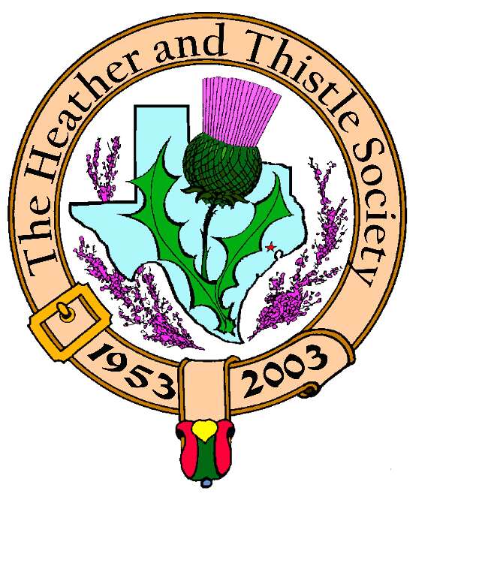

Heather & Thistle Society

Volume 6, Issue 1
September, 2005

Newsletter Editor:
Jim Monteith

Officers:

Chieftain – Cheryl May
Sub-Chieftain – Jim Monteith
Sgt.-at-Arms – Victor Carsrud
Secretary - Sharon Monteith Treasurer - Robert Moore

Committee Chairs:

Sunshine-Eileen Moore
Membership-Eileen Moore
Past Chieftains-Ed Biddle
Burns Supper-Becci Himes
Publicity-Melvyn Douglass
Programs-Cheryl May

Happy Birthday

The Society wishes Mickey Carmichael a belated 80th birthday wish on 8-19-05.

2006 Burn’s Supper

The Heather and Thistle Society of Houston, Texas presents the 53rd Annual Burns Supper on Saturday January 28, 2006 at 7:00 pm. The event, one of the largest Burns Suppers in the world, will be held at the Houston Marriott Westchase at 2900 Briarpark Drive, Houston, Texas. Tickets on sale to H&T members Nov. 1, 2005 and to non-members Dec. 1, 2005. To receive the H&T discount price on Burns tickets, member dues must be current and paid by September 30th. Highland Evening Dress is encouraged at the Supper. Ticket order forms will be available at the monthly H&T membership meetings and also at our website: www.heatherandthistle.org
The Houston Scot
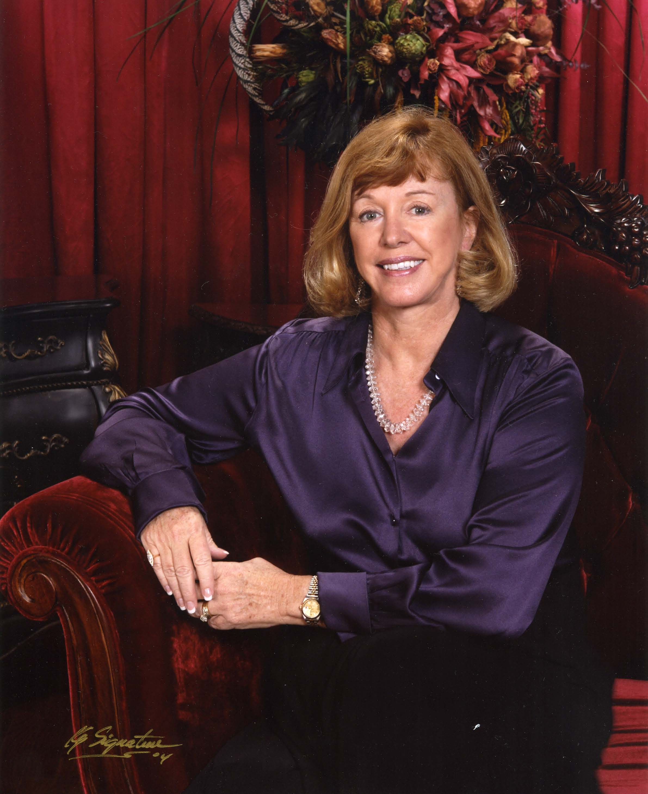

Chieftain’s Letter,

Another season has past, and I know all of us are looking
forward to the cooler temperatures. I hope you were able to
enjoy your summer and perhaps had the time to travel to a
favorite destination.

Our next meeting is scheduled for Monday, September 26th.
Jay Dooling will share his Travel & Tales about one of his
favorite subjects: Ireland. So many of us claim that Scots-
Irish heritage. Come enjoy the program on our Celtic
neighbor, Ireland.

As all of you know, we have many evacuees here in our city as the result of Katrina. I have spent as much time as possible helping through my church and personally. I know many of you have also. The plight of many families is hard to imagine. The food banks are stretched to their limit. I would like to ask all H&T members to bring a few food items to the meeting on the 26th. The Heather & Thistle Society cares about the community, and we can make a difference. I will happily take the items to one of the food banks.

I have good news about plans for a Kirking Service this November. Jack Hume and his minister, The Reverend Patricia Clark, have invited us to St. Stephen Presbyterian Church on Sunday, November 20th. We are planning a catered church luncheon afterward for all our members, so mark your calendars. More details will follow as they are finalized.

Walter and I attended the memorial service held at Christ Church Cathedral on July 25th for the victims of the British subway bombings. Judith Slater, our British Consulate General, gave her thoughts and prayers at the service. The Heather & Thistle Society joins with all Americans in heartfelt sympathy for the loss of life and the heartbreak suffered by the families of our allies.

In closing, our Heavenly Father has called home one of our finest, Past Chieftain Ed Brodie. He was a man of true character who was cherished by all. The respect with which he was held was demonstrated by the large turnout of many Past Chieftains and H&T friends at his service. We send our sincere condolences to his family.

Yours aye,

Cheryl Duthie May

Chieftain

Texas Scottish Events

Celtic Heritage Festival---Presents The Heritage of the Seven Celtic Nations: Ireland-Scotland-Wales-Cornwall-Isle of Man-Brittany-Galicia, October 8 and 9, 2005, Saturday 11am to 10pm, Sunday 12 Noon to 6 pm, adults $7, students and seniors $5, children under 10 free at the Bedford Boys Ranch Park, 2801 Forest Ridge Drive, Bedford, Texas

Austin Celtic Festival---Highland Games, Musical Performers, Dance, Storytelling, Theatre. November 5 and 6, 2005, Saturday 11am to 9pm, Sunday 11am to 9pm, Fiesta Gardens, Austin, Texas

44th Annual Salado Scottish Clan Gathering and Highland Games---November 11, 12, 13, 2005, Central Texas Area Museum, Salado, Texas

South Texas Celtic Music Festival---November 12, 2005 from 2pm to 10pm, Water Street Market Complex, 308 N. Water Street, Corpus Christi, Texas

In Memoriam

Edward Fulford Brodie went to
Be with the Lord on Saturday, July 16, 2005. He was born in Kansas City, Missouri on June 25, 1927. Ed’s memory will live on in the hearts of his many friends and family. Ever caring for others, Ed donated his earthly body to the University of Texas Health Science Center, in lieu of interment. Ed, a Retired Army Lt.Col. was involved with several hereditary societies including: Sons of the American Revolution, Sons of Union Veterans of the Civil War, and Sons of Confederate Veterans. He was a CPA, retired from Cooper’s & Lybrand, the Convenor and Chieftain of the Clan Brodie Association in America; was a past Chieftain of the Heather & Thistle Society, and with his wife Gaye, supported the Houston Highland Games Association. Ed was an Elder and Intercessor at St. Andrew’s Presbyterian Church, active in the New Covenant Presbytery, and also Bible Study teacher at Terrace Retirement Community where he resided. Ed was smart, funny, generous and loved by all who knew him.
A large contingent of Heather and Thistle Society Past Chieftains and members attended his memorial service. Bill Robertson provided beautiful bagpipe selections.

Royal Scottish Country Dance Society

September Classes: On the 12, 19, and 26, classes held at League City and The Woodlands.
- on the 13, 20, and 27 Beginner’s class held at St. Lukes 7:30 to 9:30 pm.
- on the 14, 21, and 28 General class held at Memorial Presbyterian 7:30 to 9:30 pm.

October Classes: On the 3, 10, 17, 24, and 31, classes held at League City and The Woodlands.
- on the 4, 11, 18, 25 Beginner’s class held at St. Lukes 7:30 to 9:30 pm.
- on the 5, 12, 19, and 26 General class held at Memorial Presbyterian 7:30 to 9:30 pm.

Addresses of Locations:
-St. Luke’s Presbyterian Church, 8915 Timberside Dr. Houston
-Memorial Drive Presbyterian Church, 11612 Memorial Dr. Houston
-Classical Arts Dance Studio, 530 N. Illinois, League City
-Woodlands Class, 2235 Lake Robbins Dr., The Woodlands

Contact Leigh Jenkins during the evenings at 713-529-7651 for more information or questions. Heather & Thistle Society – Minutes
June 27, 2005

Chieftain Cheryl May called meeting to order at 7:32 PM in the auditorium of St. Thomas School. Motion made to accept May’s minutes as published in the newsletter. Motion seconded and passed.

Treasurer reports $1603.28 balance. Dr. Moore reports in response to late notices mailed out he has received $440.00 in member dues.

Membership chairman reports 38 members have been dropped as of June 27, 2005 for non-payment of dues. Membership now stands at 90 family, 55 single, 33 life, 4 complimentary, 39 exempt, for a total of 211. Chairman also reports several newsletters have been returned by the post office as undeliverable. They were turned over to the newsletter editor.

Committee Reports called for by Sub-Chieftain Jim Monteith:

Burns Club: Anniversary of Robert Burns death on July 21st is coming up. There will be a memorial service at the Burns bust at the Hermann Park Rose Garden on July 24th at 5pm.
Newsletter: 69 members receiving e-mail version now. June’s printing and mailing costs were $86.30. Editor requests members submit articles for the newsletter.
Past Chieftains: No report.
Programs: September meeting will be a presentation on Ireland by Jay Dooling of the Irish Aires Assoc. October meeting Jack Hume & Ed Brodie present Dru Eds, a Halloween program. Jack Hume is looking into having a Kirking at his church. Novembers meeting will be Scottish dance lessons by RSCDS. December will be the annual Christmas party.
Membership: Eileen Moore advises that new membership directories are available at every meeting.
Sunshine: Ellen Johnson had surgery. Teresa Haines also had surgery. Al Campbell is in good spirits and Jack Hume has been visiting him regularly.
Houston Grampian: Bob Gilbert reports they will be hosting the Aberdeen Assoc. next year. The new British Consul General getting involved in the Offshore Technology Conference.
Houston Highland Games: Melvyn Douglass advises the May Games were a great success. Their treasurer is smiling and all the bills were paid. Farm and Ranch Club location is now under control of the city of Houston. Next meeting 2nd week of July.
RSCDS: Reece Wyant reports weekly social dancing on Wednesday evenings will be held during the summer at Memorial Drive Presbyterian Church.
Houston Highlanders: No report.
Burns Supper: Planning committee having there next meeting at Joan McClure’s on June 28th, 2005.
Sergeant-at-Arms Victor Carsrud reports 33 members and 2 guests present.

Old Business: Chieftain May reports she attended the last Burns Club meeting. Gave info to Robert Boyd about the new award. She brought ballots. Arthur Downs was astounded at the honor of being the first recipient of the new award. Jack Hume will present the award to Dr. Down at the Burns Supper. Walter May thanked the newsletter editor Jim Monteith for a great job and saving the Society money on publishing costs. Chieftain May thanked Derek McLeod for taking over the website duties, Melvyn for getting some e-mails out, and Mark Monroe for the new tartan stands. Bob Gilbert reports they are expecting trouble from activists groups at the G8 summit in Scotland this summer and you should beware if you are traveling to Scotland. Jim Monteith asked if any members knew where the old flag poles were bought. Southland Hardware is believed to have been the source.

New Business: Melvyn Douglass reports a recent old fashioned pub crawl yielded eleven new members for the Highland Games Association and he suggests we could try to do this with Heather & Thistle. A member asked where someone could buy bagpipes. Aberdeen Pipes in Houston was suggested. Jim Monteith advised he recently met an excellent piper named Stanley Fontenot who gives pipe instruction. Jack Hume suggested Mike Cusack be contacted about where to purchase pipes.

Meeting adjourned at 8:10 PM for refreshments.

LADIE’S EVENING DRESS
(courtesy of Lyman W. Matheson)

The recognized formal evening dress for Highland ladies is to wear a dress in the fashion of the time or of their choosing. A fairly recent custom has developed of wearing a tartan sash.
Obviously the choice of color of dress should be compatible with the tartan
to be worn. Like the bonnet feathers for the men, the shoulder on which the sash is worn is important for ladies. Lady Chiefs, the wives of Chiefs and the wives of the Colonel of the Regiment of Scottish regiments, all wear the sash over the left shoulder. All others wear the sash pinned on the right shoulder. This is one of those harmless conventions which ad spice to ladies Highland dress.



Country dancers or ladies desiring to keep the front of their dress clear secure the center of the sash with a button or small belt at the back of the waist. It is secured at the right or left shoulder by a pin or brooch so that the ends fall backwards.



Clanswomen wear the sash over the right shoulder secured there with a pin and fastened with a bow on the left hip by Ladies married out of their clan but wearing their original Clan Tartan.



The way the sash is most often seen worn is with the sash over the right shoulder fastened with a sash brooch.



FLAGS OF GREAT BRITAIN
(courtesy of Lyman W. Matheson)

Great Britain uses a family of flags. Many countries have three flags – a national flag, a merchant flag, and a naval ensign. Great Britain has five principal flags.

The British Union Flag is the national flag of the United Kingdom of Great Britain and Northern Ireland. It is sometimes called the Union Jack.
Before 1603, England’s flag bore the red cross of Saint George. Scotland’s flag bore the white cross of Saint Andrew, and Ireland’s flag bore the red cross of Saint Patrick. In 1603 Scotland and England were both ruled by James I. He combined the crosses of Saint George and Saint Andrew in the two-cross Union flag. Parliament finally recognized it officially as the national flag in 1707. The design of the Union Jack was changed to its present form in 1801, when the Irish emblem, the red cross of Saint Patrick, was added.

British Naval Flags. Until 1864, the British Royal Navy used three ensigns. The admiral in command of the whole fleet had a plain red ensign. The vice-admiral, who had charge of the forward section, or van, of the fleet, had a white ensign. The rear admiral had a blue ensign. After the Union Jack became the symbol of the British Empire, its design was added to the corner of each of the three naval ensigns.
After 1864, the British Navy continued to fly only the white ensign. The red ensign became the emblem of the British Merchant Marine. The blue ensign was assigned to government vessels other than navy ships.

The British Royal Standard, the personal flag of the British ruler, is divided into four equal cantons. The upper canton near the staff, and the lower canton at the fly end, are red and bear the English coat of arms. The Scottish arms occupy the upper canton at the fly end. The lower canton near the staff is dark blue and contains the Irish arms.

Governor-General’s Flag. The governors-general of British Commonwealth countries fly dark blue flags bearing the British royal crest, which shows the royal lion, crowned and facing front, standing on a red and gold crown, with the name of the country underneath.

Flags of British Possessions. British colonies use the British Union as a national flag, but display their individual badge or coat of arms in the center of it. They also fly the British red and blue ensigns from their ships, with the colonial badge in the fly end.


Saint George


Saint Patrick


Saint Andrew


Union Jack


Red Ensign


White Ensign


Blue Ensign


Royal Standard


Australia


Cayman Islands

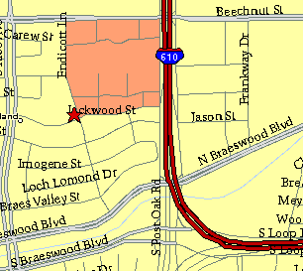

Meeting Information

Meeting Place:
St. Thomas Episcopal School
4900 Jackwood
Houston, Texas 77096

Date and Time:

Fourth Monday of the month
7:30 pm
Heather & Thistle Society Statement
And Membership Information

The Heather and Thistle Society was founded in 1953 by Scots living in Houston who wished to “cultivate an interest in and fond recollections of Scotland, its history and traditions, its literature and ideals, its minstrelsy and song, its customs and amusements, and to provide opportunities for good fellowship and social contact through typically Scottish functions, so that the blessing of our Scottish culture may never die in our new homeland”.

The Heather and Thistle Society meets 10 times a year, September through June. Programs include music, singing, dancing, lively lectures, slide shows and movies about Scotland. The Heather and Thistle Society puts on the annual Robert Burn’s Supper and Ball in late January of each year. We are an organization that promotes our Scottish heritage, in various ways.

The Heather and Thistle Society’s monthly newsletter, “The Houston Scot” is published from September through June. Original articles, information about Scottish or related events are welcome and should be sent to the editor, Jim Monteith, at 15703 Mound Road, Hockley, Texas 77447 or 936-931-2588 or jmonteith@ev1.net.

Membership in the Heather and Thistle Society is open to all with an interest in Scottish heritage and culture. Annual dues are $15 for an individual and $20 for a family membership.
Applications for membership may be obtained from our website at:
http://heatherandthistle.org/documents/membership.doc
Dues are due at the beginning of the fiscal year, March 1. Completed applications and membership fees should be mailed to: Mrs. Eileen Graham Moore
8910 Sandstone, Houston, Texas 77036-6132
For membership information please call Eileen at 713-774-0314.
