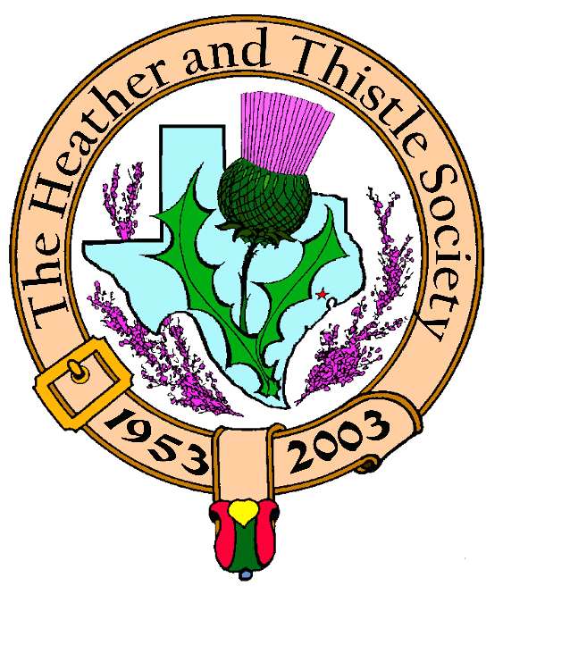

Heather & Thistle Society

Volume 5, Issue 10
June, 2005

Newsletter Editor:
Jim Monteith

Officers:

Chieftain – Cheryl May
Sub-Chieftain – Jim Monteith
Sgt.-at-Arms – Victor Carsrud
Secretary - Sharon Monteith Treasurer - Robert Moore

Committee Chairs:

Sunshine-Eileen Moore
Membership-Eileen Moore
Past Chieftains-Ed Biddle
Burns Supper-Becci Himes
Publicity-Melvyn Douglass
Programs-Cheryl May

Kirking of the Tartans:
Chieftain May has announced that the October 30, 2005 Kirking ceremony that was planned at Grace Presbyterian Church has been cancelled. Chieftain May is actively seeking another church to host our annual Kirking.

Member Dues:
Members please remember that your annual dues are due and payable at the beginning of our fiscal year, which is March 1st.

Electronic Newsletter:
All you members out there that receive ‘The Houston Scot’ newsletter by e-mail deserve a big thanks due to the savings in time for your editor and money for our Society. I know a bunch of you folks out there have e-mail access and you just have not contacted me for whatever reason. Please contact me and let me put you on the e-mail newsletter list. We currently have 67 members that receive the newsletter electronically. This way you can see the newsletter in color and you can make copies to give to interested friends and relatives.
The Houston Scot
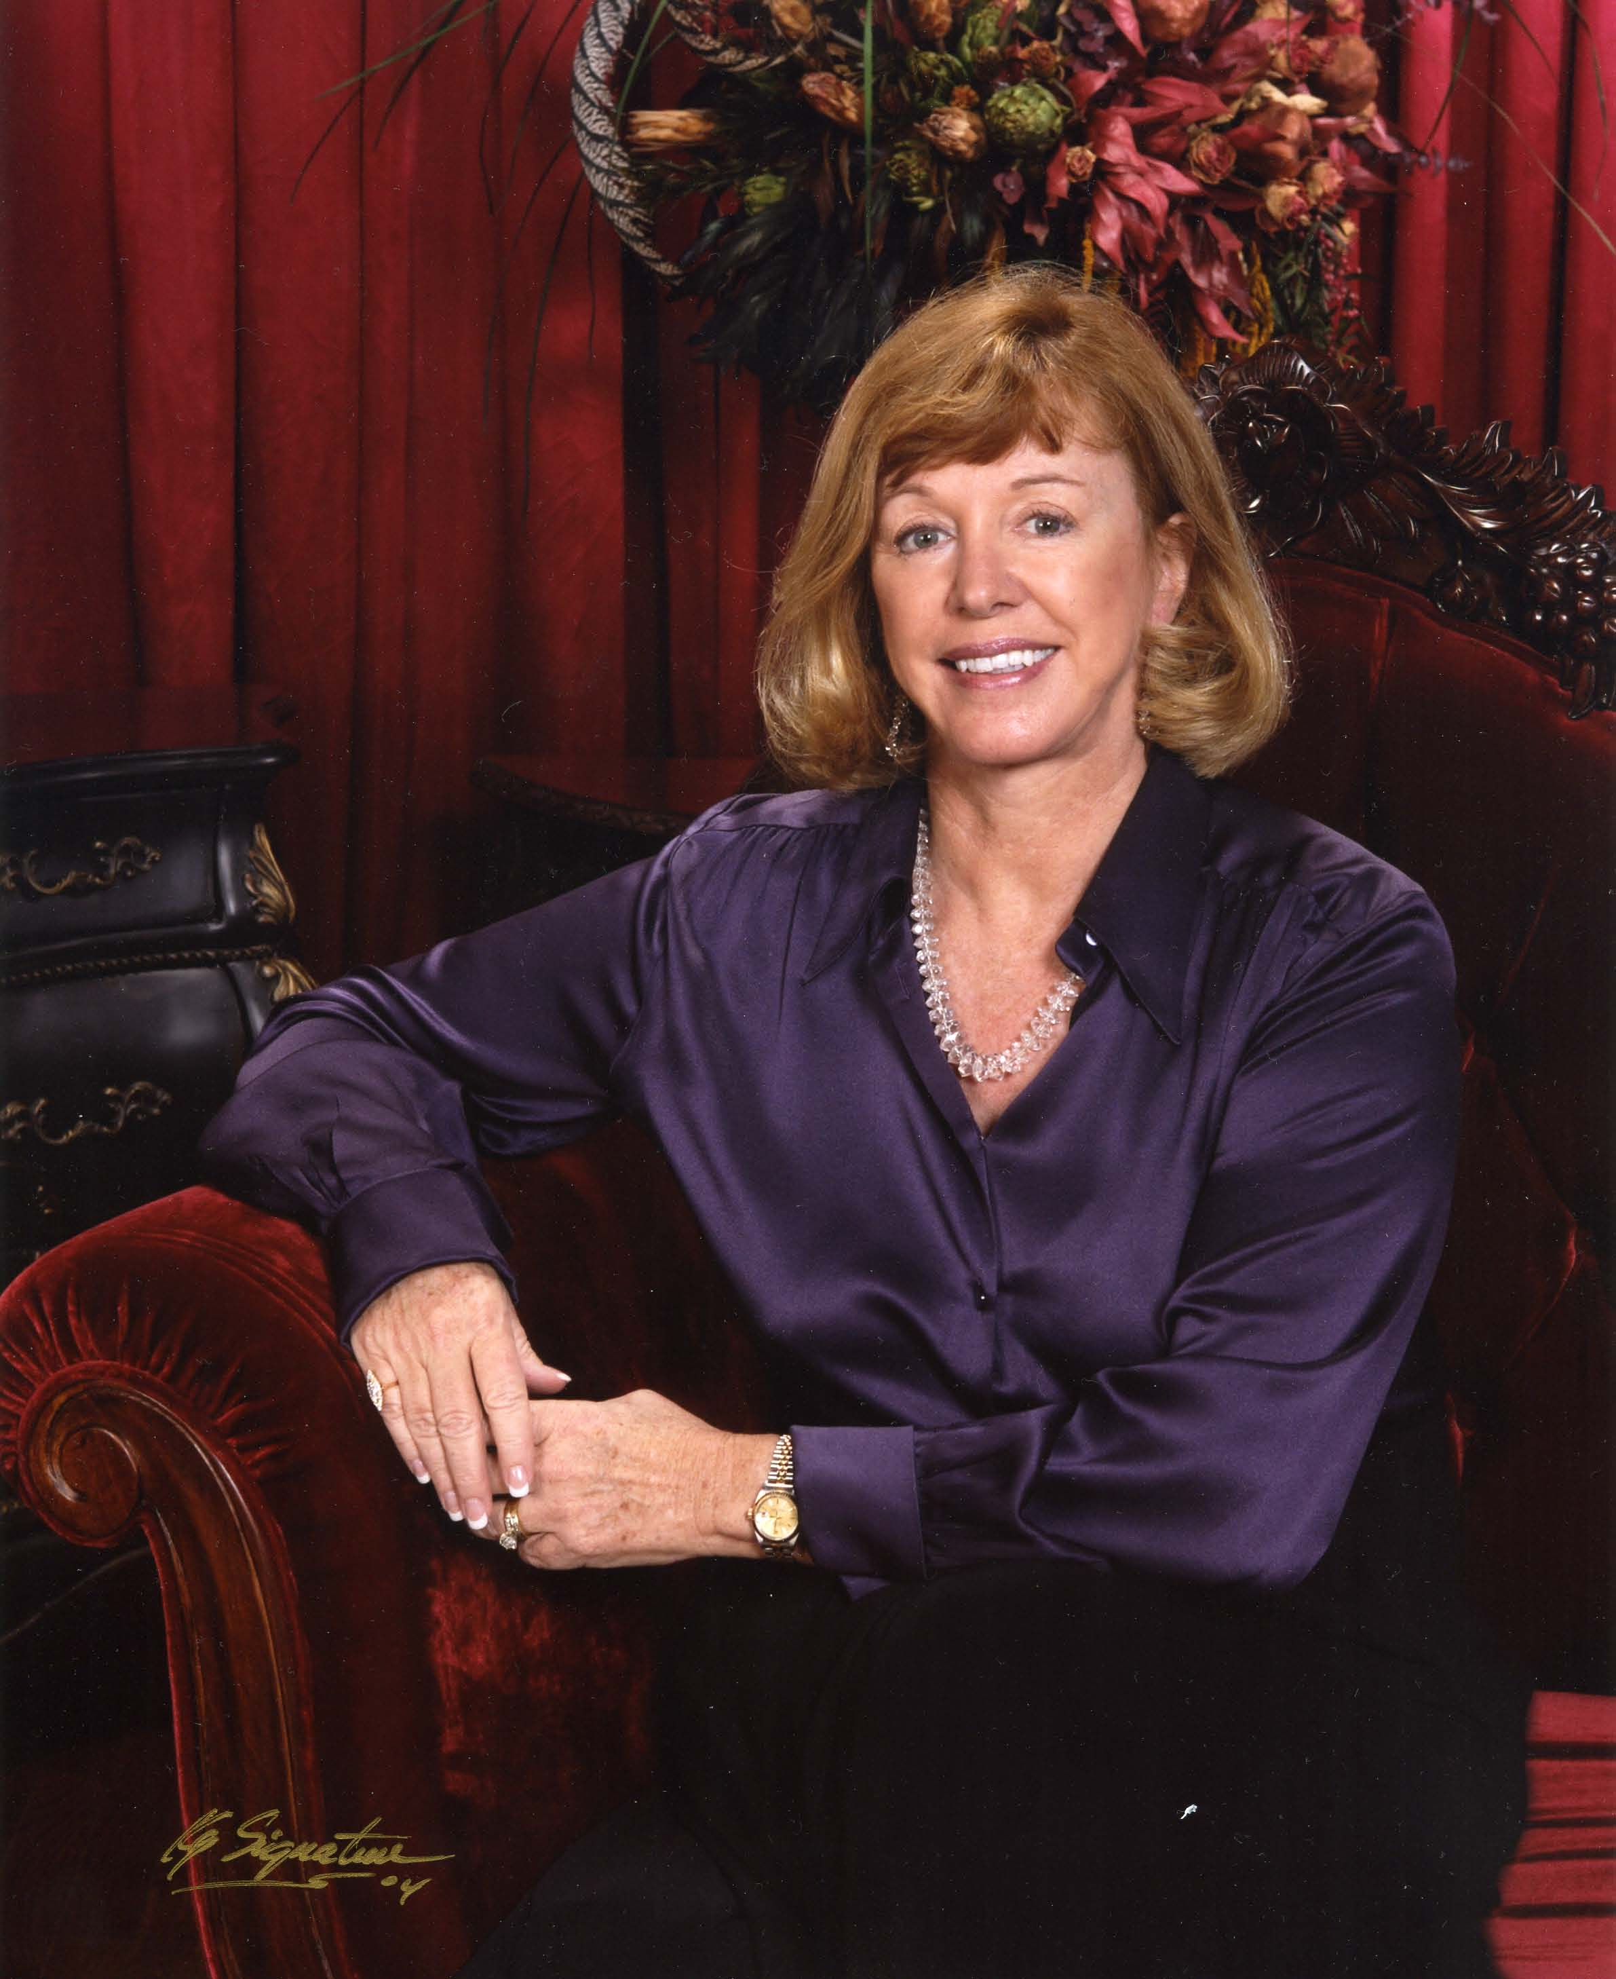

Chieftain’s Letter,

Summer has arrived and our June 27th meeting will be the
last H&T meeting until fall. We are privileged to have
Jan Erwin Dunham as our final guest speaker before we
break for summer vacation. Jan is a native Houstonian,
a member of Daughters of the American Revolution and
Daughters of the Republic of Texas. She is currently serving
as president of the Dunham/Singletary Family Connections
and as Division V Chairman for the Texas Society Daughters
of the American Revolution. Jan has been an avid genealo-
gist for over 20 years.

Jan’s topic for this evening will be: “Many Scots were Veterans of the American Revolution – today we call them Patriots.” Mel Gibson would enjoy this program! Please join us for an enriching evening.

At our last meeting, the membership approved the following motion:

The Heather and Thistle Society will annually present an award titled “The Jack & Phemia Hume Honorary Service Award” to a member of both the H&T Society and The Burns Club whose devotion and effort has been a tribute to the goals of the respective organizations and a contribution to the legacy of Robert Burns.

It is the intention of H&T that The Burns Club selects the recipient of this award.

The Burns Club had its final meeting of the season on June 9, 2005. By unanimous ballot, Dr. Arthur Down was selected by his peers to be the first recipient of this honorarium. We congratulate Dr. Down on his selection and thank him for his years of devotion to both organizations. We acknowledge that his steadfast endeavors have enabled H&T and The Burns Club to thrive. We will feature Dr. Down in a future article.

Walter and I traveled to Arlington, Texas the weekend of June 3-5 to enjoy the Highland Games and join Clan Ross for their annual general meeting. I am their Membership Secretary. We had a wonderful time as the featured Clan. Our Chief, The Ross and his lovely wife, Lady Eileen and daughter, Fiona, traveled from Scotland to be with us in the celebration. Jerry Ross, our NASA astronaut, his wife Karen and their daughter Amy also joined us for the weekend. H&T was well represented with past H&T Chieftain, Paul Ross and Mary attending along with Dr. Michael Ross. To top it off, Clan Ross won the best tent award, broke the Clan attendance record, and we won the golf tournament! It was a fantastic weekend.

Hope to see you at the June 27th meeting.

Yours aye,

Cheryl Duthie May
Chieftain

Jack & Phemia Hume Honorary Service Award

H&T members approved and established this new award on May 23, 2005. The officers and members of H&T wanted to create an award to honor Jack and Phemia Hume for their service and devotion to H&T and the Burns Club. This annual award will be given to an individual who has contributed greatly to both H&T and the Burns Club. The Burns Club will have the honor of selecting the recipient and on June 9, 2005 by unanimous decision, Dr. Arthur Down was selected as the first recipient. With approval of the Burns Supper Committee, it is hoped that Jack Hume will present the award to Dr. Down at the next Burns Supper on January 28th, 2006.
Jan Erwin Dunham presents
H&T’s June 27, 2005 Program:

The topic is “Many Scots were Veterans of the American Revolution – today we call them Patriots.” President Woodrow Wilson stated “Every line of strength in American history is colored with Scottish blood.”
Jan is the mother of 3 children and has 7 grandchildren. She grew up in Houston and became interested in the national ROTC program while attending Steven F. Austin High School. She served as Lt. Colonel in the school’s command. This early interest in the military structure and history of our country was to become a lifelong hobby. She attended both the Univ. of Texas and the Univ. of Houston, studying business preparation and history related courses. Jan became interested in genealogy over 20 years ago and has become the “Keeper of Memorabilia” and “Family Genealogist” for her family. Some of her Scots-Irish ancestors include the following names: Irwin/Erwin, Kendrick, Kennedy, Lockhart, Lucas, Morgan, and Neil.

Welcome New Members

The Heather & Thistle Society has had a banner year so far in terms of new members signing on. The recent Houston Highland Games proved to be good for our recruiting efforts. The Society would like to welcome our new members and encourage them to get the Highland spirit and volunteer their efforts for the betterment of the Society. Our new members are: Bruce Cantrell, James Laird, Robert Wayne Kerr, Judith Scott & Leon Smith, Derek J. & Elizabeth MacLeod, Bryan James & Kerri Campbell, James S. & JoAnn Currie, Sharon Tasker Rupp, Bryan Wayne & Traci Talley-Gifford, Kelly Jamison, James W. & Janet McDaniel, Vanessa McGill Perez, and George & Martha Graham.

Summer Break:

Summer is here and The Houston Scot newsletter will be taking a two month break. Your editor will keep at least the e-mail subscribers informed of any news worthy event during the summer. Members please contact your editor Jim Monteith at my e-mail address of jmonteith@ev1.net if you wish to go on the e-mail list.
Heather & Thistle Society – Minutes
May 23, 2005

Chieftain Cheryl May called meeting to order at 7:35 PM in the auditorium of St. Thomas School. Motion made to accept April’s minutes as published in the newsletter. Motion seconded and passed.

Treasurer reports $1233.31 balance. Two check outstanding to the Highland Games Association. 61 letters mailed out to delinquent members on 5/22/05.

Membership chairman reports 243 total membership, with 109 family, 57 single, 4 complimentary, 40 exempt, and 33 life. At tonight’s meeting we had five new members sign up. They are George and Martha Graham, Kelly Jamison, Vanessa McGill Perez, and Jim McDaniel.

Committee Reports called for by Sub-Chieftain Jim Monteith:

Burns Club: Alex Munroe reports meetings are 2nd Thursday every month at a member’s house. Next meeting will be at Dr. Arthur Downs house. Club members have not yet started on next year’s Burns program.
Newsletter: 62 newsletters emailed. 141 mailed out by snail mail. Editor requests member biography information for articles.
Past Chieftains: Alex Munroe reports they are working on next years Burns Supper.
Sunshine: Eileen Moore sends thanks for cards and support for Robert Moore during his illness. Sent a card to Al Campbell.
Houston Grampian: Off Shore Technology Conference was very successful.
Houston Highland Games: Next meeting will be 1st Thursday of June probably at St. Thomas.
RSCDS: No report.
Houston Highlanders: No report.
Burns Supper: Will be having a haggis tasting. Plans are moving forward for next supper.
Sergeant-at-Arms Victor Carsrud reports 24 members present. Five present are new members that signed up this night.

Old Business: Sub-Chieftain says thank you to Mark Monroe for the new tartan stands. Chieftain thanked member Derek McLeod for taking over the H&T website and updating it. It looks great!

New Business: Sub-Chieftain Jim Monteith spoke briefly about establishing an annual service award to an active H&T member who is also active in the Burns Club. The new award would be named after Jack & Phemia Hume to honor their long term service to the organization. Motion was made by Chuck Monteith to go forward with establishing the award. The motion was seconded by Derek McLeod. Members then voted and the aye’s carried it.
Sub-Chieftain also asked if any members had knowledge of where the old style (single piece) tartan poles were acquired.
A suggestion was made about displaying of our awards at St. Thomas.
Chieftain May suggests we should address the issue of paying dues by March.

Meeting adjourned at 8:05 PM for refreshments.

Chieftain May introduced Jill Hasling of the Weather Research Center at 8:25 PM. Members were treated to an excellent program about weather forecasting and Jill’s work at her non-profit organization and her efforts to establish a weather oriented museum.

Answers to Scottish Trivia on Page 3 (don’t read this first)
Music: 1. A Gaelic harp 2. Three 3. 2/4 4. Andy Stewart 5. Felix Mendelssohn
Architecture: 1. A prehistoric building, round in shape, with tall sloping sides, probably built as both dwelling and defense for many people. 2. Sir Robert Lorimer 3. A windowless one-room thatched cottage 4. A small, two-roomed house 5. Charles Rennie Mackintosh
Literature: 1. Kailyard fiction 2. Naomi Mitchison 3. David Hume 4. ‘The Author of Waverley’ 5. Thomas Carlyle
History: 1. 1320 2. 1951 3. The Ninth Legion 4. Sir John Stewart of Menteith (Perhaps a relative of our Subchieftain!) 5. 30
Whisky: 1. 1 billion 2. Morayshire (Craigellachie) 3. A Sikes Hydrometer 4. Islay 5. No. The legal definition of Scotch whisky is whisky distilled in Scotland.

Scottish Trivia
(courtesy of Chieftain May)

Music
1. What is a clarsach?
2. How many drones do Scottish bagpipes have?
3. What is the time signature of reel music?
4. What Scottish singer sang ‘A Scottish Soldier’?
5. Which German composer wrote The Scottish Symphony inspired by a visit to Holyrood?

Architecture
1. What is a broch?
2. Who designed the Scottish National War Memorial?
3. What is a black house?
4. What is a ‘but and ben’?
5. Which architect designed the Glasgow School of Art?

Literature
1. What was the name given to a school of Scottish fiction in the nineteenth century characterized by romanticism and sentimentality?
2. Name the author of Cloud Cuckoo Land and Black Sparta.
3. A Treatise on Human Nature was one of the most important pieces of philosophical writing in the eighteenth century. Who wrote it?
4. Under which name did Sir Walter Scott originally publish his novels?
5. Which Scots writer wrote a History of The French Revolution?

History
1. In which year was the Declaration of Abroath made?
2. When was the Stone of Destiny stolen from Westminster Abbey?
3. Which entire Roman legion was lost in an attempt to subdue the rebellious Scots?
4. What was the name of the man who captured William Wallace and took him to London where he was executed?
5. How many Scottish representatives were allowed to sit in Parliament at Westminster while Cromwell was in power?

Whisky
1. Approximately how many bottles of Scotch are consumed worldwide every year? a) 3 billion b) 20 million c) 1 billion
2. In which part of Scotland is the Macallan Distillery?
3. What is the name of the instrument which measures the proof of the spirit?
4. Which island is particularly well known for its malt whiskies?
5. Can Scotch Whisky be made outside Scotland? Dear Members of the Heather and Thistle Society,

We at Timber Ridge Presbyterian Church offer our deepest thanks and gratitude to each member of the Heather and Thistle Society for your generosity, support, and kindness during our first Kirkin’ o’ the Tartans. We simply could not have done it without you.

During the first Monday in May, I received permission to go forward with our first Kirkin’ o’ the Tartans Worship service. At the time, I had no idea what was necessary to plan this special service. Searching on the internet the following day, however, the Good Lord blessed me by sending me straight to the Heather and Thistle Society website.

Within days, I was in contact with Cheryl May and Jim Monteith. Over the following short weeks, and in spite of their also working on the Highland Games, Cheryl and Jim offered their support, volunteered to provide us with over a dozen tartans, and notified the Scottish community about our upcoming Kirkin’. On the morning of the service, Jim and his wonderful family arrived with a trailer full of tartans and stands and helped us to coordinate and set up for the Processional. Soon other members of the Heather and Thistle Society arrived, each offering words of kindness and support.

Few of our members had ever witnessed a Kirkin’ prior to this service. As our piper entered the Sanctuary, followed by the wave of your glorious tartan banners, it was truly a sight to behold. After the service, several members from the congregation told me that the beauty of the Procession had brought tears to their eyes. Many still speak of the wonderful time they had at the Kirkin’ and have asked that we hold it again next year.

You all have given us a great gift. Thanks to the Heather and Thistle Society, Timber Ridge Presbyterian Church now knows what it truly is to be Scottish. Your kind spirit and open hearts have blessed us all. To each of you, I offer my sincere thanks, with special gratitude to Jim and Cheryl. Next year, we definitely plan to be in touch months in advance and hope to see more of you and yours at our next Kirkin’.

God bless each of you,

Virginia Staat
Timber Ridge Presbyterian Church
7575 Alden Bridge Drive
The Woodlands, Texas 77382
(936) 321-3298

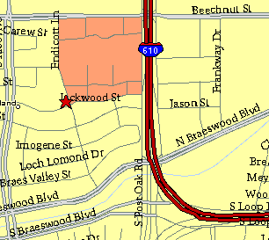

Meeting Information

Meeting Place:
St. Thomas Episcopal School
4900 Jackwood
Houston, Texas 77096

Date and Time:

Fourth Monday of the month
7:30 pm
Heather & Thistle Society Statement
And Membership Information

The Heather and Thistle Society was founded in 1953 by Scots living in Houston who wished to “cultivate an interest in and fond recollections of Scotland, its history and traditions, its literature and ideals, its minstrelsy and song, its customs and amusements, and to provide opportunities for good fellowship and social contact through typically Scottish functions, so that the blessing of our Scottish culture may never die in our new homeland”.

The Heather and Thistle Society meets 10 times a year, September through June. Programs include music, singing, dancing, lively lectures, slide shows and movies about Scotland. The Heather and Thistle Society puts on the annual Robert Burn’s Supper and Ball in late January of each year. We are an organization that promotes our Scottish heritage, in various ways.

The Heather and Thistle Society’s monthly newsletter, “The Houston Scot” is published from September through June. Original articles, information about Scottish or related events are welcome and should be sent to the editor, Jim Monteith, at 15703 Mound Road, Hockley, Texas 77447 or 936-931-2588 or jmonteith@ev1.net.

Membership in the Heather and Thistle Society is open to all with an interest in Scottish heritage and culture. Annual dues are $15 for an individual and $20 for a family membership.
Applications for membership may be obtained from our website at:
http://heatherandthistle.org/documents/membership.doc
Dues are due at the beginning of the fiscal year, March 1. Completed applications and membership fees should be mailed to: Mrs. Eileen Graham Moore
8910 Sandstone, Houston, Texas 77036-6132
For membership information please call Eileen at 713-774-0314.
