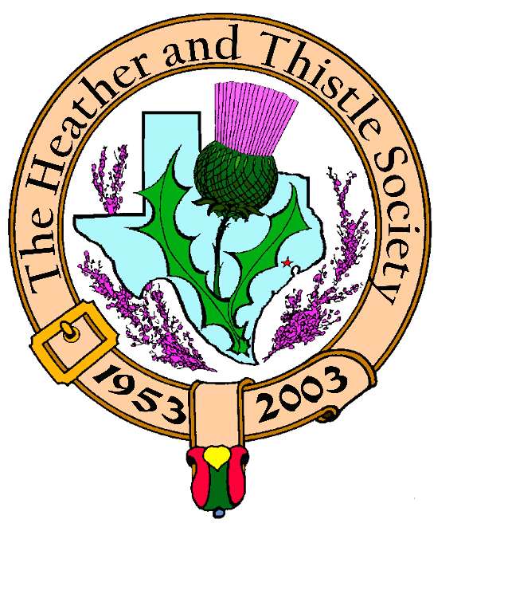

Heather & Thistle Society

Volume 5, Issue 9
May, 2005

Newsletter Editor:
Jim Monteith

Officers:

Chieftain – Cheryl May
Sub-Chieftain – Jim Monteith
Sgt.-at-Arms – Victor Carsrud
Secretary - Sharon Monteith Treasurer - Robert Moore

Committee Chairs:

Sunshine-Eileen Moore
Membership-Eileen Moore
Past Chieftains-Ed Biddle
Burns Supper-Becci Himes
Publicity-Melvyn Douglass
Programs-Cheryl May

Sunshine Corner:

Two of our most active members have recently had serious health problems.

Alistair Campbell had a stroke while in San Antonio. He is in Houston undergoing aggressive rehab. The family requests no visitations at this time.

Dr. Robert Moore entered the VA hospital recently with neurological difficulties affecting his movement.

Please keep Al and Robert in your prayers.

Society members please contact the editor with any “Sunshine” news that you would like published.

Member Biographies Requested:

Absolutely no one has responded to your editor’s request for biographies of past and present members. Members please participate and send me something to print.
The Houston Scot
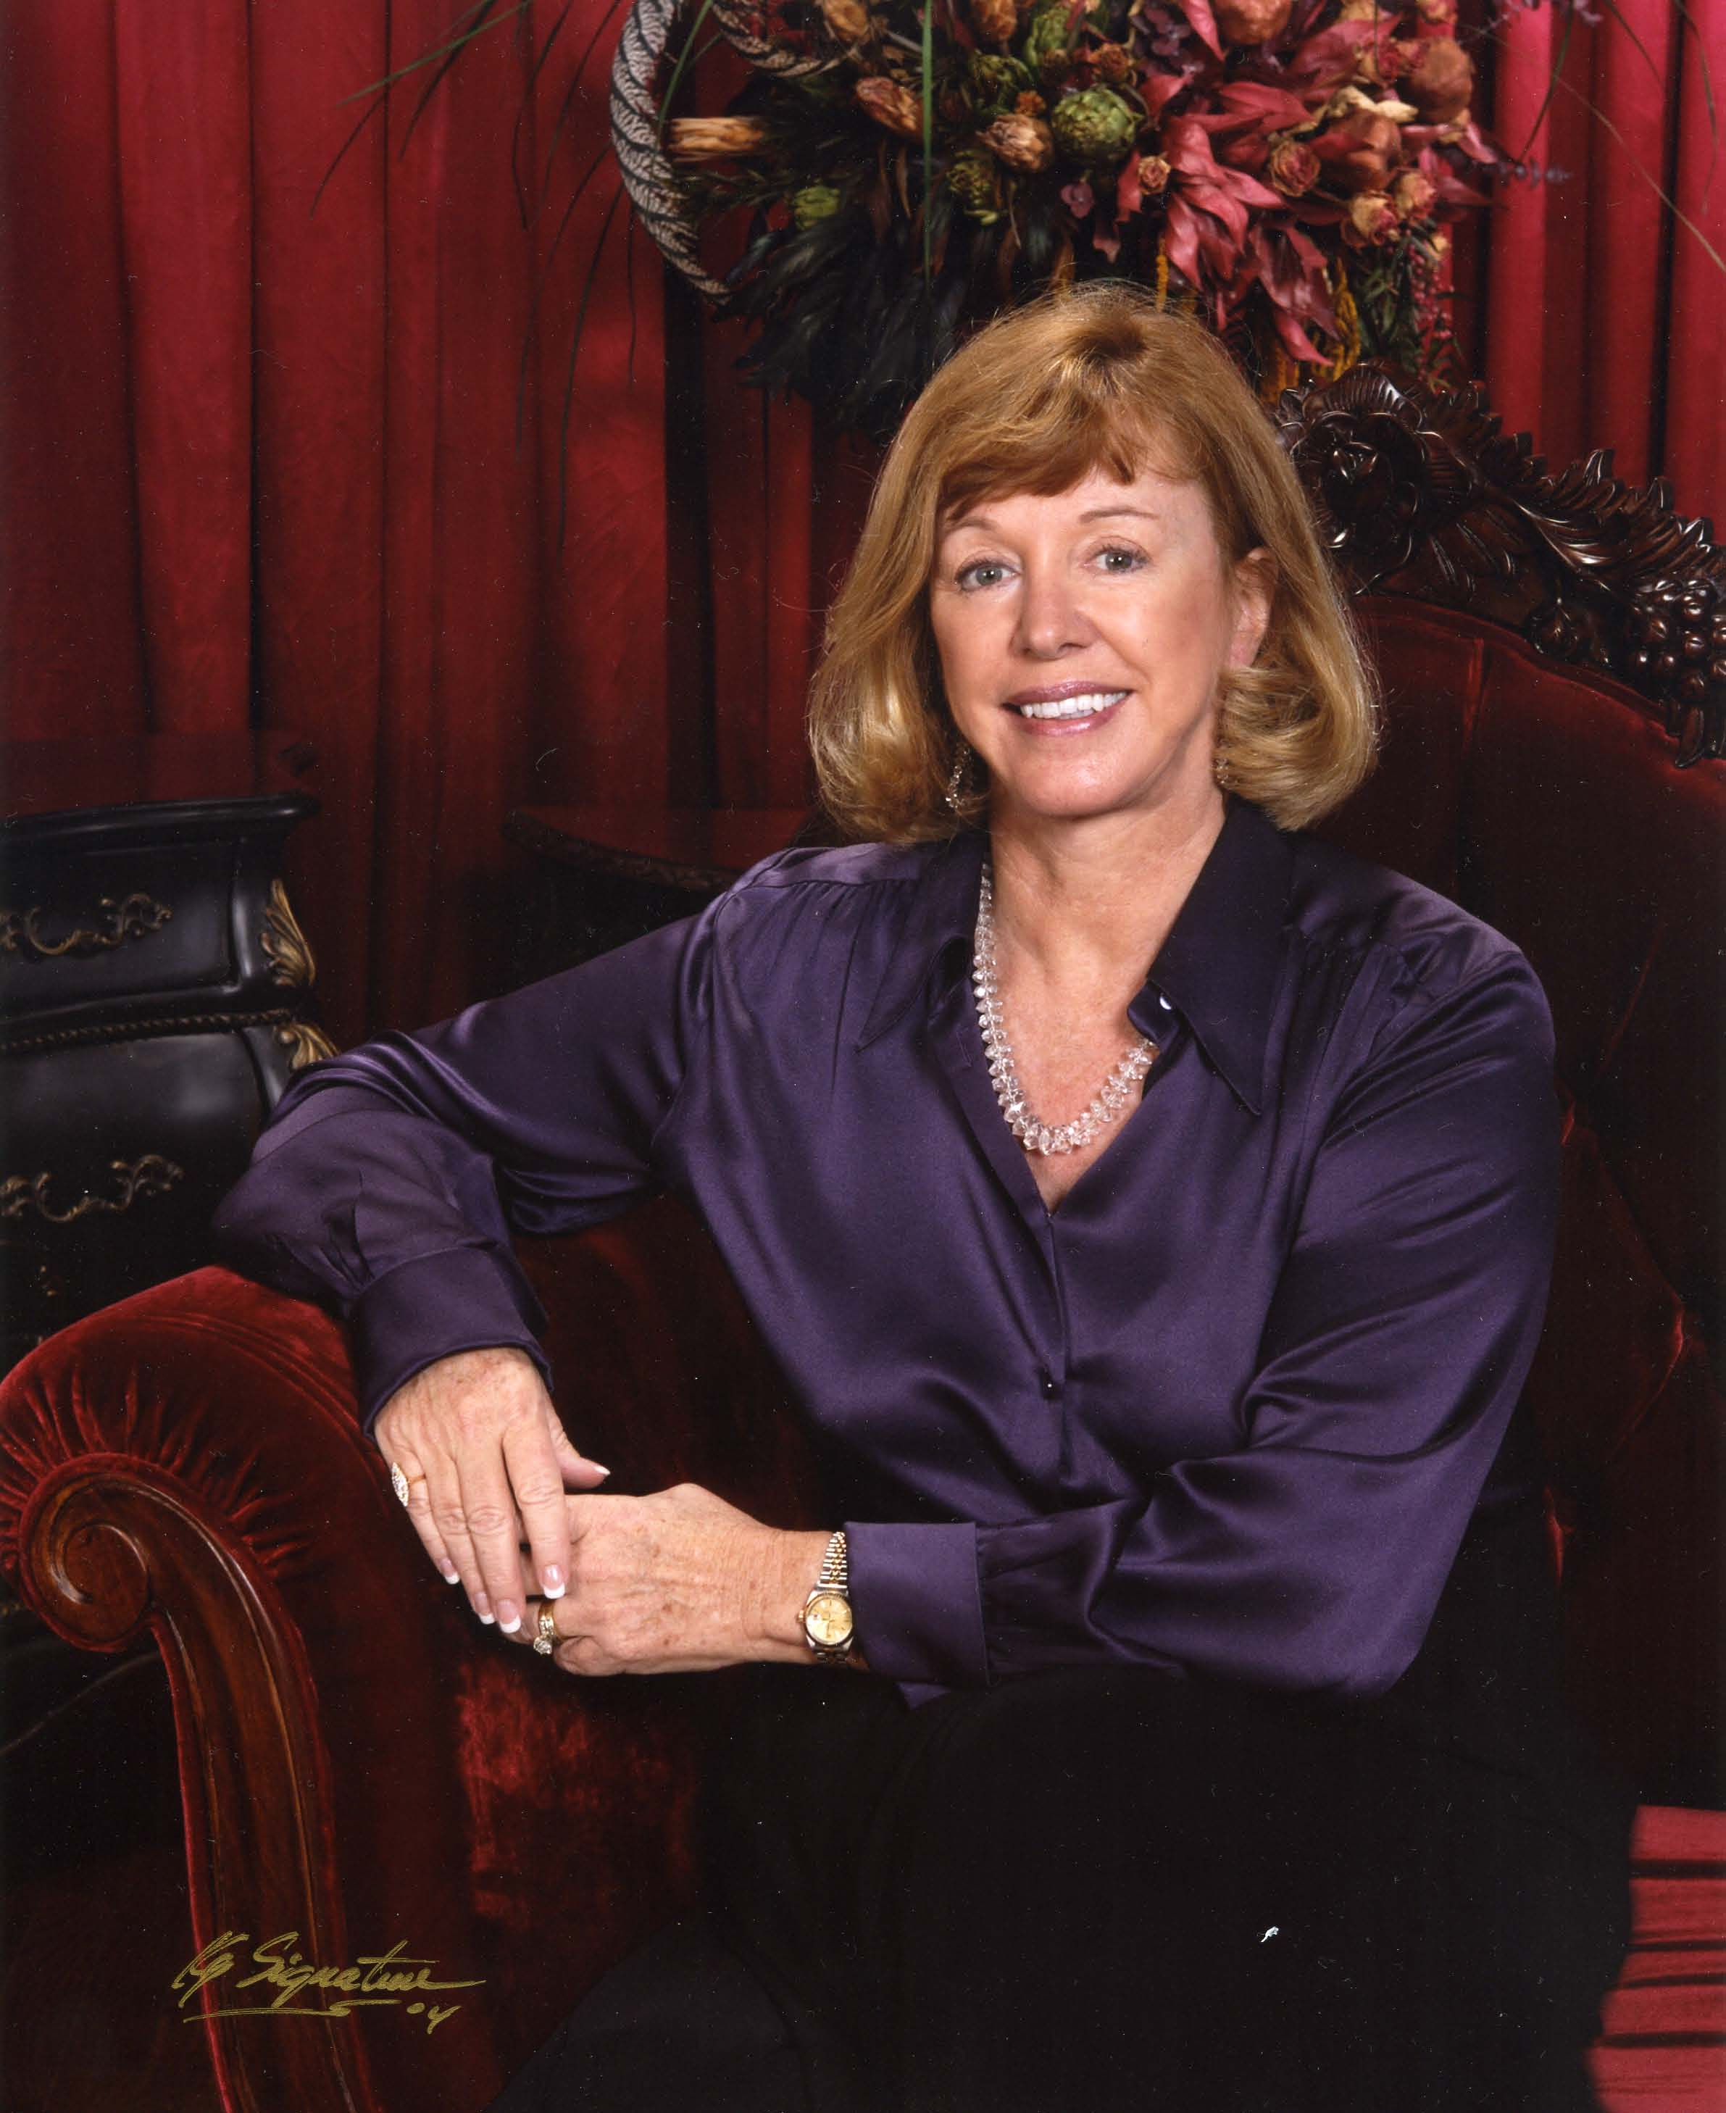

Chieftain’s Letter,

What a grand time we all had at the Houston Highland
Games. We had many volunteers and guests busily chatting
at the H&T table. We have several new members, and we
look forward to their participation. I want to thank the
many volunteers who helped promote our Society May 13th
-15th. I especially thank my officers who worked so hard to
display our banners not only at our table, but also through-
out the Games. Many of our members marched with us in
the opening ceremony, and my two little grandsons accom-
panied us in their Highland dress! We had a nice ad in the
HHG’s program that promoted our Society, The Burns
Supper and the Burns Club. Good job HHGA!

We had an exceptional H&T meeting in April. Several St. Thomas Pipers played for us, and we were treated to wonderful Highland dancing. The H&T Society gave $1,000.00 checks to both the St. Thomas Pipers and dancers. We know they will be able to use the funds to further their great programs of which we are so proud.

On May 23rd, Jill Hasling, President of the Weather Research Center in Houston, will present a very informative program for us. Jill has been actively involved with developing a Long Range Predication Model for global weather with a special interest in Texas Hurricanes. She will add a little knowledge about Scotland’s weather as well. With the season almost upon us, I know you will enjoy her program. Visit the WRC website for an insight into her work at: www.wxresearch.org

Talking about websites, lots of applause to Derek MacLeod who just completed updating our site! I encourage everyone to visit: www.heatherandthistle.org

We have received word that due to the rescheduled final sermon of Grace Presbyterian’s retiring pastor, Dave McKechnie, on October 30th we will not be able to have the Kirking service or luncheon at Grace on that date. I will do my best to find an alternative location for the Kirking Service and luncheon.

And on a personal note, I know I speak for all in wishing our Piper, Al Campbell, and our Treasurer, Robert Moore, both a speedy recovery back to good health. Our prayers are with these fine gentlemen, our special friends, who have devoted so much of their time and energy to our Society. We know they would appreciate a note or card.

Yours aye,

Cheryl Duthie May
Chieftain

Houston Highland Games A Huge Success

The Houston Highland Games held over the weekend of May 14, 15, and 16th 2005 was a great success. The weather was good and attendance seemed high. The Heather and Thistle Society booth was very popular especially on Saturday. Quite a few folks signed up and joined our organization during the event. The main arena area was decorated with 24 tartans supplied by our Society. Our booth area was decorated with the Heather and Thistle banner and 12 tartans. Two new 7 hole stands donated by member Mark Monroe added greatly to our booth. The Society would like to thank all the members that contributed to our effort at the games. Thank you Cheryl May, Walter May, Sharon and Jim Monteith, Victor Carsrud, Mark Monroe, Ken and B.J. Sorrels, Chuck Monteith and Ted Hirtz.

Heather & Thistle
Society Website:

Our new website is up and running thanks to member Derek MacLeod. He has graciously taken over the duties as webmaster and has updated and improved the site. To see what great work he has done go to the site at www.heatherandthistle.org. The Society would also like to thank all the members that have contributed to and maintained the website in the past.

Snacks and Goodies at Our Meetings:

Just a thank you to all the members that have provided refreshments at out monthly meetings.
Members are requested to bring “goodies” to the meetings to share with all.

Membership:

The H&T membership committee has advised that we have 64 members that are delinquent in renewing their memberships. The Society would encourage members to renew so they don’t miss out on any fun and get those special Society member prices on the Burns Supper tickets. We would also like to see increased turnout at our monthly meetings. We must have a minimum of 20 members at each meeting to conduct an official business meeting. Members are encouraged to bring guests.

New Tartan Stands Donated to Heather & Thistle Society

Member Mark Monroe has delivered his promised new, seven hole tartan stands to our Sgt.-at-Arms Victor Carsrud. We now have six new beautiful, white, sturdy, stands for our priceless tartans to be displayed upon. The Society would like to thank Mr. Monroe for this wonderful gift.

Kirking of the Tartans
Sunday May 22, 2005

Heather and Thistle Society members are invited to a Kirking at Timber Ridge Presbyterian Church, 7575 Alden Bridge Drive, The Woodlands on May 22 at 11:00 am. Our Society will be providing tartan banners and stands for the ceremony. Heather & Thistle Society – Minutes
April 25, 2005

Chieftain Cheryl May called meeting to order at 7:30 PM in the auditorium of St. Thomas School. Motion made to accept March’s minutes as published in the newsletter. Motion seconded and passed.

Treasurer reports the Society has a balance of $1,418.94 in the checking account. Also reports we have 64 members that are delinquent on their annual dues.

Committee Reports called for by Sub-Chieftain Jim Monteith:

Burns Club: Jack Hume reports the Club had a record turnout of 12 and the topic was the humor of Robert Burns. Jack will be representing the Burns Society in Milwaukee. Next meeting the 2nd Thursday of the month at the Monroe’s home.
Newsletter: March issue cost $90.00 to mail out 142 newsletters.
Past Chieftains: Walter May advises that the last meeting was Tuesday April 19. Funds left over to be donated to St. Thomas programs tonight.
Programs: Tonight we will be donating $1000.00 to the St. Thomas Pipe Band and $1,000.00 to the St. Thomas Scottish dance program. Weather Research Center program next month. Kirking of the Tartans still planned at Grace Presbyterian in October. Society member Sally Hawkins planning a Kirking at her church in Burton the last Sunday in May.
Sunshine: No report due to Chairman Eileen Moore being sick.
Houston Grampian: OTC breakfast this Saturday at 9:00 AM at the former Double Tree Hotel. $35 or $40 for non-members.
Houston Highland Games: Pier Laird reports games on schedule for May 14, 15 & 16 2005. Many activities planned. Cheryl May advises a sign up sheet is available for Society members wishing to man the H&T booth.
RSCDS: Annual General Meeting next Tuesday at 7:30 PM. Socials are moving to St. Thomas Presbyterian on Memorial Drive and will be on Wednesdays.
Houston Highlanders: Usual spokesman Al Campbell reported to be at practice tonight.
Burns Supper: Walter May reports there will be a Haggis tasting.
Membership: 236 total members. 151 total paid membership, 87 non-paying memberships. 64 members delinquent on dues. 106 family, 93 single, 33 life, 4 complimentary, and 40 exempt.

Sergeant-at-Arms Victor Carsrud reports 26 members present and former guest Derek MacLeod has joined the Society tonight.

Old Business: All monies were refunded to the Society for the bad Haggis. Jack Hume suggests a note about member dues and the September deadline to get discounted Burns Supper tickets should be placed in the newsletter. Jim Monteith asked Mark Monroe how the new tartan stands were coming along. Mr. Monroe reports they are under construction. Ken Sorrels reports he attended the Sam Houston Folk Festival in Huntsville and the Scots were very popular. Victor Carsrud suggests the Society consider manning a booth at next years event. Cheryl May encouraged members to join our sister organization the Houston Highland Games.

New Business: None

Meeting adjourned at 8:04 PM for a short refreshment break before tonight’s program.

Tonight’s program was a performance by members of St. Thomas Episcopal School’s Scottish Dance and Bagpipe program. After the performances a $1,000.00 check was presented to each group by our Chieftain Cheryl May.

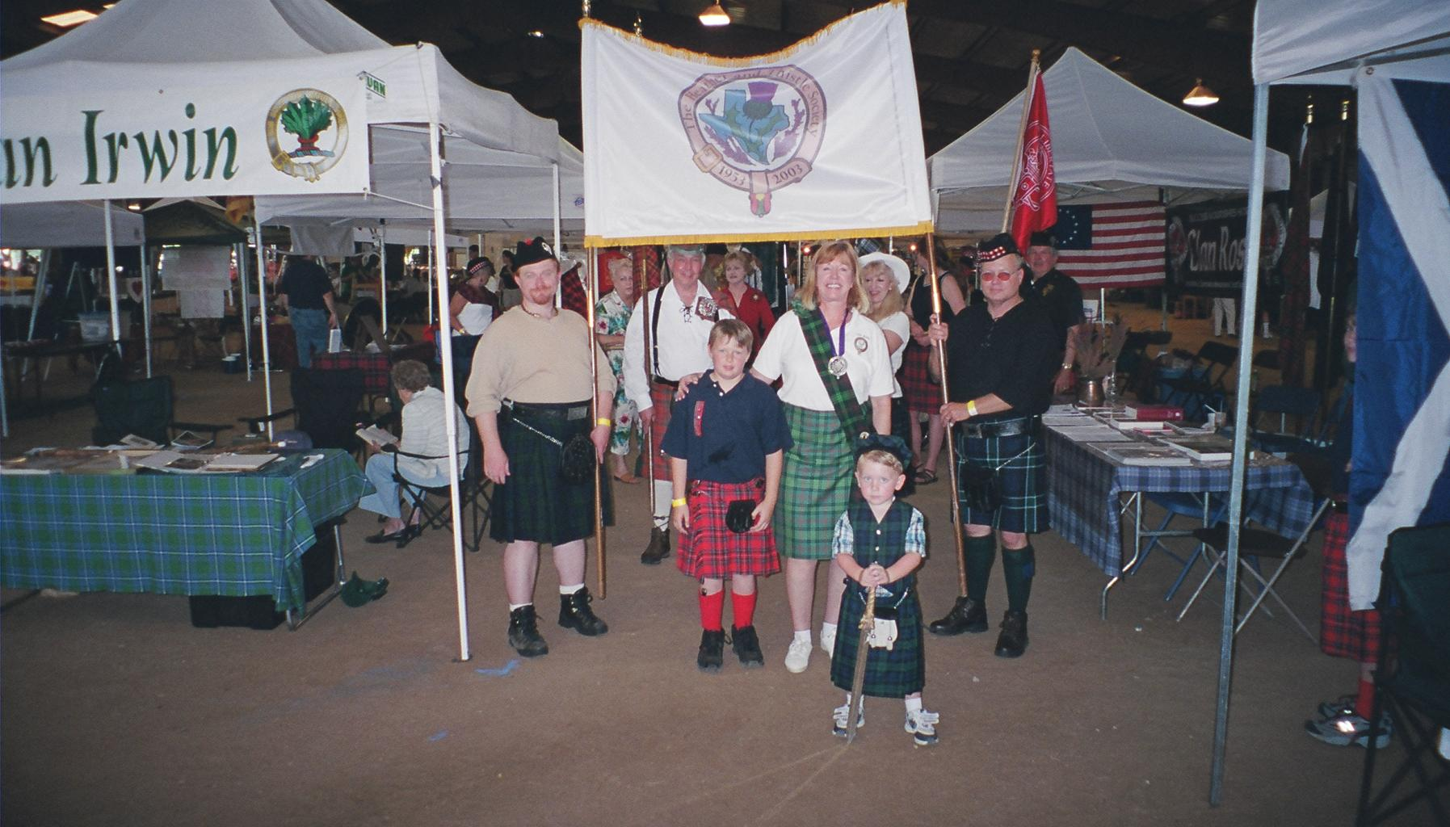Heather & Thistle members at the Houston Highland Games

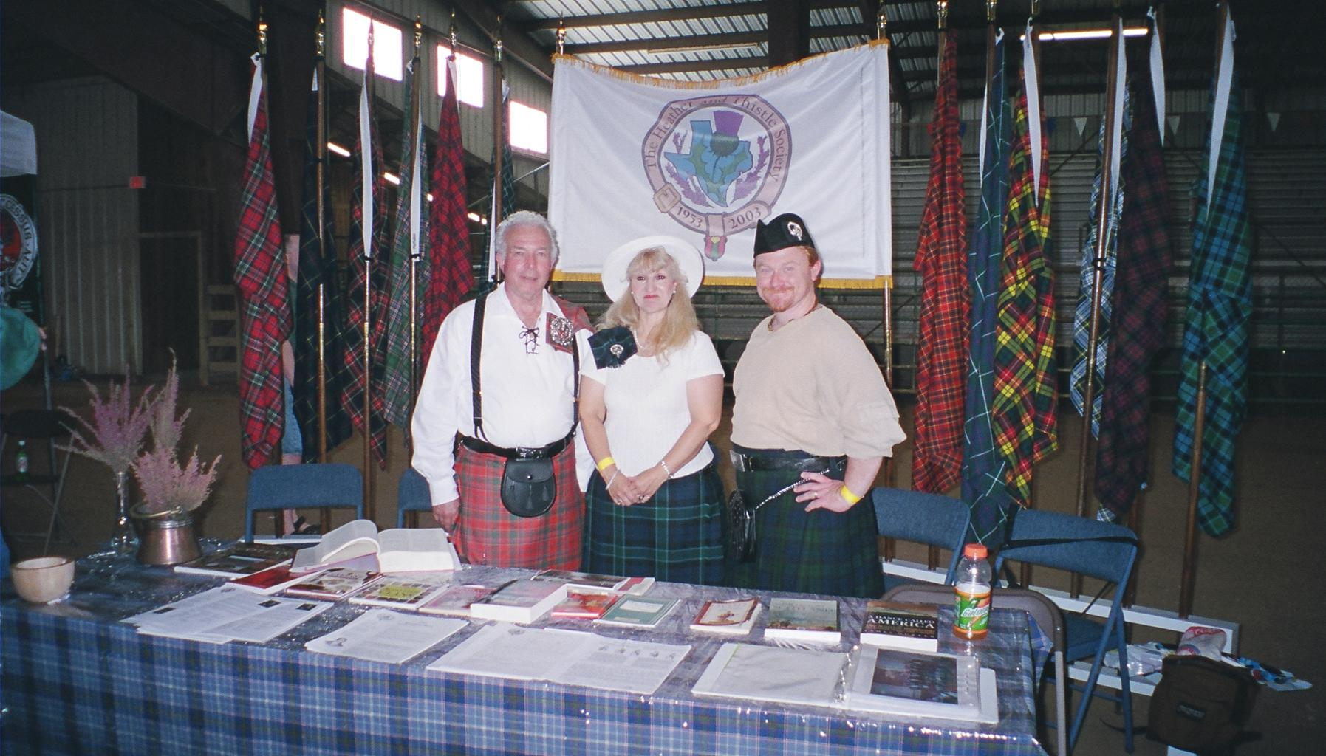Sharon Monteith, Mark Monroe, & Victor Carsrud manning the Heather and Thistle Society booth at Highland Games

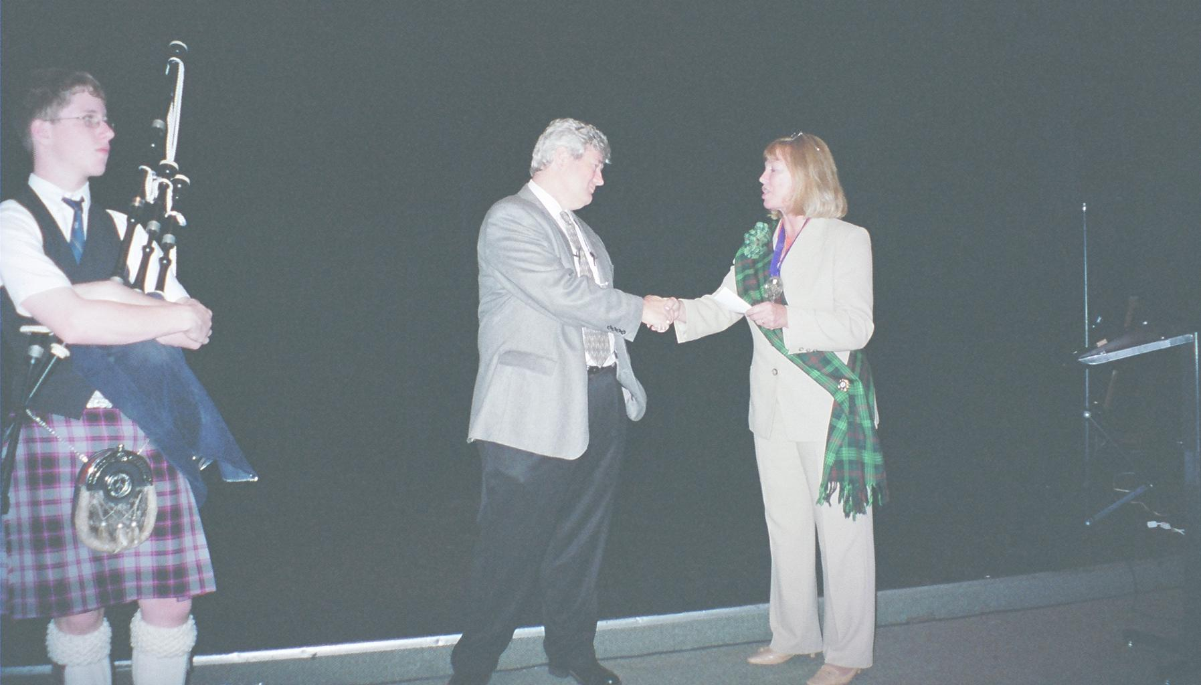
Chieftain Cheryl May donating $1,000.00 to Mike Cusack

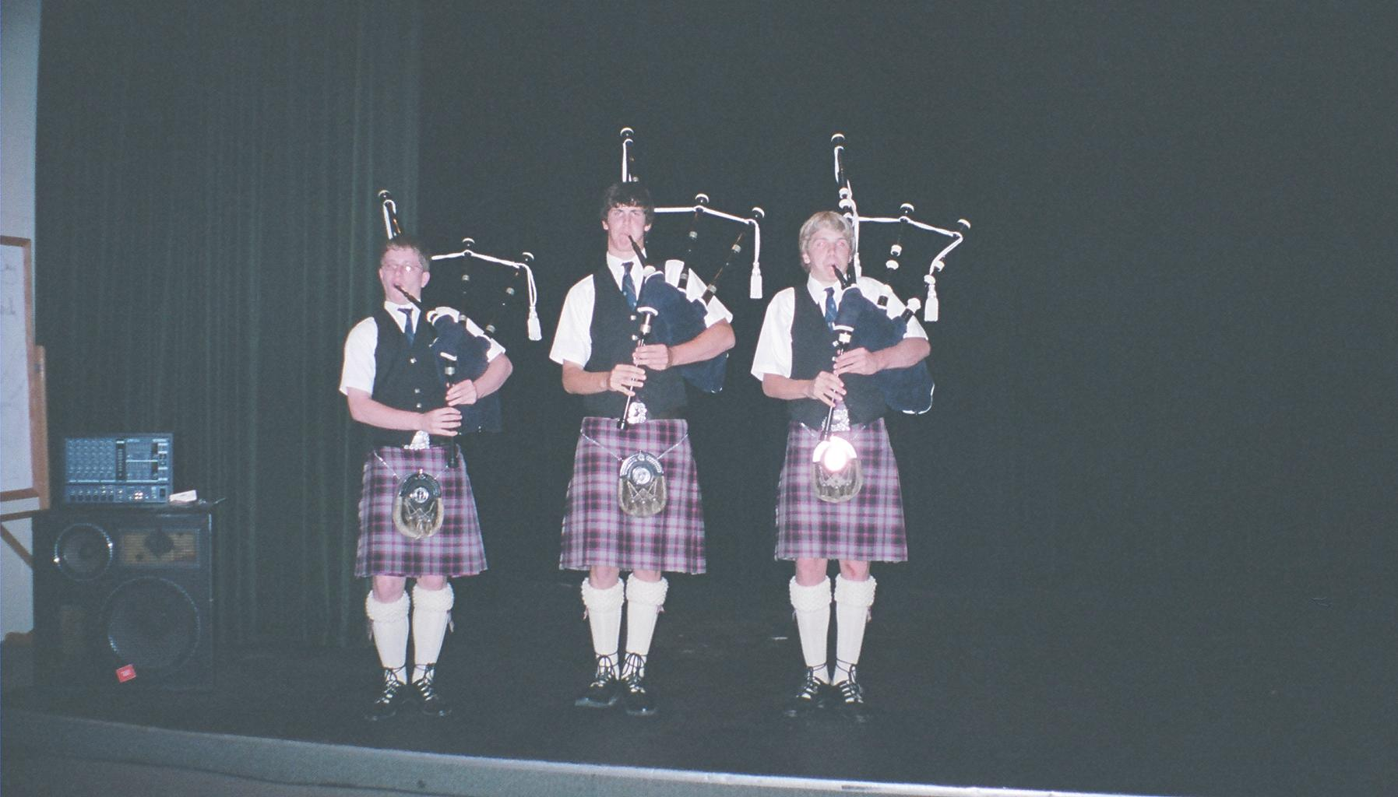
St. Thomas Episcopal Pipers performing for H&T
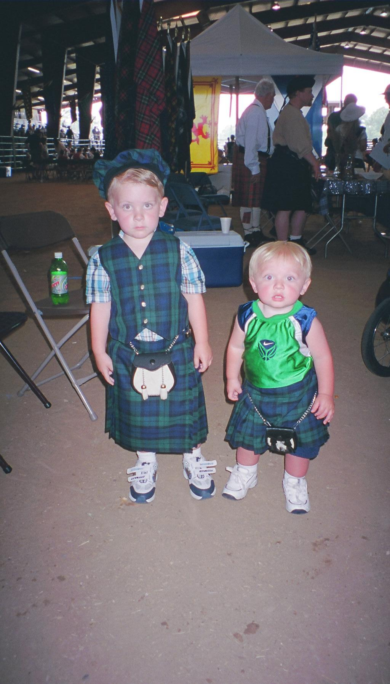
Chieftain May’s grandsons Connor (3) and Collin (1)

Chieftain May donating $1,000 to St. Thomas Dance program

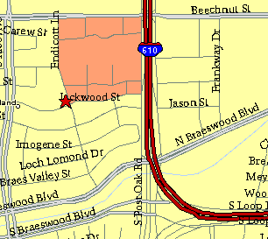

Meeting Information

Meeting Place:
St. Thomas Episcopal School
4900 Jackwood
Houston, Texas 77096

Date and Time:

Fourth Monday of the month
7:30 pm
Heather & Thistle Society Statement
And Membership Information

The Heather and Thistle Society was founded in 1953 by Scots living in Houston who wished to “cultivate an interest in and fond recollections of Scotland, its history and traditions, its literature and ideals, its minstrelsy and song, its customs and amusements, and to provide opportunities for good fellowship and social contact through typically Scottish functions, so that the blessing of our Scottish culture may never die in our new homeland”.

The Heather and Thistle Society meets 10 times a year, September through June. Programs include music, singing, dancing, lively lectures, slide shows and movies about Scotland. The Heather and Thistle Society puts on the annual Robert Burn’s Supper and Ball in late January of each year. We are an organization that promotes our Scottish heritage, in various ways.

The Heather and Thistle Society’s monthly newsletter, “The Houston Scot” is published from September through June. Original articles, information about Scottish or related events are welcome and should be sent to the editor, Jim Monteith, at 15703 Mound Road, Hockley, Texas 77447 or 936-931-2588 or jmonteith@ev1.net.

Membership in the Heather and Thistle Society is open to all with an interest in Scottish heritage and culture. Annual dues are $15 for an individual and $20 for a family membership.
Applications for membership may be obtained from our website at:
http://heatherandthistle.org/documents/membership.doc
Dues are due at the beginning of the fiscal year, March 1. Completed applications and membership fees should be mailed to: Mrs. Eileen Graham Moore
8910 Sandstone, Houston, Texas 77036-6132
For membership information please call Eileen at 713-774-0314.
