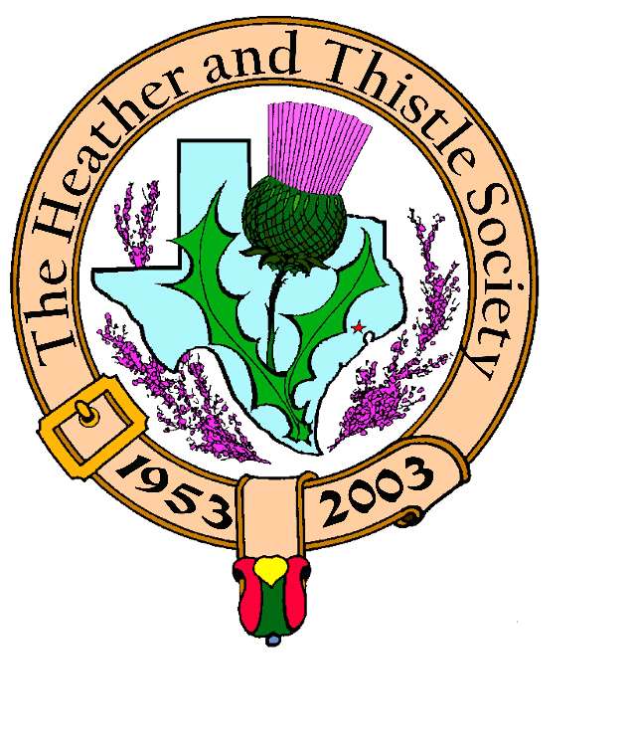

Heather & Thistle Society

Volume 5, Issue 8
April, 2005

Newsletter Editor:
Jim Monteith

Officers:

Chieftain – Cheryl May
Sub-Chieftain – Jim Monteith
Sgt.-at-Arms – Victor Carsrud
Secretary - Sharon Monteith Treasurer - Robert Moore

Committee Chairs:

Sunshine-Eileen Moore
Membership-Eileen Moore
Past Chieftains-Ed Biddle
Burns Supper-Becci Himes
Publicity-Melvyn Douglass
Programs-Cheryl May

Round Tartan Display Stand

Jack Hume recently presented your editor with the plans for making a round flag stand that would display up to 12 tartans. Jack observed one of these round stands being used in the Beaumont area and stated it was a very impressive way to display the tartans.
If anyone is interested in making one of these stands for the Society I will provide them with the plans.

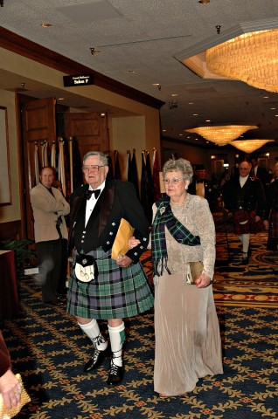
Robert & Eileen Moore The Houston Scot
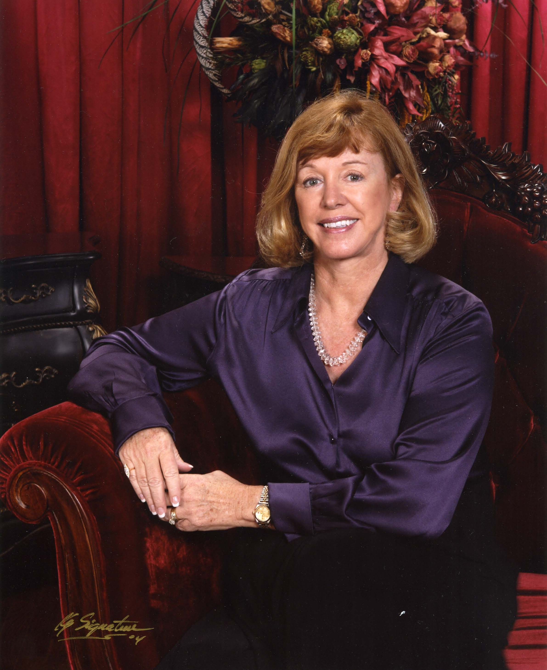

Chieftain’s Letter,

On March 28th Al Campbell piped the procession of officers
elect to center stage. We were privileged to once again have
Jack Hume presiding over the ceremony. Jack dedicated the
evening to the remembrance of three founding ladies includ-
ing his beautiful wife, Phemia. Thank you Al and Jack for all
your efforts on behalf of The Heather & Thistle Society.

It is my honor to serve as Chieftain 2005-2006. I follow in
The great shoes of Aaron Buchanan; however, I promise to
do my utmost to ensure that on January 28, 2006 I will not
make it a tradition to declare the Haggis “UNFIT” to eat!
Kidding aside, the Society has truly benefited from his leadership and hard work. I am not going to say he will be sorely missed. His youth guarantees that he will be part of the Society for many years to come.

There is a good deal of comfort knowing that my officers are well acquainted with their jobs, several having served in the same capacity the previous year. The new face on board is Victor Carsrud. Believe me, at the meeting we all found out that Victor has the perfect Voice for Sergeant-At-Arms! I know he will be a great asset to the team. I thank all the Committee Chairs for their willingness to serve another year.

Our April program will be a favorite, the pipe band of St. Thomas Episcopal School. We hope everyone will attend and give their support and praise to this outstanding group of young people who once again brought home first place honors when they competed in Scotland this past summer.

Don’t forget to attend the Houston Highland Games May 14th & 15th at the Houston Farm & Ranch Club near Bear Creek Park. The Heather & Thistle Society will have a space, and we welcome volunteers and visitors. HHGA will be presenting the 2005 National Scottish Fiddling Championships.

Enjoy Spring!

Cheryl Duthie May
Chieftain

Programs and Scheduled Events for 2005 – 2006

April 25, 2005 May 13-15, 2005 May 23, 2005
H&T meeting Houston Highland Games H&T meeting
St. Thomas Pipe Band Houston Farm & Ranch Club Weather Research Center
Bear Creek Park, Houston Jill Hasling, CCM

June 27, 2005 September 26, 2005 October 24, 2005
H&T meeting H&T meeting H&T meeting
Fisher House Foundation Ireland, Our Celtic Neighbor Halloween Program: Dru Eds
Janice Dunham DAR Jay Dooling of Irish Aires Ed Brodie & Jack Hume

October 30, 2005 November 28, 2005 December 19, 2005
Kirking of the Tartans H&T meeting H&T meeting
Grace Presbyterian Church Scottish Dancing Exhibitions Christmas Party & White Elephant
11:15 am Service, Member & Lessons Gift Exchange
Luncheon to Follow RSCDS
10221 Ella Lee, Houston

January 23, 2006 January 28, 2006
H&T meeting Robert Burns Supper & Ball
Burns Club Program Marriott Westchase
2900 Briarpark Dr. Houston

Religion in Scotland

The Church of Scotland (often referred to as The Kirk) functions as the national church. It differs from the Church of England in that it has a Presbyterian form of church governance, not subject to state control. This goes back to the Scottish experience of reformation, initiated in 1560 by John Knox. The Scottish Reformation in essence took place at a grassroots level, and the Scots chose Presbyterianism as their method of church government. This differs from the situation in England, where Henry the Eighth personally unleashed the English Reformation and chose the Episcopal system that survives to this day in the Church of England.
A number of other Christian denominations exist in Scotland, amongst them Roman Catholicism, the largest faith after The Kirk. As well as The Kirk we find various other Protestant churches, including the Scottish Episcopal Church, which forms a full part of the Anglican Communion, and the Free Church of Scotland, a Presbyterian off-shoot from the established Church of Scotland.
Islam has the largest number of adherents outside of Christianity in Scotland, although its numbers remain very small.
Much of Scotland (particularly the West Central Belt around Glasgow) has experienced problems owing to the religious divide between Presbyterians and Catholics. This problem has historically manifested itself in a number of ways, particularly in employment and in football fanaticism. The problems associated with sectarianism in Scotland have diminished markedly compared with the past, although issues do remain to a certain degree. Scottish police have recently moved to restrict the number of orange parades.
Figures from the 2001 Census on Religion in Scotland:

Church of Scotland – 42% of the population

Roman Catholic – 16%

Other Christian – 7%

Islamic – 0.8%

Buddhist – 0.1%

Sikh – 0.1%

Judaism – 0.1%

Hindu – 0.1%

Other Religion – 0.5%

No Religion – 28%

No Answer – 5%  Heather & Thistle Society – Minutes
March 28, 2005

Installation of new officers ceremony was held by Jack Hume with Al Campbell providing the bagpipe music. Dr. Robert Moore was sworn in as Treasurer, Sharon Monteith sworn in as Secretary, N. D. Victor Carsrud sworn in as Sgt.-at-Arms, Jim Monteith sworn in as Sub-Chieftain, and Cheryl May sworn in as Chieftain.
Chieftain Cheryl May spoke afterward and expressed thanks to Jack Hume for performing the ceremony and Al Campbell for the piping. She also expressed thanks to all the Officers of the Society, Paul Ross, Chairman of the Past Chieftain’s Committee, and to Walter May, Chairman of the Burns Supper Committee. Chieftain May thanked outgoing Chieftain Aaron Buchanan and presented him with a departure gift, a silver Buchanan quaich.

Meeting called to order by Chieftain Cheryl May at 8:35 PM in the St. Thomas auditorium.

Motion to adopt the minutes as published in the February, 2005 newsletter made and passed.

Treasurer’s Report: Balance of $1,097.51. All bills reported to be paid.

Committee Reports:

Membership: We have 236 members. 105 family, 54 single, 33 life, 4 complimentary, and 40 exempt. 159 members are paid up and 77 not paid for 2005. Jack Hume suggested sending a copy of the new membership directory to Walter Watson, President of the World Burns Federation.
Burns Club: Meeting will be on the second Thursday in April.
Newsletter: A few members have reported problems downloading the e-mail newsletter. E-mailed 55 copies and snail mailed 142. Cost were $88.07 for the March issue.
Past Chieftains: Paul Ross advises that Ed Biddle will be taking over as Chairman. Also stated that the audit of the Burns Bust funds is complete.
Programs: The April program will be a performance by the St. Thomas School Pipe & Drum Band. The Society will present the school with our annual donation.
Sunshine: Sympathy card sent to Sheila Gilbert on the death of her brother.
Burns Supper: Walter May announced Becci Himes will be taking over as Chairman. Burns Supper for 2006 planned for January 28th at the same location as this year.
Houston Grampian: Bob Gilbert reports a large contingent of Scots will be coming over for the Offshore Technology Conference. The HGA will be hosting a breakfast at 9 AM at the Hilton Post Oak Hotel (formerly Doubletree) on April 30.
Houston Highlanders: Will be playing at a cancer charity at the Pin Oak Equestrian Center.
Houston Highland Games: Booth space will be $25.00. Motion made and passed to provide an H&T tent at the Games.
RSCDS: No report.

Sgt.-at-Arms reports 20 members present and one guest, Mr. James Laird. Mr. Laird is from Baytown, Texas and says his family came to Texas in 1840. He is a counselor at Cenikor Corp. Mr. Laird joined the Society and became our newest member. He is the father of Pier Laird, Society member.

Old Business: None to discuss.

New Business: Grace Presbyterian Church at 10221 Ella Lee, Houston will be the site of this year’s “Kirking of the Tartans”. The service will be at 11:15 AM and will be followed by an H&T Society member luncheon.

Meeting adjourned at 9:00 PM.

Texas Scottish Events:

Sam Houston Folk Festival Houston Highland Games & Texas Scottish Festival &
Friday, Saturday, Sunday Celtic Festival Highland Games
April 22,23,24,2005 May 13,14,15,2005 Arlington, Texas
On the campus of Sam Houston Houston Farm & Ranch Club Friday, Saturday, Sunday
State University, Huntsville on State Hwy 6 in west Harris June 3,4,5,2005
Trinity Scottish Society’s County. H&T volunteers Contact 1-800-650-1918
Annual Festival will now be a needed to man the tent.
part of this festival. No fee for Texas Folklife Festival
clan space & up to 4 members Thursday thru Sunday
per clan. Contact Jean North at June 9, 10, 11, 12, 2005
936-594-0195 HemisFair Park in San Antonio.
More than 40 ethic groups.

Member Profile of the Month

Welcome to our new column featuring
short biographies of H&T members. I
hope members will participate by writing
a short bio of themselves and getting it to
me. This month’s member profile will be
our new Chieftain, Cheryl Duthie May.

Cheryl Duthie May spent her youth in Cheyenne, Wyoming, where her paternal family settled in the late 1800’s. As a child, Cheryl rode in the Cheyenne Frontier Days Parade with her great grandmother, grandmother and parents in a wagon titled “The Four Generations of Wyoming.” She loved her horses and spent many hours hunting and fly-fishing with her father, John Duthie, a first generation American. Her paternal grandfather, Alexander Duthie, was born in Carnoustie, Scotland and her paternal grandmother was born in Seacombe, England. Cheryl’s maternal side settled in the states in the 1700’s, having journeyed “across the pond” from Wales and England.

Cheryl graduated from the University of Wyoming with a Bachelors Degree in Business Administration and from the University of Houston with a Masters Degree in Accounting. She is a CPA and recently accepted a position as a Controller with Edge, Inc.

Cheryl’s oldest daughter, Tracy is an RN and the mother of a two-year old daughter, Taylor. Cheryl’s middle daughter, Toni, is an Occupational Therapist at Methodist Hospital in the medical center. Kelly, Cheryl’s youngest daughter, is a computer guru, who now devotes herself to caring for two little boys, Connor, 3, and Collin, 1. Being a grandmother has to be one of the greatest joys in Cheryl’s life. Her official name is “MeMa.”

In addition to serving Heather & Thistle, Cheryl is an Elder at Grace Presbyterian Church, an active Stephen’s Minister, on the Speaker’s Committee of the Houston Livestock Show & Rodeo, Membership Secretary of Clan Ross USA and is active in Zonta, an international women’s service organization. On weekends, Cheryl likes to spend pleasurable hours antiquing and gardening. Past Chieftain, Walter May, and Cheryl enjoy skiing, tennis and a variety of activities together.

The Texas Highway Patrol reminds you to: Slow Down or Move Over

Drivers approaching stopped law enforcement and public safety vehicles that have emergency lights activated must either:
--Slow down 20 miles/hour below the speed limit or;
--Vacate the lane closest to the stopped emergency vehicle, if the road has multiple lanes traveling in the same direction.

You should only move over if you can safely do so, otherwise, slow down 20 miles per hour below the speed limit. Clan MacIntyre

The name MacIntyre in Gaelic is rendered “Mac-an-t-saoir”, meaning son of the carpenter or son of the wright. It is a 1,200 year old name and history from the bards (folk tellers) first recall MacIntyre’s being on the Isle of Skye about 800 A.D. From 800 A.D. to 1100 A.D., the ancestors of those who would eventually be called MacIntyres, MacDonalds, MacDougalls, and MacNeils, lived on the islands west of Scotland. It was from these early times, that the numerous MacIntyre legends originated.

Two of the most popular legends that explain how the MacIntyre’s came about are “The Thumb Carpenter” and “Maurice MacNeil and Somerled. The Thumb Carpenter relates how an ancestor of a MacDonald living in Sleat was aboard a boat that was sinking due to a leak. The MacDonald stuck his thumb in the hole, chopped it off and hammered it firm, saving the boat and crew. He was thereafter called the thumb carpenter or Saor-na-h-ordaig and his son was the first to be called Mac-an-t-saoir, i.e. son of the carpenter. The tale of Maurice MacNeil and Somerled occurred in the first half of the 12th century and tells of a man named Somerled who was the Thane of Argyll. Somerled was establishing his lordship in the Western Isles when he met resistance with a Norse King. He sought a diplomatic solution by seeking the Kings daughter, Ragnhild, hand in marriage. Somerled had a nephew named Maurice MacNeil who assured his uncle that he could help him win the bride. Maurice managed to bore holes into the Norse King’s galley, which he plugged with tallow. Maurice contrived to be a passenger on the galley that went to sea with the King. Heavy seas washed out the tallow and the galley began to sink. Maurice, who had brought along a supply of wooden plugs, promised he could save the King’s life if he would promise his daughter Ragnhild hand to Somerled. The King agreed and Maurice saved the galley and was thereafter known as the wright or carpenter. Somerled became the King within a few years and Maurice “The Wright” became a clan chief and his son the first son of The Wright and Chief of Clan MacIntyre.

Maurice MacIntyre’s descendants later established themselves on the mainland, where legend says, a spirit warned them to only settle where a white cow in their herd came to rest. The white cow rested in the rich and fertile Glen Noe by a mountain called Ben Cruachan on Loch Etive. By the end of the 13th century the MacIntyres were foresters to the Lord of Lorn and held their land by right of the sword. The lordship passed from the MacDougalls to the Stewarts and finally the Campbells. The MacIntyre chiefs cannot be listed with any accuracy due to family records having been lost, but the first chief of record was Duncan. Duncan married a daughter of Campbell of Barcaldine and through this connection the MacIntyre chiefs claim descent from Robert the Bruce.

The MacIntyre’s had acquired feudal obligations to the Campbells. The payments were purely symbolic until the early eighteenth century. At this time Campbell of Breadabane persuaded the MacIntyre chief to pay a cash rent. The rent was raised to a point where Donald, the 4th recorded chief, was unable to pay. Donald emigrated to America in 1783 leaving his brother, Duncan, to manage the lands. Duncan also left the glen in 1806. The chiefly line continued to honor their Scottish origins in America, preserving the armorial great seal, signet ring and quaffing cup. In 1991 the correct shield of arms was recorded by the 9th Chief and the MacIntyres once more took their seat on the Council of Clan Chiefs.

Clan MacIntyre’s motto is: Per ardua (Through difficulties)

There are 41 variations of the spelling of the name and all are pronounced MacIntyre.
Prior to 1820-1840 less than five percent of our ancestors in Scotland, America, and Canada had the education to read or write, with possibly a few more people able to spell their own name. Many of the variations developed because of a lack of knowledge. Mistakes were made in official records of births, marriages, army enlistments, sales of land, deaths, etc., because the given name variations were incorrectly recorded.

Clan MacIntyre Septs

Coshem MacCosham MacKintyre
MacTear MacTeer MacTier
McCoiseam Tyre Wright

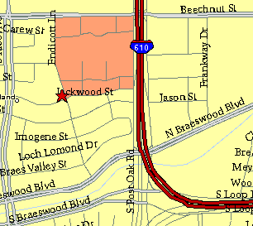

Meeting Information

Meeting Place:
St. Thomas Episcopal School
4900 Jackwood
Houston, Texas 77096

Date and Time:

Fourth Monday of the month
7:30 pm
Heather & Thistle Society Statement
And Membership Information

The Heather and Thistle Society was founded in 1953 by Scots living in Houston who wished to “cultivate an interest in and fond recollections of Scotland, its history and traditions, its literature and ideals, its minstrelsy and song, its customs and amusements, and to provide opportunities for good fellowship and social contact through typically Scottish functions, so that the blessing of our Scottish culture may never die in our new homeland”.

The Heather and Thistle Society meets 10 times a year, September through June. Programs include music, singing, dancing, lively lectures, slide shows and movies about Scotland. The Heather and Thistle Society puts on the annual Robert Burn’s Supper and Ball in late January of each year. We are an organization that promotes our Scottish heritage, in various ways.

The Heather and Thistle Society’s monthly newsletter, “The Houston Scot” is published from September through June. Original articles, information about Scottish or related events are welcome and should be sent to the editor, Jim Monteith, at 15703 Mound Road, Hockley, Texas 77447 or 936-931-2588 or jmonteith@ev1.net.

Membership in the Heather and Thistle Society is open to all with an interest in Scottish heritage and culture. Annual dues are $15 for an individual and $20 for a family membership.
Applications for membership may be obtained from our website at:
http://heatherandthistle.org/documents/membership.doc
Dues are due at the beginning of the fiscal year, March 1. Completed applications and membership fees should be mailed to: Mrs. Eileen Graham Moore
8910 Sandstone, Houston, Texas 77036-6132
For membership information please call Eileen at 713-774-0314.
