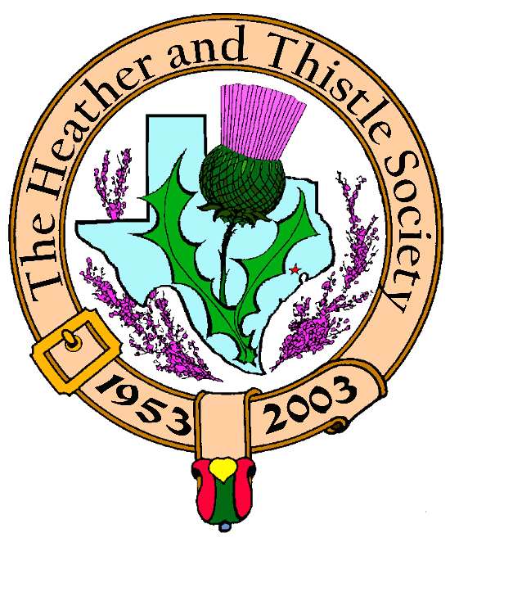

Heather & Thistle Society

Volume 5, Issue 7
March, 2005

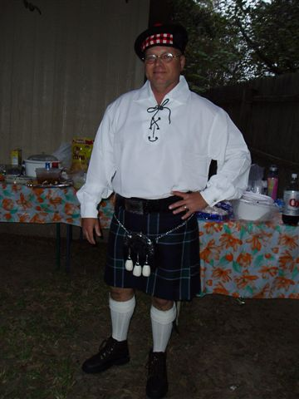

Newsletter Editor:
Jim Monteith

Officers:

Chieftain – Aaron Buchanan
Sub-Chieftain - Cheryl May
Sergeant-at-Arms - Jim Monteith
Secretary - Sharon Monteith Treasurer - Robert Moore

Committee Chairs:

Sunshine-Eileen Moore
Membership-Eileen Moore
Past Chieftains-Paul Ross
Burns Supper-Walter May
Publicity-Melvyn Douglass
Program-Cheryl May


In a landslide election new
Chieftain Cheryl May was
elected. On her coat tails
the infamous “Alabama Scotsman” Jim Monteith was elected Sub-Chieftain, Victor Carsrud was elected Sgt.-at-Arms, Sharon Monteith elected to Secretary, and Dr. Robert Moore elected to
Treasurer.

THE
HOUSTON SCOT

Chieftain’s Letter,

Wow! My last Chieftain’s letter. It has been an excellent year, and it has been my
great honor, pleasure, and privilege to serve you as Chieftain this past year. I want
to thank my executive committee for making this year a success. I could not have done
it with out you. I want to also thank Jim for cranking out a wonderful newsletter
each and every month, Walter for planning an excellent Burns supper, and everyone
in the Society for supporting me.

I figure every Chieftain wonders how he/she will be remembered while they were in
office. I had hoped to be remembered as the youngest Chieftain to ever serve.
However, I’m afraid I may be remembered by these seven words, “I pronounce this
Haggis Unfit to Eat!”

Thank you all,
Aaron C. Buchanan
Chieftain

Aaron, Sharon & daughters Aaron, Walter Watson & Jack Hume
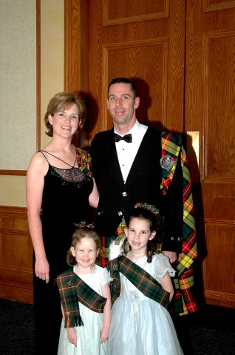
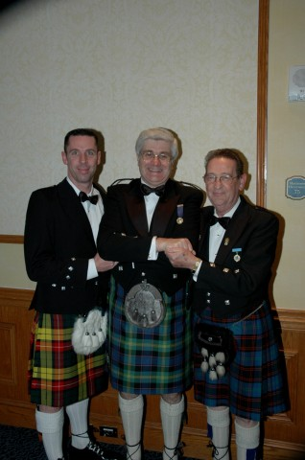

List of Tartans that Heather & Thistle Society Possess

1. American Bicentennial 2. Anderson 3. Baird 4. Black Watch 5. Boyd 6. Brodie
7. Buchanan 8. Cameron 9. Campbell (Dress) 10. Campbell (Dress) 11. Douglas (Modern)
12. Elliot 13. Ferguson (Ancient) 14. Ferguson (Ancient) 15. Graham of Menteith (Ancient)
16. Graham of Montrose 17. Grant 18. Gunn 19. Home 20. Hunter 21. Isle of Skye
22. Kerr (Modern) 23. Kincaid (Ancient) 24. Leslie 25. Leslie 26. MacBeth 27. MacCallum
28. MacLeod (Dress) 29. MacLeod of Harris 30. MacDonald 31. MacDuff 32. MacFarlane
33. MacGregor 34. MacIntyre (Hunting) 35. MacKay 36. MacKenzie 37. MacKinnon
38. MacLean (Duart) 39. MacLean (Hunting) 40. MacMillan (Old) 41. MacNab 42. MacRae
43. MacTavish 44. Malcolm 45. Margaret Rose 46. Matheson (Hunting) 47. Matheson (Red
Ancient) 48. Maxwell 49. McNeill 50. McNeill of Barra 51. Munro 52. Province of New
Brunswick 53. Ramsey 54. Robertson 55. Ross (Hunting) 56. Ross (Hunting Ancient)
57. Ross (Hunting Weathered) 58. Ross (Red) 59. Robert Burns Heritage 60. Stewart (Black)
61. Stewart (muted blue) 62. Stewart (Royal) 63. Thompson 64. Wallace

Upcoming Programs :
March 28, 2005
Jack Hume will perform the
lavishly scripted Installation
of Officers Ceremony. Our own
Alastair Campbell will provide
the piping in of the new officers.
Celebration after the meeting at
Kelvin Arms, 2424 Dunstan
(Rice Village), Houston, Tx.

April 25, 2005
The St. Thomas Pipe Band
will perform.
Scottish Events:

Sam Houston Folk Festival
April 22, 23, 24, 2005
On the campus of Sam Houston
State University, Huntsville.
Trinity Scottish Society annual
Festival will now be a part of
tis festival. No fee for Clan
space and up to four members
per Clan. Contact Jean North at
936-594-0195

Houston Highland Games &
Celtic Festival
Friday, Saturday, Sunday
May 13, 14, 15, 2005
Heather & Thistle volunteers
Needed to man the tent.

Texas Scottish Festival &
Highland Games
Arlington, Texas
Friday, Saturday, Sunday
June 3, 4, 5, 2005
-contact 1-800-650-1918

Heather & Thistle Society – Minutes
February, 28, 2005

Meeting called to order at 7:40 PM in the auditorium of St. Thomas Episcopal School.

Motion to adopt the minutes as published in the January, 2005 newsletter made and passed.

Treasurer’s Report: Balance of $1,160.51. $35.00 check from Highland Games not cleared.

Committee Reports:

Burns Club: Meetings are the second Thursday of each month at a members home.
Burns Supper: Becci Himes reports she will be taking over as Chairman and next Burns Supper is scheduled January 28, 2006.
Newsletter: Editor reports he is up to 57 members receiving the newsletter by e-mail now.
Past Chieftains: Slate of new officers will be announced by Paul Ross. Election tonight. Installation of new officers next meeting (March 28, 2005).
Programs: Sgt.-at-arms announced proposed schedule of programs for 2005.
Sunshine: Sympathy card sent to the John Stansell family.
Membership: Three new members have joined. New membership directories are out. Ask Eileen for a copy. 2005 annual dues are due. We have 236 total members, 106 family, 53 single, 33 life, 4 complimentary, and 40 exempt.
Houston Grampian: James Parppas has been nominated to be their new president.
Houston Highlanders: No report.
Houston Highland Games: Tonight’s program.
RSCDS: No report.

Sgt.-at-Arms reports 20 members present. Derek MacLeod was our one guest. Left over Christmas presents from our Christmas party were given out. Guest Derek MacLeod received one. Winners of the other two were Eileen Moore and Rosemary McBride.

Chieftain Buchanan presented a Certificate to the Burns Club for last months performance.

Old Business: The Burns Bust financial books have been turned over for audit.

New Business: Election of officers tonight. Slate of new officers announced and voted on by acclamation. Elected to Chieftain was Cheryl May, to Sub-Chieftain Jim Monteith, Victor Carsrud to Sgt.-at-Arms, to Secretary Sharon Monteith, and to Treasurer Robert Moore. Installation of new officers will occur at the March 28, 2005 meeting.

Business meeting adjourned at 8:00 PM.

Tonight’s program was a presentation of the history of the Houston Highland Games and other prominent Highland Games around the world. Presented by Melvyn Douglass, President of the Houston Highland Games Association.

THE KILT
(SUBMITTED BY PAUL ROSS)

When I first joined Celtic League American Branch (CLAB), one of the first articles that I read in the KELTOI newsletter (which I naturally can’t find now) said that back about the time that the European rulers (Celts) started bumping up against the Greeks, they named the peoples the Keltoi and commented about the colorful checked clothing that they wore. This was about 600 BCE. As a side note, these same peoples were called Gauls by the Romans, so the modern word Celt should have the Greek C rather than the Roman C, i.e. “kelt”, not “selt” – personal opinion. Drawings of these peoples throughout the ages, or at least up through the fifteenth century, show them (o.k. the males) as either naked or wearing trews. There is also a sprinkling of shirts or robes or capes or gambesons leading up to the lienne croich or saffron shirt in the fourteenth through early seventeenth centuries, but the trews persist.
The lienne croich was a unisex garment worn throughout the gaeidhealtachd, usually with a brat or mantle, often with an ionar or jacket. The ionar had open sleeves which could be attached at the wrist, but is usually depicted as hanging loose. For wandering about in public, ladies would often wear a bodice and skirt over their lienne when going out in public.
Somewhere between 1550 and 1600, the dress of the Irish and Highlanders started to diverge, and by 1600, we get the first evidence of kilts and airisaides. The first written description of a kilt like garment is from 1590, so a good guess would be that it evolved around 1570 or 1580. The first kilts are referred to as Breachanfeiles and are simply “ a length of tartan material (plaid refers to the garment itself, tartan to the cloth, sett to the design) between 5 and 8 yards in length, and about 54 – 60 inches wide, that is pleated and belted around at the waist, with the remainder tucked up around the body and belt to form “panniers and a cloak.” (THE KILT by Cormac MacCliuin). Other sources give the yardage from as little as 4 yards to as long as 12 yars. I read one document that said 24 yards, but I suspect it meant feet, which would be 8 yards.
(PERSONAL SPECULATION) I may have to quibble with Lord O’Domnaill (Cormac MacCliuin), based on the 1988 Clan Ross Association’s Stone Mountain Seminar presented by Ruiridh, somebody (I tried, but I can’t remember which of two warring families he belongs to, so I’ll stop right there, and make both of them a little bit irritated with me). He explained that in the old days, the looms were generally 28 inches wide (as the still are in many rural areas of the world [like Guatemala]), and to get wider cloth, two pieces were sewn together along the selvage. Well, I like great kilts, and I’m not what folks consider a small man, but anything over 5 yards is a LOT of kilt. I would suspect that the 8+ yard designation for a faile-mohr indicates this sewn together configuration.
Over the years, I have come to the understanding that what we refer to as the great kilt came in two slightly different configurations (others who have also done considerable study say that it’s two names for the same garment, you choose): the breachan-faile and the faile-mohr. It is my belief that the breachan-faile is the older of the configurations and could very well be up to 12 yards of material of the narrower variety worn as a faile-beag with the tail brought up like a modern piper’s plaid.
Whatever, all the sources that I have seen (except the web-site “how to wrap a great kilt” by a skinny fellow who wears his vertically) show the faile-mohr being worn the same basic way:
- place your belt on a flat surface (I like the bed, so I don’t have to subject my knees to crawling around on the floor.)
- center the tartan on the belt parallel to the belt.
- pleat the tartan, thereby shortening it, until there’s about two feet of unpleated fabric on each end.
- Center yourself on the creation so the break of your knee is lined up with the selvage and cover yourself with the fabris, right side first, then fasten the belt. (see why step a is boldfaced)
- Stand up. (if your tartan was only 28 inches wide, you would now be kilted in a faile-beag and could go outside and play.)
- Draw the front overhanging tartan back up and tuck it back through the belt to create one or two panniers or pockets. I prefer to create just the one, because I’m a bit taller than many of my kinsmen.
- Pull the rear overhand up the back and by gently tugging at the selvage, find a spot just to the right of center (so when it’s pinned, it won’t try to fall off your shoulder as you move) and hold it over your left shoulder. Grab the overhanging tartan from somewhere in the front or left and bring it up the front and pin it to the stuff you were holding from the back. – You’re done – Go play.
The airisaidh is done similarly, except the tartan is placed perpendicular to the belt so that, when complete, the hem reaches to the ankle, the selvage to the points of the hip (not overlapping in front) and the excess is worn as a cape and hood, or over the shoulder as a plaid.
In the 18th century, the first Highland Regiment was formed (eventually known as the Black Watch), and like all military endeavors everywhere, standardization and such soon set in. A friend of mine tells the story that, because of the location of the creation of this regiment, most of the members were Grants, and therefore the Grant tartan (hunting) was selected as the Regiment tartan. And, before the turn of the century, the faile-beag was replaced by the tailored kilt, or wee kilt.
The military kilt evolved a bit more in that the pleats were arranged so that no vertical parts of the sett show, but otherwise, the structure of the kilt has pretty much remained the same. Sometime before the Siege of Quebec, the 78th Fraser Highlanders introduced an extra pleat in the front of the kilt so that the bib would lay flat whilst climbing ladders. One of the highland chiefs had a kilt made with pockets and was hollered at by common folk who took offense at the challenge to tradition. And, if you surf the web, you’ll see pictures of great kilts worn sideways, a mini-kilt with the sporran worn at the hip, and lots of other stuff.

Not long ago Al Campbell showed me (Jim Monteith) a beautifully made sterling silver brooch made by a local man. It was the Heather and Thistle Society emblem. They can be made with either a clasp pin on the back or military style pin. Some of the Houston Highlanders have been buying them. I have ordered one for my wife and hope to have it at the March 28, 2005 H&T meeting to show folks. The man’s name that is making them is Jim Holcomb. The price is $40.00. He can be contacted at
713-681-7687 or by e-mail at jmhol@swbell.net.

Heather and Thistle Society Sterling Silver Brooches Available

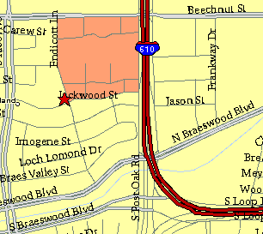

Meeting Information

Meeting Place:
St. Thomas Episcopal School
4900 Jackwood
Houston, Texas 77096

Date and Time:

Fourth Monday of the month
7:30 pm
Heather & Thistle Society Statement
And Membership Information

The Heather and Thistle Society was founded in 1953 by Scots living in Houston who wished to “cultivate an interest in and fond recollections of Scotland, its history and traditions, its literature and ideals, its minstrelsy and song, its customs and amusements, and to provide opportunities for good fellowship and social contact through typically Scottish functions, so that the blessing of our Scottish culture may never die in our new homeland”.

The Heather and Thistle Society meets 10 times a year, September through June. Programs include music, singing, dancing, lively lectures, slide shows and movies about Scotland. The Heather and Thistle Society puts on the annual Robert Burn’s Supper and Ball in late January of each year. We are an organization that promotes our Scottish heritage, in various ways.

The Heather and Thistle Society’s monthly newsletter, “The Houston Scot” is published from September through June. Original articles, information about Scottish or related events are welcome and should be sent to the editor, Jim Monteith, at 15703 Mound Road, Hockley, Texas 77447 or 936-931-2588 or jmonteith@ev1.net.

Membership in the Heather and Thistle Society is open to all with an interest in Scottish heritage and culture. Annual dues are $15 for an individual and $20 for a family membership.
Applications for membership may be obtained from our website at:
http://heatherandthistle.org/documents/membership.doc
Dues are due at the beginning of the fiscal year, March 1. Completed applications and membership fees should be mailed to: Mrs. Eileen Graham Moore
8910 Sandstone, Houston, Texas 77036-6132
For membership information please call Eileen at 713-774-0314.

