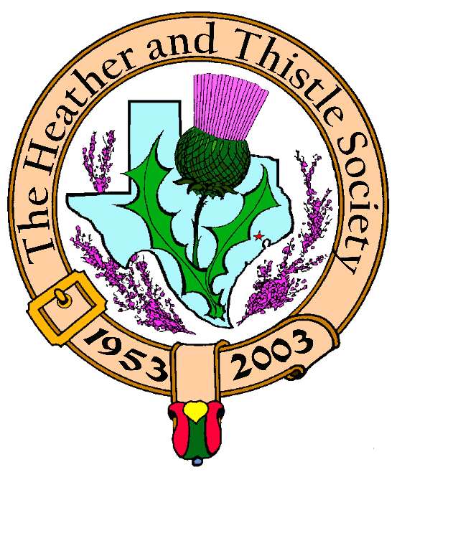

Heather & Thistle Society

Volume 5, Issue 6
February, 2005

Newsletter Editor:

Jim Monteith

Officers:

Chieftain - Aaron Buchanan
Sub-Chieftain - Cheryl May
Sergeant-at-Arms - Jim Monteith
Secretary - Sharon Monteith Treasurer - Robert Moore

Committee Chairs:

Sunshine-Eileen Moore
Membership-Eileen Moore
Past Chieftains-Paul Ross
Burns Supper-Walter May
Publicity-Melvyn Douglass
Program-Cheryl May



2005 Nominations for
Heather & Thistle Officers:

Chieftain: Cheryl May
Sub-Chieftain: Jim Monteith
Sgt-At-Arms: N. D. Victor
Carsrud
Secretary: Sharon Monteith
Treasurer: Robert Moore

 THE
HOUSTON SCOT

Chieftain’s Letter,

WOW! What a night! For those of you that attended this year’s Burns Supper, I want to thank
you. It was a wonderful evening; Sharon, Ariana, Ciara and I had a wonderful time. The night
was full of drama, danger, and adversity, yet all who attended had a good time.

Once again, I want to thank Walter May and the Burns Supper committee for arranging the
evening, all the H&T officers for their help, Walter Watson for delivering an excellent immortal
memory, and RSCDS and the Houston Highlanders for their stellar performances.

You will notice in the newsletter a slate of officers. Yes it is that time again; at our February H&T
meeting you will have the opportunity to vote for the new officers, so I hope to see you all there.

Your Chieftain,
Aaron C. Buchanan

“ I Declare This Haggis Unfit to Eat “
The above words were pronounced for the first time in the history of “The Heather and Thistle Society by our Chieftain at the 52nd Annual Burns Supper. I was told that the first reaction in our audience was incredulous disbelief. “It’s a joke,” some said. But, unfortunately it was no joke.
The Burns Supper Planning Committee researched a number of sources and we had several tastings – such tough duty. Some of us ordered haggis from this supplier to verify quality and it was excellent in all cases. This was the supplier of haggis for the Houston Grampian Association 2004 St. Andrews Dinner and the Clan Ross 2004 Annual General Meeting in Charleston. So we put our faith in this company, ordered their product and looked eagerly forward to the haggis at our 52nd Annual Burns Supper.
The haggis came properly packed and was delivered to the Marriott Westchase Hotel. At 5:30 PM on the night of the Supper I received a call to the kitchen to examine the product. The containers were in poor condition and there was a strong indication that the container’s integrity had failed, causing leaking. The committee agreed that we could not take the risk of serving this haggis and making even one person ill. In addition the hotel properly refused to serve it.
In retrospect, I think you will have to agree with me that we took the best course.
Walter May, Chairman
2005 Burns Supper Planning Committee

CUT OUT BALLOT AND BRING TO FEBRUARY MEETING
Chieftain: Cheryl May ___yes Member Name ___________________

Sub-Chieftain: Jim Monteith __yes Please place an X in the yes column if
you wish to vote for that candidate.
Sgt-At-Arms: N.D. Victor Carsrud___yes
Secretary: Sharon Monteith ___yes

Treasurer: Robert Moore ___yes

Members should present their ballot in person at the Annual General Membership Meeting on February 28, 2005. Members who cannot attend may present their ballot forms in person to any member of the Nominating Committee any time before the Annual General Membership Meeting. Voting shall be on the basis of one voter per adult member present and in good standing.
Nominating Committee:
Paul Ross 3015 Castlewood, Houston, Texas 77025-3215 713-668-4663
Ed Biddle 9514 Willow Trace Court, Houston, Texas 77064 281-807-7892
Wayne Barton 13801 Hershe, Houston, Texas 77015 713-450-4042
Walter May 6143 Sienna Arbor Lane, Houston, Texas 77041-6038 713-983-8866
Becci Himes 12035 Scottsdale Meadows Place, Houston, Texas 77477 713-729-3557

Upcoming Program February, 28, 2005
Mel Douglas will give a
presentation on The Houston
Highland Games
March 28, 2005
Jack Hume will perform the
installation of New Officers
Ceremony
Scottish Events: North Texas Irish Festival
Fair Park in Dallas, Texas
March 4, 5, 6, 2005
Produced by Southwest Celtic Music Assoc. of Dallas -Irish & Scottish entertainment including world famous musicians, dancers, storytellers and educational workshops St. Thomas Episcopal School Scottish Festival Tattoo Friday, March 11, 2005 8pm Toyota Center, Houston

Sam Houston Folk Festival
April 22, 23, 24, 2005
On the campus of Sam Houston
State University, Huntsville.
Trinity Scottish Society annual
Festival will now be a part of
this festival. No fee for Clan
space and up to four members
per Clan. Contact Jean North at
936-594-0195.

In Memoriam

John A. Stansell, 87 , born
July 20, 1917, died Jan. 11, 2005
Longtime Heather and Thistle
member, graduate of Texas
A & M in 1939, and veteran of
the U.S. Army during WWII.
Married Bettie Gray Nix before
shipping overseas where he
fought in numerous battles and
landings until becoming a
German POW. Lived in Bellaire,
Texas after the war and entered into sales. He is survived by his
wife, three sons, numerous grandchildren and great grand-
daughter.

Heather & Thistle Society – Minutes
January 24, 2005
Chieftain Aaron Buchanan introduced Dr. Arthur Down at 7:34 PM who then made a special introduction of our guests from Scotland, Walter Watson, President of The Robert Burns World Federation, and his wife Liz Watson.

Tonight’s program was a performance by Heather & Thistle’s Burns Club of “A Night at Poosie Nansie”s Inn.

Refreshments were had by members after the performance.

Meeting called to order at 8:55 PM.

Motion to approve December 2004 minutes as published in newsletter made and approved.

Committee Reports:

Treasurer’s Report: Balance of $1,381.50 as of 01-22-05.
Sunshine: John Stansell passed away on Jan. 11, 2005 at 87 years of age. Arthur Stansell, son of John spoke briefly about his father’s life.
Membership: 232 members total with 102 family, 53 single, 33 life, 40 exempt, and 4 complimentary.
Past Chieftains: No Report.
Burns Supper: Walter May reports 538 dinners were served at the 52nd Supper. He apologized for the Haggis situation and reports the supplier of the Haggis sent us product that was possibly contaminated. The Chef at the Marriott refused to serve it and the Burns Committee concurred. Walter also reported that our Burns Supper had competition for guests due to the Confederate Ball, the British Petroleum Burns Supper, and the Inauguration of the President. Walter welcomes any comments on the event.
Publicity: Two photographers were hired to take digital pictures at the Burns Supper.
Burns Club: Will be having their Burns Supper on Feb. 19, 2005.
Newsletter: Editor reports e-mailing about 48 a month and mailing out about 146. Editor would like to get more e-mail addresses. Spending between $74 and $110 per month to publish and mail.
Highland Games: This years games should be the weekend May 15. National Fiddling competition again.
Houston Grampians: Annual general membership meeting will be Feb. 12, 2005.
Houston Highlanders: Al Campbell reports they will be practicing for next years Burns Supper and are still looking for pipers and drummers.
RSCDS: Moonyeen Weiss reports they enjoyed Saturday night (Burns Supper) and noted some
people confused their young ladies with the St. Thomas dancers.
Programs: Cheryl May thanked everyone who helped at the Burns Supper. Mel Douglas will give a presentation on the Houston Highland Games at the February 28, 2005 meeting. March meeting will be installation of new officers. Jack Hume will perform installation ceremony. Still looking for book reviews. September program on Ireland. Ed Brodie will present a Halloween program in October. November hope to have RSCDS again to give dance lessons.

Sergeant-At-Arms reports 46 members and 2 guests. Guests were Liz and Walter Watson.

Guest Walter Watson, President of The Robert Burns World Federation spoke and expressed a huge thank you. Members have entertained them royally. He spoke of the quality of our Burns Supper. He thanked Jack Hume for tonight’s program, which took him back sixty years to when he was a small boy watching his parents perform ‘The Jolly Beggars”. Mr. Watson thanked everyone from the bottom of their hearts.

Old Business: Jack Hume reports he is frustrated about the inaction on the audit of the Burns Bust Fundraising effort.

New Business: Jim Monteith made a motion to buy ten more poles for tartans. We have nine tartans without poles. Motion tabled until costs of poles can be determined. Mark Monroe has offered to make and donate 4 new 7-hole pole stands. Margaret Reuter spoke about a television series made in Scotland named “Hamish MacBeth”. It is on BBC America Mondays from 6 to 7 PM. She says it is low key and delightful with a cast of real Scottish characters. Maryann Munroe asked if the Society hired the woman who took pictures at the Burns Supper. Chieftain Buchanan responded and advised a man and wife team were hired, the photos were digital and on a CD and will be available to buy.

Meeting adjourned at 9:22 PM.

2005 Burns Supper

The 52nd Annual Burns Supper put on by The Heather and Thistle Society at the Houston Marriott Westchase on January 22, 2005 was a great time had by all. Yes, there was a problem with the Haggis that had been supplied, but the Burns Supper Committee took the appropriate action, thinking of the safety of the diners, by refusing to serve it. Our Chieftain, Aaron Buchanan, tasted the questionable Haggis and was forced to declare it “unfit to eat”. Though the incident was unfortunate and there were some diners that complained we should appreciate the position the Burns Supper Committee and the Chieftain were put in and applaud their action. We look forward to next year and the hope that we will be served double rations of Haggis at the 53rd Annual Burns Supper.

Ted Hirtz and his Haggis crew performed
a memorable “Address to a Haggis”. Al
Campbell and the Houston Highlanders
filled the room with their wonderful music. The St. Thomas dancers performed the Highland dances. The toasts were elegant and Daniel Buchanan’s singing was phenomenal. The Royal Scottish
Country Dance Society demonstrated
their art and grace. The Bayou Big Band
made everyone want to dance. The night
ended to soon as everyone joined hands
and sang “Auld Lang Syne”.

2005 Burns Memorial Ceremony

On January 23, 2005 at the Rose Garden, Herman Park, Houston, a service celebrating the anniversary of Robert Burn’s birth was performed. In front of the bust of Robert Burns, which was placed in the Garden in January, 2003 by the Heather and Thistle Society, attendees were treated to poetry and song written by “The Bard” and bagpipe music performed by Al Campbell. Walter Watson, President of The Robert Burns World Federation, spoke briefly on the condition and goals of the World Federation and thanked the Society for all they had done to make his and wife Liz Watson’s stay in Houston memorable.

Chieftain Buchanan at Burns Ceremony
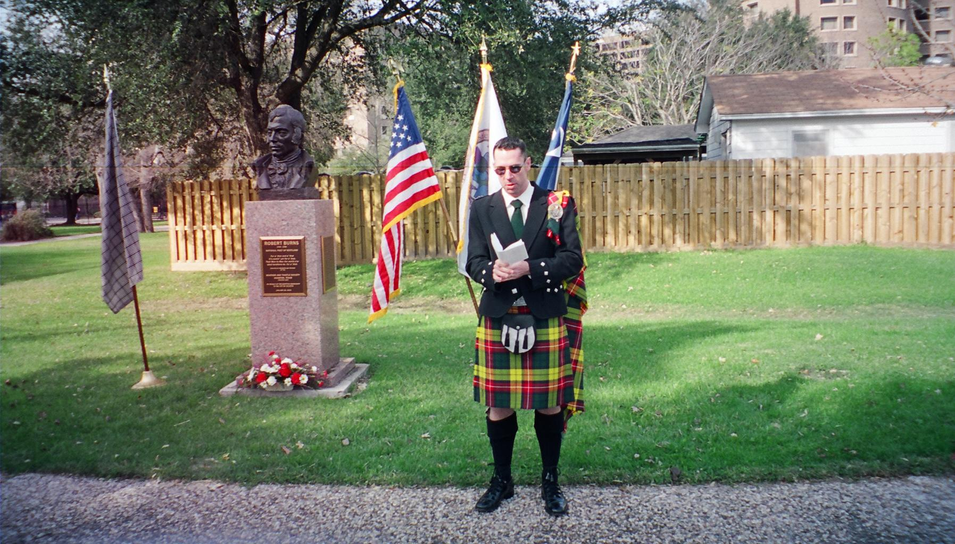
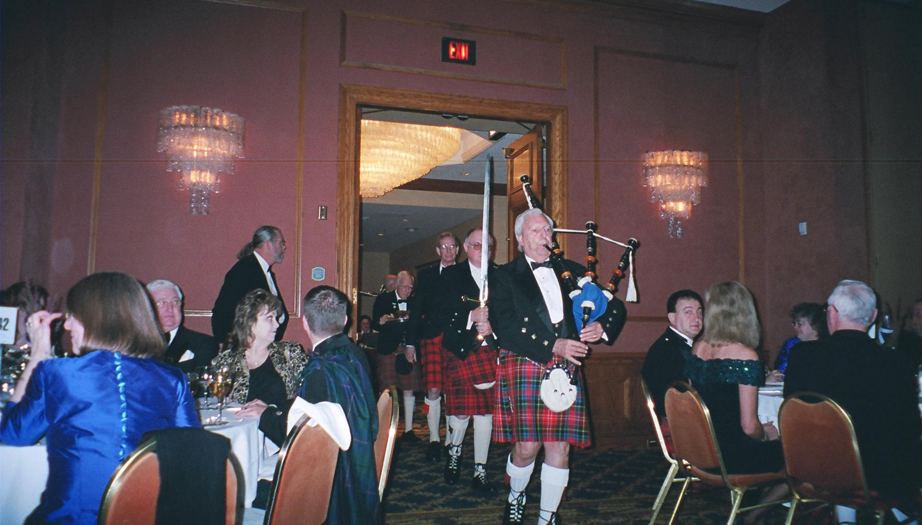 Haggis ceremony 2005 Burns Supper 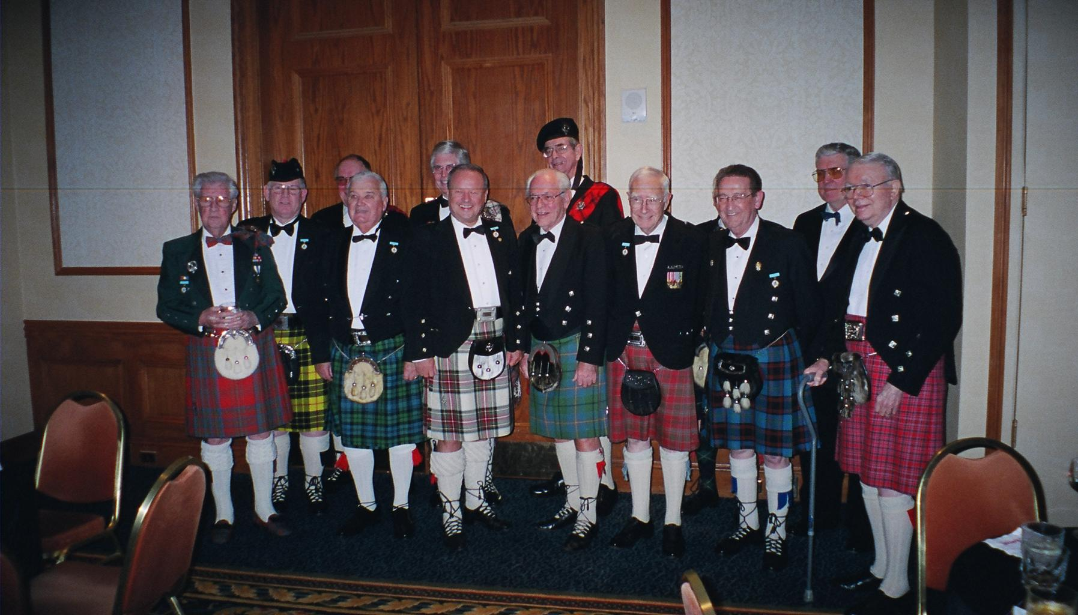 Past Chieftains at 2005 Burns Supper 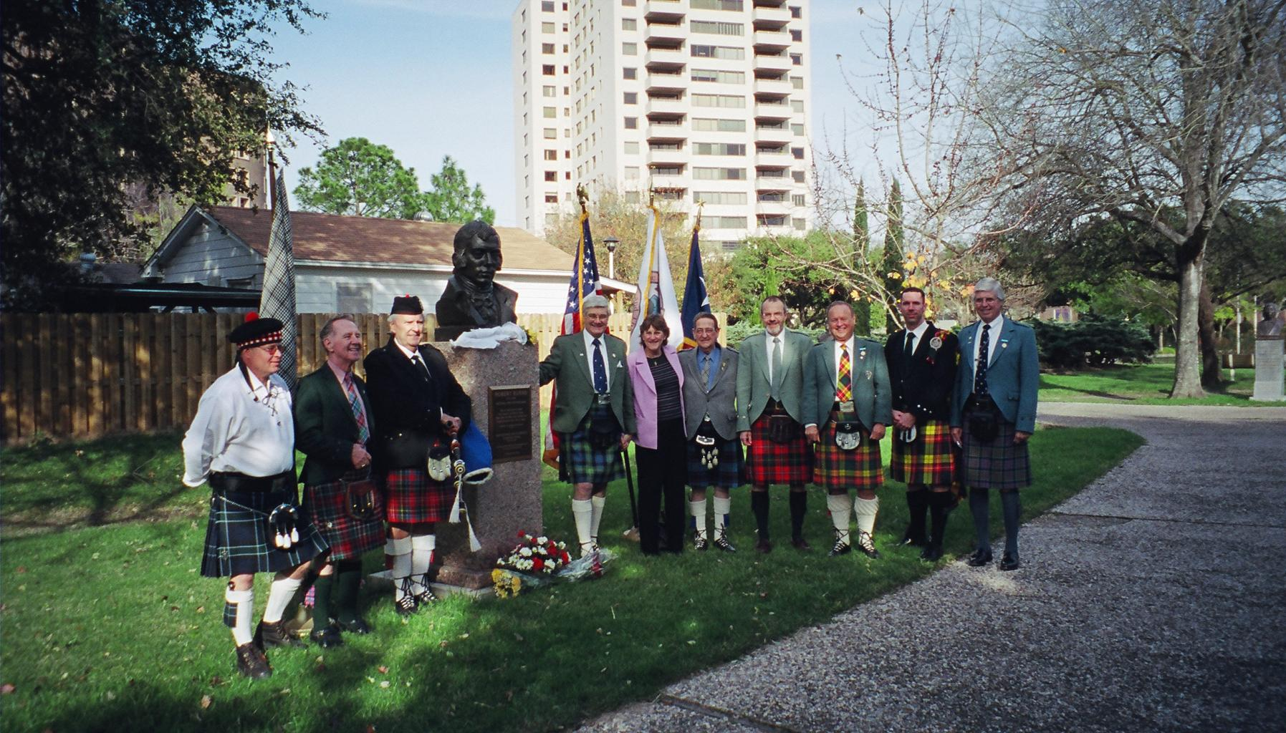 Burns Ceremony at Herman Park Rose Garden

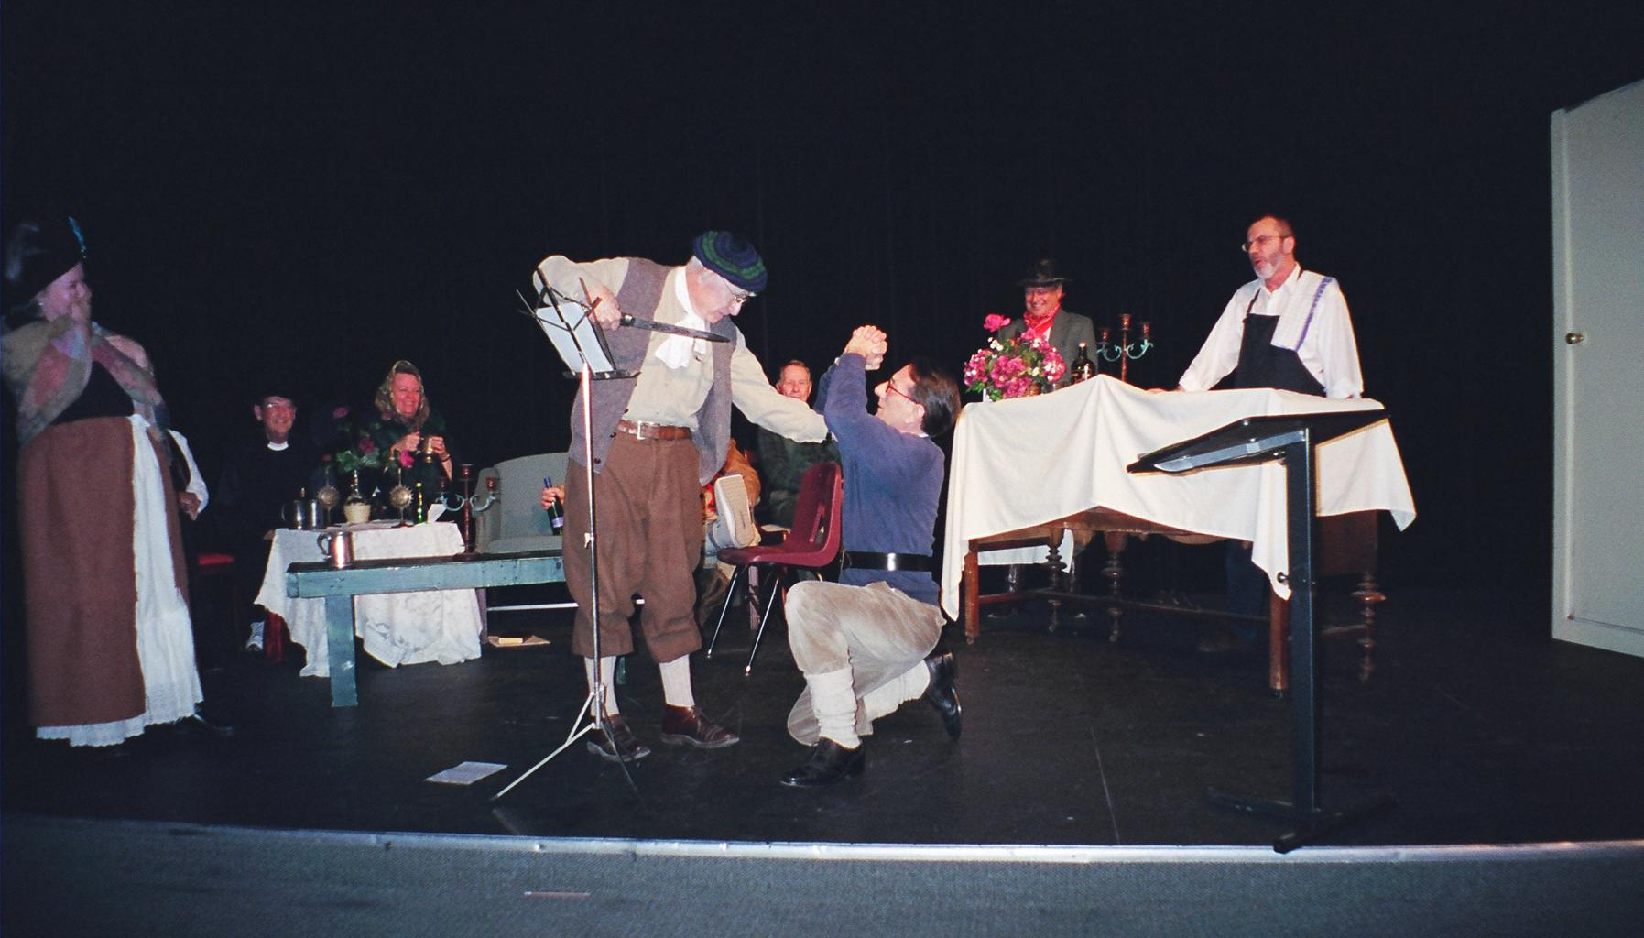 Burns Club performance Feb. 2005 meeting

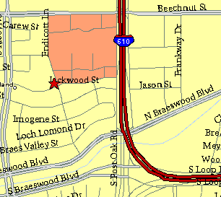

Meeting Information

Meeting Place:
St. Thomas Episcopal School
4900 Jackwood
Houston, Texas 77096

Date and Time:

Fourth Monday of the month
7:30 pm
Heather & Thistle Society Statement
And Membership Information

The Heather and Thistle Society was founded in 1953 by Scots living in Houston who wished to “cultivate an interest in and fond recollections of Scotland, its history and traditions, its literature and ideals, its minstrelsy and song, its customs and amusements, and to provide opportunities for good fellowship and social contact through typically Scottish functions, so that the blessing of our Scottish culture may never die in our new homeland”.

The Heather and Thistle Society meets 10 times a year, September through June. Programs include music, singing, dancing, lively lectures, slide shows and movies about Scotland. The Heather and Thistle Society puts on the annual Robert Burn’s Supper and Ball in late January of each year. We are an organization that promotes our Scottish heritage, in various ways.

The Heather and Thistle Society’s monthly newsletter, “The Houston Scot” is published from September through June. Original articles, information about Scottish or related events are welcome and should be sent to the editor, Jim Monteith, at 15703 Mound Road, Hockley, Texas 77447 or 936-931-2588 or jmonteith@ev1.net.

Membership in the Heather and Thistle Society is open to all with an interest in Scottish heritage and culture. Annual dues are $15 for an individual and $20 for a family membership.
Applications for membership may be obtained from our website at:
http://heatherandthistle.org/documents/membership.doc
Dues are due at the beginning of the fiscal year, March 1. Completed applications and membership fees should be mailed to: Mrs. Eileen Graham Moore
8910 Sandstone, Houston, Texas 77036-6132
For membership information please call Eileen at 713-774-0314.

