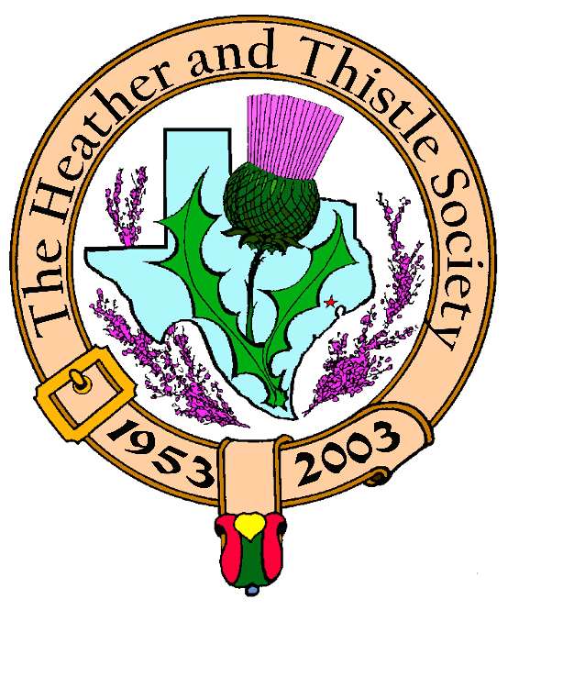

Volume 5, Issue 5
January, 2005

Newsletter Editor:

Jim Monteith

Officers:

Chieftain - Aaron Buchanan
Sub-Chieftain - Cheryl May
Sergeant-at-Arms - Jim Monteith
Secretary - Sharon Monteith Treasurer - Robert Moore

Committee Chairs:

Sunshine-Eileen Moore
Membership-Eileen Moore
Past Chieftains-Paul Ross
Burns Supper-Walter May
Publicity-Melvyn Douglass
Program-Cheryl May

Inside this Issue:

Chieftain’s Letter…………………1

Burns Supper Announcement.1
Burns Club Presentation.……..1
Upcoming Programs…………….2
Scottish Events…………………….2
RSCDS Meetings………………….2
Burn’s Supper Ticket Form…..3 Society Information……………..4
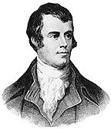
The
Houston Scot Chieftain’s Letter

Greetings, I hope every0ne had a wonderful Christmas and a Happy New Year.

Well it is about that time for our annual Burns supper, time to make sure your kilt is
pressed and your lady has a new dress. The Burns supper committee has been working
Hard to put together the finishing touches to make sure this years dinner is as wonderful
as ever.

I hope everyone has purchased their tickets, if not be sure to do so as quickly as possible,
there are a few tables available. For those of you who are planning to attend, I will see
you there!

We will all have a busy couple of days following the Burns supper. On the Sunday imme-
diately after, January 22, we will hold a service celebrating our favorite poets birthday at
the Burns bust in The Rose Garden of Herman Park at 3 pm.

Also, I want to encourage everyone to attend the performance of the X-rated play “The
Jolly Beggars” presented by our very own Burns club. The play was unpublished in Burns
Time because it was too sexy, too anti-government, and too anti-established religion. The
performance will be on Monday, January 24 in the auditorium of the St. Thomas Episco-
pal school at 7:30pm, our usual time.

See you all soon,

Your Chieftain,

Aaron C. Buchanan

THE BURNS CLUB OF THE HEATHER AND THISTLE SOCIETY,
PRESENT FOR THE EDIFICATION AND DELIGHT OF OUR MEMBERS:
“THE JOLLY BEGGARS: A CANTATA”
JANUARY 24, 2005 IN THE ST. THOMAS EPISCOPAL AUDITORIUM

WARNING !!! THIS PRESENTATION CONTAINS ADULT STUFF…….

THE 52nd ANNUAL BURNS SUPPER AND BALL
SATURDAY, JANUARY 22, 2005 AT 7 PM
HOUSTON MARRIOTT WESTCHASE, 2900 BRIARPARK DRIVE
100 TICKETS LEFT TO SELL, PLENTY OF TABLES LEFT
WE MUST SELL THESE TICKETS MEMBERS !!!!!!!!!!!!!!!!
SEE PAGE THREE FOR ORDERING FORM !!!!!!!!!!!!!!!!!!!
TIME IS DRAWING NEAR, ACT QUICKLY !!!!!!!!!!!!!!!!!!!!

Upcoming Programs :
January 24, 2005
Burn’s Club Program
“The Jolly Beggars: A Cantata”
February, 28, 2005 Election of Officers for 2005

Scottish Events: North Texas Irish Festival
Fair Park in Dallas, Texas
March 4, 5, 6, 2005
Produced by Southwest Celtic Music Assoc. of Dallas -Irish & Scottish entertainment including world famous musicians, dancers, storytellers and educational workshops St. Thomas Episcopal School Scottish Festival Tattoo Friday, March 11, 2005 8pm Toyota Center, Houston

New York Tartan Day Parade
Saturday, April 2, 2005
-all Scottish clans and families
invited for a national parade
-contact at 212-980-0844
-website www.tartanweek.com

Houston Highland Games &
Celtic Festival
Friday, Saturday, Sunday
May 13, 14, 15, 2005

Texas Scottish Festival &
Highland Games
Arlington, Texas
Friday, Saturday, Sunday
June 3, 4, 5, 2005
-contact 1-800-650-1918



2004 Juvenile World
Champions
The St. Thomas Episcopal Pipe
Band spent the month of August
2004 in Scotland winning every
Grade III and Juvenile
Competition they entered,
Including the Cowal Games and
The World Championships for
the fourth time
Heather & Thistle Society – Minutes
December 20, 2004
Sub-Chieftain Cheryl May called meeting to order at 7:40 pm.

Motion to accept October, 2004 minutes approved and seconded.

There were at least 20 members present and two guests; Ken & B.J. Sorrels

Committee Reports:

Burns Club: January 24, 2005 program will be performance of “The Jolly
Beggars: A Cantata”

Newsletter: Editor advised mailing out 147 newsletters and e-mailing 48 at a cost of about $110.00 per month.

Past Chieftains: No report.

Programs: Tonight’s program will be a presentation by Walter May on the influence of Scots in the United States. Information on The Tartan Day Parade on April 5, 2005 in New York City was presented. Burns Club will perform the January 24th program.
February program will be election of new officers.

Sunshine: No report.

Treasurer Report: Balance of $1815.01 as of 12/14/04.

Membership: 230 members total with 101 family, 52 single, 33 life, 40 exempt,
and 4 complimentary

Houston Grampian: St. Andrew’s day dinner was successful. Thanks to H&T members that went.

Highland Games: No report.

RSCDS: They had a wonderful time at the Grampian St. Andrew’s dinner.

Houston Highlanders: No report.

Burns Supper: Ted Hirtz and Alex Munroe will be carrying the Haggis. Still 110 to 120 tickets left to sell. Sub-Chieftain May suggests asking friends and neighbors. Wayne Barton will send out a flyer.

New Business: None.

Old Business: Eileen Moore thanked all who participated in the Kirking of the Tartans at her church. Jack Hume requested the audit of the Robert Burns bust funds be completed.

Walter May give members an educational speech on the influence of Scots on the United States and Texas.

Meeting adjourned for Christmas Party refreshments.
ROYAL SCOTTISH COUNTRY DANCING SOCIETY
PRESENTS
JANUARY TUESDAY SOCIALS
AT
ST. LUKE’S PRESBYTERIAN FELLOWSHIP HALL
8915 TIMBERSIDE, HOUSTON AT 7:30 PM
COST ONLY $5.00

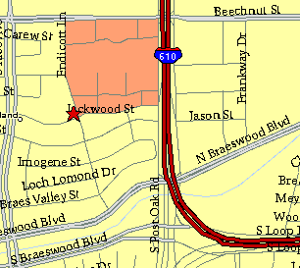

Meeting Information

Meeting Place:
St. Thomas Episcopal School
4900 Jackwood
Houston, Texas 77096

Date and Time:

Fourth Monday of the month
7:30 pm
Heather & Thistle Society Statement
And Membership Information

The Heather and Thistle Society was founded in 1953 by Scots living in Houston who wished to “cultivate an interest in and fond recollections of Scotland, its history and traditions, its literature and ideals, its minstrelsy and song, its customs and amusements, and to provide opportunities for good fellowship and social contact through typically Scottish functions, so that the blessing of our Scottish culture may never die in our new homeland”.

The Heather and Thistle Society meets 10 times a year, September through June. Programs include music, singing, dancing, lively lectures, slide shows and movies about Scotland. The Heather and Thistle Society puts on the annual Robert Burn’s Supper and Ball in late January of each year. We are an organization that promotes our Scottish heritage, in various ways.

The Heather and Thistle Society’s monthly newsletter, “The Houston Scot” is published from September through June. Original articles, information about Scottish or related events are welcome and should be sent to the editor, Jim Monteith, at 15703 Mound Road, Hockley, Texas 77447 or 936-931-2588 or jmonteith@ev1.net.

Membership in the Heather and Thistle Society is open to all with an interest in Scottish heritage and culture. Annual dues are $15 for an individual and $20 for a family membership.
Applications for membership may be obtained from our website at:
http://heatherandthistle.org/documents/membership.doc
Dues are due at the beginning of the fiscal year, March 1. Completed applications and membership fees should be mailed to: Mrs. Eileen Graham Moore
8910 Sandstone, Houston, Texas 77036-6132
For membership information please call Eileen at 713-774-0314.

