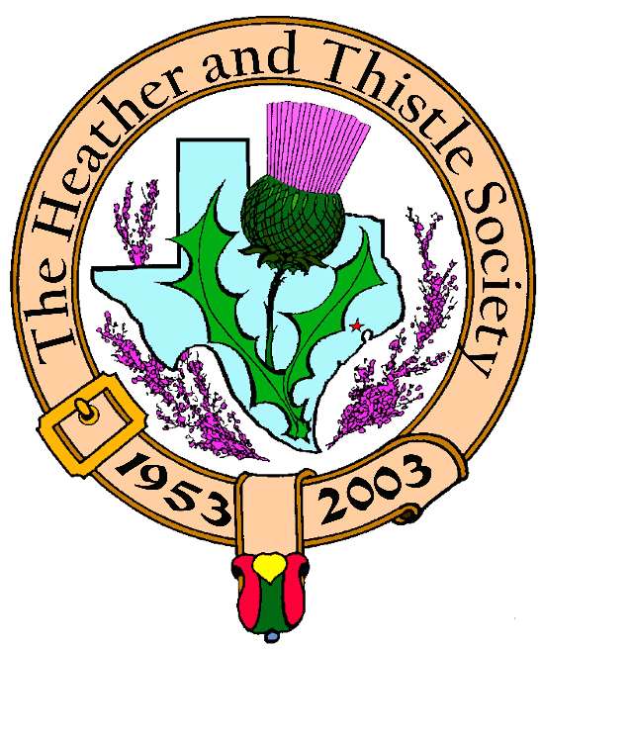

Volume 5, Issue 4
December, 2004

Newsletter Editor:

Jim Monteith

Officers:

Chieftain - Aaron Buchanan
Sub-Chieftain - Cheryl May
Sergeant-at-Arms - Jim Monteith
Secretary - Sharon Monteith Treasurer - Robert Moore

Committee Chairs:

Sunshine-Eileen Moore
Membership-Eileen Moore
Past Chieftains-Paul Ross
Burns Supper-Walter May
Publicity-Melvyn Douglass
Program-Cheryl May

Inside this Issue:

Chieftain’s Letter…………………1

Burns Supper Announcement.1
Christmas Party…………………..2
Upcoming Programs…………….2
Scottish Events…………………….2
Burn’s Supper Ticket Form…..3 Society Information……………..4

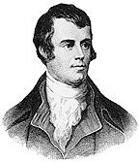
The
Houston Scot Chieftain’s Letter

Greetings, Time to hang the mistletoe, trim the tree, sing Christmas carols, and get your Burn’s Supper tickets! It is just over a month away, and fast approaching. I know the supper committee has been working hard to finalize all the details, and 2005 will be just as wonderful as ever. I want to say thank you to all the members that braved the bad weather for last month’s meeting. There were not enough members in attendance to conduct business, but all had a good time learning some Scottish country dance steps. This month’s meeting will be our traditional white elephant gift exchange. Please note that the meeting will be held on the third Monday, December 20th, so we can have it before Christmas. We will be meeting in the Ingram Room (same place as last year) at St. Thomas. There will be signs posted if you don’t know where it is and I’m sure we will all have a great time! Also we will have a special treat from Past Chieftain Walter May, as he will be presenting “ The Scottish Influence on Texas” as part of our Christmas Program. Happy Holidays! Aaron C. Buchanan Chieftain

THE 52ND ANNUAL BURNS SUPPER AND BALL JANUARY 22, 2005 SATURDAY, 7:00 PM HOUSTON MARRIOTT WESTCHASE 2900 BRIARPARK DRIVE, HOUSTON, TX. 713-978-7400 TICKETS ON SALE NOW !!!!!! H&T MEMBERS ----- $50 NON-MEMBERS----- $65 SEE PAGE 3 FOR MAIL IN TICKET FORM HIGHLAND EVENING DRESS ENCOURAGED

Upcoming Programs : December 20, 2004 H&T annual Christmas Party
-White elephant gift exchange
-“The Scottish Influence on
Texas” presented by Walter
May

January 24, 2005
Burn’s Club Program
-“A Night at Poosie Nansie’s
Tavern” presented for the
edification and delight of
the members Scottish Events:

New York Tartan Day Parade
Saturday, April 2, 2005
-all Scottish clans and families
invited for a national parade
-contact at 212-980-0844
-website www.tartanweek.com

Houston Highland Games &
Celtic Festival
Friday, Saturday, Sunday
May 13, 14, 15, 2005

Texas Scottish Festival &
Highland Games
Arlington, Texas
Friday, Saturday, Sunday
June 3, 4, 5, 2005
-contact 1-800-650-1918
-website ScottishFestival.com

Heather & Thistle Society
November 2004 Meeting

Due to bad weather on this night the necessary quorum of
20 members was not met and no business meeting was held.
Only announcements were
made, then refreshements, and
then members present were
treated to personalized Scottish
Country Dance instruction by
Dianna Shipman and friends





You are cordially invited to the annual

Heather & Thistle Christmas Party

Monday, December 20, 2004 at 7:30 pm

St. Thomas Ingram Room

Bring a <$10.00 Gift for the

White Elephant Gift Exchange

Bring your Christmas Goodies to Share

Happy Holidays

Merry Christmas

Happy New Year

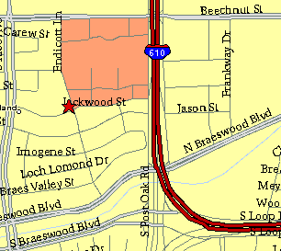

Meeting Information

Meeting Place:
St. Thomas Episcopal School
4900 Jackwood
Houston, Texas 77096

Date and Time:

Fourth Monday of the month
7:30 pm
Heather & Thistle Society Statement
And Membership Information

The Heather and Thistle Society was founded in 1953 by Scots living in Houston who wished to “cultivate an interest in and fond recollections of Scotland, its history and traditions, its literature and ideals, its minstrelsy and song, its customs and amusements, and to provide opportunities for good fellowship and social contact through typically Scottish functions, so that the blessing of our Scottish culture may never die in our new homeland”.

The Heather and Thistle Society meets 10 times a year, September through June. Programs include music, singing, dancing, lively lectures, slide shows and movies about Scotland. The Heather and Thistle Society puts on the annual Robert Burn’s Supper and Ball in late January of each year. We are an organization that promotes our Scottish heritage, in various ways.

The Heather and Thistle Society’s monthly newsletter, “The Houston Scot” is published from September through June. Original articles, information about Scottish or related events are welcome and should be sent to the editor, Jim Monteith, at 15703 Mound Road, Hockley, Texas 77447 or 936-931-2588 or jmonteith@ev1.net.

Membership in the Heather and Thistle Society is open to all with an interest in Scottish heritage and culture. Annual dues are $15 for an individual and $20 for a family membership.
Applications for membership may be obtained from our website at:
http://heatherandthistle.org/documents/membership.doc
Dues are due at the beginning of the fiscal year, March 1. Completed applications and membership fees should be mailed to: Mrs. Eileen Graham Moore
8910 Sandstone, Houston, Texas 77036-6132
For membership information please call Eileen at 713-774-0314.

