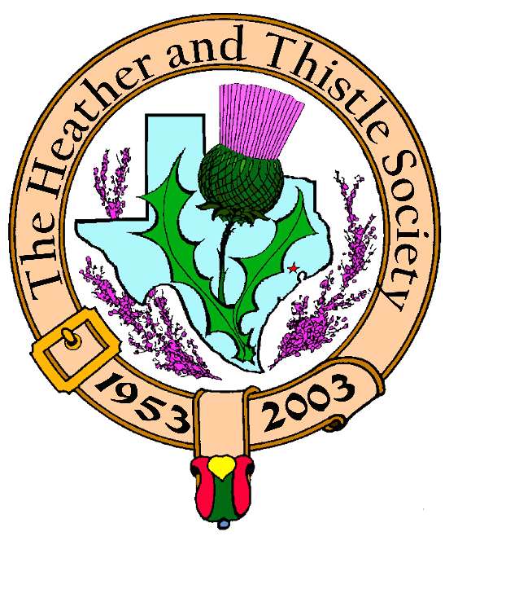

Volume 5, Issue 3
November, 2004

Newsletter Editor:

Jim Monteith

Officers:

Chieftain - Aaron Buchanan
Sub-Chieftain - Cheryl May
Sergeant-at-Arms - Jim Monteith
Secretary - Sharon Monteith Treasurer - Robert Moore

Committee Chairs:

Sunshine-Eileen Moore
Membership-Eileen Moore
Past Chieftains-Paul Ross
Burns Supper-Walter May
Publicity-Melvyn Douglass
Program-Cheryl May

Inside this Issue:

Chieftain’s Letter…………………1
Upcoming Programs…………….1 H&T Minutes……………………...2 Scottish Events……………………2
Burn’s Supper Ticket Form…..3 Society Information……………..4

Upcoming Programs At

Heather & Thistle Meeting:

November 22, 2004
“Lets Have A Ceilidh”
Presented by Dianna Shipman with
Live music by Hugh Morrison on the accordion.
Dianna will teach us in the gym the
dances usually done at the Burn’s
Supper (Gay Gordons, Canadian Barn Dance, St. Bernard’s Waltz and Dashing White Sergeant) plus a couple of similar dances.

December 20, 2004
H&T annual Christmas party in the
Ingram Room at St. Thomas.
“White Elephant Gift Exchange”

January, 24, 2005
Burn’s Society Program

The
Houston Scot Chieftain’s Letter

Greetings All, Well the Holidays are fast approaching and we will soon be bringing out the heavy coats for winter, o.k. maybe just a light jacket after all it is Houston. Regardless of the weather it is time to start getting ready for the Burn’s supper. This months H & T meeting will feature Scottish country dancing. If you ever wanted to participate in the dances at the Burn’s supper here is your chance to learn the steps, without several hundred people watching you. We also have the Kirking of the Tartans scheduled for November 28th and I hope to see you all there. Please see page two of the newsletter to see what other local events are going on this month for St. Andrews day and the Texas Day of the Scots. On a personal note, I would like to send out a message this month to all the officers , committee chairs, members, and volunteers that keep H&T running smoothly. Your hard work and dedication does not go unnoticed and in this time of Thanksgiving I want to say how much I appreciate you. Thank you, Aaron C. Buchanan Chieftain
Editor’s Review of Jim Malcolm Concert

Sharon and I attended and represented the Heather and Thistle Society at the recent performance of Scottish singer Jim Malcolm at the Chocolate Buddha in Pattison, Texas. The Chocolate Buddha is a house in the country which features performances of folk singers in the back yard of Sandy Buller and his wife Janet. They have a very nice stage set up in their large back yard. The performers are all professional musicians from all over the world that perform their own music. At 6pm, there is a potluck dinner and at 7pm the music begins. There is a $10 per person suggested donation. We did not attend the dinner and arrived about 15 minutes late. Sharon and I were dressed in informal Scottish attire and we were a big hit amongst the other guests. The duet Butterfly Sky opened the concert for a short set and then Jeff Talmadge, a solo performer sang. It was a cold night and it was decided that the main event performer, Jim Malcolm, would be moved inside the house. There were about 30 people in attendance and we were cozily seated in the den of the house. Jim Malcolm began his performance, playing the acoustic guitar and harmonica, and singing a combination of his original compositions and other popular Scottish folk music. Between songs Jim entertained us with jokes and commentary about the history of each song. His singing voice reminded me of the popular artist Gordon Lightfoot. His skill on the guitar and harmonica was evident. It was a thoroughly enjoyable evening. Mr. Malcolm was very cordial and engaging during the break and after the performance and even took a hefty tittle from my sporran flask. I heartily recommend listening to Jim Malcolm. I purchased his latest CD and Sharon and I will have it playing at the refreshment table before the meeting and during the break. Jim Malcolm’s website is www.jimmalcolm.com. The Chocolate Buddha website is www.chocolatebuddha.org.

page 2  Scottish Events: Kirking of the Tartans
November 28, 2004
Sunday, 10:45 am
Saint Paul Presbyterian Church will be the site for the 2004 Kirking of the Tartans ceremony. Dr. Kevin Boyd will be leading worship. All members and friends of the Heather and Thistle Society of Houston are invited. Highland dress will be appropriate. The church is located at 7400 Bellaire Blvd., Houston. This is at the corner of Bellaire Blvd. and the Southwest Freeway. For more information please call Eileen or Robert Moore at 713-774-0314.

St. Andrew’s Day Celebration
November 30, 2004
Tuesday, 7:00 pm
The Houston Grampian Association
Celebrates St. Andrew’s Day at
The Warwick Hotel, in the Murat
Room at 5701 Main St., Houston,
Texas
$50 per person/$400 per table (8)
R.S.V.P. – Call 281-481-8360

Houston Highland Games

Association

Texas Day of the Scots
November, 30, 2004
Tuesday, 5 pm at the
McGonigel’s Mucky Duck
2425 Norfolk St. Houston
$12 per person (smoke-free)

52nd Annual Burns Supper
The Heather and Thistle Society of Houston, Texas
January 22, 2005
Saturday, 7:00 pm
Houston Marriott Westchase (formerly Adams Mark Houston) at 2900 Briarpark Drive, Houston, Tx.
Tickets on sale to members Nov. 1, 2004 for $50 and to non-members on Dec. 1, 2004 for $65. Highland
Evening Dress Encouraged.
--see page 3 of newsletter for mail in form to order your tickets.

Heather & Thistle Society – Minutes
October 25, 2004

The meeting was called to order at 7:40 pm.

Tonight’s program by Dr. Arthur Down was announced.

Motion to accept the September minutes was approved.

There were 25 members present. Mary Harris was our one guest.

Committee Reports:

Burns Club: Jack Hume reports they are working on the poetry for January.

Newsletter: Editor asked if member e-mail address could be put on membership applications and if he should print the Burns Supper ticket form in the next two issues. Jack Hume suggested members that don’t have computer internet access should use relatives e-mail address to receive the newsletter.

Programs: November meeting there will be Scottish dancing. December meeting will be our Christmas party. Cheryl May suggests we do the “white elephant gift exchange” again this year.

Membership: 229 members. 99 family, 49 single, 37 life, 4 complimentary, 40 exempt.

Publicity: No report.

Houston Grampian: Walter May will discuss under new business.

Houston Highlanders: Playing Oct. 31 at the Presbyterian Church at San Felipe and Loop 610. Also playing at the Daughters of the British Empire bazaar on Nov. 6, 2004 and at Dickens on the Strand Dec. 4 and 5, 2004.

Houston Highland Games: Meeting to be held on November 4, 2004.

RSCDS: Fall dancing has started and will go through November. Lessons are available. Dancing on Tuesday nights at St. Luke’s Presbyterian Church.

Burns Supper: 58 tables will be available. 12 will be seated at the head table. Tickets on sale Nov.1 and will be mailed out after Nov. 15th.

Sunshine: Sympathy card mailed to Jack Hume.

Treasurer Report: Balance of $1427.00 as of 10-25-04.

New Business: Walter May spoke about the Houston Grampian Association and urged H&T members to join this organization. He asked permission to obtain the H&T membership mail out labels in order to mail H&T members membership information about HGA. He also intends to invite HGA members to join H&T. St. Andrews celebration at Houston Warwick put on by HGA. Motion to give Walter May membership labels passed. 19 for, 5 against. Invitation to members to attend the Kirking of the Tartans at St. Paul’s on Sunday, November 28, 2004.

Old Business: None.

Meeting adjourned for refreshments at 8:10 pm.

Tonight’s program was a presentation by Dr. Arthur Down on the Scottish Regiments in the British Army and some of the campaigns they fought. Dr. Down also passed around medals from his private collection that were given to the men that fought in these campaigns.

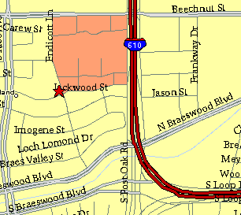

Meeting Information

Meeting Place:
St. Thomas Episcopal School
4900 Jackwood
Houston, Texas 77096

Date and Time:

Fourth Monday of the month
7:30 pm
Heather & Thistle Society Statement And Membership Information The Heather and Thistle Society was founded in 1953 by Scots living in Houston who wished to “cultivate an interest in and fond recollections of Scotland, its history and traditions, its literature and ideals, its minstrelsy and song, its customs and amusements; and to provide opportunities for good fellowship and social contact through typically Scottish functions, so that the blessing of our Scottish culture may never die in our new homeland”. The Heather and Thistle Society meets 10 times a year, September through June. Programs include music, singing, lively lectures, slide shows and movies about Scotland. We are an organization that promotes our Scottish heritage, in various ways. The Heather and Thistle Society’s monthly newsletter, “The Houston Scot”, is published from September through June. Original articles, information about Scottish or related events are welcome and should be sent to the editor, Jim Monteith, at 15703 Mound Road, Hockley, Texas 77447 or 936-931-2588 or jmonteith@ev1.net. Membership in the Heather and Thistle Society is open to all with an interest in Scottish heritage and culture. Annual dues are $15 for an individual and $20 for a family membership. Applications for membership may be obtained from our website at: http://heatherandthistle.org/documents/membership.doc Dues are due at the beginning of the fiscal year, March 1. Completed applications and membership fees should be mailed to: Mrs. Eileen Graham Moore 8910 Sandstone, Houston, Texas 77036-6132 For membership information please call Eileen at 713-774-0314.

