Heather and Thistle Society
Volume 5, Issue 2

October 2004
Newsletter Editor-Jim Monteith
Officers
Chieftain-Aaron Buchanan
Sub-Chieftain-Cheryl May
Sergeant-at-Arms-Jim Monteith
Secretary-Sharon Monteith
Treasurer-Robert Moore

Committee Chairs
Sunshine - Eileen Moore
Membership - Eileen Moore
Past Chieftains - Paul Ross
Burns Supper - Walter May
Publicity - Melvyn Douglass
Program – Cheryl May

Upcoming Texas
Scottish Events

November 13, 2004
Saturday, 10 am to 10 pm
S. Tx. Celtic Music Festival
-Water St. Market Complex -309 N. Water Street
-Corpus Christi, Texas

November 13, 2004
Chocolate Buddha House
Concert, Saturday 7 pm
Pattison, Tx. 281-375-5378
-Scottish singer/writer
Jim Malcolm will perform

Inside this Issue:

Chieftain’s Letter 1
Scottish Events 1
H&T Minutes 2
Scotland Facts 2
In Memoriam 3
Saint Andrew 3
Burns Supper 3
Upcoming Program 3
Society Information 4



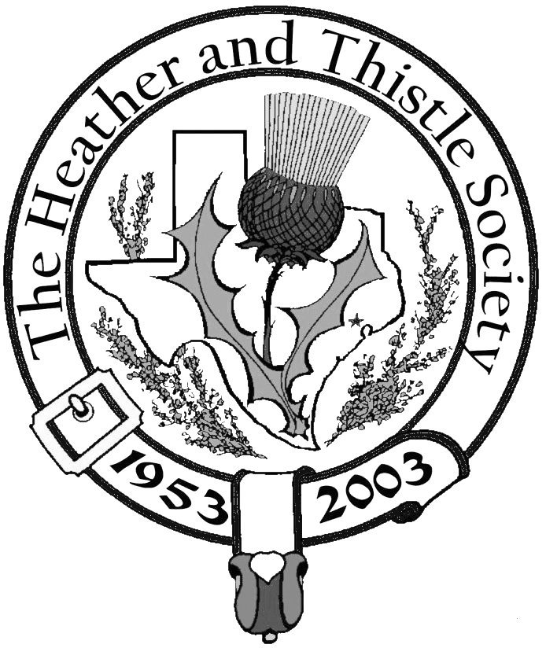

The Houston

Scot

Chieftains Letter
Greetings,

The Heather and Thistle Society lost one of our great matriarchs this month, so I would like to dedicate this months issue of the newsletter in honor of our friend Phemia Hume. Our prayers are with Jack and the rest of the family, in hope that they might find peace and comfort in this difficult time.

The planning for the 2005 Burn’s Supper is moving along very well, be sure to mark your calendars for Saturday, January 22, 2005!

I hope everyone enjoyed the September meeting and presentation of the Houston Grampian’s trip to Aberdeen. I apologize for not being able to attend, due to my being needed out of town. This months meeting will be at the usual date, time, and place, that is October 25th, 7:30 pm, at the St. Thomas Episcopal School. Dr. Down has an excellent program for us. (See page 3 of the newsletter for more details). I look forward to seeing you all there.

I want to thank all of you that have sent in your surveys. I have been compiling all of the data, but I am still waiting on quite a few that haven’t been sent in or received yet. Your responses will remain anonymous, so please feel free to send in your survey expressing your true feelings.

Here is my home address: Aaron Buchanan
5126 Aberton
Your Chieftain, Spring, Texas 77379
Aaron Buchanan


Kirking of the Tartans
Saint Paul Presbyterian Church will be the site for the 2004 Kirking of the Tartans ceremony. Dr. Kevin Boyd will be leading worship. All members and friends of the Heather and Thistle Society of Houston are invited and encouraged to attend. The service will be held at 10:45 am, Sunday, November 28, Highland dress will be appropriate. Saint Paul Presbyterian Church is located at 7400 Bellaire Blvd. (The corner of Bellaire Blvd. at the Southwest Freeway---across from Sharpstown Center.) Hope to see everyone there. For more information, please call Eileen or Robert Moore at 713-774-0314 or the church office at 713-774-7446.

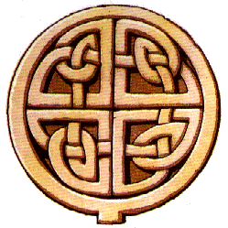
Page 2


Scotland Facts ……….

~~~~~~~~~~~~~~~~~~~~~~~~~
About 55,000 residents of Scotland still speak Scots Gaelic.
The rest speak English, although many speak various Scots dialects which differ markedly from Standard English.
~~~~~~~~~~~~~~~~~~~~~~~~~
Scotland’s legal system is based on Roman law and was retained as part of the terms of union with England.
~~~~~~~~~~~~~~~~~~~~~~~~~
Scotland maintains a separate education system. Scotland was the first country since Sparta in Ancient Greece, in which a system of general public education was implemented. It began with the Education Act of 1696.
~~~~~~~~~~~~~~~~~~~~~~~~~
Heavy industries such as mining, steelworks and shipbuilding once dominated in Scotland. Due to decreasing numbers of jobs in these industries Scotland’s manufacturing industry has shifted to electronics and office equipment. A significant source of jobs is the North Sea oil industry, but in spite of this, unemployment is high in Scotland. Farming is dominated by stock and sheep farming in the Highlands and milk production in the south. Fishery is important as 2/3 of Great Britain’s total catch is landed at Scottish ports. Tourism and whiskey production are two rapidly expanding industries.
~~~~~~~~~~~~~~~~~~~~~~~~~


Heather & Thistle Society - Minutes


September 27, 2004
The meeting was called to order at 7:34 pm.
Minutes from the June meeting were approved and seconded.

Treasurer Report: $1,402.74 in the bank.

There were 23 members present and three guests: Derek MacLeod, Kenneth Sorrels and Dr. Boyd.

Committee Reports:

Burns Club: Jack Hume is ill, no report.

Burns Supper: Coming along fine, next years Supper will be at the Adams Mark Hotel January 22, 2005 at 7 pm.

Newsletter: Editor reports about 40 good e-mail addresses.

Past Chieftains: No Report.

Programs: Dr. Downs will speak on Scottish Regiments of the British Army in October.
Highland Dancing in November and the annual Christmas party in December.
Sub-Chieftain Cheryl May requested ideas or suggestions for future programs.

Sunshine: No report.

Membership: 223 members in good standing as of 09-27-04.

Publicity: No Report

Houston Grampian: Walter May announced St. Andrews Day event on Tuesday,
November 30th at the Warwick Hotel in Houston. Contact him for more info.

RSCDS: No report.

Houston Highland Games: No report.

Old Business: Members are having difficulty obtaining 2004 Burns Supper photos.

New Business: Sub-Chieftain May reminded members to fill out and return member
Survey. Suggestion made that we should remind members of meetings by e-mail.
Kirking O’ the Tartans to be held November 28 at St Paul Presbyterian Church.

Houston Highlanders: Looking for new members. Will be playing at the Scarecrow
Festival in Chappel Hill on the weekend of Oct. 9 & 10.

Meeting adjourned for refreshments at 8:05 pm.

The night’s program was a presentation by Cheryl and Walter May of the Houston Grampian and Grampian Houston Associations recent visit to Abeerdeen to commemorate the Silver Jubilee.

Page 3
In Memoriam

Euphemia (Phemia) Hume
12/10/30 – 10/01/04
Phemia Hume died at home after a long struggle with lung diseases which she fought with personal courage and fortitude. More concerned for her family and friends than for her own health, she remained so concerned to the very end. Phemia was born in Scotland and emigrated to Texas in 1955 where she joined the Heather & Thistle Society. She was an active member until ill health curtailed her activities. She was a proud Texan and citizen of the United States and maintained a lasting affection for Scotland. Following a private cremation, her ashes will be returned to Scotland. Phemia leaves behind her husband of 54 years, Jack Hume, and many other loved ones. Memorials may be made to her favorite charity: St. Jude Children’s Research Hospital, 332 N. Lauderdale, Memphis, Tn. 38105.
Website: www.stjude.org

Upcoming Oct. Program

Dr. Arthur L. Down will present ‘Scottish Regiments of the British Army’. Dr. Down will speak only about the Scottish Regiments on the Regular Army List. The List originally included one Guards Regiment, one Cavalry and sixteen Regiments of the Line, five Lowland and eleven Highland. The review will discuss just two aspects, the Raising of the regiment and a campaign for which a campaign medal is in his collection. British campaign medals have rank, name, and unit engraved around the rim. The campaign’s have been chosen with a view to showing the many parts of the world Scottish Units fought.

Saint Andrew

St. Andrew’s Day is celebrated by Scots on November 30th every year. Saint Andrew is the Patron Saint of Scotland. The Cross of St. Andrew is the flag of Scotland and is a symbol of national identity.
James VII of Scotland established the “Order of Saint Andrew”, an order of Knighthood which is restricted to the King or Queen and sixteen others.
St. Andrew along with his brother Simon Peter (Saint Peter) were thought to have been fisherman in Galilee. Both became apostles of Jesus Christ. St. Andrew is believed to be responsible for spreading Christianity through Asia Minor and Greece. He was put to death by the Romans in Patras, Southern Greece by being pinned to a cross.
There are many legends of how St. Andrew became associated with Scotland and little evidence to support any of them. The popular legend of St. Rule suggests that a Greek Monk (possibly an Irish assistant of St. Columba) called St. Rule (St. Regulus) was directed by an angel, in a dream, to move the remains of St. Andrew to the “ends of the earth” for safe keeping. St. Rule removed a tooth, an arm bone, a kneecap and some fingers from the tomb of St. Andrew’s in Constantinople and dutifully transported these as far as he could. St. Rule was shipwrecked in Scotland, which was close to the “ends of the earth” or the known world at the time. The bones of St. Andrew were brought ashore at a Pictish town on the East Coast of Scotland, later to be known as St. Andrews.
Another tale explaining the association of St. Andrew with Scotland is that Acca, the Bishop of Hexham, a collector of relics, brought the bones to St. Andrews in 733 AD. There was a religious centre at St. Andrews at that time, founded by St. Rule in the 6th century or by Ungus, a Pictish King, who reigned from 731 to 761.
Whichever legend is factual, the relics were placed in a chapel. The Cathedral of St. Andrews replaced the chapel in 1160 and St. Andrews became the religious capital of Scotland, hosting Medieval pilgrims who came to view the relics.
The fate of the relics of St. Andrew is unknown, but it is most likely that they were destroyed during the Scottish Reformation. The Saints, relics, and decoration of churches were expunged by the Protestant cause, propounded by Knox, Wishart, and others. The harsh simplicity of Knox’s brand of Calvanism won out over Roman Catholism during the Reformation.
A plaque, amongst the ruins, marks the place where the relics were kept within the Cathedral at St. Andrews. The rest of St. Andrew’s remains were stolen in 1210 from Constantinople and are now in Amalfi in Southern Italy. The Archbishop of Amalfi in 1879 sent a small piece of St. Andrew’s shoulder blade to the re-established Roman Catholic community in Scotland.
Pope Paul VI in 1969 gave Gordon Gray, the leader of the Roman Catholic Church in Scotland, further relics of St. Andrew with the words “Saint Peter gives you his brother”. Gordon Gray was in Rome to be appointed the first Scottish Cardinal since the Reformation. These relics are displayed in a reliquary in St. Mary’s Roman Catholic Cathedral in Edinburgh.

52nd Annual Robert Burns Supper

The Heather and Thistle Society’s 52nd Annual Burns Supper to be held January 22, 2005, Saturday at 7:00 PM at the Houston Marriott Westchase at 2900 Briarpark Drive, Houston. Tickets on sale to members for $50.00 on November 1, 2004 and to non-members for $65.00 on December 1, 2004.
The Burns Supper Planning Committee reports: The head table will seat 14 individuals and the room should hold 680 people. In addition to the ballroom, a reception room, practice room, Pipers room, Band room, Dancers room, will be needed. The band has been secured and will consist of 12 band members. The band will try to be located opposite the head table to alleviate complaints about the audio level.

Page 4
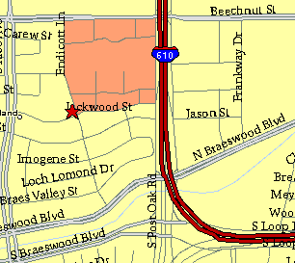

Meeting Information

Meeting Place:
St. Thomas Episcopal
School
4900 Jackwood
Houston, Texas 77096

Date & Time:
fourth Monday of the
month
7:30 pm

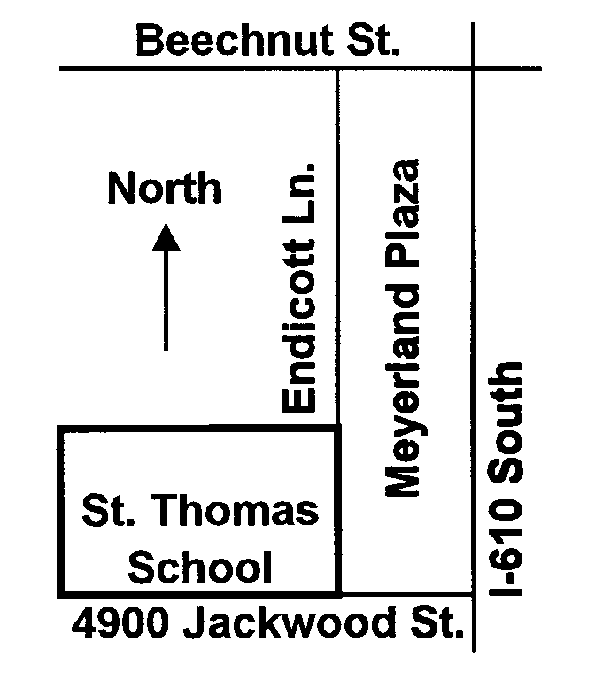

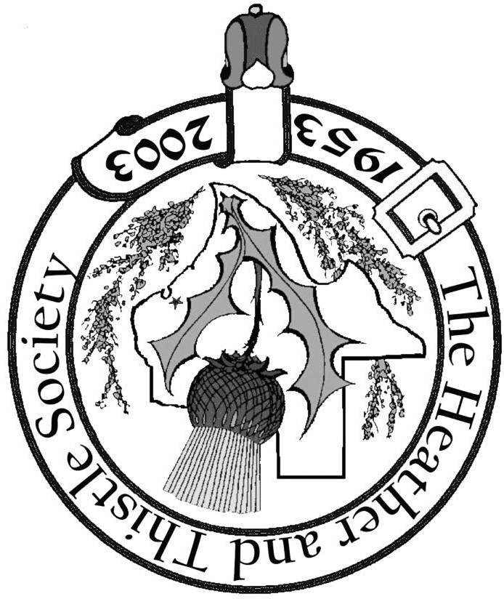
Society Statement & Membership Information

The Heather and Thistle Society was founded in 1953 by Scots living in
Houston who wished to “cultivate an interest in and fond recollections of
Scotland, its history and traditions, its literature and ideals, its minstrelsy and
song, its customs and amusements; and to provide opportunities for good
fellowship and social contact through typically Scottish functions, so that the
blessing of our Scottish culture may never die in our new homeland”.

The Heather and Thistle Society meets 10 times a year, September through
June. Programs include “ceilidhs”, lively lectures, slide shows and movies
about Scotland. We are an organization that promotes our Scottish heritage, in
various ways.

The Houston Scot is published monthly, September through June. Original
articles are welcome and should be sent to Jim Monteith at 15703 Mound Rd.
Hockley, Tx. 77447 or 936-931-2588 or jmonteith@ev1.net.

Membership in the Society is open to all with an interest in Scottish heritage and
culture. Annual dues are $15 for an individual and $20 for a family membership.
Applications for membership may be found on our web site at :
(http://heatherandthistle.org/documents/membership.doc). Dues are due at the
beginning of the fiscal year, March 1. Completed applications and membership
fees should be mailed to: Mrs. Eileen Graham Moore
8910 Sandstone, Houston, Texas 77036-6132
For membership information please call Eileen at 713-774-0314.
Membership Dues for 2004 are now due and payable.

