Heather and Thistle Society
Volume 5, Issue 1

September 2004
Newsletter Editor-Jim Monteith
Officers
Chieftain-Aaron Buchanan
Sub-Chieftain-Cheryl May
Sergeant-at-Arms-Jim Monteith
Secretary-Sharon Monteith
Treasurer-Robert Moore

Committee Chairs
Sunshine - Eileen Moore
Membership - Eileen Moore
Past Chieftains - Paul Ross
Burns Supper - Walter May
Publicity - Melvyn Douglass
Program – Cheryl May

Upcoming Texas
Scottish Event

November 13, 2004
Saturday, 10 am to 10 pm

South Texas Celtic Music
Festival

-Water St. Market Complex
309 N. Water Street
Corpus Christi, Texas

Performers include, the
Rogues, the Sarah Dinan
Band, Cluan, Gilmer &
Moore, Gravel Walk, Celtic
Menagerie, Inishfree School
of Irish Dance, Water’s Edge Pipes and Drums
Inside this Issue:
Minutes 2
Scotland Facts 2
In Memorium 3
“The Bruce” 3
Society Information 4

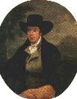

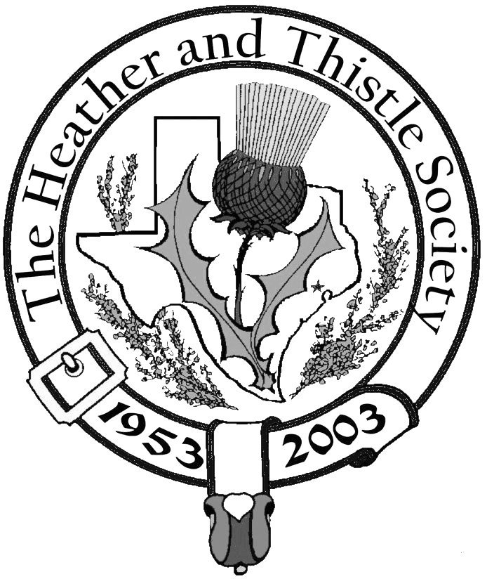

The Houston

Scot

Chieftains Letter
Greetings,

I hope all of you have had a wonderful summer. Sharon and I had an excellent trip across the pond, saw some magnificent sites, and met some wonderful people throughout Scotland. Two of the first people we spent time with was Walter and Elizabeth Watson, from the small town of Biggar. Walter is currently the Senior Vice President of the Robert Burns World Federation, and he is slated to deliver the immortal memory at our 52nd Annual Burns Supper. After leaving Biggar, we had a splendid time exploring all of Rabbie’s old haunts in Dumfries with our friend Mrs. Shirley Bell, who wishes all of you the very best. For now, I’ll spare you all the details of the rest of the trip, but next time you see Sharon, make sure to ask her what is the best way to run from a highland Coo.

You will notice there is an insert in this months newsletter. I have decided to give every member of the society an opportunity, to let me know how they feel about different aspects of Heather and Thistle. Please fill in the survey and mail it back to me. Your responses will remain anonymous, so please feel free to express your true feelings. I will gather the data, compile a report for the past chieftain’s committee, and share some of the results in upcoming newsletters. I really want to hear from you all.

September’s meeting will feature a presentation by the Houston Grampian Association and their very recent trip to our sister city Aberdeen.

Here is my home address: Aaron Buchanan
5126 Aberton
Your Chieftain, Spring, Texas 77379

Aaron Buchanan

52nd Annual Robert Burns Supper

January 22, 2005 Saturday at 7:00 PM. The Heather and Thistle Society’s 52nd Annual Burns Supper to be held at the Houston Marriott Westchase at 2900 Briarpark Drive, Houston. Tickets on sale to members for $50 on Nov. 1, 2004 and to non-members for $65 on Dec. 1, 2004.

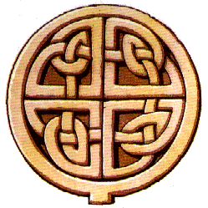
Page 2


Scotland Facts ……….

~~~~~~~~~~~~~~~~~~~~~~~~~
Scotland has since 1707 been a part of Great Britain, together with Northern Ireland, Wales and England.
~~~~~~~~~~~~~~~~~~~~~~~~~
Scotland consists of nine regions plus the outer islands of Orkney, Shetland and the Western Isles.
~~~~~~~~~~~~~~~~~~~~~~~~~
The distance between Scotland’s two major cities is only 50 km, and in this area a large share of the country;s population lives.
~~~~~~~~~~~~~~~~~~~~~~~~~
Scotland has Britain’s highest mountain (Ben Nevis, 1343 meters), largest lake (Loch Lomond, 70 sq km) and the deepest lake (Loch Ness, 229 meters).
~~~~~~~~~~~~~~~~~~~~~~~~~
Scotland’s climate is not quite as bad as you would think. The west coast is during summer noticeably wetter, breezier and cooler than the rest of the country. On the Western Isles, a yearly average of 250 to 270 days with mist, rain or snow has been recorded. During the winter though, the western parts of the country is favoured by a milder climate due to the influence of the Gulf Stream. Not even the northernmost parts of Scotland can be sure of snow more than a couple of weeks during winter.
~~~~~~~~~~~~~~~~~~~~~~~~~


Heather & Thistle Society - Minutes


June 28, 2004
The meeting was called to order at 7:40 pm.
Minutes from the May meeting were approved and seconded.

Treasurer Report: 80 delinquent on dues
$340.00 dues sent in May
$1,579.62 in the bank

There were 24 members present, including Dr. and Eileen Moore’s daughter and granddaughter from Conroe. One new member present Mark Monroe, and he presented a brief family history.

Committee Reports:

Burns Club: Meeting in South Caroline this summer

Burns Supper: Everything is progressing well, next years Supper will be at the Adams Mark Hotel January 22, 2005.

Newsletter: Stille trying to get more e-mail addresses, Jack Hume stated that he would like to see the newsletter on the website.

Past Chieftains: No Report.

Programs: No Report.

Sunshine: Get well card sent to Jack and Phemia Hume. Sympathy cards to be sent to the Buchanan family, and Ian Murray.

Membership: 214 members

Publicity: No Report

Houston Grampian: No Report

Houston Highland Games: Great turnout at this years games, and even made a slight profit.

Old Business: 2004 Burns Supper photos on the website

New Business: Survey of H & T membership. Next meeting September 27, 2004 at 7:30 pm. Jack Hume spoke about Moria Buchanan’s life and funeral. Presentation on history of Scottish Parliament.

Program: Texas Wildflowers, a group of women who sing at the Houston Livestock show and rodeo. Ten members sang songs written by women. We all enjoyed their beautiful voices and the songs they sang.

Meeting adjourned for refreshments at 8:45 pm.

Page 3
In Memorium

Marion Johnston Buchanan
1924 – 2004
Known as “Moria” to friends and family, she passed away Tuesday June 15, 2004 in Winipeg, Manitoba surrounded by family. Moria was wife of Jack Buchanan (1922-2001), Heather and Thistle’s 7th past chieftain (1959-1960) and 14th past chieftain (1966-1967). Mrs. Buchanan was a very close friend of the Humes and she and her husband contributed highly to the H&T Society. She is survived by her son Gordon and wife B. J., son Graham and wife Susan, four grandchildren, and one great grandson.

Help Save H&T Dollars

Currently it costs the Heather & Thistle Society about $1 per issue to print and mail a copy of the newsletter to every member. With our current membership, that’s in excess of $200 per month.

You could save the society $10 a year per membership by receiving the newsletter electronically. To have the newsletter emailed to you instead of receiving a printed copy send your email to the new editor Jim Monteith at jmonteith@ev1.net.
If you would like to contribute to the newsletter send any comments, articles, pictures or stories to the editor.

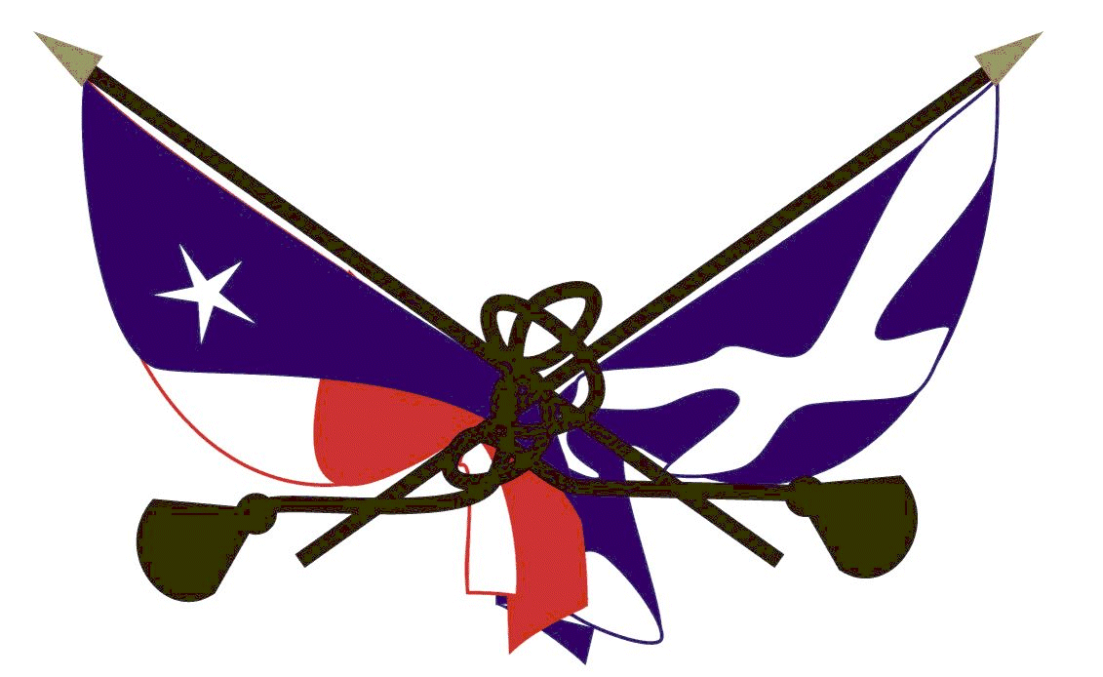

Robert I ( The Bruce ), 1274 – 1329
Robert The Bruce was 31 when he ascended the throne of Scotland in 1306. He faced an unpromising situation. He was no more than the precariously placed King of an enemy occupied country. In June 1306 he was defeated at Methven by the English commander, the Earl of Pembroke, and was forced to flee to the forests, hills and islands. Within 8 months three of his brothers had been executed, the women of his family were imprisoned, and the Countess of Buchan, who had crowned him at Scone, was incarcerated in a cage. In March 1307 he made a come-back in the West and was victorious in Glen Trool, and in May avenged Methven by defeating Pembroke at Loudon Hill. It now seemed he would have to face the full might of England. Fortunately, the “Hammer of the Scots” Edward I died in camp at Burgh-by-Sands on July 7, 1307.

Edward I son, the foolish Edward II, gave up the campaign and turned south to enjoy frivolous pursuits leaving Bruce free to conquer his kingdom. With assistance of the King’s brother Edward Bruce, his nephew Thomas Randolph and Sir James Douglas, Bruce went forward systematically and successfully with the capture and destruction of the castles from which the English had ruled the country. By 1311 it was possible to raid England and by 1313, Stirling Castle alone remained in English hands. Here, Edward Bruce agreed with Sir Philip Mowbray, the English commander of the castle, that the castle would be surrendered if not relieved by an English force before midsummer 1314.

This bizarre arrangement brought Edward II north with 20,000 men. Bruce awaited him near Bannockburn with something like 7,000 men. The battle on June 24, 1314 ended in decisive victory for the Scots. The victory was due to leadership, discipline, battle experience and use of ground, which routed the English and sent the defeated Edward II riding for Dunbar.

Bruce began, in his turn, to “hammer” the English with frequent raids, including an expedition to Ireland where his brother Edward Bruce became monarch in 1317, only to be killed a year later. The mettle of the country was shown with the noble confession of faith in Scotland’s nationhood and love of liberty known as the Declaration of Arbroath of 1320. In 1324 , David II was born to Bruce and his wife Elizabeth de Burgh. A parliament met at Cambuskenneth in 1326 and swore allegiance to Bruce’s son David II as heir to the Scottish throne. The ban of excommunication on Bruce was lifted in 1328. Edward II was disposed of by England’s disreputable Queen Isabella who acknowledged Bruce’s claims to Scottish independence. It was agreed that David II would marry Joanna, sister of Edward III of England. Bruce died at Cardoss in 1329, possibly of leprosy. He lies, like St. Margaret, in the Parish Church at Dunfermline.

From “A Holiday History of Scotland” by Ronald Hamilton
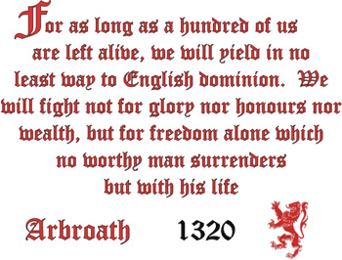

Page 4
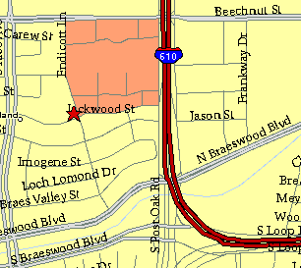

Meeting Information

Meeting Place:
St. Thomas Episcopal
School
4900 Jackwood
Houston, Texas 77096

Date & Time:
fourth Monday of the
month
7:30 pm

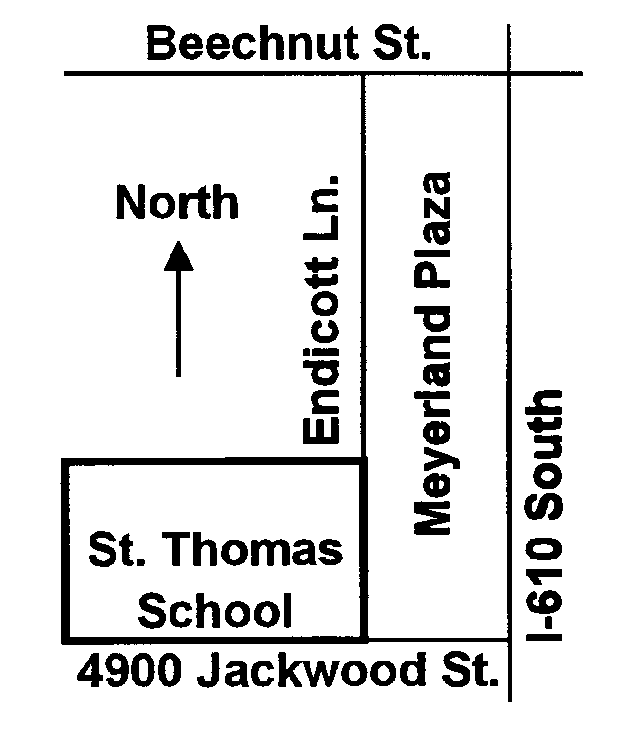

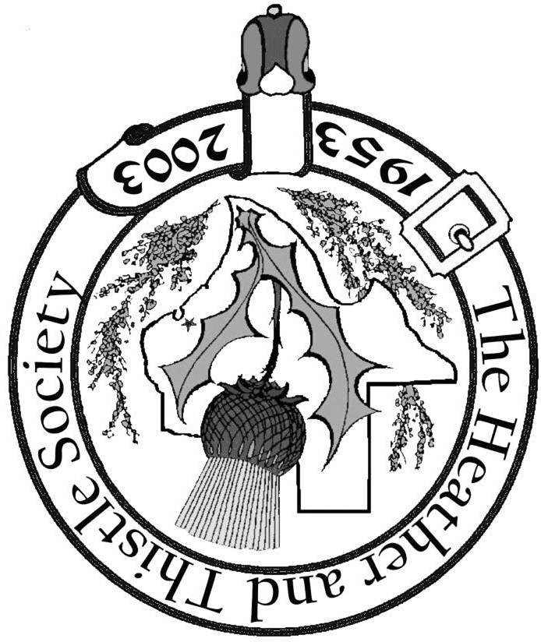

Society Statement & Membership Information

The Heather and Thistle Society was founded in 1953 by Scots living in
Houston who wished to “cultivate an interest in and fond recollections of
Scotland, its history and traditions, its literature and ideals, its minstrelsy and
song, its customs and amusements; and to provide opportunities for good
fellowship and social contact through typically Scottish functions, so that the
blessing of our Scottish culture may never die in our new homeland”.

The Heather and Thistle Society meets 10 times a year, September through
June. Programs include “ceilidhs”, lively lectures, slide shows and movies
about Scotland. We are an organization that promotes our Scottish heritage, in
various ways.

The Houston Scot is published monthly, September through June. Original
articles are welcome and should be sent to Jim Monteith at 15703 Mound Rd.
Hockley, Tx. 77447 or 936-931-2588 or jmonteith@ev1.net.

Membership in the Society is open to all with an interest in Scottish heritage and
culture. Annual dues are $15 for an individual and $20 for a family membership.
Applications for membership may be found on our web site at :
(http://heatherandthistle.org/documents/membership.doc). Dues are due at the
beginning of the fiscal year, March 1. Completed applications and membership
fees should be mailed to: Mrs. Eileen Graham Moore
8910 Sandstone, Houston, Texas 77036-6132
For membership information please call Eileen at 713-774-0314.
Membership Dues for 2004 are now due and payable.

