Volume 4, Issue 8

June 2004
Newsletter Editor-Jim Monteith
Officers
Chieftain-Aaron Buchanan
Sub-Chieftain-Cheryl May
Sergeant-at-Arms-Jim Monteith
Secretary-Sharon Monteith
Treasurer-Robert Moore

Committee Chairs
Sunshine - Eileen Moore
Membership - Eileen Moore
Past Chieftains - Paul Ross
Burns Supper - Walter May
Publicity - Melvyn Douglass
Program – Cheryl May

Upcoming Programs

June 28, 2004 – The Texas
Wildflowers sing a variety
of old Country Western
and patriotic songs written
by women.

July – August – No meeting.

September 24, 2004 - TBA
Inside this Issue:
Minutes 2
Scotland Facts 2
Newsletter Editor 3
H & T photos 3
Society Information 4



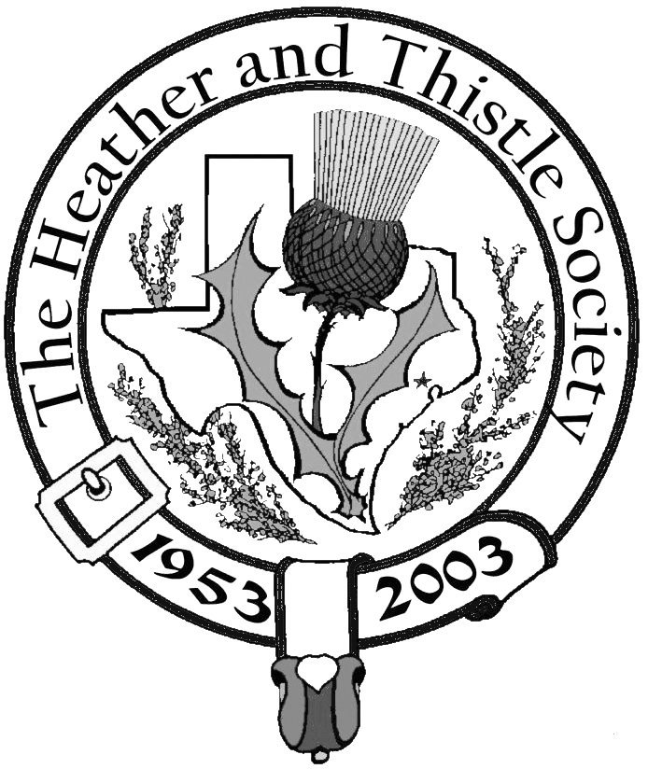

The Houston

Scot

Chieftains Letter
Greetings,

Last months meeting was an especially enjoyable experience for me and my whole family. I want to thank the three young ladies; Natalie Sue Cox, Anna Lee Gordon, and Rachel Marie Gordon for performing several beautiful Highland dances for us all. These girls are all students at St. Thomas Episcopal School, and have been very successful in there competitions. We wish them all the luck!

I want to extend a personal Thank you to Doug Burns for his service as newsletter editor; as he has done an excellent job. I also want to welcome our new newsletter editor Sergeant at arms Jim Monteith.

Well it is coming up to our last meeting before the summer break, and we will be serenaded by the Texas Wildflowers. This “bouquet” of singers is a part of the publicity function of the Houston Livestock Show and Rodeo Speakers’ Committee. This a cappella group is comprised of eight to twelve women singers who perform music composed only by Texas women.

I hope everyone has a great summer,

Chieftain Aaron C. Buchanan

For any questions, comment or concerns email the Chieftain
chieftain@heatherandthistle.org

2004 H & T Burns Supper Photos
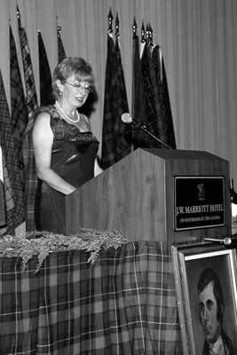
are now available on-line at: www.ibis-arts.com


photo courtesy of:
Ibis Arts Photography and Web Services


Page 2

Scotland Facts ……….

~~~~~~~~~~~~~~~~~~~~~~~~~
The population of Scotland was 5.1 million in 1995. Glasgow is the largest city with 619,000, Edinburgh, the capital, has 448,000 and Aberdeen has about 219,000.
~~~~~~~~~~~~~~~~~~~~~~~~~
Scotland has approximately 600 golf courses. There are just over 100 whisky distilleries there.
~~~~~~~~~~~~~~~~~~~~~~~~~
Scotland covers an area of 48,955 sq. miles and is situated between 55 and 60 degrees north. Shetland is closer to the Arctic Circle than to the south of England. Scotland comprises 34% of Britain’s land mass and is roughly two-thirds the size of England.
~~~~~~~~~~~~~~~~~~~~~~~~~
The rocks in Scotland are amongst the oldest in the world, about 3 billion years old. Scotland was at one time part of a huge continent linking North America and Scandinavia. Scotland was separated from England by a sea 1,000 miles wide. Scotland was once south of the equator and baked in sub-tropical temperatures.
~~~~~~~~~~~~~~~~~~~~~~~~~


~~~~~~~~~~~~~~~~~~~~~~~~~
Caledonia (Latin)

Alba (Scots Gaelic)

Scotland (English)


Heather & Thistle Society - Minutes

May 24, 2004
Tonight’s program was presented first and introduced by Walter May. Members were
Treated to a Highland Dance performance by three young ladies that attend St. Thomas.
Natalie Sue Cox, Anna Lee Gordon, and Rachel Marie Gordon performed three dances. The Gordon girls are the daughters of Laurie and David Gordon who are H&T members. Walter May presented the girls with certificates of appreciation.

Meeting was adjourned for refreshments at 7:40 PM.

Meeting was called to order by Chieftain Buchanan at 7:58 PM on May 24, 2004 in the theater of St. Thomas Episcopal School.

Motion to approve the minutes from last months meeting was made and approved.

Treasurer Dr. Robert Moore reported a balance of $1,327.92 as of last statement date.

Sergeant-at-Arms Jim Monteith called for committee reports:

- Burns Club: Jack Hume reported that a pleasant meeting was held at his home recently and they are working on a program for the Burns Supper.
- Burns Supper: The ticket prices are going to go up to $50 for members and $65 for non-members. Probably will be around 640 tickets available. Reports that the Haggis team is in place. The location will be at the Adams Mark Hotel which will soon become a Marriott. It is on Briar Park off of Westheimer. Date will be the 22nd of January, 2005.
- Newsletter: Doug Burns has retired as editor of the newsletter. Jim Monteith has taken over. Members applauded Doug’s excellent work for the last year and a half. Discussion was held about a monthly publishing date, e-mailing, and posting on the H&T website.
- Past Chieftains: No report.
- Program Committee: Texas Wildflowers vocal group set for next month.
- Sunshine: No report.
- (Membership: Eileen Moore reports 125 family, 64 single, 37 life, 4 complimentary, and 40 exempt for a total of 270 members. There are 80 members whose dues are delinquent.
- Grampians: Bob Gilbert reports a trip to Aberdeen is coming up in late August and early September. Will be celebrating the 25th anniversary of the sister city program.
- Houston Highlanders: Al Campbell reports will be playing at a big wedding this Saturday.
- Houston Highland Games: Chieftain Buchanan reports over 100 applications for membership were given out at the Heather and Thistle table. Signed up three new members at the games.
- RSCDS: No dancing lessons will be given during the summer. They will be meeting socially at 7:30 PM on Tuesdays at St. Luke’s Presbyterian Church at 8915 Timberside.

Sergeant-at-Arms Jim Monteith reported 21 members in attendance and one guest.

Old Business: None discussed.
New Business: None discussed.

Meeting adjourned at 8:13PM.

Page 3


Newsletter Editor

This is my first issue as
editor for The Houston Scot.
I want to thank Doug Burns
on behalf of the entire mem-
bership for his term as
editor and for bringing a
professional look to the
newsletter.

I hope I am able to figure out
this computer stuff and get
the job done. Send any comments, articles, pictures or stories to Jim Monteith at jmonteith@ev1.net. Deadline for the next issue will be Sept. 1, 2004. Have a great summer.

Help Save H&T Dollars

Currently it costs the Heather & Thistle Society about $1 per issue to print and mail a copy of the newsletter to every member. With our current membership, that’s in excess of $200 per month.

You could save the society $10 a year per membership by receiving the newsletter electronically. To have the newsletter emailed to you instead of receiving a printed copy send your email to the new editor Jim Monteith at jmonteith@ev1.net.



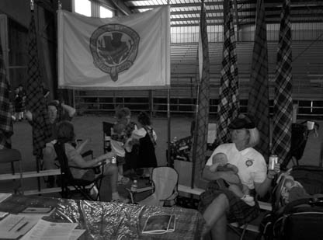
(right) Sub-Chieftain Cheryl May and grandson Collin Michael Croucher, born Feb. 20, 2004, relaxing at the H & T table at last months games

.
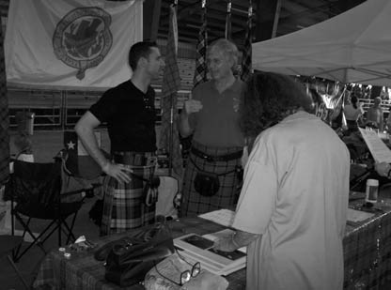

(left) Chieftain Aaron Buchanan and Past Chieftain Walter May discussing important society issues

(right) Chieftain Aaron Buchanan, Sub-Chieftain Cheryl May, Treasurer Robert Moore, and Secretary Sharon Monteith on Sunday at the games.
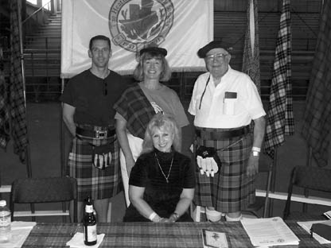



(above and right) Natalie Sue Cox, Anna Lee Gordon, and Rachel Marie Gordon performing at last months H & T meeting

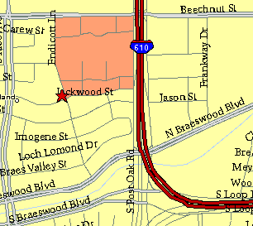

Meeting Information

Meeting Place:
St. Thomas Episcopal
School
4900 Jackwood
Houston, Texas 77096

Date & Time:
fourth Monday of the
month
7:30 pm

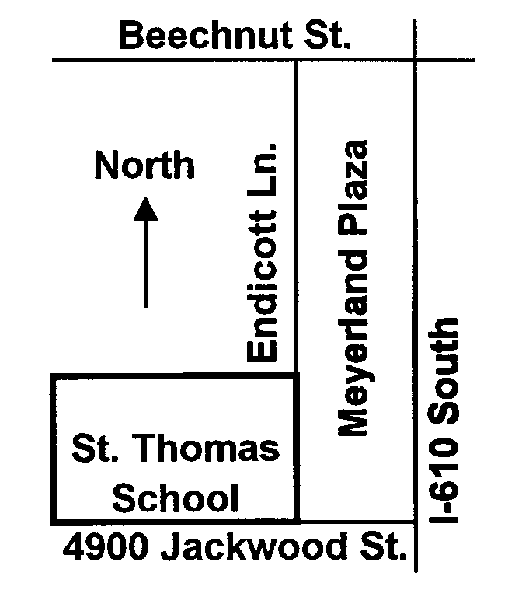

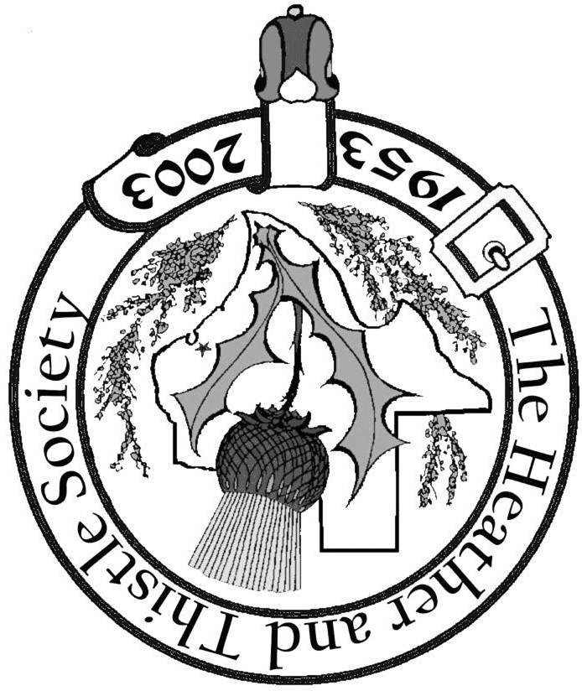

Society Statement & Membership Information

The Heather and Thistle Society was founded in 1953 by Scots living in
Houston who wished to “cultivate an interest in and fond recollections of
Scotland, its history and traditions, its literature and ideals, its minstrelsy and
song, its customs and amusements; and to provide opportunities for good
fellowship and social contact through typically Scottish functions, so that the
blessing of our Scottish culture may never die in our new homeland”.

The Heather and Thistle Society meets 10 times a year, September through
June. Programs include “ceilidhs”, lively lectures, slide shows and movies
about Scotland. We are an organization that promotes our Scottish heritage, in
various ways.

The Houston Scot is published monthly, September through June. Original
articles are welcome and should be sent to Jim Monteith at 15703 Mound Rd.
Hockley, Tx. 77447 or 936-931-2588 or jmonteith@ev1.net.

Membership in the Society is open to all with an interest in Scottish heritage and
culture. Annual dues are $15 for an individual and $20 for a family membership.
Applications for membership may be found on our web site at :
(http://heatherandthistle.org/documents/membership.doc). Dues are due at the
beginning of the fiscal year, March 1. Completed applications and membership
fees should be mailed to: Mrs. Eileen Graham Moore
8910 Sandstone, Houston, Texas 77036-6132
For membership information please call Eileen at 713-774-0314.
Membership Dues for 2004 are now due and payable.

We’re on the Web www.heatherandthistle.org

The Heather and Thistle Society
P. O Box 270030
Houston, Texas 77277-0030

